**AppDev: Lab #1**

**Name:** Anthony Nadeau - 2058983 **Date:** 02/09/2021

**Course:** AppDev (420-331-VA) **Semester:** Fall 2021

**Section:** 00001 **License:** CC BY 4.0

---------------------------------------------------------------------------------------------------------------------

**Example-01: How to set up a project in C#:**

1. The following is the output of part 9 of Example 1 of the Lab document.

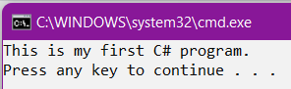

And here is the error message



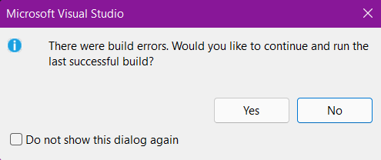

**Example-02: Performing Arithmetic operation**

1. The following is the output of part 3 of Example 2 of the Lab Document.

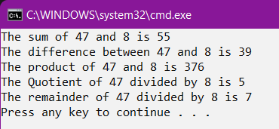

Then we have the output of a different number combination.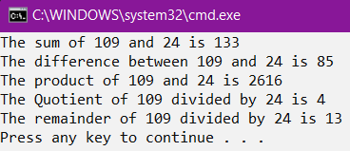

**Example-03: Using the string Data Type**

1. Finally, here is the output for example 3:

