**AppDev: Lab #2**

**Name:** Anthony Nadeau - 2058983 **Date:** 23/09/2021

**Course:** AppDev (420-331-VA) **Semester:** Fall 2021

**Section:** 00001 **License:** CC BY 4.0

---------------------------------------------------------------------------------------------------------------------

**Question 1 (Figure 9.2):**

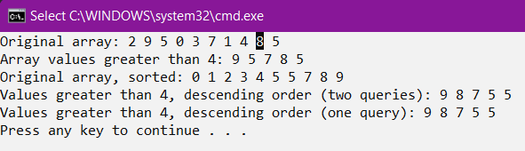

**Question 2: (Figure 9.3 - 9.4)**

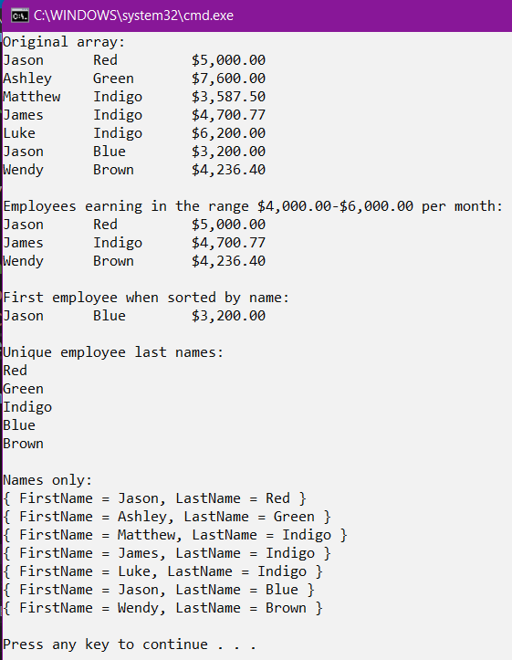

**Question 3 (Figure 9.6):**

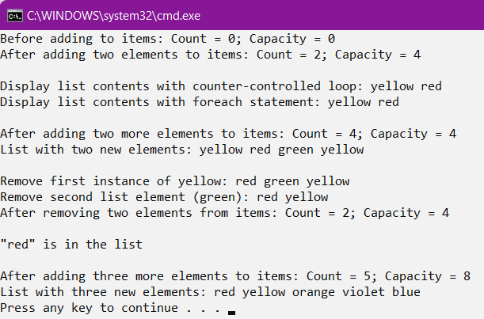

**Question 4 (Figure 9.7):**

