**Programming Patterns: Assignment #1**

**Name:** Anthony Nadeau **Date:** 10/09/2021

**Course:** Programming Patterns (420-301-VA) **Semester:** Fall 2021

**Section:** 00001 **License:** CC BY 4.0

---------------------------------------------------------------------------------------------------------------------

**Part 1:**

Here is the output for the Driver Class of part 1

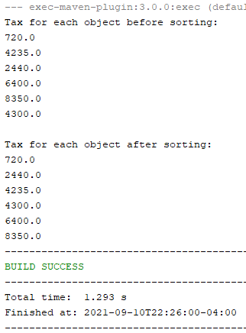

**Part 2:**

Here is the output of the Driver Class for part 2 question 1

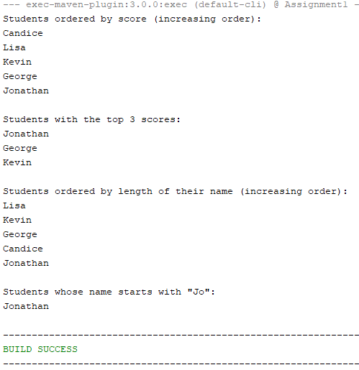

Here is the output for part 2 questions 2 and 3

