**Programming Patterns**

**Name:** Anthony Nadeau - Konstantinos Nikopoulos **Date:** 04/11/2021

**Course:** Programming Patterns (420-331-VA) **Semester:** Fall 2021

**Section:** 00001 **License:** CC BY 4.0

---------------------------------------------------------------------------------------------------------------------

**Q1.**

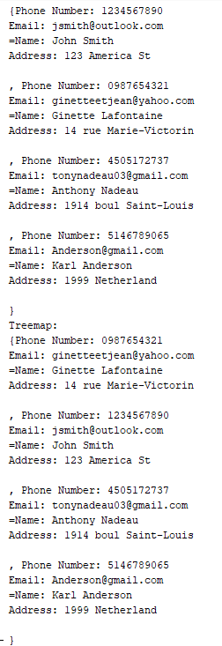

**Q2.**

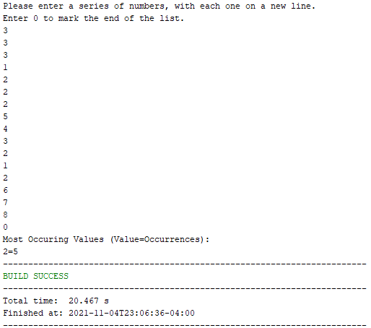

**Q3.**

