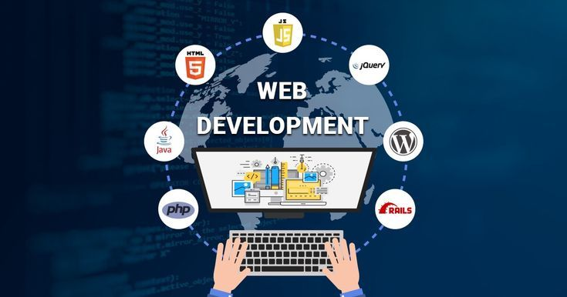
Name: BuhleBakhe Ngwenya
Student no: ST10511301
Module: WEDE5020

Table of content
Proposal 1 3
Organization overview 3
Website goals and objectives 3
Current Website Analysis 3
Proposed Website Features and Functionality 4
Design and User Interface 4
Technical Requirements 5
Timeline and Milestones 5
Budget 5
References 5
Proposal 2 6
Organisation Overview 6
Website Goals and Objectives 6
Current Website Analysis 7
Proposed Website Features and Functionality 7
Design and User Experience 7
Technical Requirements 8
Timeline and Milestones 8
Budget 8
Reference 8

Proposal 1

Organization overview
Name: Pretoria Community Kitchen
Brief history: In 2022, three teachers in the area discovered that children were going to school hungry in the Pretoria CBD. They began by preparing 30 meals in a garage, and this initiative has since grown to serve over 500 people each week at two locations. The organisation is funded entirely by donations, volunteers, and community goodwill.

Objective: To combat hunger with dignity by providing nutritious meals and a sense of hope to vulnerable families in the Tshwane area and surrounding regions.
Objective: No individual should go to bed hungry.
Values: compassion, dignity, community, respect, and responsibility
The main group is low-income families, homeless people, and schoolchildren. The secondary group consists of donors, corporate sponsors, volunteers, and partner NGOs in Gauteng, between the ages of 20 and 55, who want to achieve real impact.

Website goals and objectives
Business goals:
Raise monthly donations by 35% within six months of the launch.
In the first year, recruit 50 new active volunteers.
Improve transparency by sharing monthly impact reports and stories.

Current Website Analysis
PCK currently uses TikTok and Facebook
Drawbacks include information being lost, there being no central point where donations can be made, it being difficult to find new volunteers, and a lack of professional credibility for corporate sponsors.
There's the opportunity that a dedicated website will provide PCK with continuous visibility, help to build trust among donors, and make it easier for people to assist.

Proposed Website Features and Functionality
On the homepage, you can find information about food support as well as ways in which people can get involved, for example by donating or volunteering; it also advises people to tell the news to their close ones.
About Us: Our story, our mission, our vision, photographs of the team and the beneficiaries with their consent.
Enquiry: enquiry form if you either want to donate, volunteer, sponsor, or just a general enquiry
Services: community meals, food donations, sponsorships and community support
Contact information is provided, including embedded Google Maps showing the two feeding sites in the Pretoria CBD and Sunnyside, as well as a contact form.

Design and User Interface
The colours are warm orange to symbolise hope, white to represent clarity, and charcoal grey for trust.
For the body text, use Aptos because it's easy to read, and for the heading, use Lora since it gives a and warm feel.
The design follows a story-first approach and includes large, real photos of people; it is built with mobile use in mind so that donors can donate using their phones.
Focus on the user experience by ensuring that donations can be made in three clicks, using simple language and providing accessibility features such as alternative text and high contrast mode for older donors.
Wireframes Flow: Header> Impact Stats> Story> How to help> Footer
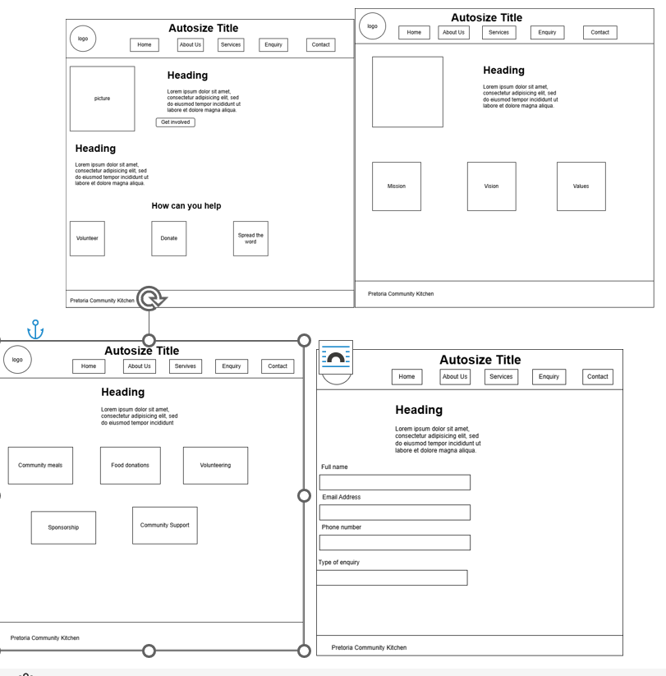
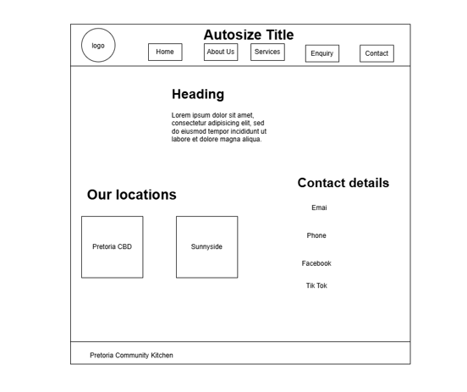

Technical Requirements
Hosting: Netlify Free Tier and Custom Domain
Domain name: pretoriacommunitykitchen.org.za
Languages: HTML, CSS, JavaScript for form validation
Third- Party Integrations: Google Maps for locations, Google Maps embed for donations, social media feed
Tools: VS Code, Git, GitHub for version control

Timeline and Milestones
Week 1-2: Finalise content, gather photos and complete proposal
Week 3-4: Build HTML structure+ CSS styling for all 5 pages
Week 5: Implement forms, JavaScript and test on mobile
Week 6: SEO optimisation, final testing and submission

Budget

References

- Canva.com
- Catalyst Baptist Church (2025) Training for the Community Meal Team. Available at: bing.com [Accessed 14 August 2026].
- Donna. (n.d.) Archie Bray Home - Archie Bray. Available at: za.pinterest.com [Accessed 14 August 2026].
- Ela Janiak. (n.d.) Pretoria map. You can find it at za.pinterest.com.[ Accessed 14 August 2026.]
- Laura Soriano. (n.d.) Icono de teléfono vectorial. Vector Premium. Available at: za.pinterest.com. Accessed 14 August 2026.
- Pinterest. (n.d.) Getting Clearer: Our Students Need S Not.... Available at: za.pinterest.com [Accessed 14 August 2026].
- Pinterest (n.d.) defines what is meant by community health and explains why it is important. The source can be accessed at za.pinterest.com [Retrieved 14 August 2026].
- Lifestyle Concept. (n.d.) Donation bags for charity. Available at: za.pinterest.com [Accessed 14 August 2026].
- Ubuntu Village Inc. (no date) Community Kitchen - Sharing Meals, Sharing Joy. Available at: za.pinterest.com [Accessed 14 August 2026].
- W3schools

Proposal 2

Organisation Overview
Name: EcoGlow Reusable Bottles PTY LTD
Overview: EcoGlow was founded in 2024 in Pretoria East by two graduates studying environmental science. Because they were annoyed by the amount of plastic waste on campus, they began selling double-walled stainless steel bottles from a market stall. Within 12 months, their customer base had grown to over 800, and they now provide bottles to three gyms in Gauteng.
Objective: To present sustainable hydration in a stylish, affordable, and accessible way to all people in South Africa.
Objective: Remove all single-use plastic bottles from Gauteng by 2030, achieving this one refill at a time.
The main group of customers consists of health-conscious students and young professionals between the ages of 18 and 35 in Pretoria and Johannesburg, with corporate clients who want branded environmental merchandise and gyms as a secondary target audience.

Website Goals and Objectives
Business Goals:
Set up an online store with the aim of raising monthly sales by 50% within six months.
Get 30 good B2B leads for bulk company orders each quarter.
Establish your brand's authority by making yourself the leading eco-bottle brand in Pretoria.
Success Indicators:
Number of online orders and average order value per month.
The number of enquiry form submissions relating to bulk orders.
The conversion rate and the traffic from Instagram and TikTok.

Current Website Analysis
EcoGlow is currently available only via Instagram direct messages and at the weekend markets.
Drawbacks include the absence of an e-commerce function, a limited market reach, the lack of a product catalogue, the inability of customers to make payments online, and the fact that there is no SEO, meaning we do not show up on Google.
Opportunity: Having a website that enables e-commerce will provide 24-hour-a-day sales, give corporate clients a sense of professional credibility, and cut down on the time spent responding to direct messages.

Proposed Website Features and Functionality
On the homepage, there is a hero banner containing the "Ditch Plastic" call to action together with the featured products and customer testimonials.
About Us: A narrative of the founder, our commitment to sustainability, and some statistics regarding our impact, such as the number 12,000 plastic bottles saved.
The product offering includes an e-commerce catalogue which provides images, prices, sizes, and colours, together with the ability to add items to the cart.
Query: A form for handling bulk/corporate orders, custom branding, and wholesale inquiries.
Contact: Contact form, WhatsApp click-to-chat, store location with Google Maps, and delivery information

Design and User Experience
The colour scheme consists of forest green to represent nature, beige to provide a sense of warmth, and white for the clean focus on the product.
For headings, we'll use Montserrat to give a modern look, and for the body text, Aptos since it's easier to read.
The design takes the product as its focus, features large images of lifestyle scenarios, and is built with mobile use in mind since 80% of the traffic will come from social media.
Focus on the user experience by ensuring checkout can be completed in two clicks, providing clear information about shipping and returns, and making sure the page loads in under three seconds.
The wireframe flow is as follows: Header, Hero, Bestsellers, About, Reviews, and Footer.

Technical Requirements
Hosting: Hostinger Premium Shared Hosting
Domain Name: ecoglow.co.za
Languages: HTML5, CSS3, JavaScript for cart and form validation
For third-party integrations, you can use Payfast for payments, Google Maps for the pickup location, and Meta Pixel for ads.
For version control, the tools used are VS Code, Git, and GitHub.

Timeline and Milestones
Week 1-2: Content, product photos, and proposal finalisation
Week 3-4: Build 5 HTML pages + CSS styling + responsive design
Week 5: JavaScript for cart, form validation, and PayFast integration
Week 6: SEO setup, testing, and launch

Budget

Reference

