Important

Coding for the Virtual CV was done mainly in the CV_and_Projects Repository however upon viewing the rubric I realised that the Virtual CV must have its own repository, and I then proceeded to create a new repository (Virtual_CV) and moved the code to the new repository hence most commits are on the CV_and_Projects repository

My Virtual CV is an online representation of my professional qualifications, designed to showcase my skills and experiences to potential employers.

Key Elements Include**:**

* **Personal Information**: My name and contact details.
* **Education**: Academic qualifications and relevant coursework.
* **Skills**: A list of both technical and soft skills.
* **Portfolio/Projects**: Links to my work samples and projects.
* **Certifications and Awards**: Relevant certifications I have earned.
* **References**: Contact details for my professional references.

Design Considerations**:**

I ensure my Virtual CV has a clean, professional layout, is visually engaging although has a rather simple look to it and is mobile-responsive. The Virtual CV can be viewed on both laptop and mobile device as I have coded it to adjust properly according to screen size

## Features of My Virtual CV

My Virtual CV includes several key features designed to effectively showcase my professional qualifications:

**1. Interactive Links**

I have embedded clickable hyperlinks that lead to my professional profiles, such as LinkedIn, as well as my portfolio and relevant projects. This makes it easy for employers to access my work.

**2. Responsive Design**

My Virtual CV is optimized for viewing on any device—be it a smartphone, tablet, or desktop—ensuring that it looks great no matter how it’s accessed.

**3. Downloadable Format**

I can easily download my CV as a PDF, providing a professional format for offline sharing when required.

# Screenshots:

## Laptop View:

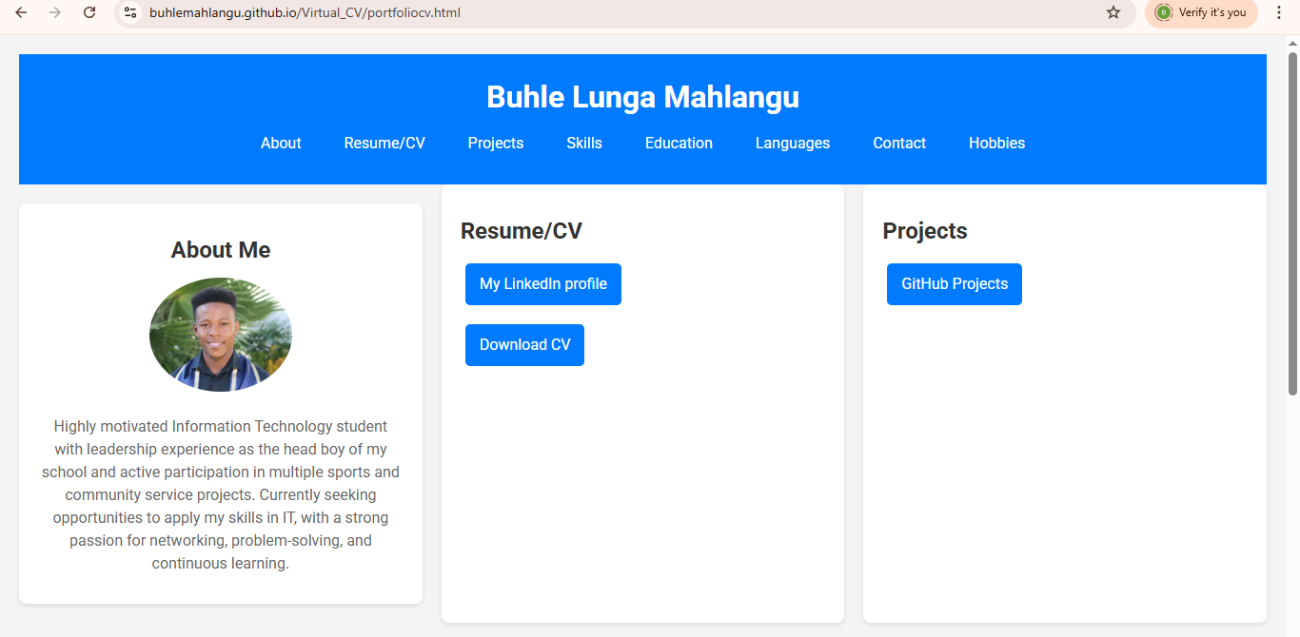

Smartphone View:



