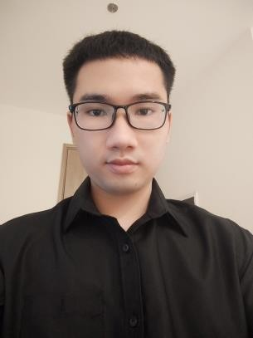

Duc Phu Bui

Mobie Developer

Contact

**Address:**

Ho Chi Minh City

**Phone:**

+84 987 567 503

**Email:**

[buiphu05012002@gmail.com](mailto:buiphu05012002@gmail.com)

**LinkedIn:**

[linkedin.com/in/đức-phú- 3257b027b](linkedin.com/in/đức-phú-%203257b027b)

**GitHub:**

https://github.com/Bui-Duc-Phu

Languages

English – Basic

# Summary

Android Developer specializing in front end and backend development. Experienced with all stages of the development cycle for Android project. Well-versed in numerous programming languages including Java, Kotlin, SQL Server, Javascript, MySQL.

# Skill Highlights

|  |  |
| --- | --- |
| * React-Native, Java, Kotlin, OOP,Design Pattern, MVC, MVP * SQL,NoSQL * Restful API | * Research * Problem Solving * Git,Docker |

Education

**Posts and Telecommunications Institute of Technology**

Bachelor of Science – BS

Security Information (2020 - 2025)

# Projects

**App Chat (BE Kotlin)**

* An application built by android studio for people to send messages to each other
* Programming language: Kotlin
* Database : Firebase (firebaseAuthen,Realtime,Storage,Cloud Messaging )
* Link: [https://github.com/Bui-Duc-Phu/Messenger_App](https://github.com/Bui-Duc-Phu/Messenger_App.git)
* Link Demo: [https://s.net.vn/M3HF](https://s.net.vn/M3HF%20)

**App Chat (BE Nodejs)**

* An application built by android studio for people to send messages to each other
* Programming language: Kotlin(Service notification), Nodejs
* Database : MySQL
* Link: <https://github.com/Bui-Duc-Phu/ChatAPP.git>
* Link Demo: [https://s.net.vn/36ew](https://s.net.vn/36ew%20)

**App Coffe**

* Coffee app for chain stores
* Programming language: Kotlin
* Database: Firebase (firebaseAuthen,Realtime,Storage,Cloud Messaging )
* Link: <https://github.com/Bui-Duc-Phu/App_Coffe.git>