CPT Code Analytical Utility App
  - Huy Bùi / ACS46 (solo)

Introduction

Motivation
The application, referred to as “Clinic Utility”, is a full-stack web-based application designed to handle the principal administrative and clinical operations of a medical clinic. It serves as a centralized and interactive platform for managing providers (largely synonymous with “doctors” in this context), service catalogs, patient billing, and business intelligence (BI) analytics. The system facilitates the efficient recording of medical services, tracks the revenue stream, as well as provides relevant insights through data visualization and trend analysis.
In the healthcare industry, efficient data management is critical, not only for professional operations but also for the collection and analysis of data for both medical and commercial motivations. Many small-to-medium-sized and budget-restrained clinics still rely on fragmented systems, if not manual processes, for billing and scheduling, leading to errors and inefficiencies. I chose this application to be the course project from the experiences and knowledge that I have been exposed to during previous internships and observations, targeting to address real-world challenges by constructing a unified solution that demonstrates data integrity, scalability, and serves realistic BI.

Components
The project consists of four primary modules:
- ‘Provider’ management: a directory of medical staff and doctors with detailed profiles and their specialty management.
- ‘Service’ catalog: a management interface for the clinic’s medical procedures, linked to the standard, nationally-recognized Current Procedural Terminology (CPT) codes.
- ‘Billing’ portal: a transactional hub for logging billing events and provisions of services.
- ‘Dashboard’ and ‘Analytics’: BI modules that visualize trends, performance, as well as service bundle suggestions.

Database design
The database is designed with a Relational Model to ensure data consistency and eliminate redundancy for functional and physical efficiencies. It’s implemented using Microsoft SQL Server.

Relational designs
The following graphics do not strictly follow the exact designations & naming as implemented in the actual database or the schemas to be represented, but is structurally up-to-date:
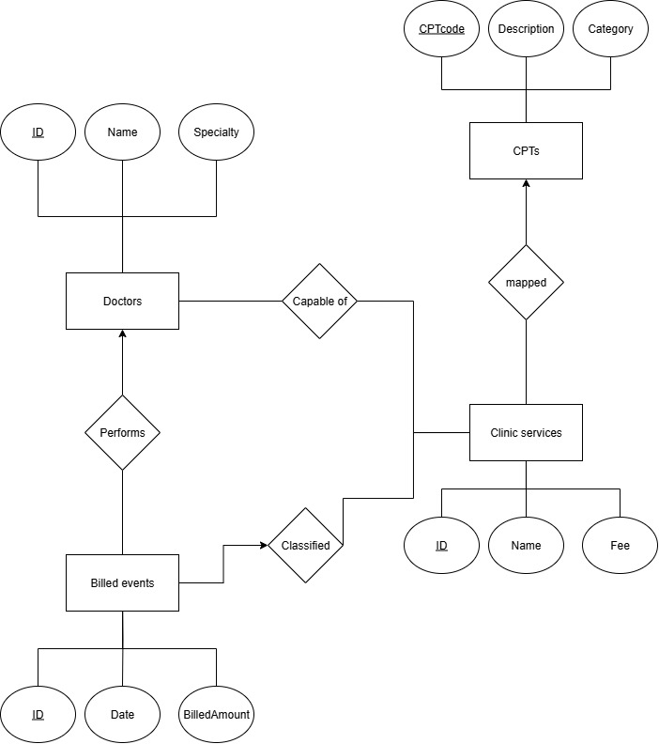

DB relational schema
Primary key
Foreign key

Providers -- doctors
DrID(int) -- doctor’s ID
FirstName(varchar)
LastName(varchar)
Specialty(varchar)

CPTs
Code(varchar) -- CPT code
Description(text)
Category(varchar)

ClinicServices
ServiceID(int)
ServiceName(varchar)
Fee(decimal)
CPTcode(int) CPTs.Code

BilledEvents
EventID(int)
ServiceID(int) ClinicServices.ServiceID
DrID(int) Providers.DrID
DateOfService(date)
BilledAmount(decimal)

Providers_Capabilities
DrID(int) Providers.DrID
ServiceID(int) ClinicServices.ServiceID

Events_Class -- event’s classification
EventID(int) BilledEvents.EventID
ServiceID(int) ClinicServices.ServiceID

Dependencies & constraints
The tables are defined in 3NF.
- Primary keys: defined for all entities to ensure uniqueness.
- Foreign keys: enforce referential integrity and the definition of weak entities.
- Logical constraints: e.g. application mechanically prevents providers from being associated with capabilities that they were not assigned.

Functionalities

Basic (CRUD)
- (C)reate: adding new providers, defining new services, logging new billing events.
- (R)ead: displaying paginated lists of providers, services, and billing history, alongside support of searching by names, specialties, codes, and the objects’ core information.
- (U)pdate: editing and saving existing records.
- (D)elete: deleting and voiding existing records.

Advanced (logical and technical implementation)
- Capability enforcement: restricting the creation and assignment of billing entries by only allowing doctors to be named with capabilities that they have been registered in the database.
- Searching & pagination: utilizing parameters and optimized SQL queries to retrieve only a relevant subset of data for every request to relieve pressure on the frontend (client)’s system when handling supposedly large sets of data, ensuring high performance and smooth user experience.
- Analytics: utilizing SQL self-join to identify pairs of services that are frequently booked together to recommend service bundles, assisting marketing operations.
- Trend visualization: utilizing SQL aggregation queries and web visualization libraries to showcase trends and financial performance in multi-axis interfaces.

Implementation

Frontend (client)
Angular 19 framework (TypeScript/JavaScript, HTML, CSS) is utilized to operate and render the web-based user interface. Bootstrap 5 is chosen as the library to conveniently implement visual interfaces, while various JS-based libraries are also utilized for chart rendering. The frontend application is developed in 5 main components: ‘Dashboard’, ‘Providers’, ‘Services’, ‘Billing’, and ‘Analytics’, practically being represented as 5 “tabs” of the web interface.

Backend (server-side)
- Database: Microsoft SQL Server (MSSQLS)
- API: Microsoft ASP.NET Core Web API 10 to connect the frontend web interface to the backend database server, including the sending of designated queries and receiving of JSON-structured data. As a RESTful API, the API functions also have POST/GET/PUT/DELETE methods corresponding to the four C/R/U/D functions, which are handled correctly to implement the application’s overall logic.
- Data access: Dapper ORM integrated into the API compilation as a library and protocol to execute SQL queries and retrieve data, serving as the mechanical bridge between the server and client and the functional soul of the API.

Repositories
As describing the implementation of the project is impractical in a word report, you are welcome to examine the actual codes and builds of the entire project at CS4710-DB-proj, with the API project can be specifically found at CS4710-DB-proj-API (sub-repo) and the frontend project directly at CS4710-DB-proj-CLIENT (also sub-repo).

Experiences
While constructing and implementing the database system in this project went flawlessly on my side, I found that the implementation of the API and web application was more troublesome, because I had to deal with interconnected components and mechanisms to make the final compilation run gracefully. Besides that, as a developer, I have to think about the user experience and keep making adjustments to the user interface, which was time-consuming but also a valuable experience for me to know how full-stack development works, especially with a database-operated application.

References
Generative AI platforms like ChatGPT, Google Gemini, and Microsoft/GitHub Copilot are mainly utilized to assist me in how to structure and design the web client, alongside some large-scale troubleshooting for the front-end web project, as well as some in the .NET API project. There was largely no AI or external assistance for the creation and implementation of the database server, as well as its logic and data structures.

