Huy Bùi

CSC 4710 Database Systems

Stage 4 project report
Timeline as initially proposed in the Stage 3 report:
- By Oct. 26: foundation & backend setup (establishing the SQL server)
- By Nov. 2: constructing API functions serving core entities
- By Nov. 9: projecting and setting up the frontend interface using planned platforms

SQL Server setting up
Status: Practically done!
SQL Server with a projected table and dedicated design has been established successfully and is operated flawlessly.
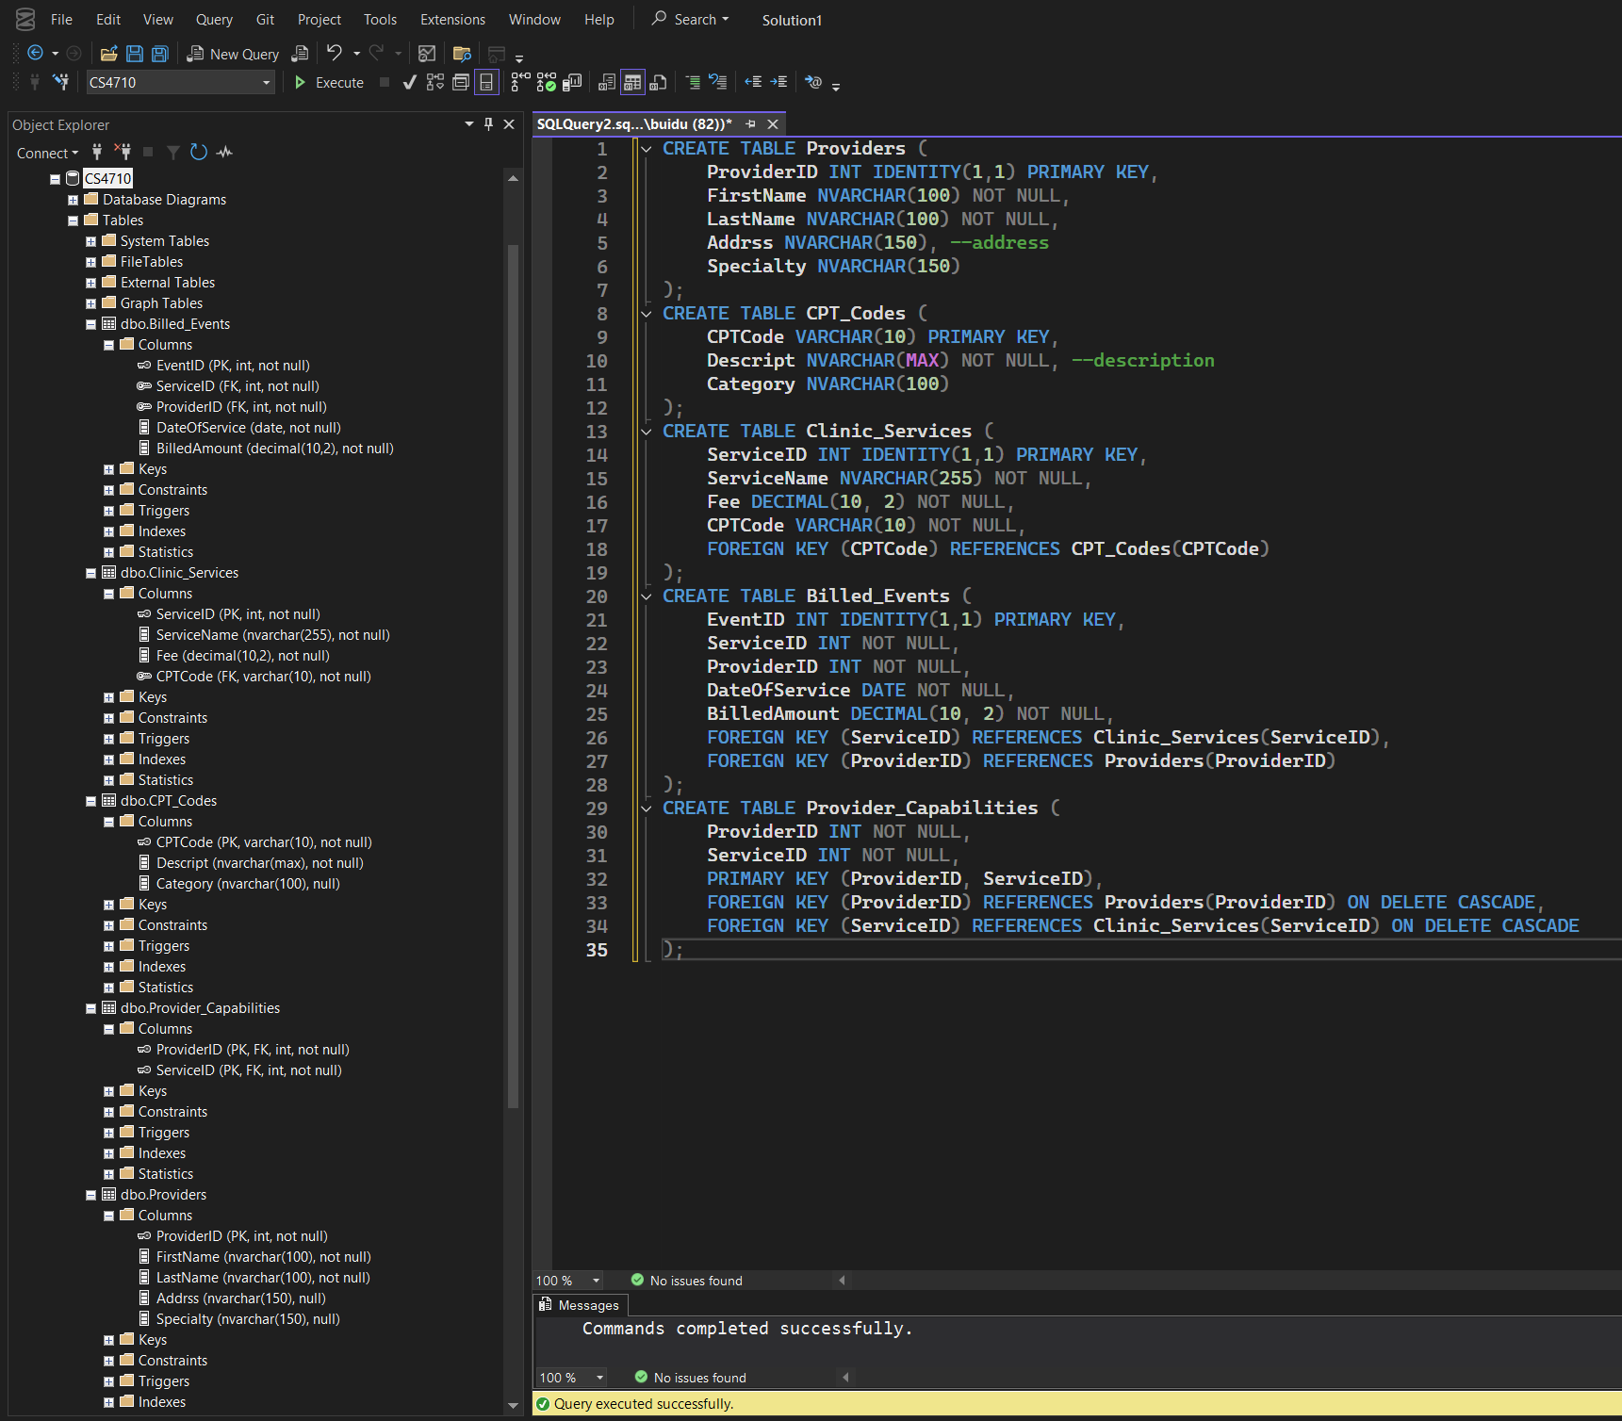

Developing and establishing an API connection
Status: ongoing/ partially completed.
The feasibility of the technical approach and solution is comprehensively proven.
Successfully connected to the SQL server using the Microsoft .NET Core API and performed CRUD operations. Did not implement the API for all of the projected tables, but techniques and challenges during API development and deployment have been studied from the implementation on the first tables, so major struggles are not expected when implementing on the rest of the project’s database.
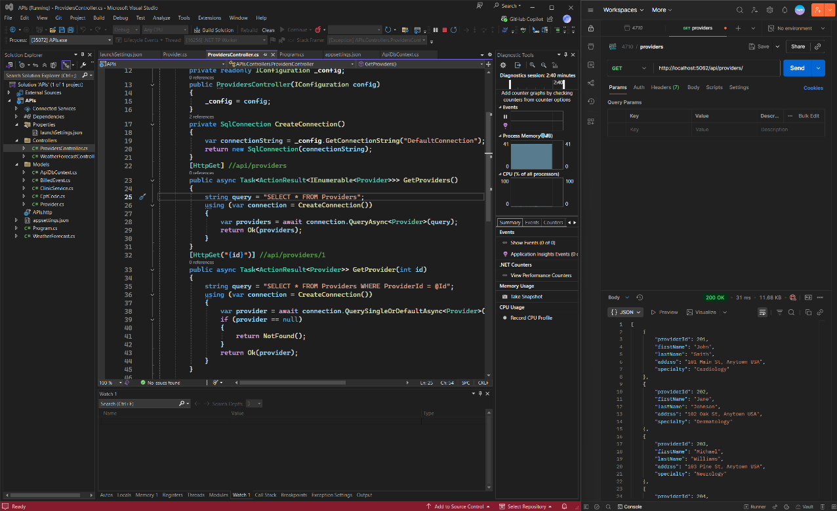

Frontend
Status: not done yet.
As API development is not fully completed, it is impractical to start with the web interface.

Things still need to be done: (ongoing & future works)
- Constructing API functions serving core entities (ongoing/completing)
- Projecting and setting up the frontend interface using planned platforms
- Implementing core app logic and functionalities like logging and viewing billed events.
- Building and implementing advanced features like trend analysis.
- Building and implementing advanced features like service suggestions.
- Deploying & presenting the finalized project.

