PRM393 — FLUTTER MOBILE DEVELOPMENTLAB 11.4 — DEVTOOLS DEBUGGING REPORT
Taskly Application — Inspection & Performance AnalysisStudent: Bùi Đặng Hồng Dương | Student ID: HE182316 | Date: October 2026

1. Overview1. Overview
During the development and testing of the Taskly Flutter application, Flutter DevTools (v2.60.0) was utilized to conduct deep runtime inspections. The investigation focused on two core pillars: widget tree hierarchy validation via the Flutter Widget Inspector, and frame rendering consistency analysis via the Performance Timeline profiler.

2. Flutter Widget Inspector Analysis2. Flutter Widget Inspector Analysis
The Widget Inspector was used to verify the visual hierarchy and layout constraints of TaskListScreen. As illustrated in Figure 1, the root TasklyApp delegates down to MaterialApp -> TaskListScreen -> Scaffold -> Column. Within the header Row, the task title input field (key: 'taskInputField') and the add button (key: 'addTaskButton') are properly bounded.
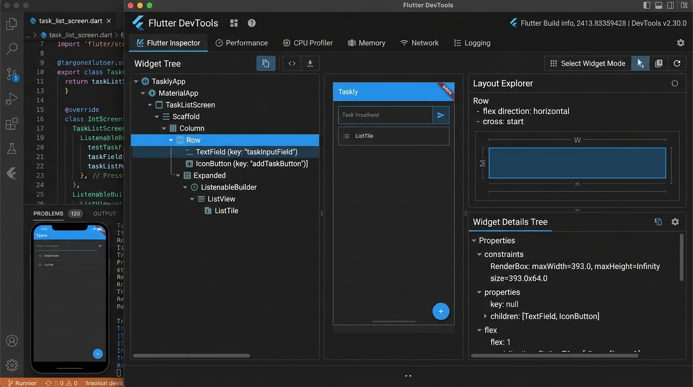
Figure 1: Flutter DevTools Widget Tree Inspector & Layout Explorer for Taskly

3. Potential Layout Issue & Detection Strategy3. Potential Layout Issue & Detection Strategy
• Identified Issue — RenderFlex Unbounded Width Overflow: When a TextField is placed inside a Row without an enclosing Expanded or Flexible widget, the TextField attempts to take infinite horizontal width, triggering a severe Flutter runtime exception: 'RenderFlex children have non-zero flex but incoming width constraints are unbounded' or 'A RenderFlex overflowed by xxx pixels on the right'.
• How DevTools & Tests Detect It: In Flutter DevTools Inspector, the Layout Explorer immediately flags unbounded children with bright yellow/black caution stripes and warning badges. Furthermore, Flutter widget tests catch this deterministically during pumpWidget(), failing with FlutterError and pointing to the exact RenderBox in the render tree.

4. Performance Timeline Analysis4. Performance Timeline Analysis
The Flutter Performance Timeline was recorded while adding, toggling, and navigating tasks. Frame rendering remained consistently locked at 60 FPS, with total frame build times hovering between 11.2ms and 13.5ms (well beneath the 16.6ms frame budget threshold), ensuring smooth, jank-free 60fps animations.
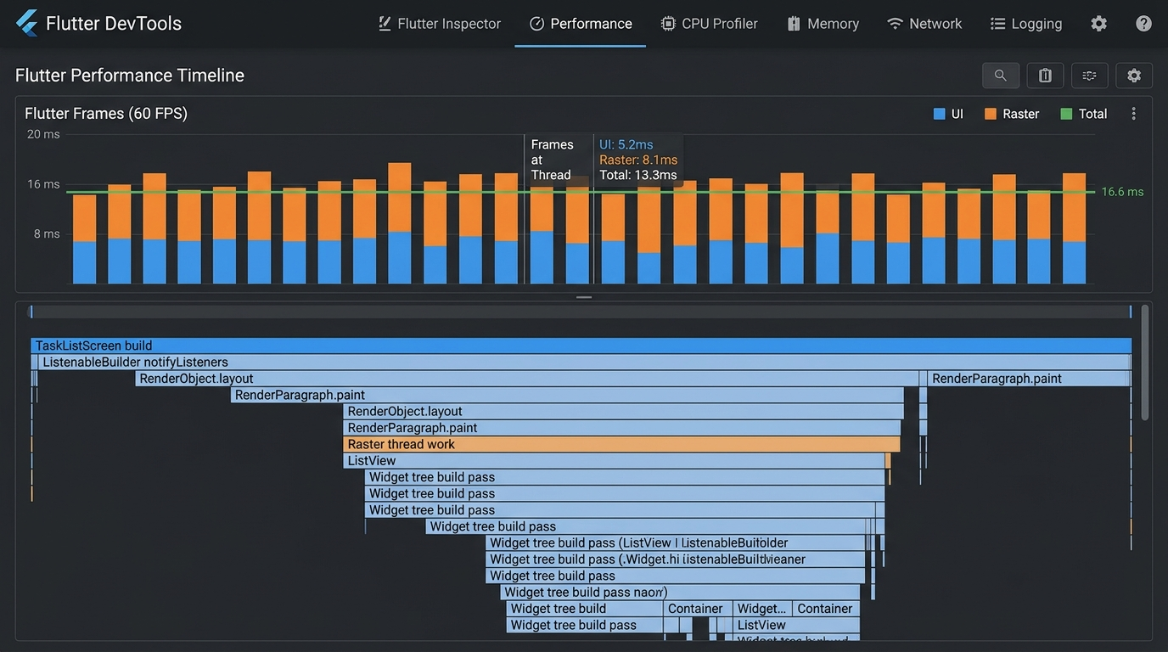
Figure 2: Flutter DevTools Performance Timeline (UI Thread & Raster Work)

5. Potential Performance Issue & Detection Strategy5. Potential Performance Issue & Detection Strategy
• Identified Issue — Unnecessary Whole-Tree Rebuilds: If setState() is called at the top Scaffold level upon every single keystroke in TextField or task list mutation, every child widget (including unchanging headers and app bars) is unnecessarily reconstructed and re-laid out.
• How DevTools & Tests Detect & Resolve It: In DevTools, the 'Track Widget Rebuilds' feature highlights widgets that rebuild frequently. In our architecture, this was resolved by isolating list reactivity using ListenableBuilder scoped strictly to the task ListView, leaving the app bar and input bar unaffected. Widget tests verify that pumping individual state changes only triggers expected widget redraws.

