HANOI UNIVERSITY OF SCIENCE AND TECHNOLOGY
School of Information and Communications Technology

Software Requirement Specification
Version 1.1

AIMS
Subject: Phân tích và thiết kế hệ thống

Bùi Hoàng Tú 20200547

Hanoi

Table of contents

Table of contents 1
1 Introduction 2
1.1 Objective 2
1.2 Scope 2
1.3 Glossary 2
1.4 References 2
2 Overall requirements 3
2.1 Actors 3
2.2 General use case diagram 4
2.3 Lower-level use case diagrams Error! Bookmark not defined.
2.4 Business processes 4
3 Detail requirements 5
3.1 Specification of Use case UC001 - “<Use case 1 name>” 6
3.2 Specification of Use case UC002 - “<Use case 2 name>” 9
4 Supplementary specification 14
4.1 Functionality 14
4.2 Usability 14
4.3 Reliability 14
4.4 Performance 14
4.5 Maintainability 14
4.6 Design Constraints 14

Introduction

Objective
This document presents the detailed description for User management subsystem, user group and their usable function at run time. This document also describes the objectives and features of the system, interfaces and constraints of the system in response to external action.
This document is for stakeholders and related software developers.

Scope

Glossary

References

Overall requirements

Actors
- Admin: Staffs who manage the store
- User: Clients who use buy the products
- VNPay: Paying port

General use case diagram
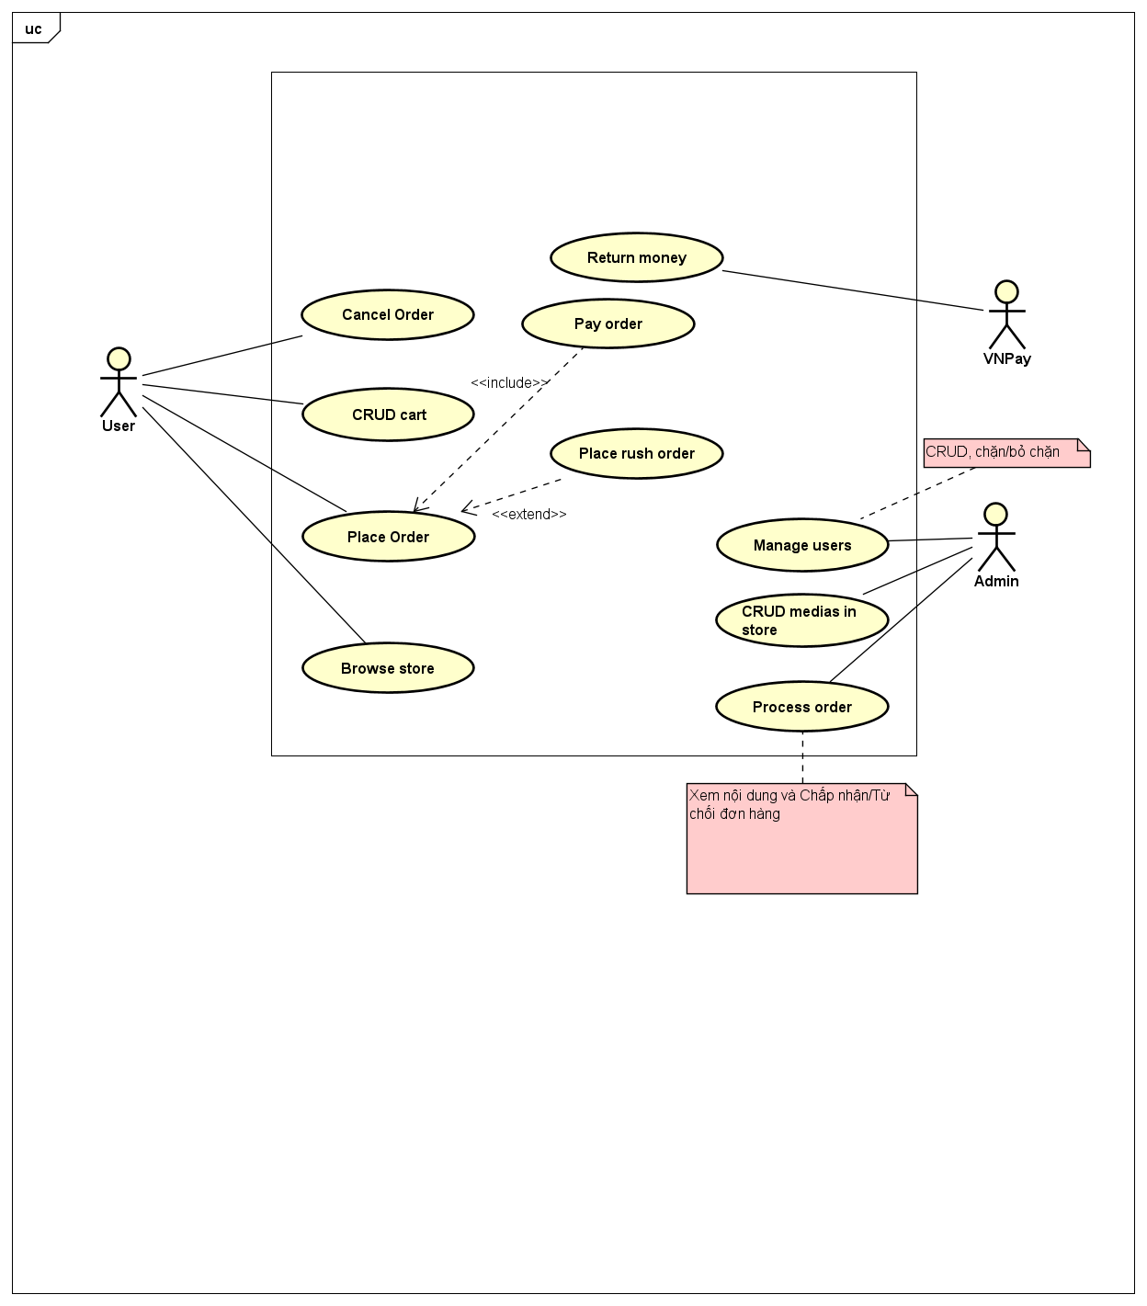

Business processes
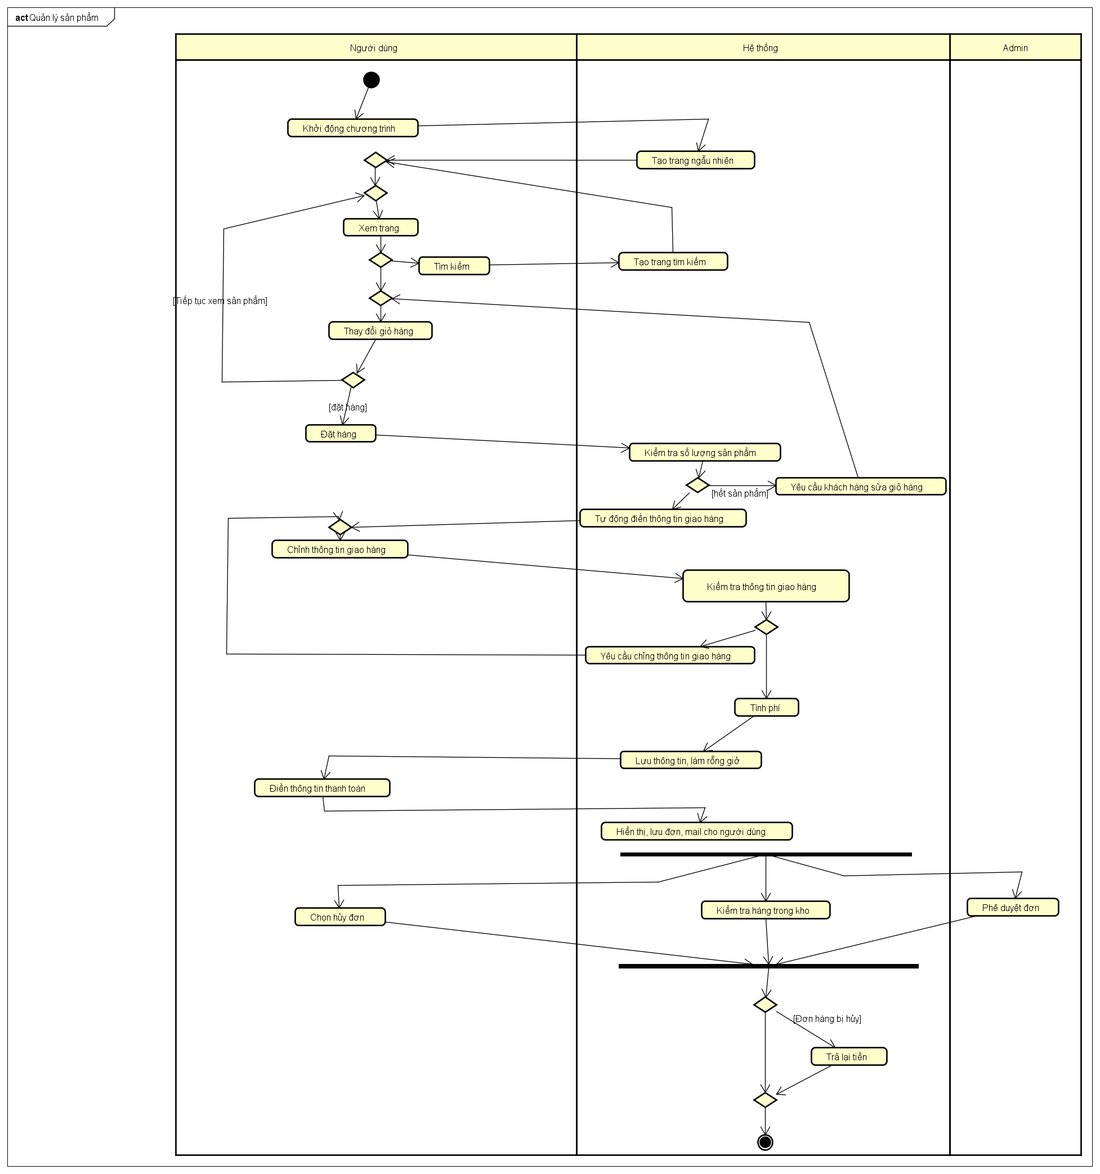

Detail requirements
Details of the use cases given in following sections are specified below.

Specification of Use case UC001 - “Place Order”
- Use case code
UC001
- Brief Description
UC “Place Order” describes he interaction between customers and AIMS software when the customer wishes to place order
- Actors
- User
- Preconditions
No
- Basic Flow of Events
- The customer requests to place order in the cart
- The AIMS software checks the availability of products in the cart
- The AIMS software displays the form of delivery information
- The customer enters and submits delivery information
- The AIMS software calculates shipping fees
- The AIMS software displays the invoice
- The customer confirms to place order
- The AIMS software calls UC “Pay order”
- The AIMS software creates a new order
- The AIMS software makes the cart empty
- The AIMS software sends email about the order notification and information
- The AIMS software displays successful order notification and the order information
- Alternative flows
Table Alternative flows of events for UC Place order
No | Location | Condition | Action | Resume location
 | Step 2 | If product is not available | - Notifies users then navigate them to “View Cart” | End
 | Step 4 | If the delivery info is invalid | - notifies that the delivery info is invalid (blank or wrong format | Step 3
 | Step 4 | If the user chooses to place a rush order | - Navigate user to UC003 | Step 5
 | Step 8 | If the order payment is not successful | - notifies that the payment is not successful | Step 7

- Input data
Table Input data of delivery information
No | Data fields | Description | Mandatory | Valid condition | Example
 | Receiver Name |  | Yes |  | Bui Hoang Tu
 | Phone Number |  | Yes | 10 digits | 0987 654 321
 | Province | Choose from list | Yes |  | Hanoi
 | Address |  | Yes |  | 12/18 Dai Co Viet street, Hai Ba Trung district
 | Shipping instructions |  | No |  | Drive in for about 100m

- Output data
Table B-Output data of displaying invoice
The first 4 rows are repeated for each product
No | Data fields | Description | Display format | Example
 | Title | Title of a media product |  | DVD Phim A
 | Price | Price of the corresponding media product | - Dot for thousands separator  - Right alignment | 10.000
 | Quantity | Quantity of the corresponding media | Right alignment | 3
 | Amount | Total money of the corresponding media | • Dot for thousands separator  • Right alignment | 100.000
 | Subtotal Before VAT | Total price of products in the cart before VAT | • Dot for thousands separator  • Right alignment | 1.000.000
 | Subtotal | Total price of products in the cart with VAT |  | 1.100.00
 | Shipping fees |  |  | 37.000
 | Total | Sum of subtotal and shipping fees |  | 1.137.00
 | Currency |  |  | VND
 | Name |  |  | Bui Hoang Tu
 | Phone number |  |  | 0987654321
 | Province |  |  | Hanoi
 | Address |  |  | 12/18 Dai Co Viet street, Hai Ba Trung district
 | Shipping instructions |  |  | Drive in for about 100m

Specification of Use case UC002 - “Pay order”
- Use case code
UC002
- Brief Description
This use case describes the interaction between users and the AIMS software and VNPay when the customer wishes to pay his/her order.
- Actors
- User
- VNPay
- Preconditions
The AIMS software has calculated the total amount of money which the customer has to pay.
- Basic Flow of Events
- The AIMS software displays the payment screen
- The customer enters credit card info and confirms to pay order
- The AIMS software asks the Interbank to process the payment transaction
- The Interbank processes the payment transaction
- The AIMS software saves the payment transaction
- The AIMS software displays transaction information
- The AIMS software sends e-mail to the customer
- Alternative flows
Table N-Alternative flows of events for UC Place order
No | Location | Condition | Action | Resume location
 | At Step 3 | If the card info is in invalid | - The AIMS software notifies that the card info is invalid | At Step 1
 | At Step 4 | If the card info is wrong | - The AIMS software notifies that the card info is wrong | At Step 1
 | At Step 4 | If the balance is not enough | - The AIMS software notifies that the balance is not enough | At Step 1

- Input data
Table Input data of credit card information
No | Data fields | Description | Mandatory | Valid condition | Example
 | Card holder name |  | Yes | Maximum of 50 characters, all in uppercase | BUI HOANG TU
2. | Card number |  | Yes | 16 digits | 0123 4567 8912 3456
3. | Expiration date |  | Yes | Consist of month and last 2 digits of year only | 01/23
4. | Security code |  | Yes | 3 digits | 221

- Output data
Table B-Output data of …
No | Data fields | Description | Display format | Example
 | Transaction ID
 | Card holder name |  |  | BUI HOANG TU
 | Amount | Amount of money has been subtracted from your account | - Right alignment  - With Vietnamese currency (VND)  - Vietnam locale | 12.000VND
 | Transaction Content
 | Balance | New balance after this transaction | • Right alignment  • With Vietnamese currency (VND)  • Vietnam locale | 2.300.123VND
 | Transaction Date |  | dd/mm/yyyy | 12/08/2002

Specification of Use case UC003 - “Place rush order”
- Use case code
UC003
- Brief Description
This use case describes the interaction between users and the AIMS software and VNPay when the customer wishes to have fast delivery.
- Actors
- User
- VNPay
- Preconditions
User choose to have fast delivery from UC001
- Basic Flow of Events
- Users put in their address
- The AIMS software checks the availability of service in address and items
- AIMS asks for rush order information
- User fills in rush information
- Return to UC001
- Alternative flows
Table Alternative flows of events for UC Place order
No | Location | Condition | Action | Resume location
 | Step 2 | If address is not supported or no item support rush order | - Notifies the error in address or no supported item | Step 1

- Input data
Table Input data of delivery information
No | Data fields | Description | Mandatory | Valid condition | Example
 | Extra Address |  | Yes |  | 12/18 Dai Co Viet street, Hai Ba Trung district
 | Shipping instructions |  | No |  | Drive in for about 100m
 | Receive time |  | Yes | hh:mm | 13:34

- Output data
- Post Condition

Supplementary specification
<Presenting other requirements if necessary, including non-functional requirements such as performance, reliability, usability, and supportability; or other technical requirements such as database system, used technology…>

Functionality
<List of the functional requirements that are general to many use cases. E.g. Among the flow of events of use case, in all the steps that interacts with the database system, if there are errors in the connection or operation processes, there need to be a corresponding error notifications so that the actor knows that the error is related to the database system rather than the user>

Usability
<Requirements that relate to, or affect, the usability of the software. Examples include ease-of-use requirements or training requirements that specify how readily the software can be used by its actors>

Reliability
<Any requirements concerning the reliability of the software. Quantitative measures such as mean time between failure or defects per thousand lines of code should be stated>

Performance
<The performance characteristics of the software. Include specific response times. Reference related use cases by name>

Maintainability
<Any requirements that will enhance the supportability or maintainability of the software being built>

Design Constraints
<Any design constraints on the software being built>

