**VIETNAM NATIONAL UNIVERSITY OF HCMC**

**INTERNATIONAL UNIVERSITY**



**PROJEC REPORT**

**TETRIS**

**Member:**

**Bùi Quang Hiếu – ITITIU18286**

**Trần Thanh Lập – ITITIU18277**

1. Overview

Tetris is a tile-matching video game created by Russian software engineer Alexey Pajitnov in 1984

In *Tetris*, players complete lines by moving differently shaped pieces, which descend onto the playing field. The completed lines disappear and grant the player points, and the player can proceed to fill the vacated spaces. The game ends when the playing field is filled. The longer the player can delay this inevitable outcome, the higher their score will be

In this project, my team will code Tetris game again with our stye.

1. Goals

Study and practice the skills of the subject, another side we can work in groups and learn teamwork skill.

Understand the java programming language.

Improve thinking about solving problems encountered when doing projects.

1. Resource Requirements
   1. Hardware resource

Our pc

* 1. Software Resource

Eclipse, JDK, GitHub

* 1. Human Resource

Member of our team

1. Class diagram

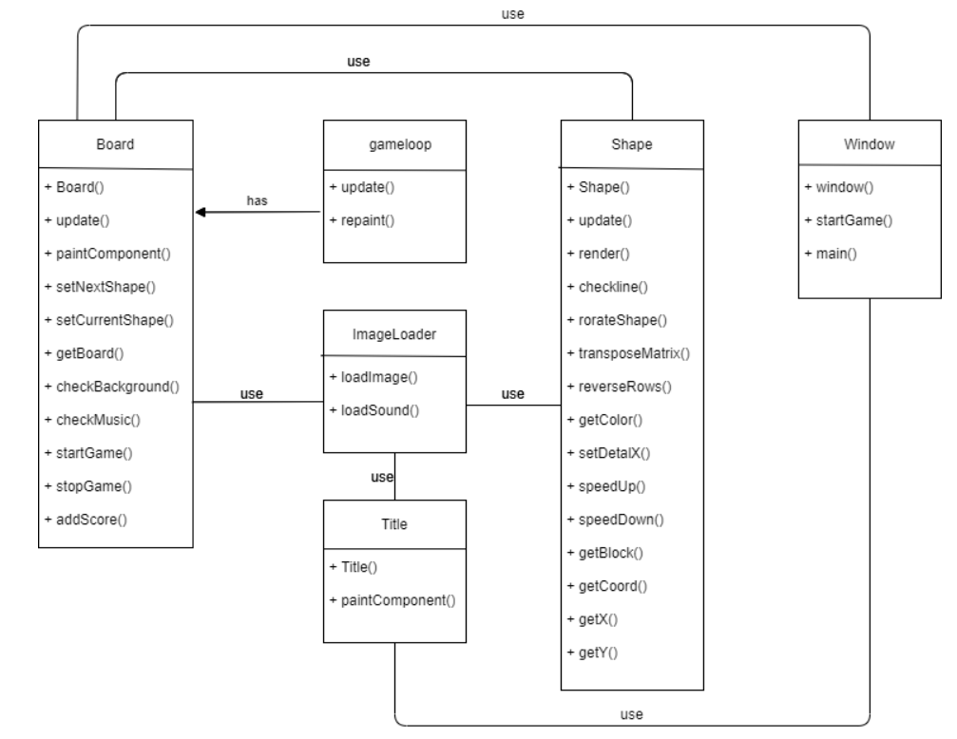

1. Some picture of our project

