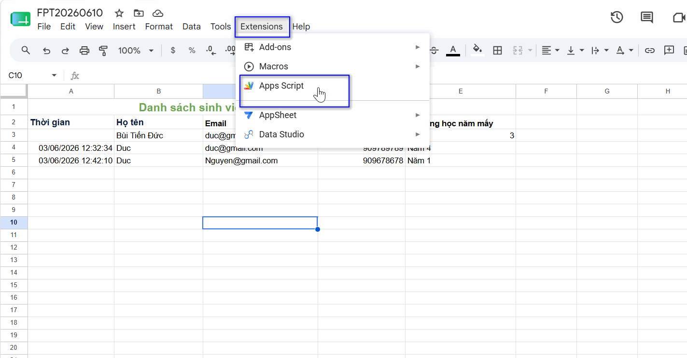
Chọn Web App

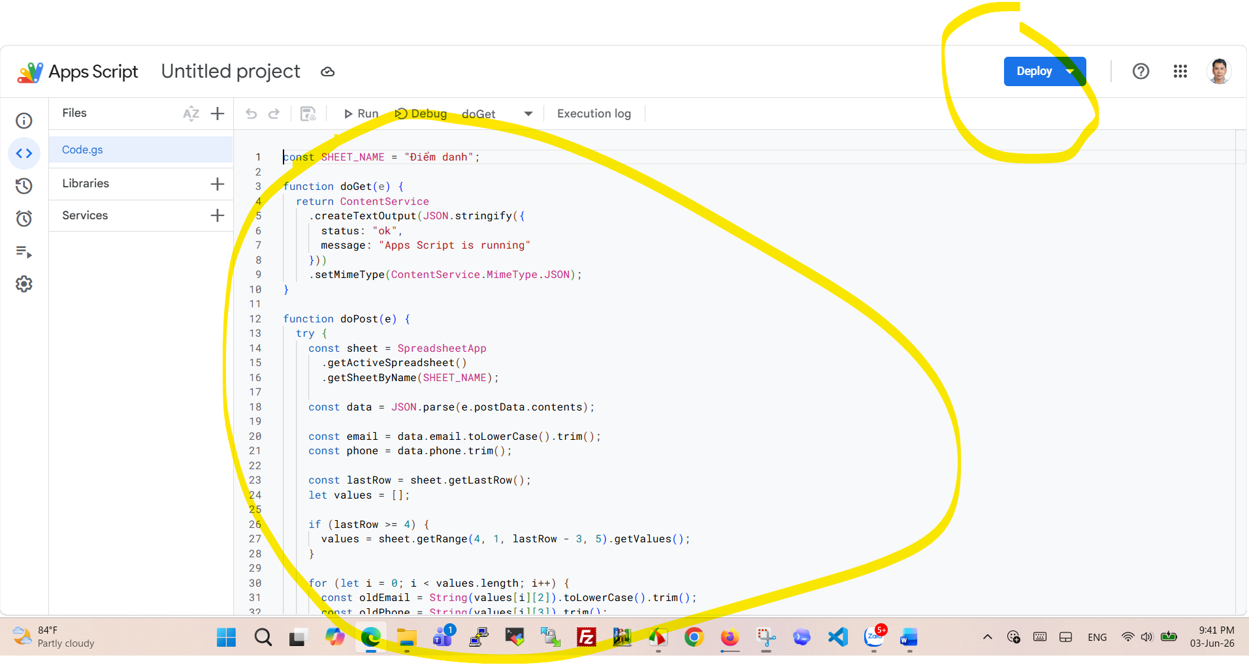
const SHEET_NAME = "Điểm danh";

function doGet(e) {
return ContentService
.createTextOutput(JSON.stringify({
status: "ok",
message: "Apps Script is running"
}))
.setMimeType(ContentService.MimeType.JSON);
}

function doPost(e) {
try {
const sheet = SpreadsheetApp
.getActiveSpreadsheet()
.getSheetByName(SHEET_NAME);

const data = JSON.parse(e.postData.contents);

const email = data.email.toLowerCase().trim();
const phone = data.phone.trim();

const lastRow = sheet.getLastRow();
let values = [];

if (lastRow >= 4) {
values = sheet.getRange(4, 1, lastRow - 3, 5).getValues();
}

for (let i = 0; i < values.length; i++) {
const oldEmail = String(values[i][2]).toLowerCase().trim();
const oldPhone = String(values[i][3]).trim();

if (oldEmail === email || oldPhone === phone) {
return ContentService
.createTextOutput(JSON.stringify({
status: "duplicate",
message: "Bạn đã check-in trước đó"
}))
.setMimeType(ContentService.MimeType.JSON);
}
}

let nextRow = Math.max(lastRow + 1, 4);

sheet.getRange(nextRow, 1, 1, 5).setValues([[
data.time,
data.full_name,
data.email,
data.phone,
data.year
]]);

return ContentService
.createTextOutput(JSON.stringify({
status: "success",
message: "Check-in thành công"
}))
.setMimeType(ContentService.MimeType.JSON);

} catch (error) {
return ContentService
.createTextOutput(JSON.stringify({
status: "error",
message: error.toString()
}))
.setMimeType(ContentService.MimeType.JSON);
}
}

