

Requirement & Design Specification

Parking Management System
Group 8

Table of content
I. Overview
1. User Requirements
1.1 Actors
1.2 Use Cases
a. Diagram(s)
b. Descriptions
2. Overall Functionalities
2.1 Screens Flow
2.2 Screen Descriptions
2.3 Screen Authorization
3. System High Level Design
3.1 Database Design
a. Database Schema
b. Table Descriptions
II. Requirement Specifications
1. Common Functions
III. Design Specifications
IV. Appendix
1. Assumptions & Dependencies
2. Limitations & Exclusions
3. Business Rules

I. Overview
The Parking System is a web application designed to optimize the management of a parking lot. It is developed using ASP.NET Core MVC, Entity Framework Core, and SQL Server. It provides comprehensive features for administrators to configure the system, staff to manage check-ins/check-outs, and members to register their vehicles and monthly passes.

1. User Requirements

1.1 Actors
# | Actor | Description
1 | Admin | Manages the entire system, including staff accounts, parking configurations, and viewing revenue/traffic reports.
2 | Staff | Manages vehicle check-ins/check-outs, approves member parking requests, monitors parking status, and searches for vehicles.
3 | Member | Customers who register an account to manage their personal vehicles, register/renew monthly passes, view parking history, and submit parking requests.

1.2 Use Cases
a. Diagram(s)
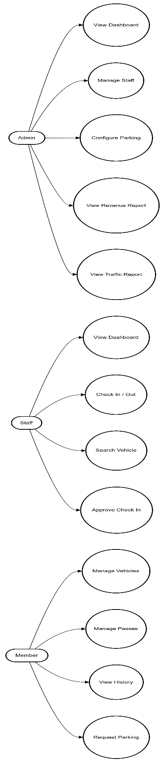
b. Descriptions
ID | Feature | Use Case | Use Case Description
01 | Admin | Manage Staff | Add, edit, or disable staff accounts.
02 | Admin | Configure Parking | Set the total parking capacity (cars, motorbikes) and parking fee rates (hourly, monthly).
03 | Admin | View Reports | Set the total parking capacity (cars, motorbikes) and parking fee rates (hourly, monthly).
04 | Staff | Check In / Out | Record vehicle entry/exit times and automatically calculate parking fees.
05 | Staff | Approve Check In | Approve advance parking requests submitted by Members.
06 | Staff | Search Vehicle | Search for parked or departed vehicles using their plate numbers.
07 | Member | Manage Vehicles | Add or remove personal vehicles.
08 | Member | Manage Passes | Register, renew monthly passes for vehicles, and handle fee payments.
09 | Member | Request Parking | Send an advance check-in request before arriving at the parking gate.

2. Overall Functionalities

2.1 Screens Flow

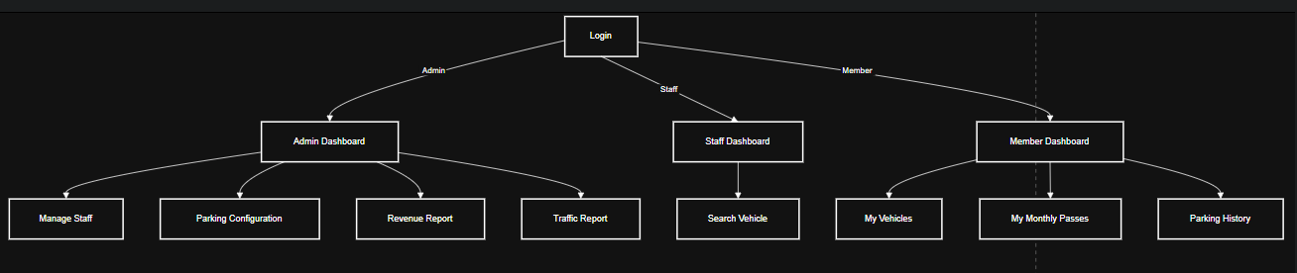

2.2 Screen Descriptions
# | Feature | Screen | Description
1 | Auth | Login / Register | Allows users to authenticate or register a new member account.
2 | Admin Dashboard | Admin Index | Summarizes active vehicles, total revenue, and active monthly passes.
3 | Manage Staff | ManageStaff | Displays staff lists, allows creating and toggling account statuses.
4 | Configuration | ParkingConfig | Interface to manage parking slot capacities and fee configurations.
5 | Reports | RevenueReport / TrafficReport | Visual charts and metrics for revenue and traffic data analysis.
6 | Staff Dashboard | Staff Index | Control panel for staff to perfom check-ins, check outs, and approve waiting vehicles
7 | Member Dashboard | Member Index | Member homepage displaying vehicle summaries and pass statuses.
8 | Member Vehicles | MyVehicles | List of personal vehicles, with options to add or delete vehicles..
9 | Member Passes | MyPasses | Interface to register and renew monthly passes for registered vehicles.

2.3 Screen Authorization
# | Screen | Admin | Staff | Member
1 | Login / Register | X | X | X
2 | Admin Dashboard | X
3 | Manage Staff | X
4 | Configuration | X
5 | Reports | X
6 | Staff Dashboard |  | X
7 | Member Screens (Index, Vehicles, Passes) |  |  | X

3. System High Level Design

3.1 Database Design
a. Database Schema
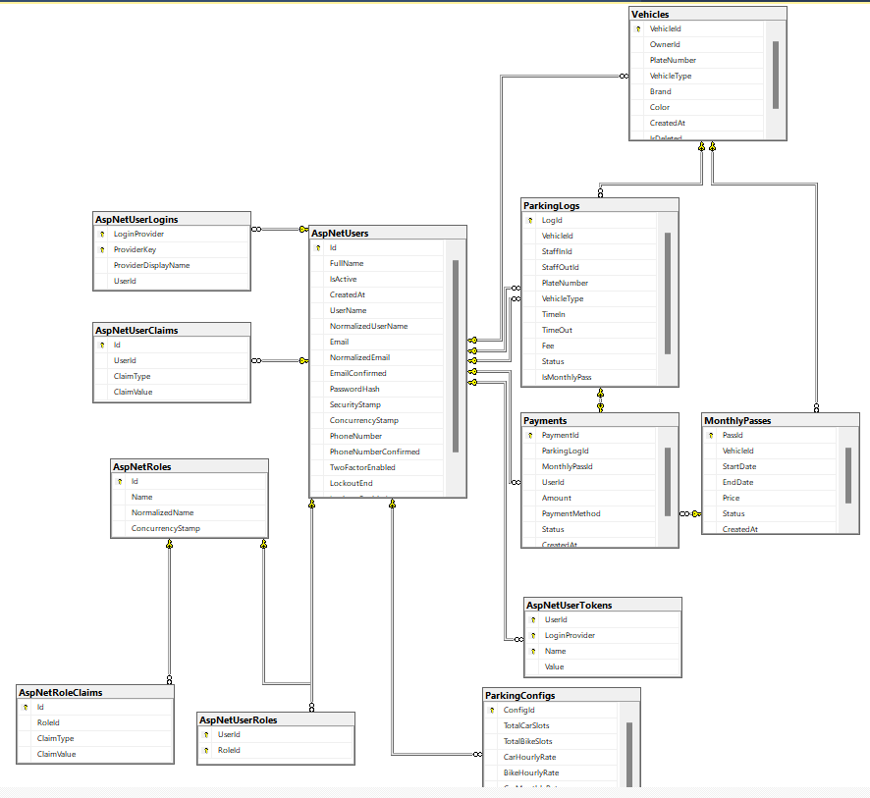
b. Table Descriptions
No | Table | Description
01 | ApplicationUser | - Manages user accounts (Admin, Staff, Member). Inherits from IdentityUser.  - Primary key: Id
02 | Vehicle | - Stores user vehicle information (plate number, type, brand).  - Primary key: VehicleId
03 | MonthlyPass | - - Manages monthly subscriptions for vehicles (start date, end date, status).  - Primary key: PassId
04 | ParkingLog | - Records vehicle entry and exit history, assigned staff, and parking fees.  - Primary key: LogId
05 | Payment | - Stores payment history for parking fees and monthly pass registrations.  - Primary key: PaymentId
06 | ParkingConfig | - Stores global parking settings like total slots and pricing rates.  - Primary key: Id

II. Requirement Specifications

1. Common Functions
- Sign In: Authentication form for all roles to log in using Email and Password.
- Sign Up: Registration for new Member accounts.
- Logout: End the current user session.
- Role-based Redirection: Automatically redirects authenticated users to their respective dashboards based on their role.

III. Design Specifications

1. Login Screen
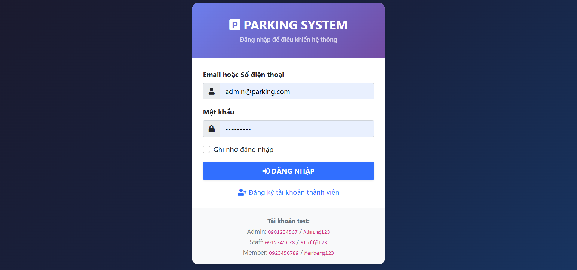
Field Name | Field Type | Description
Username | Text Box | This is for the user to input email or phone number for logging in.
Password | Password Box | This is for the user to input password for logging in.
Remember Me | Checkbox | Option to keep the login session active.
ĐĂNG NHẬP | Button | User clicks to authenticate into the system with provided credentials.
Register | Link | Navigates to the Member registration page.

2. Admin Dashboard Screen
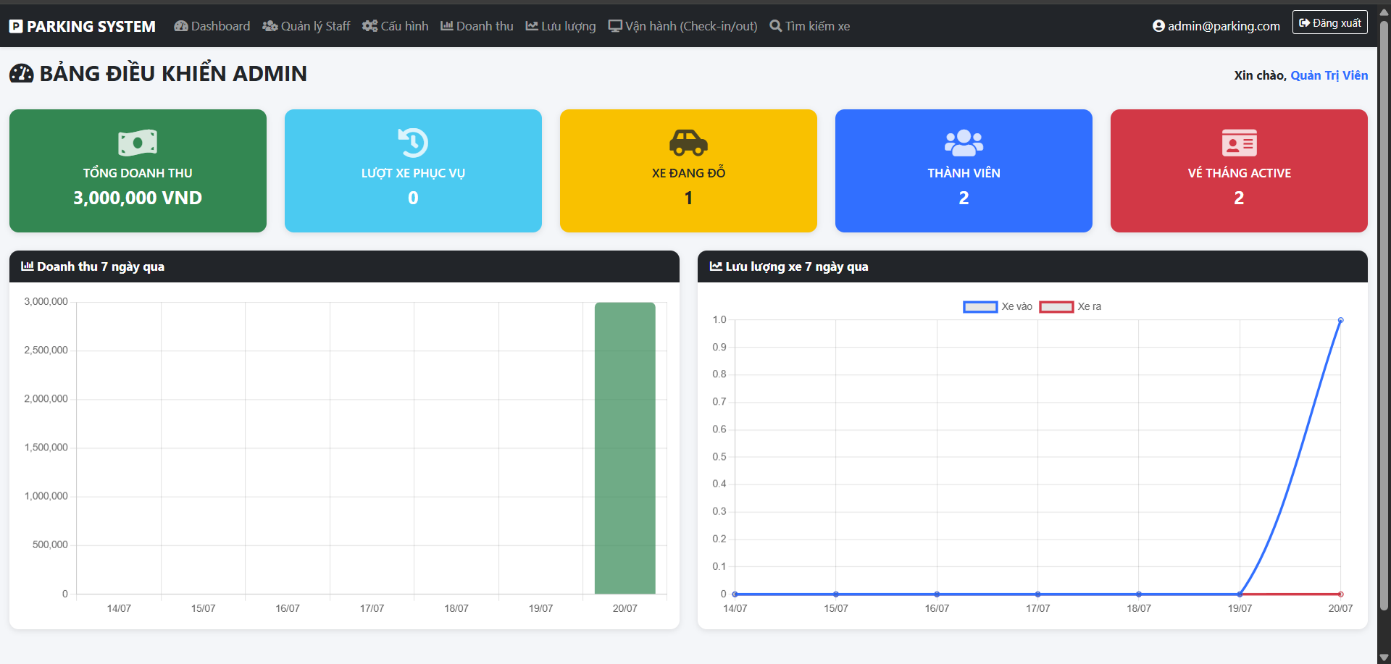
Field Name | Field Type | Description
Statistics Cards | Panel | Displays total revenue, total served vehicles, current parked vehicles, total members, and active passes.
Revenue Chart | Bar Chart | Visualizes the daily revenue for the past 7 days.
Traffic Chart | Line Chart | Visualizes the number of vehicles checking in and out over the past 7 days.

3. Admin Manage Staff Screen
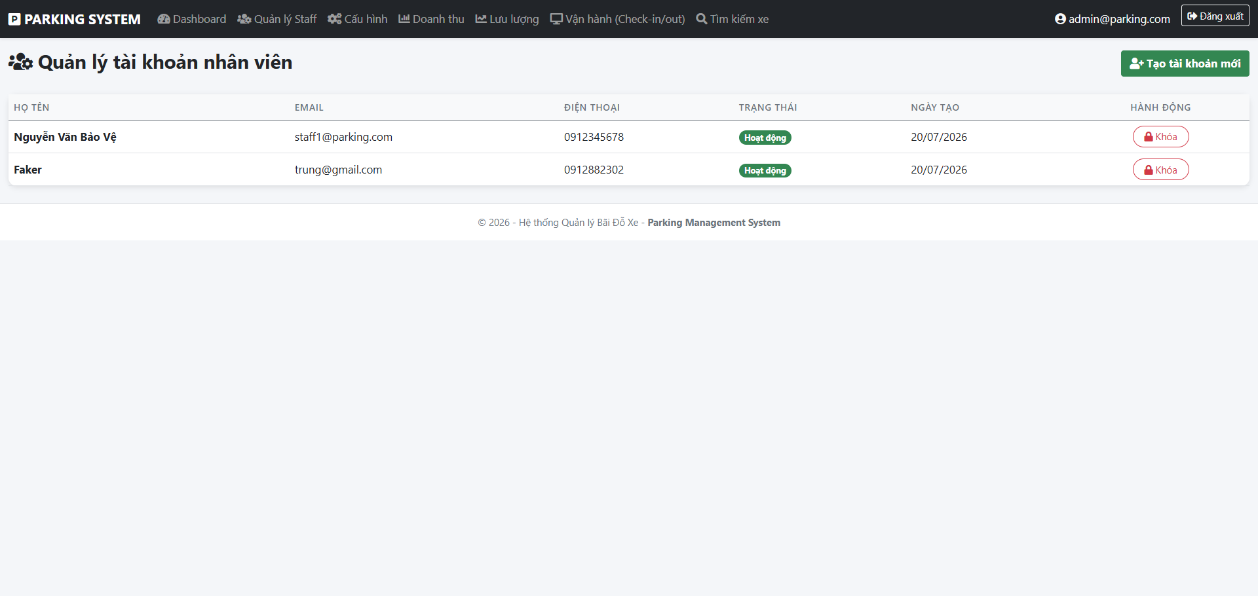
Field Name | Field Type | Description
Add New Staff | Button | Navigates to a form to create a new staff account.
Lock / Unlock | Button | Toggles the active status of a staff account to enable or disable their access.
Staff List | Data Table | Displays information about all registered staff members (Name, Email, Status).

4. Admin Parking Configuration Screen
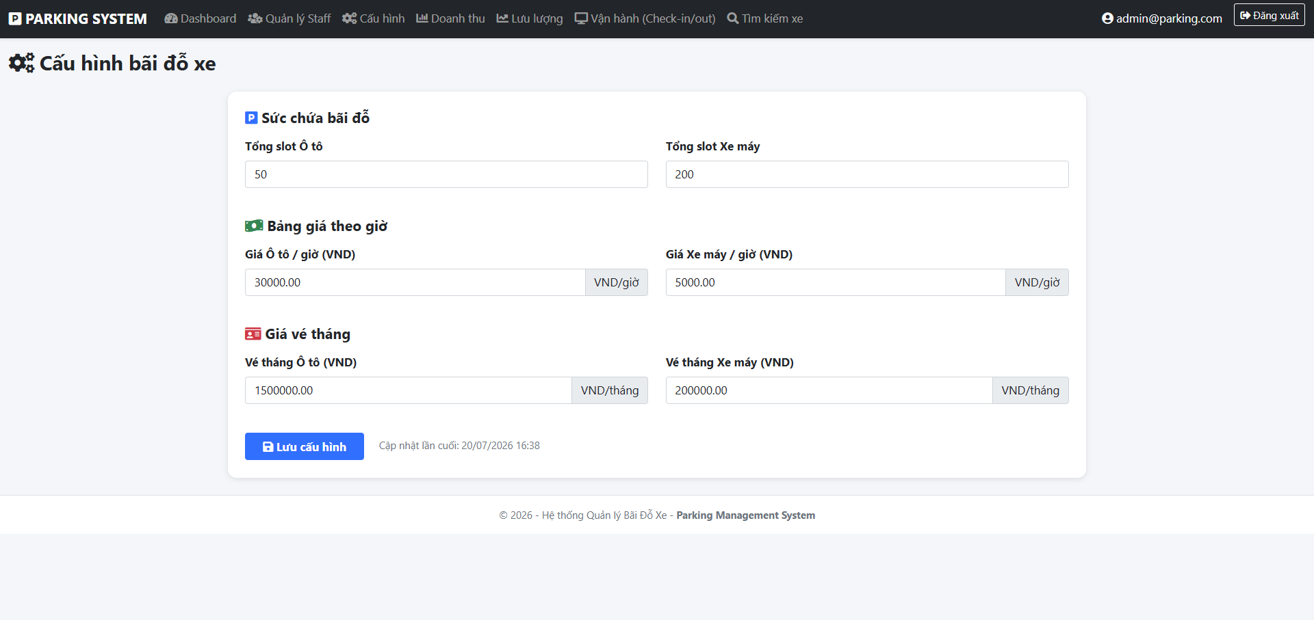
Field Name | Field Type | Description
TotalCarSlots / BikeSlots | Number Box | Sets the maximum capacity for cars and motorbikes in the parking lot.
Hourly / Monthly Rates | Number Box | Configures hourly and monthly parking fees for each vehicle type.
Save Configuration | Button | Applies the new settings and updates the system rules.

5. Staff Dashboard Screen (Check-In / Check-Out)
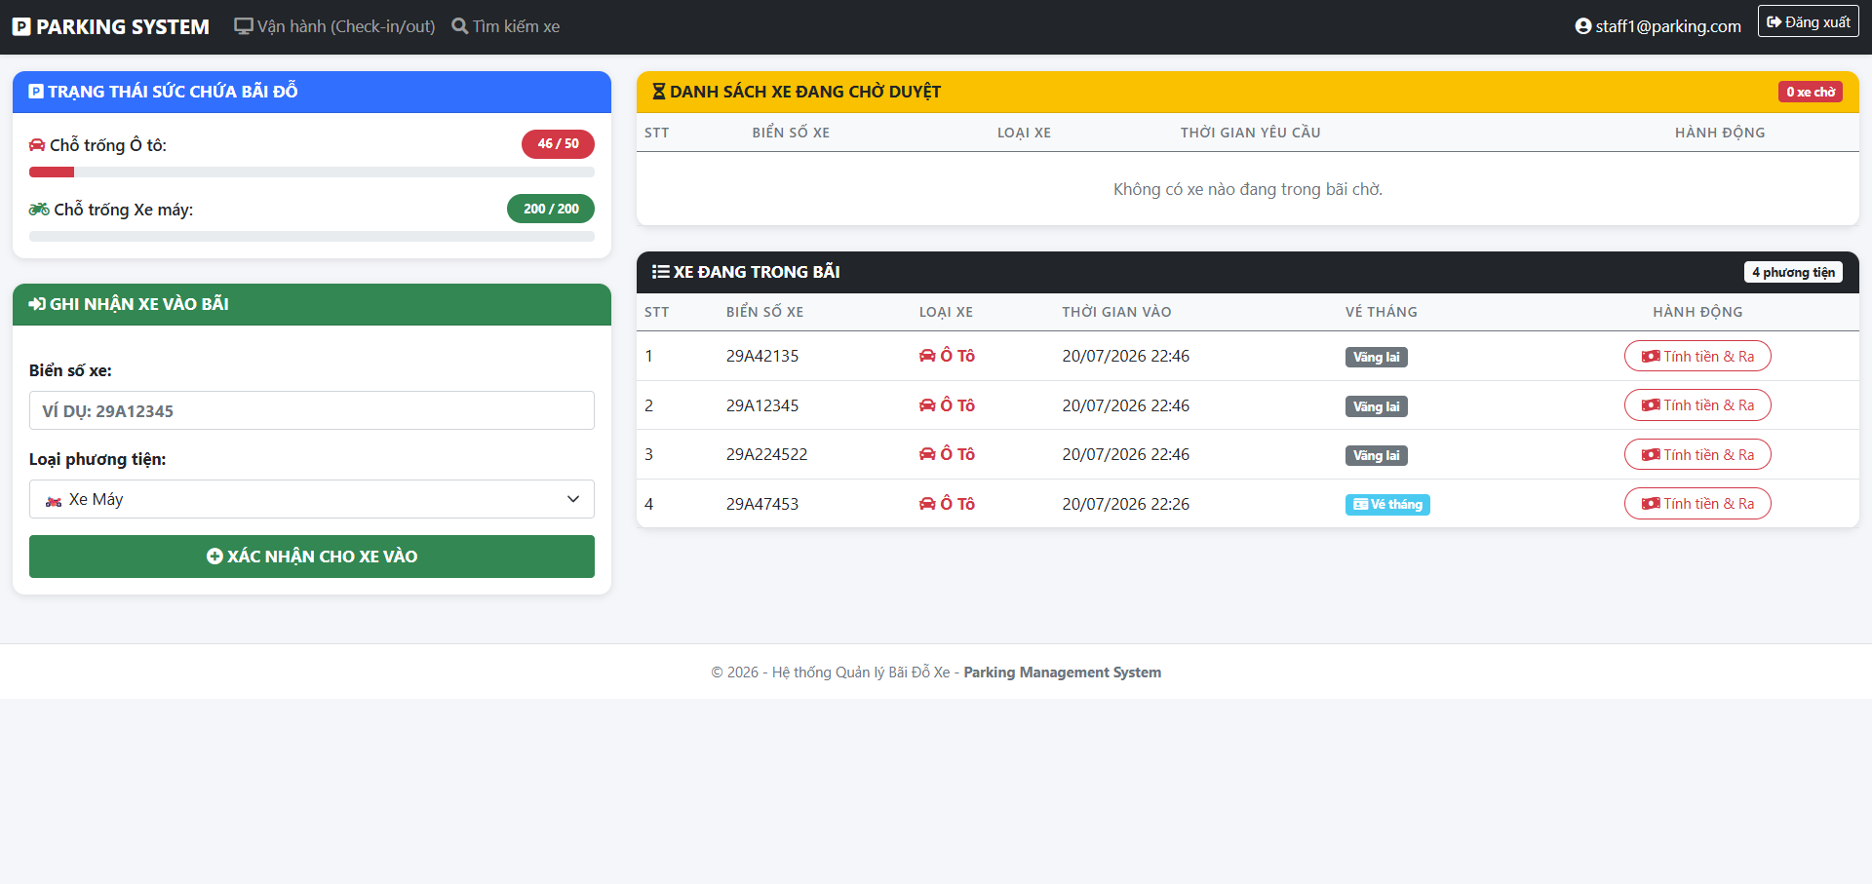
Field Name | Field Type | Description
PlateNumber | Text Box | Staff inputs the incoming vehicle's plate number here.
VehicleType | Dropdown | Select between Motorbike and Car.
XÁC NHẬN CHO XE VÀO | Button | Records the vehicle into the parking lot (Check-In).
Duyệt Vào | Button | Approves advance parking requests submitted by Members (from the Waiting list).
Tính tiền & Ra | Button | Calculates the parking fee and records the vehicle exiting the lot (Check-Out).

6. Member Dashboard & Monthly Passes Screen
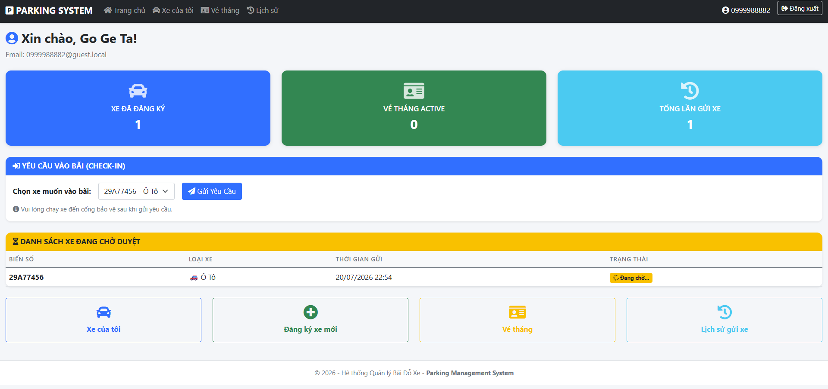
Field Name | Field Type | Description
Add Vehicle | Button | Opens a form to register a new personal vehicle (plate number, type, brand).
Request Parking | Button | Submits an advance check-in request to the Staff before reaching the gate.
Renew Pass | Button | Opens the payment and renewal process for extending a vehicle's monthly pass.
Delete Vehicle | Button | Removes the registered vehicle from the member's account.

IV. Appendix

1. Assumptions & Dependencies
- AS-1: The system will be used within the organization's internal network or deployed securely online.
- AS-2: Admin has set up the initial parking configurations before use.
- DE-1: Users have basic knowledge of using modern web browsers.

2. Limitations & Exclusions

L-E-1: Automatic License Plate Recognition (ALPR) via cameras is not fully integrated in this version; staff manual approval or entry is required.

L-E-2: Electronic payments (EWallet, BankTransfer) currently log mock transaction data and are not fully integrated with real-world payment gateways.

3. Business Rules
- BR-1: Default admin account: admin@parking.com, password: Admin@123.
- BR-2: Default staff account: staff1@parking.com, password: Staff@123.
- BR-3: Default member account: member1@parking.com, password: Member@123.
- BR-4: A single vehicle (unique plate number) can only be assigned to one owner at a time.
- BR-5: A vehicle cannot be checked in if the parking lot has reached its maximum capacity for that specific vehicle type.
- BR-6: Vehicles with an active monthly pass are exempted from standard parking fees during check-out.

