Purpose
Define Purpose of this process

Scope
Define for which products, processes or areas this process description is applicable

Definitions
ISO 9001:2015 | International standard that defines requirements for a quality management system to help organizations consistently deliver products and services that meet customer and regulatory requirements.
QMS | Quality Management System
SOP | Standard Operations Procedure

- Responsible Person(s)
Name the functions responsible to carry out this process.

- References
ISO 9001:2025.

- Measurement
KPI: % of released SOPs

- Procedure
Process Flow Diagram:
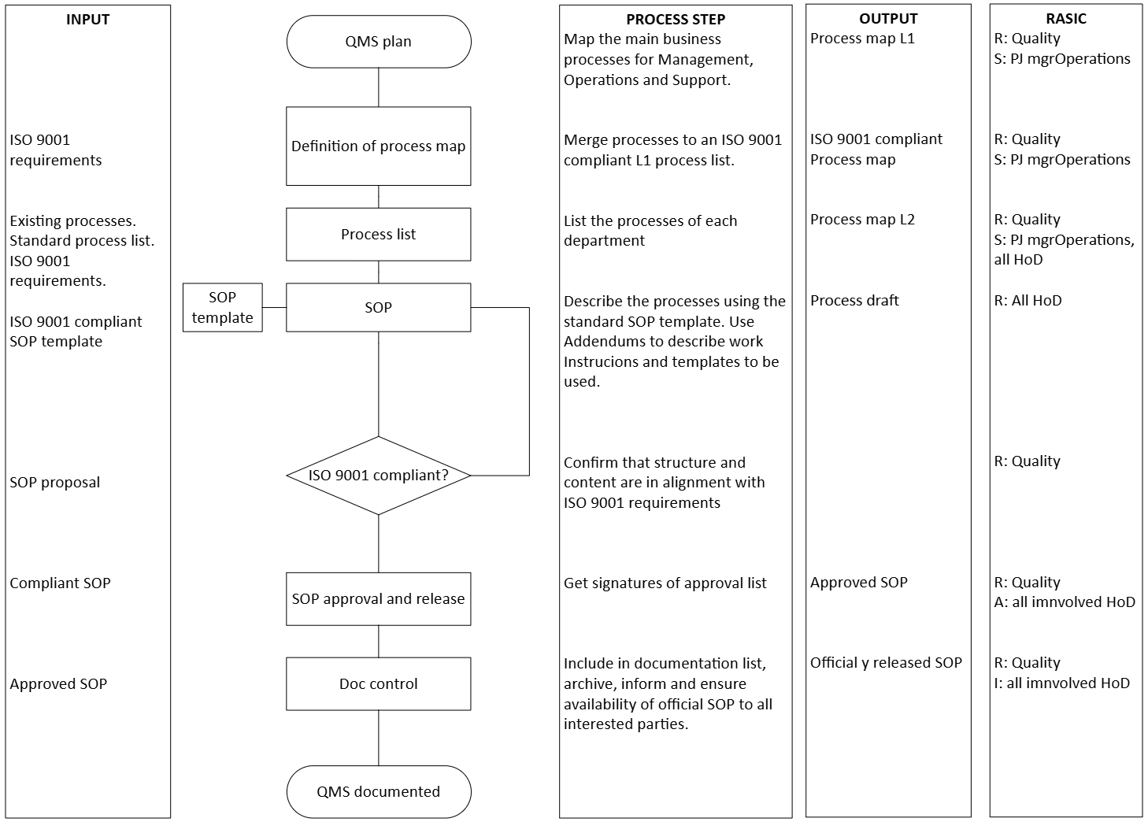
R: Responsible. A: Approval. S: Support. I: Information. C: Collaboration
- Anexes and forms

Appendix A: Determine required information of header and footer
Appendix B: Review all WI and determine required attributes across teams. Make proposal of what’s needed as a part of the “template”

- Change History
Version | Changes | Created By:  (Name / Position / Date)
1.0 | Description of changes. Reference specific sections as applicable | Robbie Miller  Quality Manager  MM/DD/YYYY

- Change Approvals
 | Name | Position | Date
Reviewed By
Department Manager Release
Associated Department
Associated Department
Quality Approval

