## 3 Ways to Alter Motive Lengths

### Given Motives

Here are the two motives that you are going to use. Make sure you play or sing them so you know what the originals sound like.

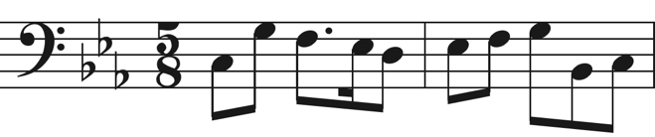

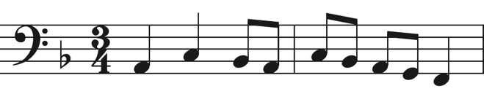

### Repeating Fragments

First, on the original motives, circle any fragments that you think you can repeat. Then, write two new versions of each motive using the repeated fragments. Feel free to repeat the fragments literally, sequence through them, or do something else.

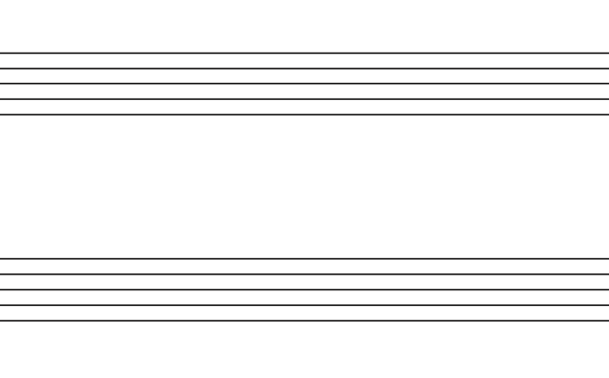



### Altering Time Signatures

Same thing as above, expect this time try changing the time signatures. One or both measures can have a new time signature from the original. The time signatures do not need to be the same for both measures.





### Adding/Deleting Measures

Write two final variations of each motive. This time use one variation to add a measure. Use the second to delete a measure from the original.



