## Fractal Melodies

Below is one of the melodies from the 4th movement of Holst’s *First Suite in Eb*. Analyze it as a fractal melody.

Hint: the slurs are for the players, not you. And some parts go 4 layers deep!

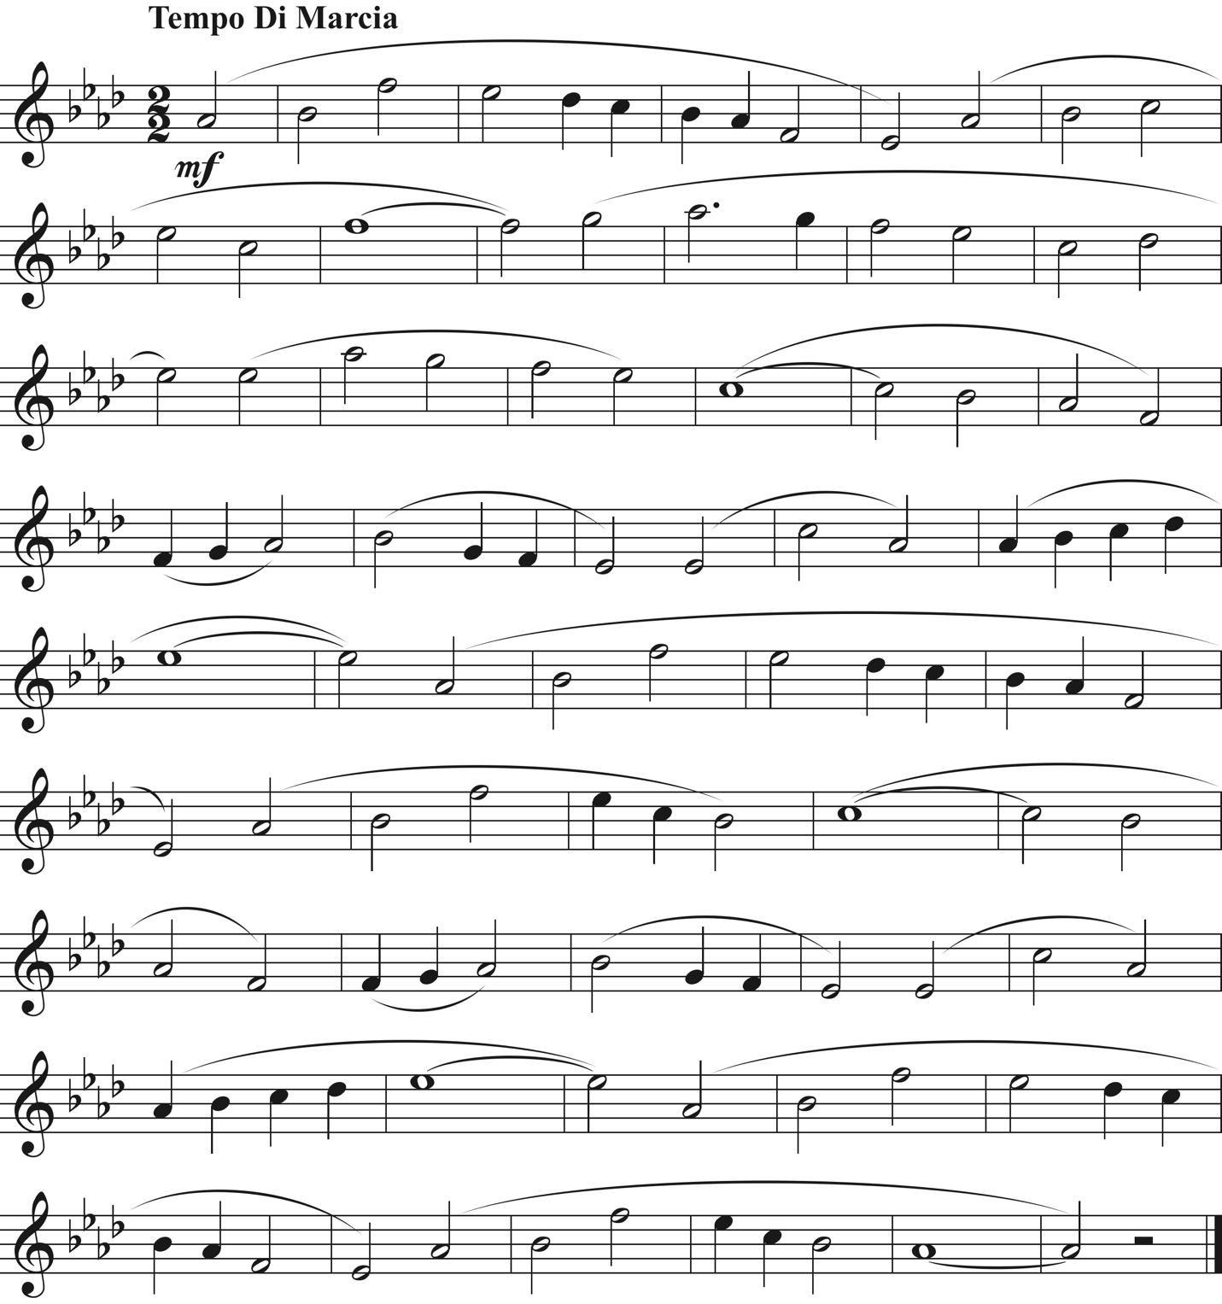

If you want version without the slurs to write on, go to the next page. The answer is on the last page.

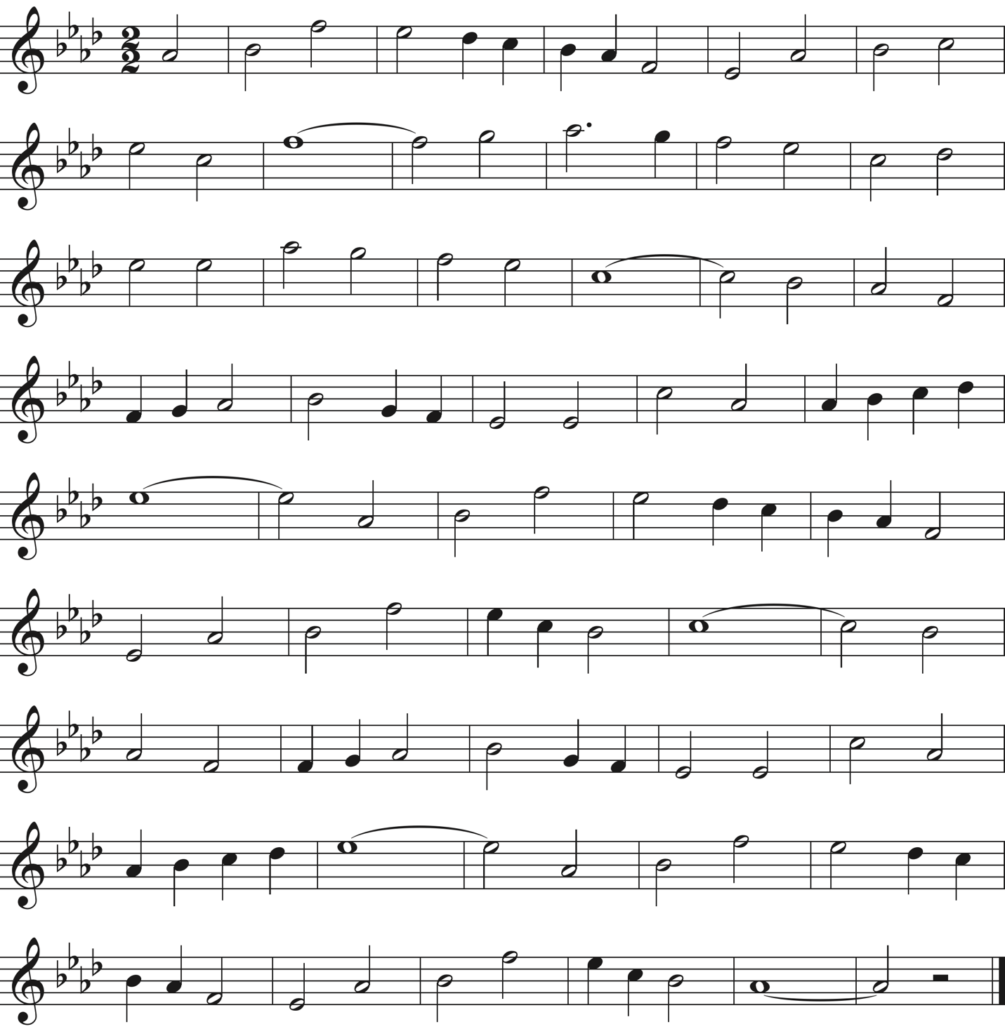

Here’s my answer. You’ll notice that he doesn’t strictly obey the rule of needing to vary *A* or *B* before using *C*, but Holst can get away with it because it is a 6 motive main phrase with plenty of repetition already.

If you really want to geek out, notice how he reuses many of the smaller motives in different larger motives. Is there any pattern to those?

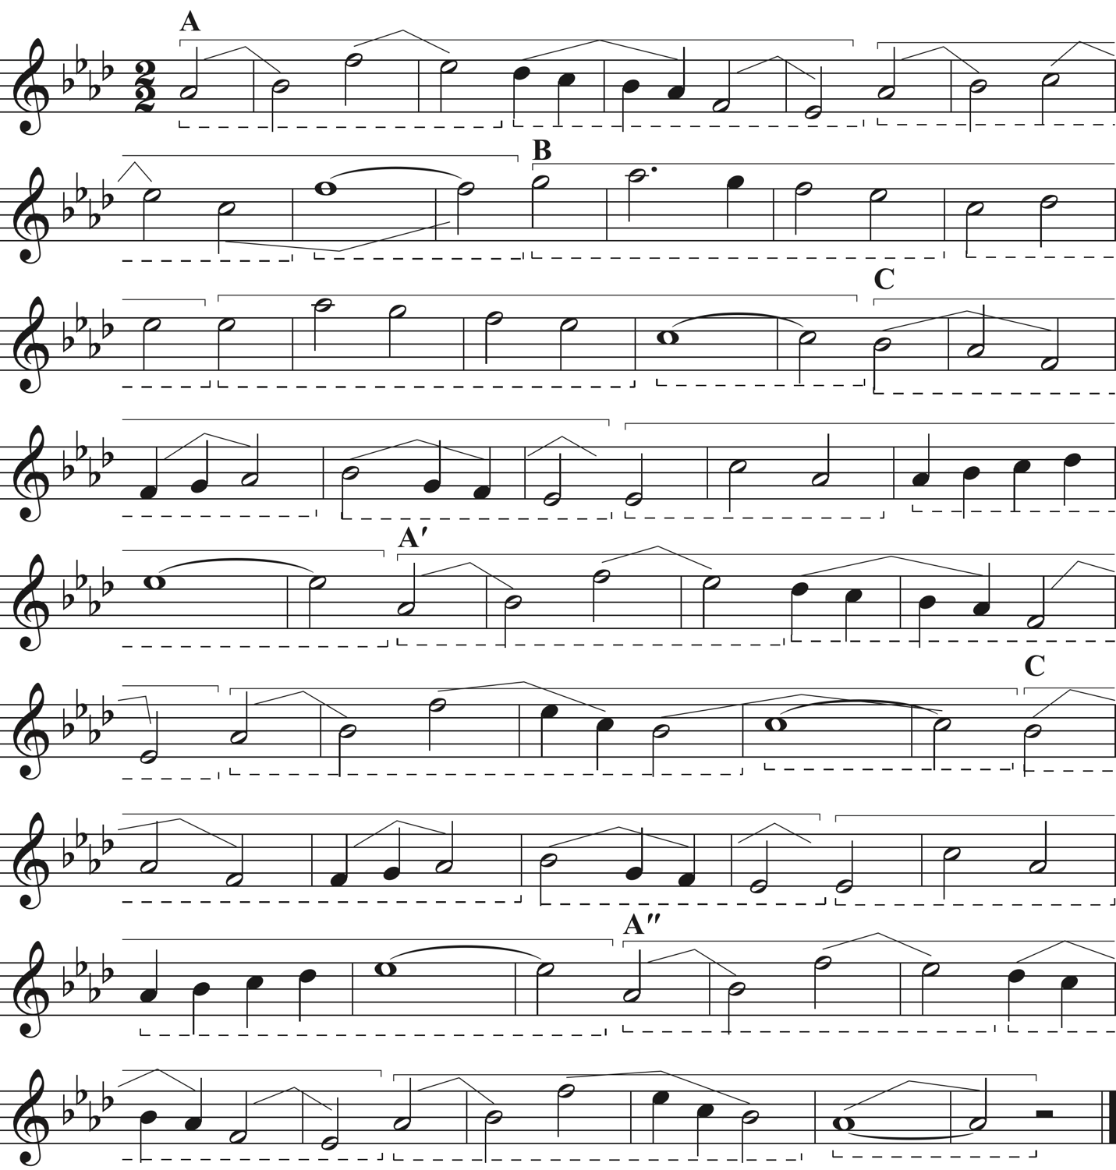

I didn’t label all the motive names, but those should be easy to figure out at this point.