## Magic Moving Note: The Key to Keeping Your Melodies Going

When stripping down melodies, you have to remember that the goal is to find the most important notes in the phrase. In a lot of ways, it’s more of an art than a science. But here are some general guidelines:

* Longer notes are typically more important
* You can ignore all dissonances (or notes likely to be a dissonance when harmonized)
* Notes on the beats and downbeats are probably more important

Lastly, it’s a process of elimination. Get rid of the unimportant notes and keep refining until you get the core structure.

Let’s try it with an example from Mozart.

With this phrase, see if you can start to eliminate the obviously unimportant notes.

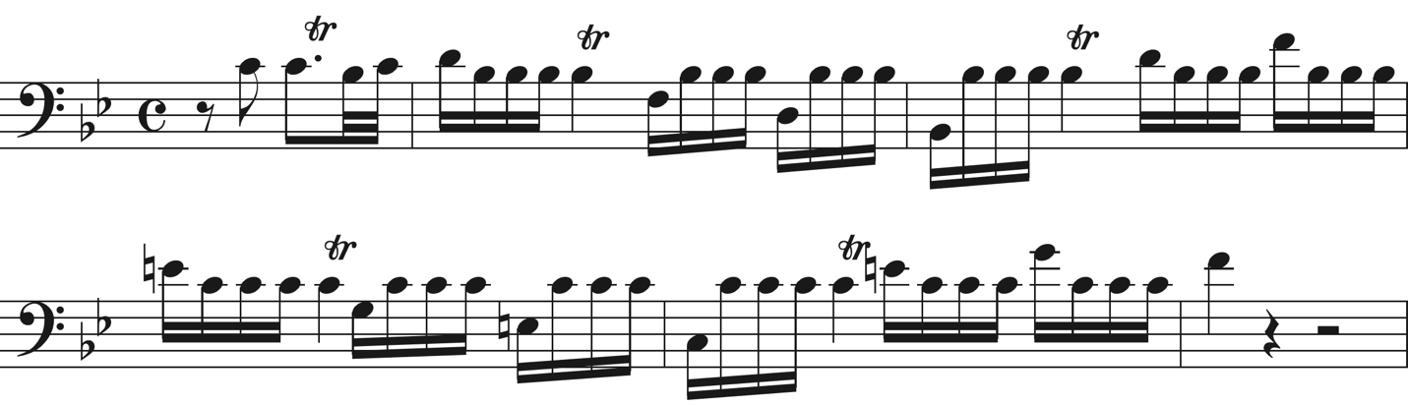



Now compare yours with mine. I noticed that the entire thing is basically 16ths. The inner notes are not too important. So I immediately got rid of those.

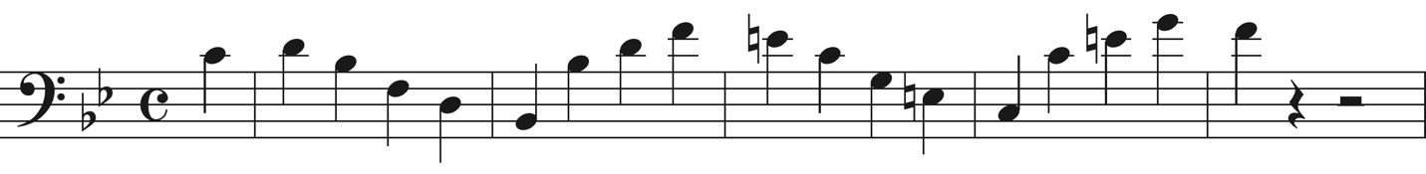

Now, using my first reduction, try to eliminate the next obvious unimportant notes. Notice that we basically just have arppeggiation.



Again, here’s what I did. Notes on beat 1 are typically more important than the rest of the notes. So I simply eliminated everything else.

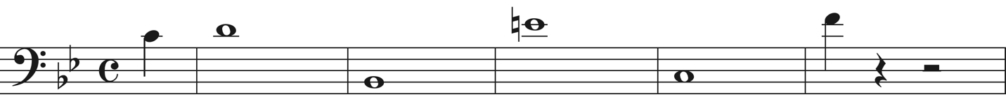

We still can’t see exactly where this phrase is going. The arpeggio moved up then down, but other than the top and bottom notes, we still don’t have the essence of the line.

So let’s refine it one more time.



Here’s my answer.

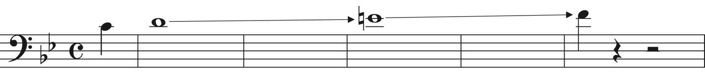

So at the end, we can see that the line simply moves upwards from C to F. Each of the steps are clearly heard because they are at the top of the arpeggios and on the downbeats.

Now in the future I’m going to dedicate an entire post on this subject because this one example doesn’t completely do the process justice. However, you’ve now had some practice at it and can start applying this concept to your own music.