## Melodies: Create Climaxes with Intervallic Tension

Write a motive with at least one skip of a third. Don’t use any interval larger than a third.

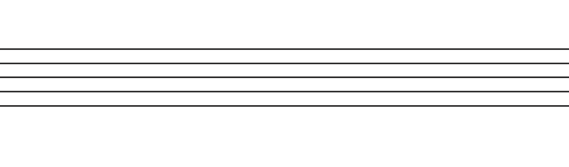

Next, write 4 variations. Give each variation a successively larger interval. Since this will be used for a climax, the variations can have quite a bit of change from the other.

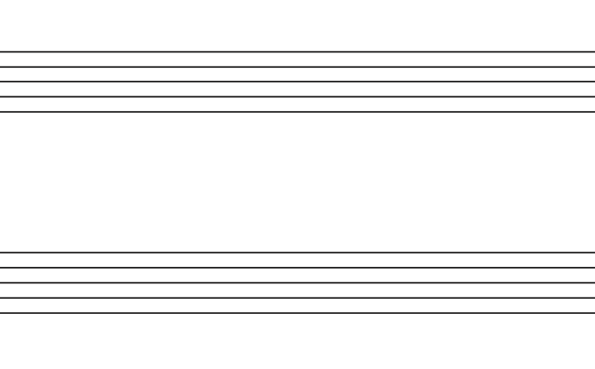



Now, look at one of your variations. Keeping the interval size the same (i.e. a 6th stays a 6th), move that interval so that it lies on more tense scale degrees. See the original post for more detail



Next, take 2 of your variations and make each of the large interval dissonant intervals.

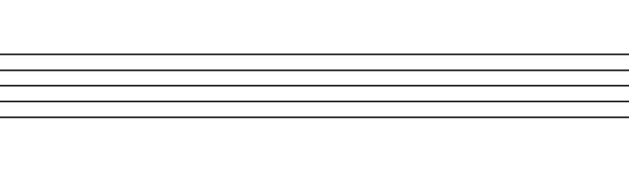



Finally, now that you have many variations on the one motive, write a melody in the form  
*a aʹ a″ b*. You’ll write a new motive for the ending. Check that the tension grows naturally as the melody progresses.

