## Melodies: Creating Unexpected Note Climaxes

Here’s a melody. We want to create an unexpected note climax where the arrow is.

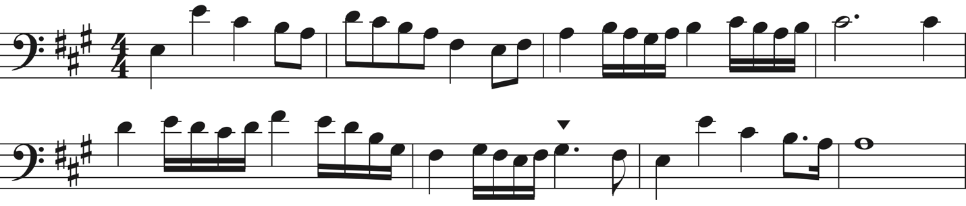

To use an unexpected note climax here, what would be unexpected? What kinds of notes are used before? And after?

Now, brainstorm two 4 different ways to change that note to be unexpected. Remember, the new note doesn’t need to be a G. It could be an F, a D, and A, or any other note you think of.

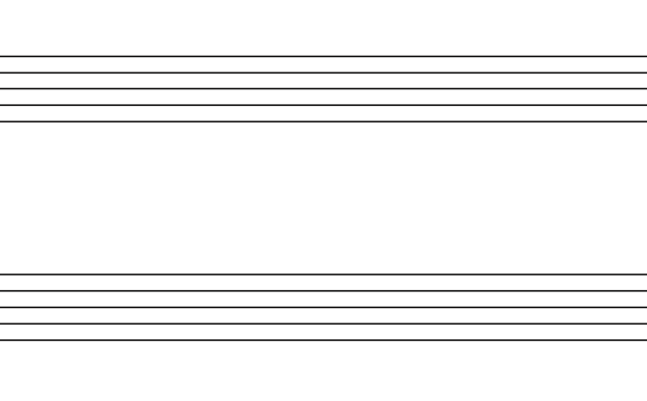



Out of all those ideas, what works best? Why?

Here’s another melody. We want to create an unexpected note climax where this arrow is.

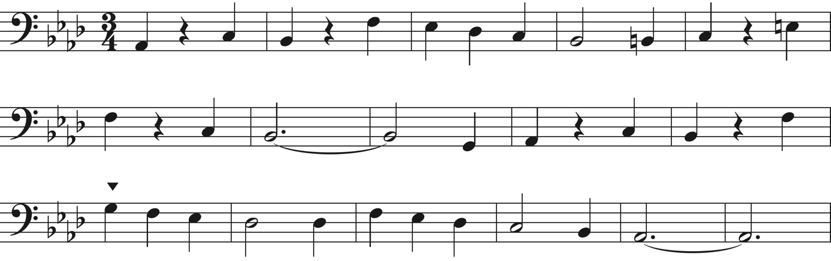

To use an unexpected note climax here, what would be unexpected? What kinds of notes are used before? And after?

Now, brainstorm two 4 different ways to change that note to be unexpected. Remember, the new note doesn’t need to be a G. It could be an F, a D, and A, or any other note you think of.





Out of all those ideas, what works best? Why?