## Melodies: Creating High/Low Note Climaxes

### Step 1: Write our Motives

As you do this, think about at least one motive having a downward arc. This will let you use that arc as a basis for your low point.

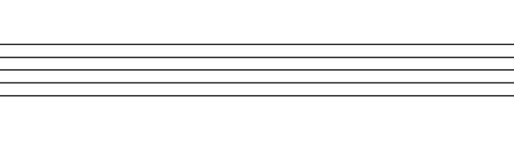



### Step 2: Create Variations

In the variations for the motive(s) with the downward arc, play around with it. Try extending the arc lower.





### Step 3: Write the Melody

Pick a form and then write the melody in that form. As you do that, make sure the low note is towards the end.



### Step 4: Edit Melody

Now that you have all the pieces together, edit the entire melody. Pay attention to how the tension is being built through increasingly lower notes.

