## Motive Names

Match each motive with its variation. You can simply draw a line between the two. As a bonus, write down the ways in which it was varied.

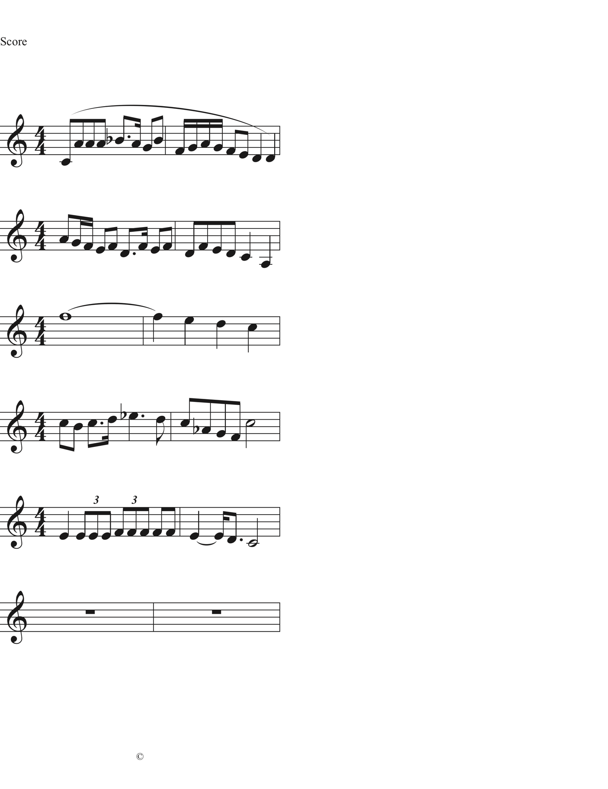

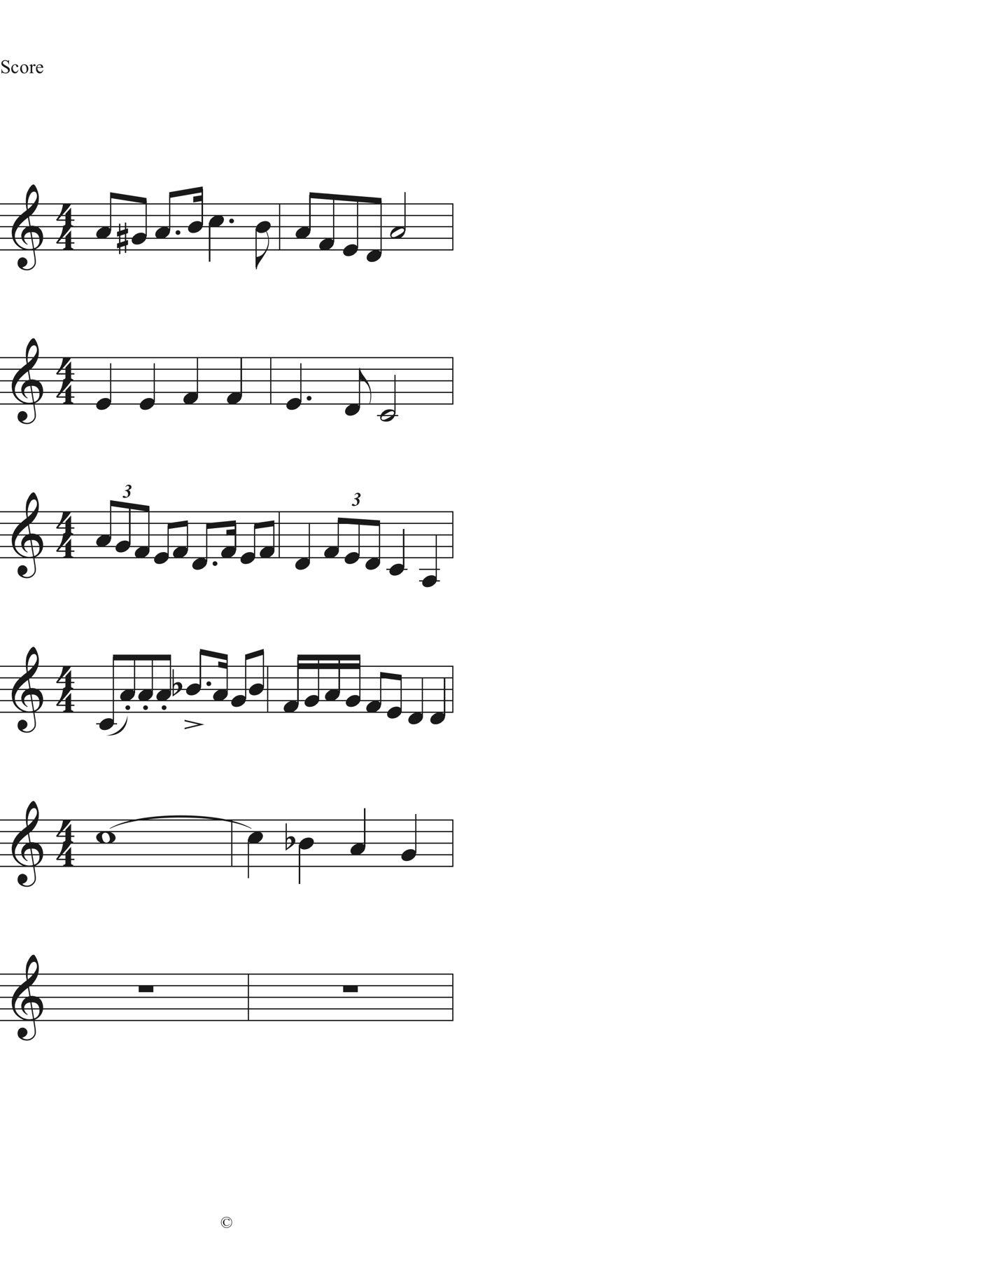

Below is the melody for *Happy Birthday*. The motives and phrases are already marked for you. Just label the names for each of the motives. The answer is on the next page.



Answer to *Happy Birthday* analysis:

