## Increase Pitch Variety in Your Melody

### Modes

Write out your favorite melody, but in a different mode (e.g. lydian).

/Users/Nick/Desktop/Books/Writing Melodies/Finale Files/Blank Staff Paper - Score.pdf

### New Scales

Octatonic scales alternate between half steps and whole steps. This makes 8 notes per octave (hence *octa*-eight and *tonic*-notes). One of these scales starting on C goes half step whole step. The notes are C, C#, D#, E, F#, G, A, A#. Write two motives using this scale.

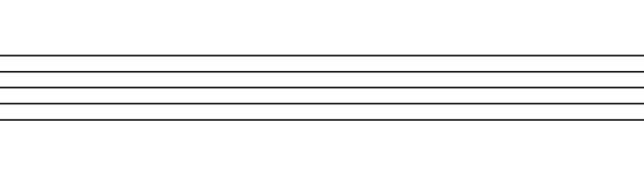



### Leading tones

On the left there are 3 different motives. On the right, rewrite each one using a leading tone. Not all leading tones should be the same. Some should resolve up while others resolve down.

