## Increase Rhythmic Variety in Your Melody

### Syncopation

Here is a motive that is definitely not syncopated. Make one change to give some syncopation.

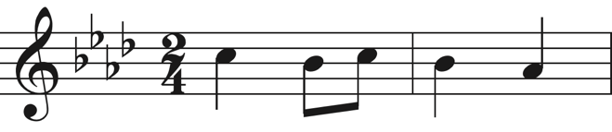

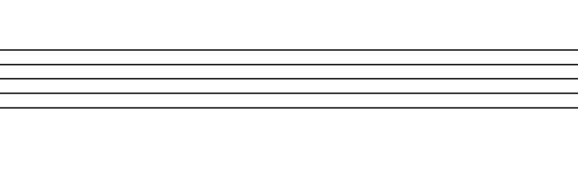

### Tuplets

Below is a motive with fairly standard rhythm. Give it some flair by rewriting it with a 5-tuplet.

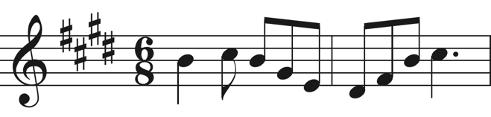



### Rests

Brainstorm 3 different motives that utilize rests. Make sure that the rests are not just at the beginning or end. There should be rest in the middle of the motives. And each motive should be in a *different* time signature.





### Time Signatures

Write two motives in 3.5/4 time. This may sound odd, but basically the subdivision is 1+1+1+0.5. In other words, the first three beats are quarter notes while the last beat is an eighth note.

