## Structuring Motives

### Write the Motives

Write two motives that you can use. Remember, they don’t need to be perfect. They just need to be written down. They should both be exactly two measures of ¾.

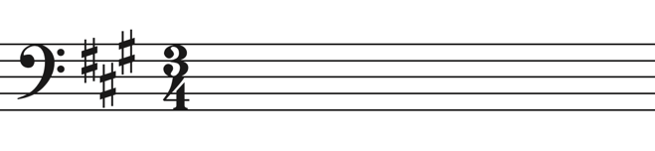



### Write the Variations

For each of your motives above, write two variations. Your variations can be pitch, articulation, or even rhythm.

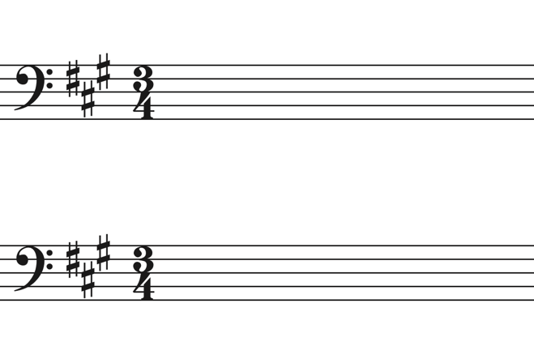



### Pick a Structure

Pick any structure you would like. Just remember the two rules:

* You must vary *a* or *b* before you can have a *c*
* The same exact motive cannot be repeated 3 times (e.g. no *a a a*)

**Structure: ____ ____ ____ ____**

### Combine the Motives into a Melody

Now that you have your motives and your structure, write the melody putting your motives into your structure.

/Users/Nick/Desktop/Books/Writing Melodies/Finale Files/Blank Staff Paper - Score.pdf