**Kavita T.**

202, 2nd Floor, Rishi Diamond Apartment,

ALIND Employees Colony, Serilingampalle (M)

HYDERABAD,TELANGANA-19.

**PERSONAL SUMMARY**

An ambitious and well-rounded User Interface Designer who takes great pride in the presentation and quality of my work, I can design and create simple, beautiful and easy to understand things. Apart from my advanced graphic design production skills, my key strengths lies in my ability to grasp needs and consider practical solutions. During my career I used typography, imagery and creative concepts to give my customers a visual feast. On a personal level I always had a professional attitude and approach to everything that I do. In addition to this I am great team player who possesses exceptional verbal and written communication skills. Right now I would like to work for a company that has a team of pleasant, experienced designers and a working environment which allows people to step-up into high-profile design roles.



**(Senior Graphic Designer) – July 2022 – Present**  
Employers name – **Royal Cosmetics Pvt Ltd.**

* Corporate Logos, Stationery, Flyers, Brochures.
* Packaging and Branding of complete cosmetic related print media
* Product Catalogues designing.
* Stationery
* Social Media Banners and Mailers
* Communicating by e-mail and phone with clients national and international.

**CAREER HISTORY**

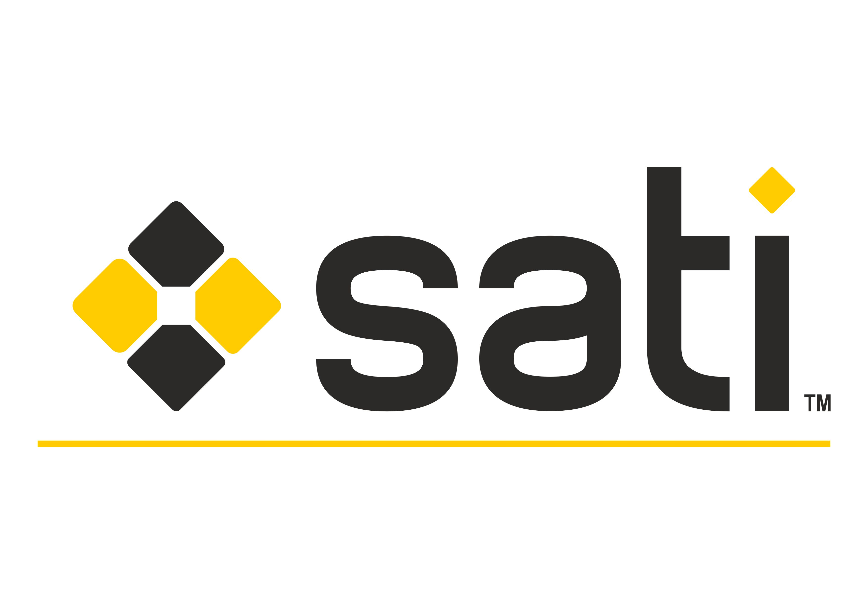

**(Graphic Designer) – January 2016 – June 2022**  
Employers name –**SATI EXPORTS INDIA Pvt. Ltd.**  
Duties:

* Corporate Logos, Stationery, Flyers, Brochures.
* Creating a consistent corporate and brand identity for clients.
* Product Catalogues designing.
* Web Banners and Mailers, greetings for website to clients worldwide, website maintenance backend.
* Artworks for International Exhibitions events like Coverings, XIAMEN, MARBLE, IZMIR, STONA, MARMOMACC.
* PASTELS Boutique all print and web related works.
* SHAKESBIERRE all print and web related works.
* AL SAFI Dubai based company mailers, banners and print media.



* **(Graphics - TEAM LEAD) – May 2013 – September 2015**   
  Employers name–**Green Gold Animation Pvt. Ltd.**  
  Responsible for developing professional design work for both print and web.

Duties:

* Complete responsibility of Books inner pages and cover page designing levels to alignment process. Proof checking and setting the print files of books for ready to print format.
* Giving total ideas for coloring and activity books for kids.
* Visualizing the design concepts for cover pages.
* Developing customized design solutions.
* Advising clients on strategic content development.
* Compiling a library of standard, user-friendly templates.
* Presenting design ideas clearly and concisely.
* Examining design work for quality, consistency, and accuracy.
* Creating a consistent corporate and brand identity for clients.
* Preparing design files for production.
* Communicating by e-mail and phone with clients national and international.

Personal

* An excellent communicator who can confidently articulate and visualize design ideas.
* Dedicated work ethic and ability to work overtime as needed.

**AREAS OF EXPERTISE**

* Comics, Activity and Coloring – Books for kids kindergarten and school kids
* User Experience interactions with user
* Creating wireframes
* Navigation and research for an application
* Research on the market situation in the mode of Digital Marketing strategies.
* Product development and digitalizing ideas.

**Ux designing Tools**

* Wireframing and UI prototyping. ...
* Visual communication. ...
* Tools, Adobe XD, Balsamiq, Axure, Sketch and Dreamweawer
* Interaction design. ...

**ACADEMIC QUALIFICATIONS**

* Osmania University (OU) – MBA (HRM) – 2010
* Dr. B. R. Ambedkar University(OU) –B.Com 2005
* Rosy High School; SSC 1998

Portfolio Link:  <https://www.behance.net/kavitabattf84a>

Current Company: Royal Cosmetics Private Limited.

Current CTC: 5.2

Expected CTC: 7.0