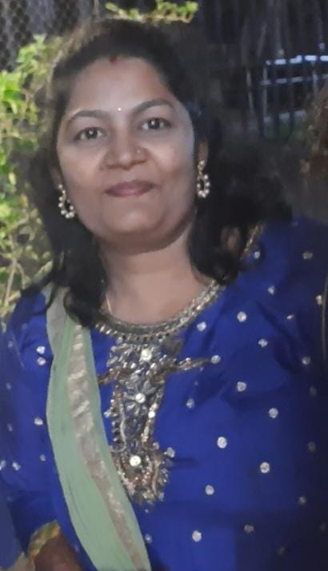**HARI PRIYA**

**CAREER OBJECTIVE**

To work in a globally competitive environment on challenging a assignments as a valuable Team member, where I could utilize acquired skills and education and where I could constantly learn and improve upon my technical and analytical abilities.

**PROFESSIONAL EXPERIENCE**

Working with M/s. Hind Flow controls as Hr &Administration executive from Feb 2022 to till date.

M/s. Hind Flow controls supplies controlling valves used in pharmaceutical companies.

**Administrative Functions :**

* Monitor day to day office correspondence activities.
* Maintaining daily MIS (Includes, Traveling Expense, Stationary Expense, & Office Maintenance etc.)
* Vendor contract, Renewal of contracts, AMC of contracts, Bills certification, Follow-up of Bills.
* Petty Cash management, keeping details of all petty cash expenses with supporting documents .
* Travel arrangement & Reservation.
* Follow-up with Accounts Payable Department to ensure invoices are paid on time.
* Managing repair, maintenance & replacement of office equipments
* Looking after all the transaction related to bank like sending cheque for deposits, monthly statement.

**HR Functions:**

* Calling candidates & schedule interview.
* Fulfilling the joining formalities like Issuing Offer Letter & Appointment Letter.
* Introduction of a newly hired employee into an organization and employee.
* Helping employee to understand their position and job requirement
* Processing onboarding paper works, Finish joining formalities (ID cards, Bank Accounts Opening or updating existing a/c.)
* Conducting Exit Interviews of the departing employees.
* Maintaining database of CVs of various candidates.
* Updating leave record and collection of attendance in excel sheet.

Worked with M/s. Johnson Controls India Pvt Ltd ( Team Lease) as Project Coordinator from July 2016 to dec 2016.

Raising PR for the material.

Preparing DC for Dispatch

Materials follow up for projects

Worked with **M/s Tyco Fire & Security India Pvt. Ltd(ALP management consultancy)** as **Admin** executive cum core HR support at Hyderabad Branch since October 2008 to June 2013.

M/s **Tyco Fire & Security** is a U.S based Multi National Company dealing in Fire Fighting, Integrated Systems, Facilities Management and Security Systems with an Indian Operations.

**ADMINISTRATIVE FUNCTIONS:**

* Comparing the quotations from vendors, recommending best supplier/vendor after Negotiation of preferential rates and sending to head office for approval.
* Vendor contract, Renewal of contracts, AMC of contracts, Bills certification, Follow-up of Bills.
* Organizing meetings, conferences calls on weekly & monthly concal for employees.
* Collecting & maintain the data base for (Transport, Stationary)
* Planning and preparing monthly reports pertaining to finance required for maintaining office infrastructure and facilities.
* Petty Cash management, keeping details of all petty cash expenses with proper approvals from BM, forwarding details of all expenses to Accounts team.
* Travel arrangement & Reservation for guest.
* Follow-up with Accounts Payable Department to ensure invoices are paid on time.
* Managing repair, maintenance & replacement of office equipments, appliances, furniture, furnishings, building, etc.
* Interacting & Coordinating with Company Tax consultant for Professional Tax, Sales tax returns & C Form, registration of labour license, ensure on time submission and other statutory matters.
* Generation of APVAT & CST way bill through Online.
* Liasioning and coordinating with various departments within the corporate office and all branch offices. Coordination with head office, submission of weekly reports.
* Looking after all the transaction related to bank like sending cheque for deposits, monthly statement
* Monitor day to day office correspondence activities.
* Maintaining daily MIS (Includes, Traveling Expense, Stationary Expense, & Office Maintenance, Dispatch, Office Assets, etc).
* Looking after the house-keeping, security guards and ensuring efficient working of the cafeteria.

**HR Functions:**

* Calling candidates & schedule interview.
* Fulfilling the joining formalities like Issuing Offer Letter & Appointment Letter.
* Introduction of a newly hired employee into an organization and employee.
* Helping employee to understand their position and job requirement
* Processing onboarding paper works, Finish joining formalities (ID cards, Bank Accounts Opening or updating existing a/c.)
* Composing emails informing new hire and exisiting employee.
* Coordinating with the IT department to set up new employee with business computer, email id creation, visiting cards etc. and arrange for work place
* Issuing confirmation letters to the employees after probation.
* Conducting Exit Interviews of the departing employees.
* Maintaining database of CVs of various candidates.
* Sending consolidated attendances to accounts.

Worked asAdministrative Executive in **M/s. Endura Controls & Automation Pvt Ltd**, which is a dealer for AREVA T & D India Ltd  for Transmission and Distribution equipment, L & T for Variable Frequency Drives, Fenner LTD for Industrial Belts and also Electrical Projects up to 132Kv Substations from **April 2005 to September 2008.**

**Duties & Responsibilities:**

* Managing repair, maintenance & replacement of office equipments, appliances, furniture, furnishings, building, etc.
* Follow-up with Accounts Payable Department to ensure invoices are paid on time.
* Collecting & maintain the data base for making the matrices (Transport, Stationary)
* Monitor day to day office correspondence activities.
* Maintaining daily MIS (Includes, Facility Management, Traveling Expense, Stationary Expense, Housekeeping &, Office Maintenance, Dispatch, Office Assets, etc).
* Petty Cash maintenance.
* Travel arrangement & Reservation
* Cash entry’s and generations of invoice .

**EDUCATION**

* Masters in business Administration with “Finance” as specialization from Pondicherry University. June  2006
* Graduation in Commerce honours from Osmania University March 2003.
* Intermediate “C.E.C” Board of Intermediate March 2000
* Schooling from Amaravathi Grammer High School
* Application: MS Word, Ms Excel & Outlook.

## PERSONAL TRAITS & SKILLS

* Knowledge in using word and excel. Able to quickly learn new software packages
* Working toward Organization objective to the fullest satisfaction of the management

**PERSONAL DETAILS**

* Date of Birth :- 14th September,1981
* Marital Status :- Married
* Sex :- Female
* Languages known :- English, Hindi & Telugu
* Nationality :- Indian
* Hobbies/Other interest :- Reading , music
* Father’s name :- Mr. Laxmi Narayana
* Permanent Address :- H. no: 11-4-51/A, Chilkalguda, Secunderabad- 61

_______________

**(HARI PRIYA.E)**