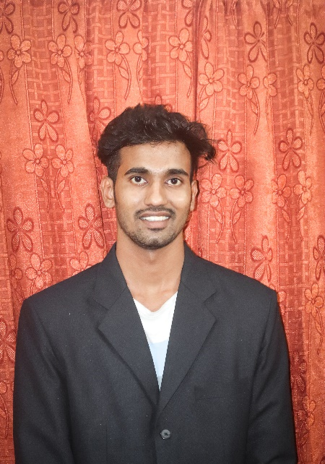sssss

**Vamshi Krishna Enumuri**

To work in a healthy, innovative and challenging environment extracting the best out of me, which is conducive to learning and grow at professional as well as personal levels thereby making me a valuable asset to the organization.

**Internships**

**Summer Internship Programme (SIP)**

**Organization –** Crystal Crop Protection Limited

**Duration –** 60 days

**Location –** Yellandu Mandal, Telangana.

**Project –** Pre-Season Campaign, Demand Generation, Sales and marketing.

**Live Project-1**

**Organization –** Reliance Retail

**Duration –** 15 days

**Location –** Near Medchal Check Post, Hyderabad

**Project –** The internship was based on procurement and dispatching of fruits, vegetables and milk products in cpc’s (collection processing centres).

**Rural Immersion Segment (RIS)**

**Organization –** Kamareddy Farmer Progressive farmer producer

company (KPFPCL)

**Duration –** 15 days

**Location –** Kamareddy, Telangana.

**Project –** To understand the working system of the FPC at the  
 ground level. To know about the background of the  
 farmer member of the FPC, their issues, benefits and  
 about the facilities provided by the FPC and activities  
 of the FPC.

**Rural Agricultural Work Experience (RAWE)**

**Organization –** KVK (Krishi Vigyan Kendra)

**Duration –** 40 days

**Location –** Lam, Guntur Dist. Andra Pradesh.

**Project –** Azolla Cultivation, Vermi compost preparation, Apiculture and Animal Husbandry

**Skills**

MS Office, Good communication, Leadership, Team-oriented.

**Co-circular**

Media cell committee Member,Photoshop

**Contact**

**Phone**

+91-8555963711/9121787439

**E-mail**

Official - [22206032@ksrm.ac.in](mailto:22206032@ksrm.ac.in)

Personal – [vamshimickel71@gmail.com](mailto:vamshimickel71@gmail.com)

**Address**

At/Po – Palvancha

City – Kothagudem

District – Badradri Kothagudem

Pin – 507115

State – Telangana

**Education**

**Master in Business Administration**

KIIT School of Rural Management

Year – Pursuing

MBA (Agribusiness Management)

CGPA – 7.3

**Graduation**

SVS collage of agriculture Dondaicha, MPKV Rahuri.

Year – 2018 - 2022

B.Sc. Agriculture

Score – 70.03 %

**Higher Secondary Education**

Krishnaveni junior collage, Kothagudem

Year – 2016-2018

Stream – BIPC (Medicon)

Board – Board of Secondary Education

Score – 83%

**Matriculation**

Zilla Parishath Seconday School bollorugudem , Palvancha

Year – 2016

Board – Board of Secondary Education Telangana

CGPA – 8.7

**Language**

Bengali, Hindi, English

**Hobbies**

Cooking, Playing Badminton