Step 1:

Enter the Amazon **DynamoDB** Console

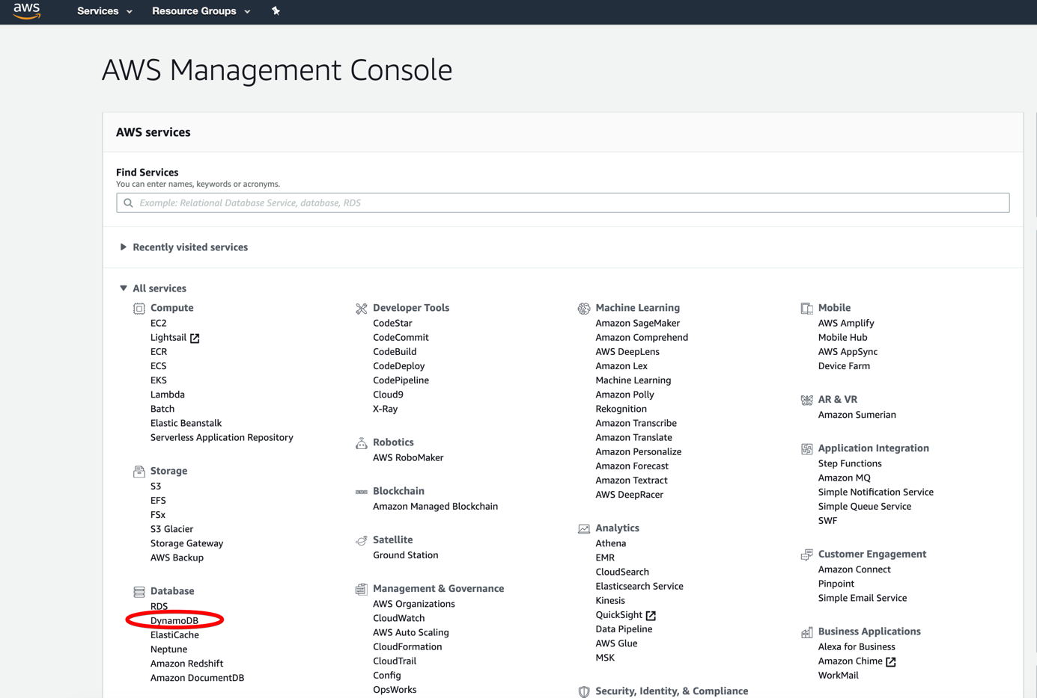

Step 2:

In the left navigation pane of the Amazon console, select **Tables** and find the table.

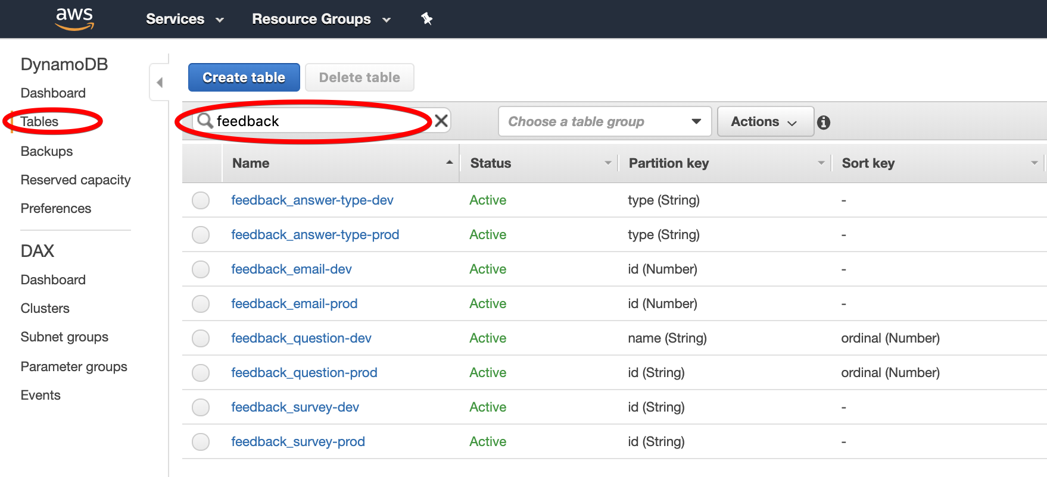

Step 3:

Click on table name ‘feedback_email-prod’ and select **Items**.

Select checkbox, and select **Edit** from **Actions**.

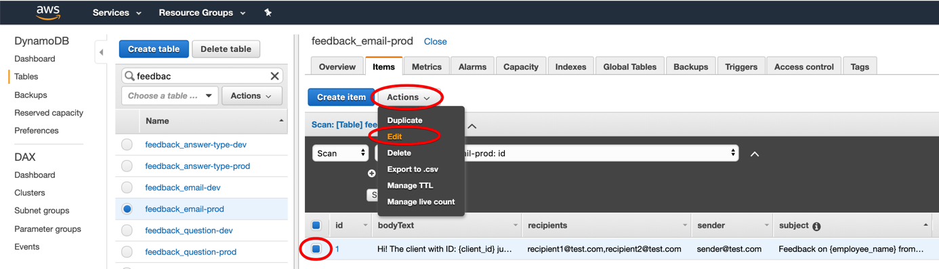

Step 4:

After selecting **Edit**, there appears pop up **Edit Item.**

When you click on the value, you can edit the value. After the edition, you should save or cancel.

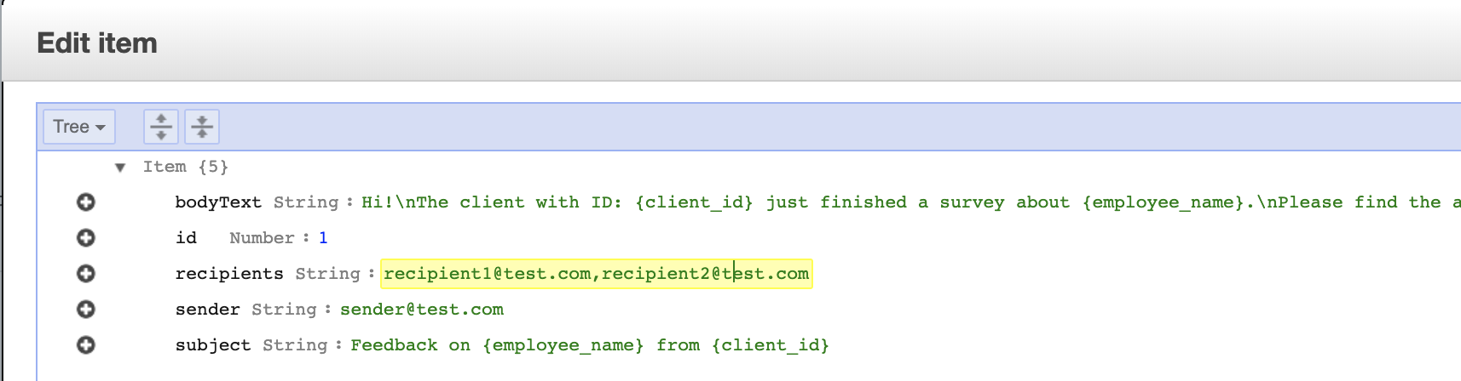

Properties:

bodyText – message content. You can use the parameters:

- {employee_name}

- {client_id}

- “\n” – a new line

recipients – recipients emails separated by a comma

sender – sender’s email

subject

bodyHtml – message content. You can add html message instead of simple text

Step 5:

Editing of questions. The steps 1-3 are the same, but table name is ‘feedback_questions-prod’.

Properties:

name – unique name of the question

ordinal – number

content – question

required – allowed values: 0, 1

type – value is required, allowed values: select, radio, rating, open-ended

answerType – allowed values: kindOfFeedback, yesNo, rating

You can also add a new question by **Create item**, but remember to add correct values as above.

