**Report on Graphical Analysis and Model Comparison of Dataset**

**Introduction**

This document gives a thorough evaluation of a dataset containing severa abilties related to life expectancy during notable nations and years. The motive is to benefit insights into the dataset's distribution, relationships, and outliers via graphical exploration, and to evaluate the overall regular overall performance of different device mastering models in predicting existence expectancy.

**Data Overview**

The dataset consists of severa abilties which encompass man or woman mortality fees, alcohol consumption, percent expenditure on fitness, prevalence of measles, BMI (Body Mass Index), occurrence of HIV/AIDS, GDP (Gross Domestic Product), population, and others. The goal variable is life expectancy, that is a vital indicator of a rustic's everyday health and properly-being.

**Data Preprocessing**

Before venture any assessment, the dataset underwent preprocessing to ensure its suitability for evaluation and modeling. This way worried managing lacking values, converting precise variables into numerical ones (if any), and scaling the abilities if crucial. Additionally, the dataset modified into divided into features and the goal variable for model training features.Moreover scaling the features guarantees that every one of them have similar scales, stopping positive talents from dominating the model education approach. This guarantees that the model can take a look at from every characteristic in addition, crucial to more strong and reliable predictions. Additionally, scaling also can assist decorate the convergence pace of optimization algorithms, resulting in quicker education times.

**Graphical Analysis**

**Histograms**

Histograms are graphical representations that show the distribution of a dataset's numerical values. By dividing the records into periods called "packing containers" and counting the big fashion of information factors in each bin, histograms provide insights into the underlying distribution of the statistics.

The histograms generated for every characteristic within the dataset show screen critical tendencies on the aspect of skewness, important tendency, and variability. For example, competencies like GDP and population can also exhibit proper-skewed distributions due to the presence of some international locations with immoderate values, at the same time as talents like BMI and percentage expenditure on fitness also can show greater symmetric distributions.

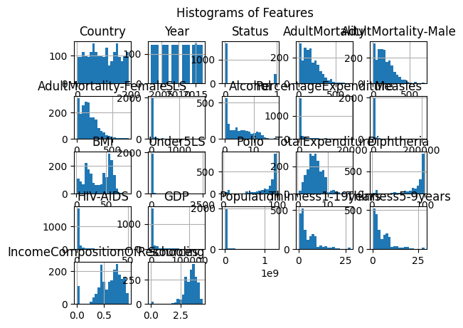

**Pairplot**

A pairplot is a grid of scatterplots that indicates pairwise relationships amongst talents in a dataset. Each scatterplot within the grid represents the relationship amongst capabilities, permitting us to visualize correlations, dispositions, and capability styles.

By studying the pairplot, we are capable of recognize any linear or nonlinear relationships amongst abilties. For example, we'd have a take a look at a superb correlation among GDP and percent expenditure on health, indicating that wealthier worldwide locations have a tendency to allocate a better percent in their GDP towards healthcare.

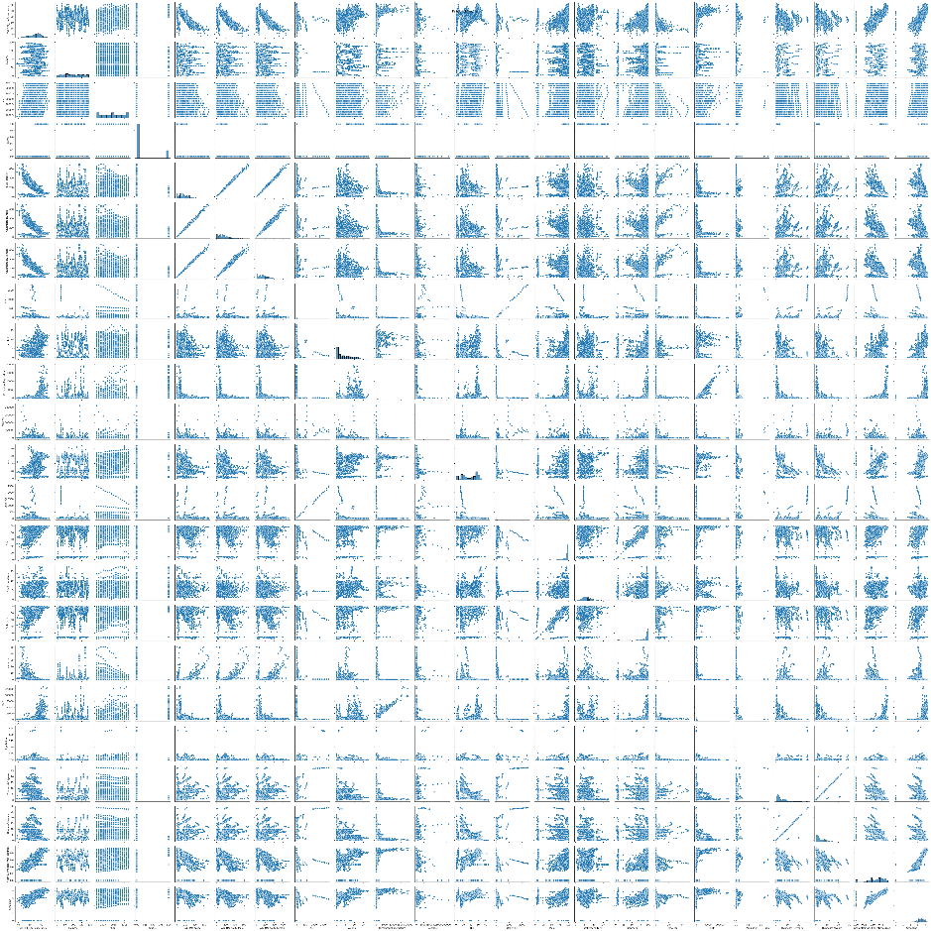

**Correlation Heatmap**

A correlation heatmap is a graphical example of the correlation matrix, which indicates the correlation coefficients amongst pairs of abilities in a dataset. Each cell in the heatmap corresponds to the correlation coefficient amongst talents, with values starting from -1 to at the least one.

The heatmap offers a visible summary of the strength and direction of relationships between skills. Strong correlations (near 1 or -1) imply a immoderate degree of linear courting, at the same time as prone correlations (near 0) advocate little to no dating.

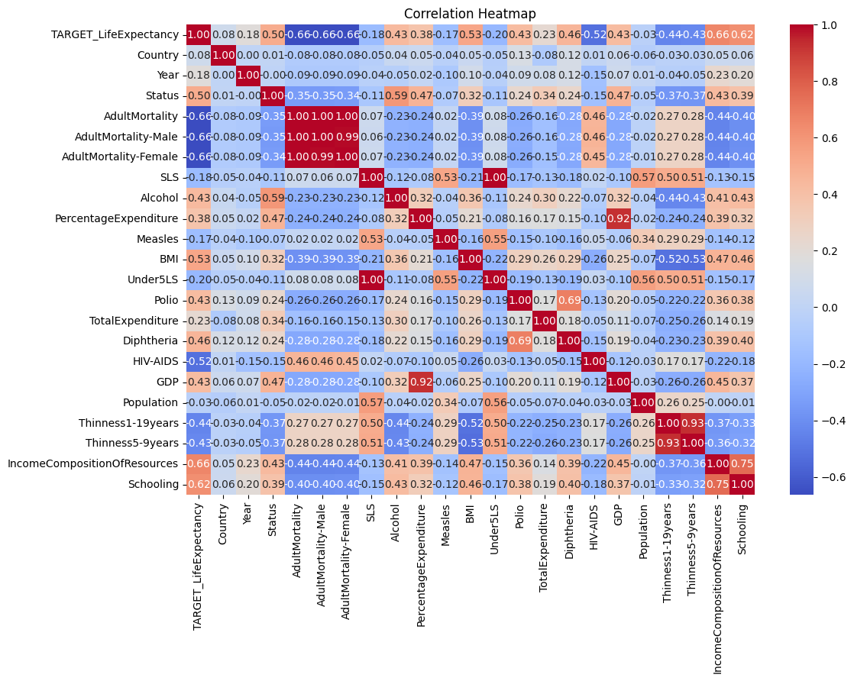

**Boxplots**

Boxplots, moreover called box-and-whisker plots, are graphical representations that summarize the distribution of numerical facts. They display key statistical measures which incorporates the median, quartiles, and capability outliers.

By studying boxplots for every feature, we are capable of end up aware about any capacity outliers or excessive values which can exist inside the dataset. Outliers can substantially impact the general performance of tool reading fashions, so it's far essential to find out and address them as it need to be for the duration of facts preprocessing.

**Model Comparison**

**Linear Regression**

Linear Regression is a statistical method used to model the relationship among a set up variable (goal) and one or greater unbiased variables (functions). It assumes a linear dating the diverse capabilities and the goal, and hobbies to discover the great-becoming line that minimizes the sum of squared mistakes.

In this assessment, we knowledgeable a Linear Regression model using the preprocessed dataset and evaluated its popular ordinary normal performance based completely completely totally on Root Mean Squared Error (RMSE). RMSE is a normally used metric to measure the accuracy of regression fashions, representing the square root of the not unusual squared differences amongst expected and real values.

**Ridge Regression**

Ridge Regression is a kind of linear regression model that contains L2 regularization, which provides a penalty term to the loss function based totally on the squared values of the regression coefficients. This penalty permits to mitigate multicollinearity and decrease overfitting by using shrinking the coefficients within the path of 0 without totally eliminating them.

In our analysis, we hired a Ridge Regression model with an alpha parameter (regularization electricity) of 0.1, and assessed its normal overall performance the use of the identical dataset and RMSE metric as Linear Regression.

**Model Evaluation:-**

**RMSE:- Root Mean Squared Error (RMSE)** is a usually used metric to assess the performance of regression models. It measures the common deviation of the predicted values from the real values, expressed within the identical gadgets as the goal variable. Lower values of RMSE mean better model overall performance.

**Comparison**

After schooling and evaluating every Linear Regression and Ridge Regression fashions, we in evaluation their frequent overall performance based totally totally on the calculated RMSE values and graphical instance of anticipated rather than real lifestyles expectancy values.

By comparing the RMSE values, we are capable to investigate the predictive accuracy of each version and determine which one plays higher on the given dataset. Additionally, the graphical assessment lets in us to visually look at how closely the expected values align with the real values for every model.

RMSE for Linear Regression: 4.874415909886893

RMSE for Ridge Regression: 4.874223030282117 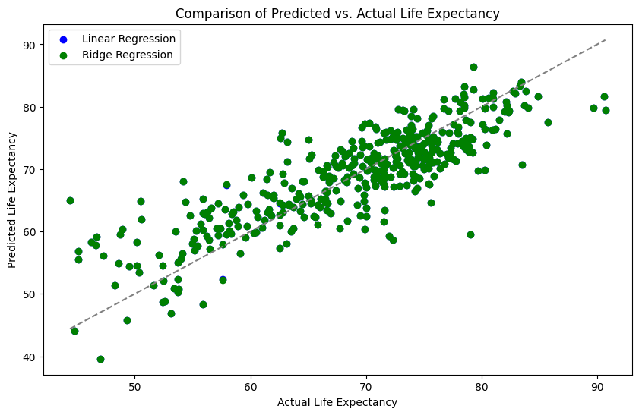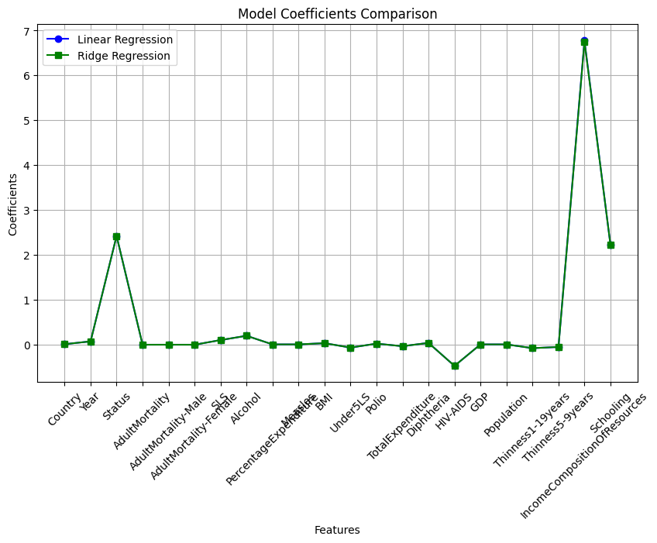

**Conclusion**

In end, the graphical evaluation supplied precious insights into the distribution, relationships, and outliers gift within the dataset. By visualizing the statistics the usage of histograms, pairplots, correlation heatmaps, and boxplots, we acquired a deeper understanding of its underlying form and trends.

Furthermore, the assessment of Linear Regression and Ridge Regression fashions allowed us to evaluate their normal average performance in predicting existence expectancy. While each fashions may additionally additionally have their strengths and weaknesses, the evaluation permits tell preference-making in choosing the maximum suitable version for destiny predictions.

**References**

* James, G., Witten, D., Hastie, T., & Tibshirani, R. (2021). *An introduction to statistical learning* (Springer Series in Statistics) (2nd ed.). Springer New York.
* Hunter, J. D. (2007, June). Matplotlib: A 2D plotting library for Python. In *Proceedings of the 9th Python in Science Conference* (Vol. 4, pp. 90-95).
* Python Software Foundation. (n.d.). *Python programming language*. <https://www.python.org/>
* **Seaborn Documentation:** [Seaborn: statistical data visualization — seaborn 0.13.2 documentation](https://seaborn.pydata.org/) (2023, [date accessed]).
* **Matplotlib Documentation:** [Matplotlib — Visualization with Python](https://matplotlib.org/) (2023, [date accessed]).
* **Pandas Documentation:** [pandas - Python Data Analysis Library](https://pandas.pydata.org/) (2023, [date accessed]).