1 - Create a new product (or edit an existing one):

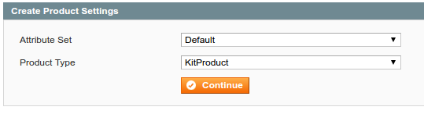

2 – Create the groups at the Custom Options tab

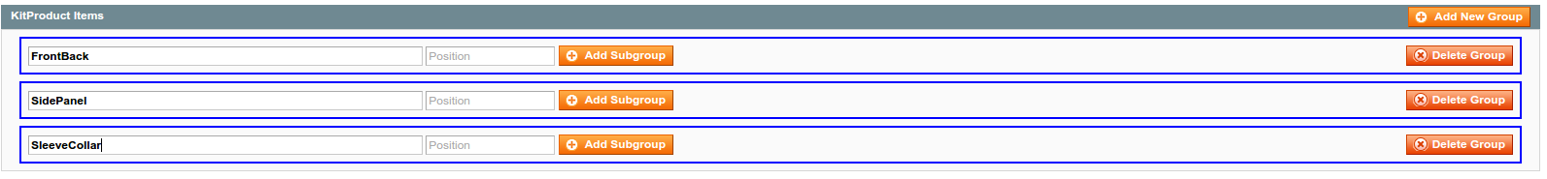

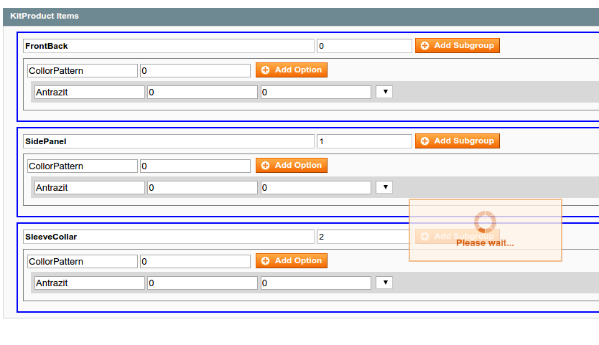3 – Save the product when you’re done creating the options

4 – The extension will create 1 configurable for each group 1 for each sub group and a simple product for each option.

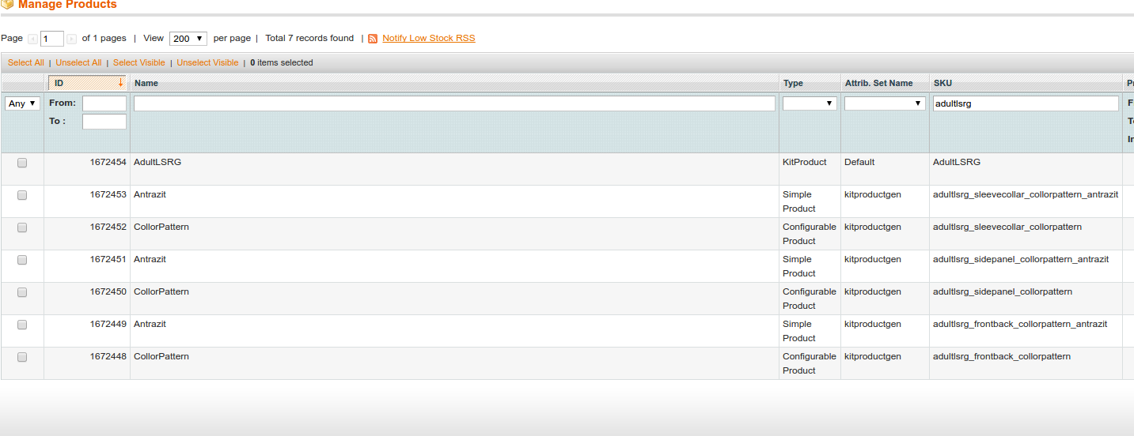

5 – Filter by simple products

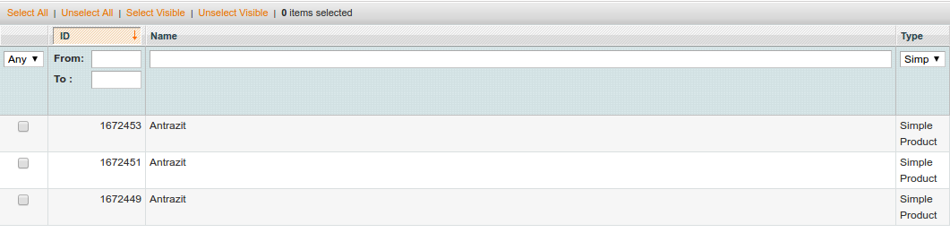

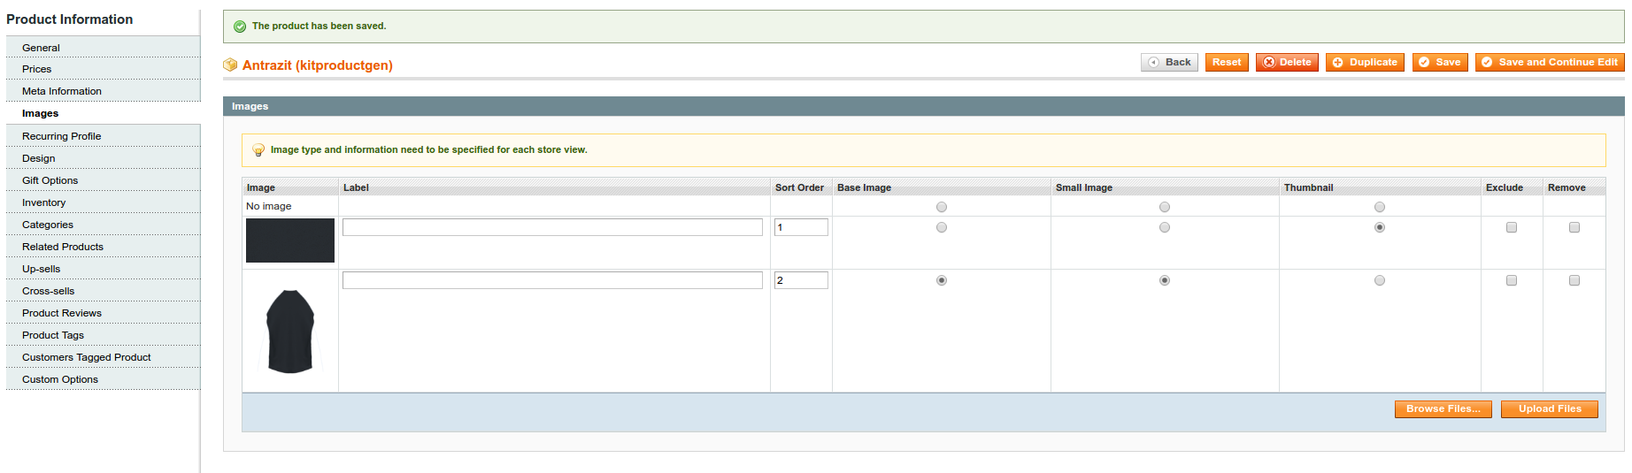6 – For each simple product, upload the images and set them as image, small image or thumbnail

7 – Go to <http://boho.buildateam.io/t-shirts/adultlsrg.html> (for example) to see the result

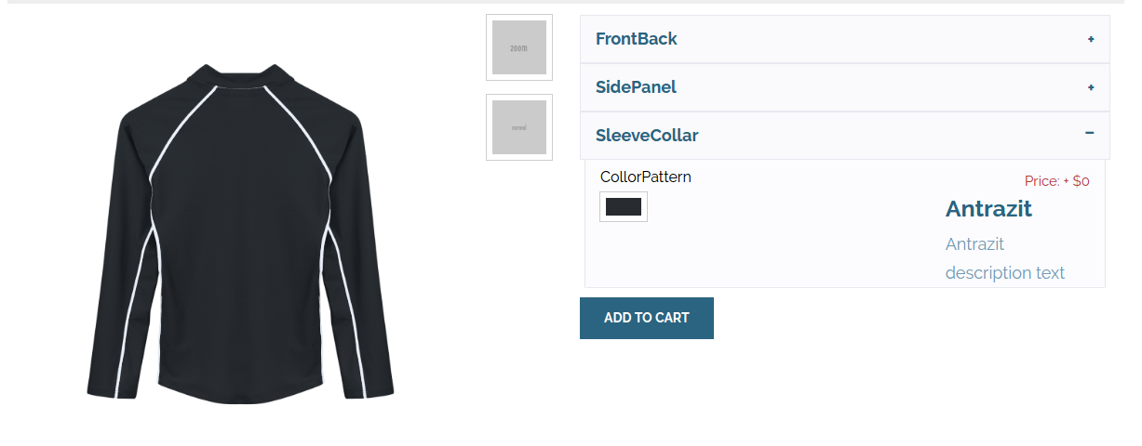8 – You can edit the product prices in the simple and configurable products following the magento standard rules.