DD v2.0 Sprints

Starting 07_11_18

# Themes page (all)

* Consistency needed in
  + Theme titles, capitalization
  + Source links with ‘open new’ icon:



* + Delineate individual Themes with background colour
* Add link to planning tool under planning/ housing charts descriptions
* Chart legends spilling over:

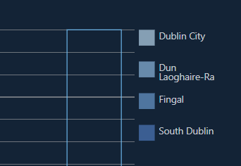

* Missing chart “Numbers by Employment Sector in Dublin” – possible a treemapping chart.
* Missing chart “Females per 1000 Males in Dublin” – think this should be dropped!
* Missing Chart “Age profile of Dublin and Ireland”
* Homeless Data needs to be added to housing section
* Tooltip missing from Grouped Bar Charts

# Landing page

* Update Historical data with Price index and a Homeless data set.