**Typical tasks performed using the Azure PaaS**

* 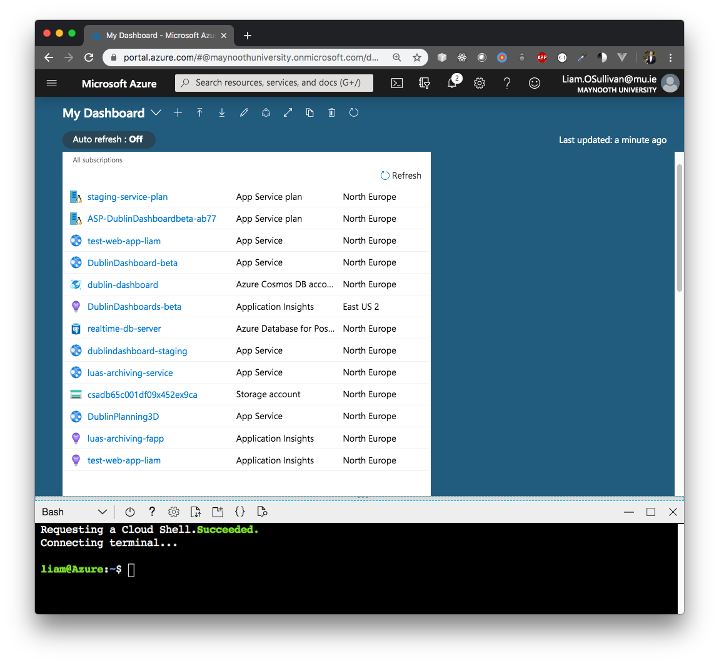Create multiple Resource Groups, App Service Plans, App Services for various process roles and other resources using the Azure Portal, as shown in the figure below.
* Create an Azure Database for PostgreSQL server using the Azure Cloud Shell (resource group, PostgreSQL server, firewall rules etc.). Use connection strings to interact with the database from a local machine.
* Use simple commands on Azure Cloud Shell to e.g. interact with service filesystem via curl.
* Create multiple Web Apps via the Azure portal as Node applications, linked to a GitHub repository branch for continuous deployment and built via the Kudu service (Deployment Centre).
* Use Scale Up and Scale Out to appropriately scale resources for best trade-offs between performance and cost (monitored via Cost Management + Billing).
* Use Development Tools (e.g. Resource Explorer), Monitoring (e.g. Log Stream) and other Portal features to diagnose and debug issues.

**Examples of application types deployed to Azure**

* Web server: Hosts the dashboard websites and their associated APIs on a MEN stack. <https://dublindashboard-beta.azurewebsites.net/>
* Worker process: Performs ETL on a third-party API for data archiving. This example extracts a snapshot of all Dublin Luas stops’ real-time information every minute, processes the data with a suitable JSON schema, and persists this data as documents.

<https://luas-archiving-service.azurewebsites.net/> (Headless)