Robotics Module: Final Report
ENGR 102 – Winter 2013
Engineering Design Lab II

Lab Section: |  | 68 | Date Submitted: | March 11, 2014
Group Number: | 01

Section Faculty: | Phillip Boettcher | Section Fellows: | James Worchester

Group Members: | James Boone | Julian Sanchez
 | Stevie Parris

Abstract
This paper explores using an NXT Lego Mindstorms kit to create a robot using special Lego pieces and sensors. The goal was to assemble a functional, moving robot that could obtain a canister, identify its color, and move it towards or away from a light source depending on that color. The following report summarizes the process of discovery in the design process of the robot with these goals and supplies in mind to prepare a robot for a competition.
Project Background/Task
The situation crafted was a train crash that spread canisters of waste around an area. The task was to create a robot that could identify two types of waste containers, determine the color of one canister from another, and deliver each type to a different point. The robot must be built using only Lego NXT Mindstorms parts and a few other miscellaneous objects such as tape or string. The robot must also be small enough to fit into a box with 1'x1'x1.5' dimensions. Robots are required to be able to do simple tasks such as collision avoidance, canister movement, and light seeking autonomously, and because of this the robot qualifies as intelligent and therefore has the “ability to monitor its environment and then adjust its actions based on what it has sensed” [1]. The test is done on a smaller scale and thus it must be taken into account that robots could get stuck on the fence surrounding the arena and must watch out for ambient light that comes from the windows. The robots must also be able to avoid the other robot in the arena that is trying to accomplish the same task. Each robot receives points for the amount of canisters that are delivered. Blue canisters are worth 5 points and need to be delivered to the light source. Yellow canisters are worth 15 points and must be delivered to the corner opposite of the light source. If a robot becomes stuck on a fence or some other object they have the option to restart with zero points or keep the points that they have earned and quit. If a robot gets stuck on another robot it is allowed to restart without losing any points.
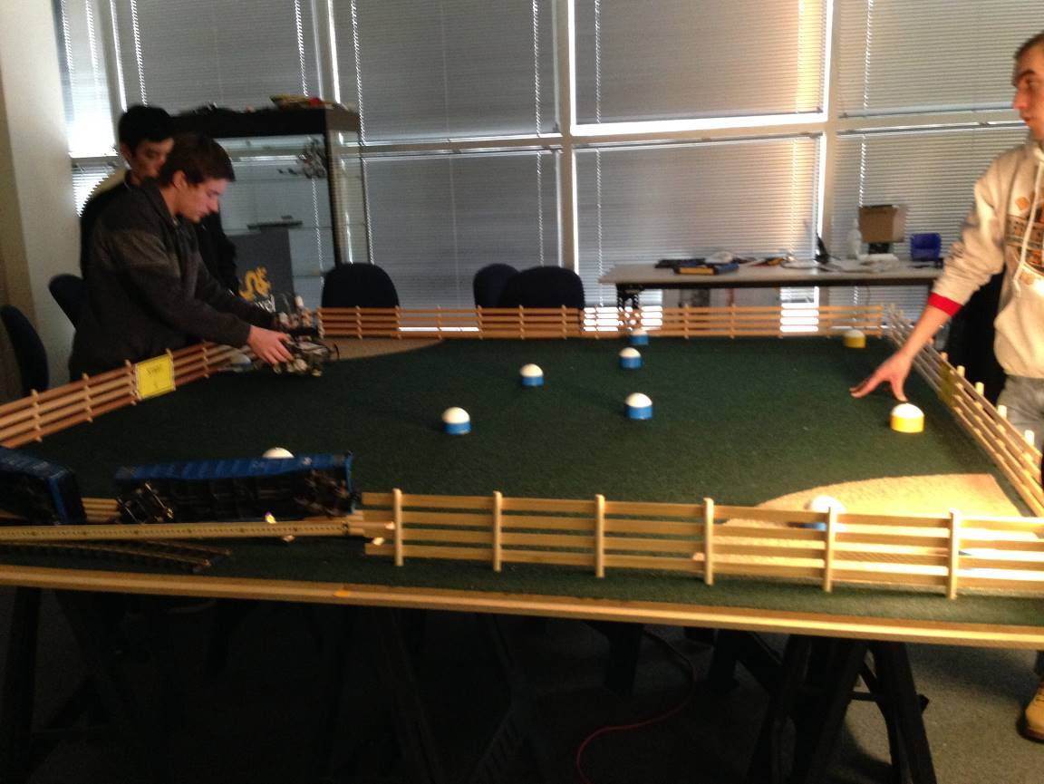
Figure 1. Robot Arena

Component Experimentation

Original Design
Since the task was to deliver the canisters with the greatest amount of efficiency, it quickly became apparent that the original design was not the best way of accomplishing this task, specifically due to the failure of the gripper’s interlocking gear mechanism. This can be below seen in Figure 2.
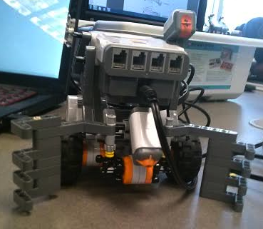
Figure 2. Original Robot Design
Gripper/Plow
Since the original gripper design wasn’t functioning the way desired, in week 4 a decision was made to change from a claw holder to a drop down box. This was originally a flat box as shown in Figure 3. It took a good amount of time to make this light enough for the motor to hold it up. This design obtained a canister in a preliminary competition, but was not sufficient to capture further canisters. However, it was soon realized that the robot’s range of canister detection was not large enough, as they were required to line directly up with the robot’s path and therefore required a plow in order to broaden its path. Adding the plow proved to be a difficult task due to the positioning of the color sensor on the front, bottom of the robot, and the limitations of the NXT kit. Another factor was also making sure that the plow was high enough off the ground that it didn’t drag on the rugged surface of the arena. The plow’s Lego pieces didn’t funnel the canisters precisely toward the color sensor, so rubber bands were added to correctly direct it toward the sensor. The last consideration was over the stability of the plow, which could shift due to the weight of the canister or canisters. This was fixed by further stabilizing it with additional pieces and additional tape. The problem that occurred with the plow’s existence was that the box was no longer sufficient to keep the canister in place, as it could not lower far enough to trap the canister. This was fixed by having the gripper in the form of an arch that would be able to capture the object without the plow impeding it.
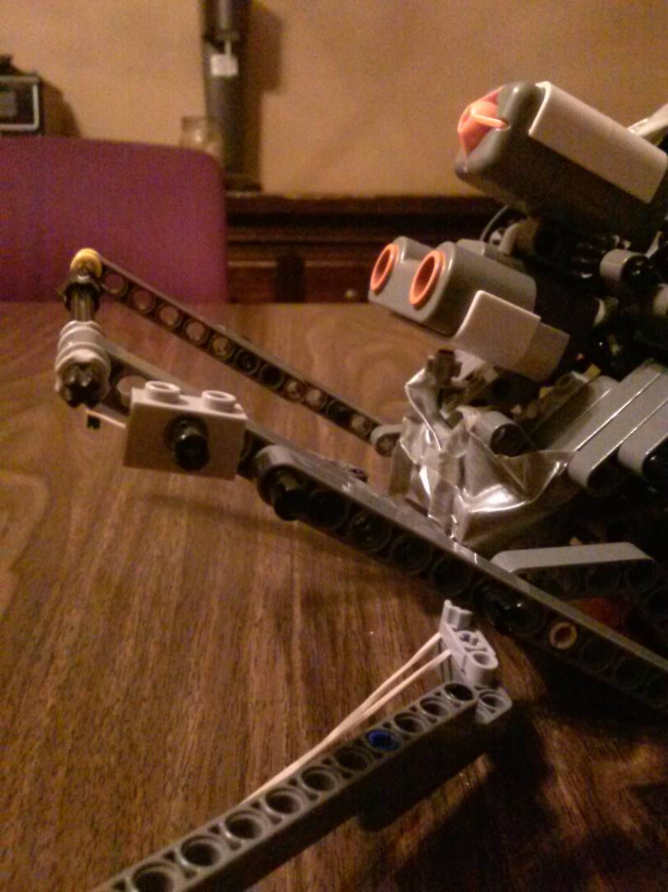
Figure 3. Box Gripper Design.
Light/Anti-Light Algorithm
In order to deliver the blue canisters, the robot needed to travel towards the light source. Although several different types of algorithms for this were attempted, the original light algorithm proved to be the most efficient. Testing was implemented with the robot turning via a constant motor movement, until the light source comparison values were less than the original. This failed due to the robots waiting time between comparisons. A comparison of light values with too short a delay caused the robot to be unable to tell the difference between measurements, and therefore would not turn. However, a wait time that lasted too long would cause the robot to miss the light source. Finding the balance between these two proved to be too difficult, as the experimental data was too inconsistent. As a result the decision was made to move back to the original algorithm. The original algorithm operates by turning at 50 degree increments to find the general area of the light source. Testing proved that at smaller increments the robot was unable to tell the difference between different portions of the darker arena. Once the robot is generally pointed toward the light source, it turns at 12 degree increments to further correct its trajectory. The robot then moves forward for approximately 15 rotations, then the robot stops and re-corrects its path using the same procedure. Once it reaches the wall of the corner, the robot then ceases to continue based on the ultrasonic reading the wall. The robot will then wait 7 seconds to make sure that the wall doesn’t move, as a robot would, then if it doesn’t it drops the canister off. Otherwise, it proceeds. In order to deliver the yellow canisters to the opposite corner, the original thought was to move directly away from the light source. However, this wouldn’t function properly, as it would only work if it was in the center of the area. The next algorithm proved more effective as an anti-light algorithm, performing the reverse operations of the light algorithm by searching for the darkest corner of the arena. The light algorithm is visually displayed below in Figure 4.
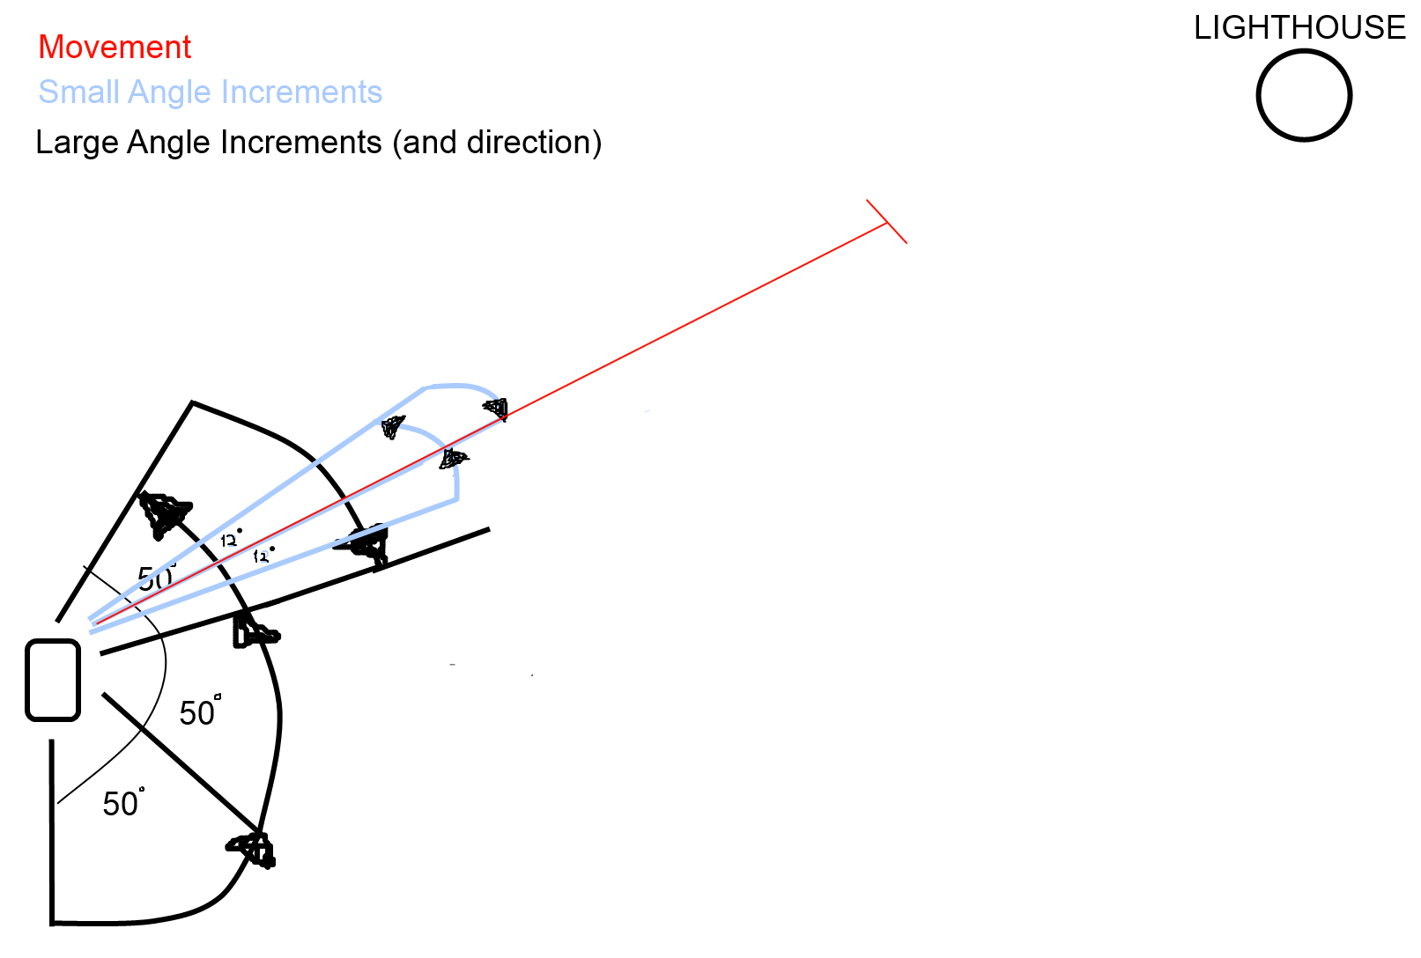
Figure 4. Light Algorithm Visual Representation
Collision Avoidance
The original collision avoidance seemed to work relatively well, except for a difficulty with the placement of the sensor. The problem encountered was that since the fence was slotted, the ultrasonic would read between the pieces of wood. Taking care of this issue was a simple matter of adjusting the ultrasonic sensor’s location then making sure that it remained fixed in place. A touch sensor is also included on the top to help detect walls or other robots. This has proved to be a relatively simple issue. This collision avoidance is used in the random movement algorithm.
Random Movement Algorithm
The random movement algorithm is relatively straightforward, as the robot moves forward with the movement under a counter until the ultrasonic sensor reads something then turns at a random angle between 90 and 180 and then continues until capturing a canister, which allows for the robot to search various parts of the arena. This is made especially effective by the plow design. If the rotations exceed the length of the arena, the robot backs up, turns, and continues. This was the algorithm used in the preliminary and worked well aside from the original placement of the ultrasonic sensor which is described above.

Future Work
With the attempts at designs previously made and the observations of other robot designs in the past ten weeks, there are few ideas that would have made the robot more efficient, if acted upon at an earlier stage, or with more time. The first is the geometric co-ordinate system based movement. This would eliminate many of the problems with using the light source and finding the opposite corner, but would only be a possibility under extensive measurements and adjustment. This idea is one that would require excessive amounts of testing to determine things such as distance under load, and the actual measurement of degrees turned among other things. This is to say that a robot isn’t knocked off course by another robot, which could cause more problem with the co-ordinate system idea, but would be fascinating to implement. In terms of general design, it was later recognized that a four wheel design that allowed the canister to pass beneath the robot would have been the most efficient way of capturing a canister and holding it until ready to release, as well as having more stability. This would prevent the problem of canister pileup in front of the object, among others. Another useful thought was to use the ultrasonic sensor to find canisters on the field, which would make a robot able to find more canisters more quickly, as it would search a larger radius. Another possibility is to use the sound sensor which “can measure sound levels, so that the same command given softly or loudly can elicit a different response” [2] in some capacity, perhaps to hear another robot coming and identify its distance away, or something along these lines. Combining these ideas would result in a fascinating product that if implemented correctly could have added a lot to its design.

Final Design
The final design was the end of the evolution of the ideas above. The end design can be seen below in Figure 5. The robot followed the random movement algorithm and light sensor algorithm described above. It uses the plow to funnel canisters, the rubber bands making it more efficient. It then uses the color sensor to identify which one it would like to take. Both the ultrasonic and touch sensor are used for collision avoidance. The duct tape is primarily used to hold wires in place, but also holds a couple other pieces as well. The light sensor sits at a point that looks toward the approximate height of the lighthouse/lamp.

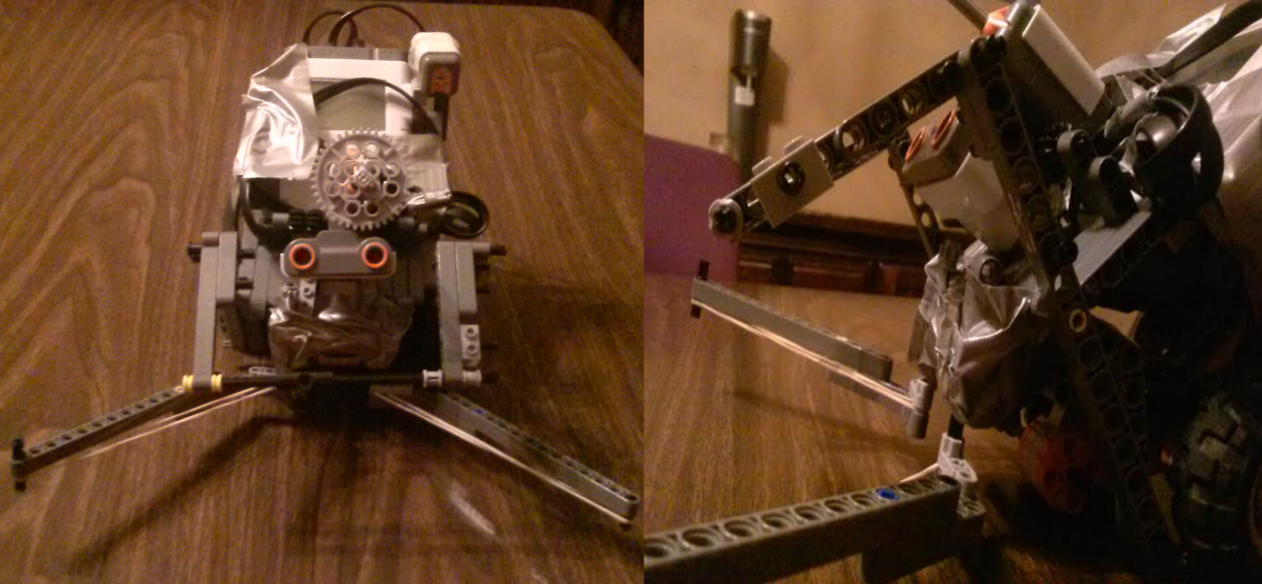
Figure 5. The final robot design.

Conclusion
Upon overcoming the difficulties of delivering the canister’s described above, what is left is a finished product that overcomes the obstacles placed before the robot and allows it to make successful deliveries. Once the gripper difficulties and the sensor placement problems had been dealt with there was a drastic increase the performance of the robot. All of these came pieces came together with the robot’s programmed behaviors in the algorithms described earlier in the report to allow it to accomplish its task. While some of the proposed design changes in the design made in the Future Work section may have added to the robots efficiency and ability to capture canisters, the design chose is functional, and should accomplish the task set before it. The robot has gone through many modifications to achieve the best results and provide the most successful delivery. The robot's new design and modifications will surely work more efficiently than the original design.

References
[1] Jarvis, John and Grant, Edward, “Intelligent Machine,” in AccessScience, McGraw-Hill Education, March 2014.
[2] Turner, Daniel, "Lego Mindstorms NXT," Technology Review, vol.109, no.3, pp.22-23, July 2006.

