Robotics Module: Design Proposal
ENGR 102 – Winter 2013
Engineering Design Lab II

Lab Section: |  | 68 | Date Submitted: | February 03, 2014
Group Number: | 01

Section Faculty: | Philipp Boettcher | Section Fellows: | James Worchester
 |  |  | Bradley Eshelman

Group Members: | James Boone | Julian Sanchez
 | Stevie Parris

Design Constraints
The average contents of the NXT set “includes 571 pieces, the NXT intelligent brick, touch, light, ultrasonic and sound sensors, 3 interactive servo motors, USB 2.0 cable, (and it) is Bluetooth enabled” [1]. The kit given also has a couple additional sensors described below.

Only four sensor ports are available on the robot.
This means a choice between the sensors, finding which ones will allow to most efficiently accomplish the task assigned. Ports similar to these are displayed in Figure 1.

The NXT kit has 6 sensors (touch, light, ultrasonic, sound, color, and magnetic) and three motors.
The NXT kit only has a certain number of Legos, which will affect their placement and make the design more conservative. Similarly, the design is limited by the types of sensors.
- Robot must fit within a 1’x1’x1.5’ box.
The size specifically alters the reach of the gripper design, creating a necessity for shorter, effective claws.
- Cannot intentionally interfere with another robot physically.
This means that the robot design will not focus on the other robots on the arena, aside from avoiding collisions with them.
- Robot must remain in the arena.
Although this wasn’t something originally considered, it helps provide focus to the project design.
- The weight of the NXT’s “mind” must be able to be carried.
The weight of the NXT’s “mind” requires a strong infrastructure to support it, on top of any additional weight added to the design, the greatest being the gripper. The mind is displayed in Figure 1.
- The cables must be accounted for.
The cables can obstruct the robots ability to navigate if not properly adjusted. These cables can be seen in Figure 1.

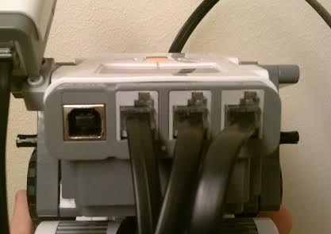
Figure 1. NXT mind ports with cables plugged

Design Proposal

Mechanical Design
For the mechanical of the robot, sensors, the gripper, and the motors were constructed in a way that would allow the robot to accomplish the set of tasks described by instructors.
Gripper
The gripper was inspired by the idea of fingers interlocking with each other as seen in Figure 2. The hands of the machine remain open while the robot drives around until encountering a canister, at which point the hands will close and lock the canister’s position against the robot. The two hands are moved by arms on the front of the robot, which are connected to the motor not being used by the wheels. The extension arm is attached to a gear, which, when the motors run, lock into another perpendicular gear. This can be seen on the left side of Figure 2. Thus, the motors motion causes the arms to swing inwards or outwards.
Sensors
In terms of the sensors’ placements, the light sensor will be located on top of robot. It will be offset to the left side as shown in Figure 2. The light sensor will be placed high on the robot so that other robots and canisters will not interfere with the robot being able to find the light source. The touch sensor is located between the two hands of the gripper. As Daniel Turner suggests in his article Lego Mindstorms NXT, “The touch sensor (not shown) can accommodate an axle that can extend the length of a bumper, which triggers the sensor when it hits an object” [2]. The placement of the touch sensor was decided so that the robot could explore until running into a canister, and upon being triggered, enclose the exterior of the canister. The natural slant of the hands will cause the canister to slide into the touch sensor, guaranteeing the triggering of the sensor. The ultrasonic sensor is placed in the middle of the front of the robot above the touch sensor so it won’t detect barrels but will detect walls. The ultrasonic sensor will be primarily used for avoidance maneuvers since it will able to detect both the walls and other robots. Finally, the color sensor will be placed next to the ultrasonic sensor. It will be pointed in a downward direction, so that the sensor gets a view of the canisters once they have been obtained by the gripper.

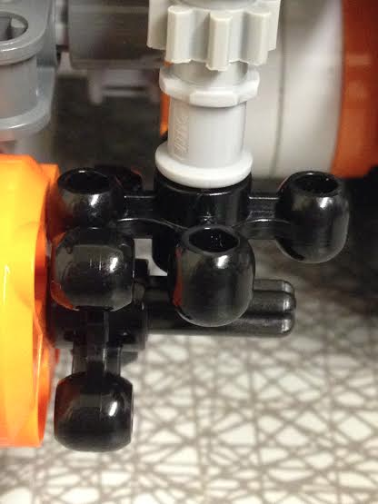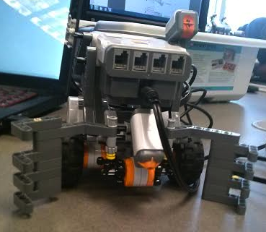
Figure 2. NXT design, grippers, interlocking gears, and sensor placement.

Algorithm Design
The code design will be done in NXT-C programming language to allow for fuller control of the robot’s functions. The different tasks will be put into functions which will be run in parallel to have the robot checking its sensors and performing the task at hand.

Searching the Arena
The robot will search the arena by moving forward at the start. Upon hitting a wall, the robot will then turn to its right at a random angle between 90 degrees and 180 degrees. The robot will then continue until running into another wall, and repeat the process, stopping upon hitting a barrel. This is represented by the flow chart below in Figure 3.

Differentiating Objects
In order to differentiate between blue and yellow objects, trash and nuclear waste, a color sensor will be used upon the pressing of the touch sensor. The robot will leave any nuclear waste and deliver trash to the lighthouse.

Location and Navigation
In the current design, the goal is to make the robot collect all trash canisters and leave the nuclear waste. The robot will search for a trash canister, then search for the light source using the light algorithm, searching by turning in 4 degree increments until it hits a certain threshold, then it will test by turning to the right 4 degrees to see if the sensor reads a higher value. If yes, it will keep turning until finds the highest value. If not, the robot will turn left until reaching its highest value. Once it has found the highest value, it will move toward the light source. Once the robot hits the walls or the lighthouse, it will drop the canister and search for the next one. If the canister is not a trash canister, it will drop it then continue its search.

Avoiding Collisions
In order to avoid collisions with other robots and the fence, the robot will use an ultrasonic sensor to detect a near object above the canister. Upon realizing the existence of such an object, the robot will back up, turn, move a certain distance, turn back to the original path, then move back into its path, correct its angle, and resume its original task.

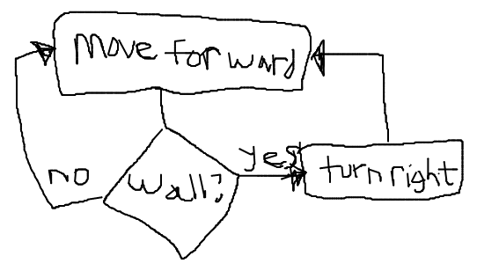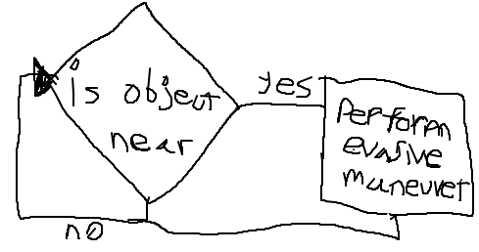
Figure 3. (left) Search Algorithm || (right) Collision Algorithm

References
- "LEGO: Lego Mindstorms NXT Drive Robotics in 2006," Normans Media Limited, M2 Presswire, June 2006.
- Turner, Daniel, "Lego Mindstorms NXT," Technology Review, vol.109, no.3, pp.22-23, July 2006.

