Table of Contents

1. Introduction

1.1 Report Description

1.1.1 Segmentation and Research Scope

1.2.1 Definition, Abbreviations, and Assumptions

1.2 Research Methods

1.2.1 Methodology

1.2.2 Research Methodology: An Outline

1.3 Research Approaches

2. Executive Summary

2.1 Global Pesticide Residue Testing Market Highlights, (USD Million)

2.2 Global Pesticide Residue Testing Market Projection

2.3 Global Pesticide Residue Testing Market CAGR, (USD Million) Growth, By Regions

2.4 Most Lucrative Country Markets, 2023

3. Market Overview & Competitiveness

3.1 Introduction

3.2 DRO Analysis

3.2.1 Drivers

3.2.1.1 Increasing demand for at-home and point-of-care testing is influencing the market growth.

3.2.1.2 Growing prevalence of infectious diseases is driving the market growth.

3.2.2 Restraints

3.2.2.1 Challenges such as regulatory hurdles and concerns about the accuracy and reliability of self-administered tests is expected to hamper the market growth.

3.2.3 Opportunities

3.2.3.1 The integration of self-testing lateral flow assays with digital technologies, such as mobile applications and cloud-based data storage, could provide new opportunities for improving test accuracy and data analysis.

3.3 Porter's Five Forces Analysis

3.4 IGR-Growth Matrix Analysis

3.4.1 IGR-Growth Matrix Analysis by Type

3.4.2 IGR-Growth Matrix Analysis by Food Tested

3.4.3 IGR-Growth Matrix Analysis by Technology

3.4.4 IGR-Growth Matrix Analysis by Region

3.5 Value Chain Analysis of Pesticide Residue Testing Market

4. Pesticide Residue Testing Market Macro Indicator Analysis

5. Global Pesticide Residue Testing Market by Type (USD Million)

5.1 Overview

5.2 Herbicides

5.2.1 Pesticides

5.2.1.1 Fungicides

5.3 Others

6. Global Pesticide Residue Testing Market by Food Tested (USD Million)

6.1 Overview

6.2 Dairy

6.2.1 Processed Food

6.2.1.1 Cereals and Grains

6.2.1.1 Meat and Poultry

6.3 Fruits and Vegetables

7. Global Pesticide Residue Testing Market by Technology (USD Million)

7.1 Overview

7.2 LC-MS/GC-MS

7.3 High-performance Liquid Chromatography

7.4 Gas Chromatography

7.5 Others

8. Global Pesticide Residue Testing Market, by Region (USD Million)

8.1 Overview

8.2 North America Pesticide Residue Testing Market

8.2.1 North America Pesticide Residue Testing Market by Type

8.2.2 North America Pesticide Residue Testing Market by Food Tested

8.2.3 North America Pesticide Residue Testing Market by Technology

8.2.4 North America Pesticide Residue Testing Market by Country

8.2.4.1 The U.S.

8.2.4.1.1 The U.S. Pesticide Residue Testing Market, by Type

8.2.4.1.2 The U.S. Pesticide Residue Testing Market, by Food Tested

8.2.4.1.3 The U.S. Pesticide Residue Testing Market, by Technology

8.2.4.2 Canada

8.2.4.2.1 Canada Pesticide Residue Testing Market, by Type

8.2.4.2.2 Canada Pesticide Residue Testing Market, by Food Tested

8.2.4.2.3 Canada Pesticide Residue Testing Market, by Technology

8.2.4.3 Mexico

8.2.4.3.1 Mexico Pesticide Residue Testing Market, by Type

8.2.4.3.2 Mexico Pesticide Residue Testing Market, by Food Tested

8.2.4.3.3 Mexico Pesticide Residue Testing Market, by Technology

8.3 Europe Pesticide Residue Testing Market

8.3.1 Europe Pesticide Residue Testing Market by Type

8.3.2 Europe Pesticide Residue Testing Market by Food Tested

8.3.3 Europe Pesticide Residue Testing Market by Technology

8.3.4 Europe Pesticide Residue Testing Market by Country

8.3.4.1 Germany

8.3.4.1.1 Germany Pesticide Residue Testing Market, by Type

8.3.4.1.2 Germany Pesticide Residue Testing Market, by Food Tested

8.3.4.1.3 Germany Pesticide Residue Testing Market, by Technology

8.3.4.2 United Kingdom

8.3.4.2.1 United Kingdom Pesticide Residue Testing Market, by Type

8.3.4.2.2 United Kingdom Pesticide Residue Testing Market, by Food Tested

8.3.4.2.3 United Kingdom Pesticide Residue Testing Market, by Technology

8.3.4.3 France

8.3.4.3.1 France Pesticide Residue Testing Market, by Type

8.3.4.3.2 France Pesticide Residue Testing Market, by Food Tested

8.3.4.3.3 France Pesticide Residue Testing Market, by Technology

8.3.4.4 Italy

8.3.4.4.1 Italy Pesticide Residue Testing Market, by Type

8.3.4.4.2 Italy Pesticide Residue Testing Market, by Food Tested

8.3.4.4.3 Italy Pesticide Residue Testing Market, by Technology

8.3.4.5 Spain

8.3.4.5.1 Spain Pesticide Residue Testing Market, by Type

8.3.4.5.2 Spain Pesticide Residue Testing Market, by Food Tested

8.3.4.5.3 Spain Pesticide Residue Testing Market, by Technology

8.3.4.6 Rest of Europe

8.3.4.6.1 Rest of Europe Pesticide Residue Testing Market, by Type

8.3.4.6.2 Rest of Europe Pesticide Residue Testing Market, by Food Tested

8.3.4.6.3 Rest of Europe Pesticide Residue Testing Market, by Technology

8.4 Asia Pacific Pesticide Residue Testing Market

8.4.1 Asia Pacific Pesticide Residue Testing Market by Type

8.4.2 Asia Pacific Pesticide Residue Testing Market by Food Tested

8.4.3 Asia Pacific Pesticide Residue Testing Market by Technology

8.4.4 Asia Pacific Pesticide Residue Testing Market by Country

8.4.4.1 China

8.4.4.1.1 China Pesticide Residue Testing Market, by Type

8.4.4.1.2 China Pesticide Residue Testing Market, by Food Tested

8.4.4.1.3 China Pesticide Residue Testing Market, by Technology

8.4.4.2 Japan

8.4.4.2.1 Japan Pesticide Residue Testing Market, by Type

8.4.4.2.2 Japan Pesticide Residue Testing Market, by Food Tested

8.4.4.2.3 Japan Pesticide Residue Testing Market, by Technology

8.4.4.3 India

8.4.4.3.1 India Pesticide Residue Testing Market, by Type

8.4.4.3.2 India Pesticide Residue Testing Market, by Food Tested

8.4.4.3.3 India Pesticide Residue Testing Market, by Technology

8.4.4.4 South Korea

8.4.4.4.1 South Korea Pesticide Residue Testing Market, by Type

8.4.4.4.2 South Korea Pesticide Residue Testing Market, by Food Tested

8.4.4.4.3 South Korea Pesticide Residue Testing Market, by Technology

8.4.4.5 Australia

8.4.4.5.1 Australia Pesticide Residue Testing Market, by Type

8.4.4.5.2 Australia Pesticide Residue Testing Market, by Food Tested

8.4.4.5.3 Australia Pesticide Residue Testing Market, by Technology

8.4.4.6 Rest of Asia-Pacific

8.4.4.6.1 Rest of Asia-Pacific Pesticide Residue Testing Market, by Type

8.4.4.6.2 Rest of Asia-Pacific Pesticide Residue Testing Market, by Food Tested

8.4.4.6.3 Rest of Asia-Pacific Pesticide Residue Testing Market, by Technology

8.5 RoW Pesticide Residue Testing Market

8.5.1 RoW Pesticide Residue Testing Market by Type

8.5.2 RoW Pesticide Residue Testing Market by Food Tested

8.5.3 RoW Pesticide Residue Testing Market by Technology

8.5.4 RoW Pesticide Residue Testing Market by Sub-region

8.5.4.1 Latin America

8.5.4.1.1 Latin America Pesticide Residue Testing Market, by Type

8.5.4.1.2 Latin America Pesticide Residue Testing Market, by Food Tested

8.5.4.1.3 Latin America Pesticide Residue Testing Market, by Technology

8.5.4.2 Middle East

8.5.4.2.1 Middle East Pesticide Residue Testing Market, by Type

8.5.4.2.2 Middle East Pesticide Residue Testing Market, by Food Tested

8.5.4.2.3 Middle East Pesticide Residue Testing Market, by Technology

8.5.4.3 Africa

8.5.4.3.1 Africa Pesticide Residue Testing Market, by Type

8.5.4.3.2 Africa Pesticide Residue Testing Market, by Food Tested

8.5.4.3.3 Africa Pesticide Residue Testing Market, by Technology

9. Company Profiles and Competitive Landscape

9.1 Competitive Landscape in the Pesticide Residue Testing Market

9.2 Companies Profiles

9.2.1 SGS

9.2.1.1 Overview

9.2.1.2 Company Snapshot

9.2.1.3 Product Portfolio

9.2.1.4 Recent Developments

9.2.2 Intertek Group plc

9.2.2.1 Overview

9.2.2.2 Company Snapshot

9.2.2.3 Product Portfolio

9.2.2.4 Recent Developments

9.2.3 Eurofins Scientific SE

9.2.3.1 Overview

9.2.3.2 Company Snapshot

9.2.3.3 Product Portfolio

9.2.3.4 Recent Developments

9.2.4 Thermo Fisher Scientific Inc.

9.2.4.1 Overview

9.2.4.2 Company Snapshot

9.2.4.3 Product Portfolio

9.2.4.4 Recent Developments

9.2.5 ALS Limited

9.2.5.1 Overview

9.2.5.2 Company Snapshot

9.2.5.3 Product Portfolio

9.2.5.4 Recent Developments

9.2.6 AsureQuality Limited

9.2.6.1 Overview

9.2.6.2 Company Snapshot

9.2.6.3 Product Portfolio

9.2.6.4 Recent Developments

9.2.7 Anacon Laboratories

9.2.7.1 Overview

9.2.7.2 Company Snapshot

9.2.7.3 Product Portfolio

9.2.7.4 Recent Developments

9.2.8 Bureau Veritas

9.2.8.1 Overview

9.2.8.2 Company Snapshot

9.2.8.3 Product Portfolio

9.2.8.4 Recent Developments

9.2.9 Microbac Laboratories, Inc.

9.2.9.1 Overview

9.2.9.2 Company Snapshot

9.2.9.3 Product Portfolio

9.2.9.4 Recent Developments

9.2.10 TÜV SÜD

9.2.10.1 Overview

9.2.10.2 Company Snapshot

9.2.10.3 Product Portfolio

9.2.10.4 Recent Developments

List of Tables

TABLE 1 GLOBAL PESTICIDE RESIDUE TESTING MARKET HIGHLIGHTS

TABLE 2 GLOBAL PESTICIDE RESIDUE TESTING MARKET BY TYPE, 2021 - 2030 (USD MILLION)

TABLE 3 GLOBAL PESTICIDE RESIDUE TESTING MARKET BY HERBICIDES BY TYPE, 2021 - 2030 (USD MILLION)

TABLE 4 GLOBAL PESTICIDE RESIDUE TESTING MARKET BY PESTICIDES BY HERBICIDES, 2021 - 2030 (USD MILLION)

TABLE 5 GLOBAL PESTICIDE RESIDUE TESTING MARKET BY FUNGICIDES BY REGION, 2021 - 2030 (USD MILLION)

TABLE 6 GLOBAL PESTICIDE RESIDUE TESTING MARKET BY OTHERS BY REGION, 2021 - 2030 (USD MILLION)

TABLE 7 GLOBAL PESTICIDE RESIDUE TESTING MARKET BY FOOD TESTED, 2021 - 2030 (USD MILLION)

TABLE 8 GLOBAL PESTICIDE RESIDUE TESTING MARKET BY DAIRY BY FOOD TESTED, 2021 - 2030 (USD MILLION)

TABLE 9 GLOBAL PESTICIDE RESIDUE TESTING MARKET BY PROCESSED FOOD BY DAIRY, 2021 - 2030 (USD MILLION)

TABLE 10 GLOBAL PESTICIDE RESIDUE TESTING MARKET BY CEREALS AND GRAINS BY REGION, 2021 - 2030 (USD MILLION)

TABLE 11 GLOBAL PESTICIDE RESIDUE TESTING MARKET BY MEAT AND POULTRY BY REGION, 2021 - 2030 (USD MILLION)

TABLE 12 GLOBAL PESTICIDE RESIDUE TESTING MARKET BY FRUITS AND VEGETABLES BY REGION, 2021 - 2030 (USD MILLION)

TABLE 13 GLOBAL PESTICIDE RESIDUE TESTING MARKET BY TECHNOLOGY, 2021 - 2030 (USD MILLION)

TABLE 14 GLOBAL PESTICIDE RESIDUE TESTING MARKET BY LC-MS/GC-MS BY REGION, 2021 - 2030 (USD MILLION)

TABLE 15 GLOBAL PESTICIDE RESIDUE TESTING MARKET BY HIGH-PERFORMANCE LIQUID CHROMATOGRAPHY BY REGION, 2021 - 2030 (USD MILLION)

TABLE 16 GLOBAL PESTICIDE RESIDUE TESTING MARKET BY GAS CHROMATOGRAPHY BY REGION, 2021 - 2030 (USD MILLION)

TABLE 17 GLOBAL PESTICIDE RESIDUE TESTING MARKET BY OTHERS BY REGION, 2021 - 2030 (USD MILLION)

TABLE 18 GLOBAL PESTICIDE RESIDUE TESTING MARKET BY REGION, 2021 - 2030 (USD MILLION)

TABLE 19 NORTH AMERICA PESTICIDE RESIDUE TESTING MARKET BY TYPE 2021 - 2030 (USD MILLION)

TABLE 20 NORTH AMERICA PESTICIDE RESIDUE TESTING MARKET BY FOOD TESTED 2021 - 2030 (USD MILLION)

TABLE 21 NORTH AMERICA PESTICIDE RESIDUE TESTING MARKET BY TECHNOLOGY 2021 - 2030 (USD MILLION)

TABLE 22 NORTH AMERICA PESTICIDE RESIDUE TESTING MARKET, BY COUNTRY 2021 - 2030 (USD MILLION)

TABLE 23 THE U.S. PESTICIDE RESIDUE TESTING MARKET BY TYPE 2021 - 2030 (USD MILLION)

TABLE 24 THE U.S. PESTICIDE RESIDUE TESTING MARKET BY FOOD TESTED 2021 - 2030 (USD MILLION)

TABLE 25 THE U.S. PESTICIDE RESIDUE TESTING MARKET BY TECHNOLOGY 2021 - 2030 (USD MILLION)

TABLE 26 CANADA PESTICIDE RESIDUE TESTING MARKET BY TYPE 2021 - 2030 (USD MILLION)

TABLE 27 CANADA PESTICIDE RESIDUE TESTING MARKET BY FOOD TESTED 2021 - 2030 (USD MILLION)

TABLE 28 CANADA PESTICIDE RESIDUE TESTING MARKET BY TECHNOLOGY 2021 - 2030 (USD MILLION)

TABLE 29 MEXICO PESTICIDE RESIDUE TESTING MARKET BY TYPE 2021 - 2030 (USD MILLION)

TABLE 30 MEXICO PESTICIDE RESIDUE TESTING MARKET BY FOOD TESTED 2021 - 2030 (USD MILLION)

TABLE 31 MEXICO PESTICIDE RESIDUE TESTING MARKET BY TECHNOLOGY 2021 - 2030 (USD MILLION)

TABLE 32 EUROPE PESTICIDE RESIDUE TESTING MARKET BY TYPE 2021 - 2030 (USD MILLION)

TABLE 33 EUROPE PESTICIDE RESIDUE TESTING MARKET BY FOOD TESTED 2021 - 2030 (USD MILLION)

TABLE 34 EUROPE PESTICIDE RESIDUE TESTING MARKET BY TECHNOLOGY 2021 - 2030 (USD MILLION)

TABLE 35 EUROPE PESTICIDE RESIDUE TESTING MARKET, BY COUNTRY 2021 - 2030 (USD MILLION)

TABLE 36 GERMANY PESTICIDE RESIDUE TESTING MARKET BY TYPE 2021 - 2030 (USD MILLION)

TABLE 37 GERMANY PESTICIDE RESIDUE TESTING MARKET BY FOOD TESTED 2021 - 2030 (USD MILLION)

TABLE 38 GERMANY PESTICIDE RESIDUE TESTING MARKET BY TECHNOLOGY 2021 - 2030 (USD MILLION)

TABLE 39 UNITED KINGDOM PESTICIDE RESIDUE TESTING MARKET BY TYPE 2021 - 2030 (USD MILLION)

TABLE 40 UNITED KINGDOM PESTICIDE RESIDUE TESTING MARKET BY FOOD TESTED 2021 - 2030 (USD MILLION)

TABLE 41 UNITED KINGDOM PESTICIDE RESIDUE TESTING MARKET BY TECHNOLOGY 2021 - 2030 (USD MILLION)

TABLE 42 FRANCE PESTICIDE RESIDUE TESTING MARKET BY TYPE 2021 - 2030 (USD MILLION)

TABLE 43 FRANCE PESTICIDE RESIDUE TESTING MARKET BY FOOD TESTED 2021 - 2030 (USD MILLION)

TABLE 44 FRANCE PESTICIDE RESIDUE TESTING MARKET BY TECHNOLOGY 2021 - 2030 (USD MILLION)

TABLE 45 ITALY PESTICIDE RESIDUE TESTING MARKET BY TYPE 2021 - 2030 (USD MILLION)

TABLE 46 ITALY PESTICIDE RESIDUE TESTING MARKET BY FOOD TESTED 2021 - 2030 (USD MILLION)

TABLE 47 ITALY PESTICIDE RESIDUE TESTING MARKET BY TECHNOLOGY 2021 - 2030 (USD MILLION)

TABLE 48 SPAIN PESTICIDE RESIDUE TESTING MARKET BY TYPE 2021 - 2030 (USD MILLION)

TABLE 49 SPAIN PESTICIDE RESIDUE TESTING MARKET BY FOOD TESTED 2021 - 2030 (USD MILLION)

TABLE 50 SPAIN PESTICIDE RESIDUE TESTING MARKET BY TECHNOLOGY 2021 - 2030 (USD MILLION)

TABLE 51 REST OF EUROPE PESTICIDE RESIDUE TESTING MARKET BY TYPE 2021 - 2030 (USD MILLION)

TABLE 52 REST OF EUROPE PESTICIDE RESIDUE TESTING MARKET BY FOOD TESTED 2021 - 2030 (USD MILLION)

TABLE 53 REST OF EUROPE PESTICIDE RESIDUE TESTING MARKET BY TECHNOLOGY 2021 - 2030 (USD MILLION)

TABLE 54 ASIA PACIFIC PESTICIDE RESIDUE TESTING MARKET BY TYPE 2021 - 2030 (USD MILLION)

TABLE 55 ASIA PACIFIC PESTICIDE RESIDUE TESTING MARKET BY FOOD TESTED 2021 - 2030 (USD MILLION)

TABLE 56 ASIA PACIFIC PESTICIDE RESIDUE TESTING MARKET BY TECHNOLOGY 2021 - 2030 (USD MILLION)

TABLE 57 ASIA PACIFIC PESTICIDE RESIDUE TESTING MARKET, BY COUNTRY 2021 - 2030 (USD MILLION)

TABLE 58 CHINA PESTICIDE RESIDUE TESTING MARKET BY TYPE 2021 - 2030 (USD MILLION)

TABLE 59 CHINA PESTICIDE RESIDUE TESTING MARKET BY FOOD TESTED 2021 - 2030 (USD MILLION)

TABLE 60 CHINA PESTICIDE RESIDUE TESTING MARKET BY TECHNOLOGY 2021 - 2030 (USD MILLION)

TABLE 61 JAPAN PESTICIDE RESIDUE TESTING MARKET BY TYPE 2021 - 2030 (USD MILLION)

TABLE 62 JAPAN PESTICIDE RESIDUE TESTING MARKET BY FOOD TESTED 2021 - 2030 (USD MILLION)

TABLE 63 JAPAN PESTICIDE RESIDUE TESTING MARKET BY TECHNOLOGY 2021 - 2030 (USD MILLION)

TABLE 64 INDIA PESTICIDE RESIDUE TESTING MARKET BY TYPE 2021 - 2030 (USD MILLION)

TABLE 65 INDIA PESTICIDE RESIDUE TESTING MARKET BY FOOD TESTED 2021 - 2030 (USD MILLION)

TABLE 66 INDIA PESTICIDE RESIDUE TESTING MARKET BY TECHNOLOGY 2021 - 2030 (USD MILLION)

TABLE 67 SOUTH KOREA PESTICIDE RESIDUE TESTING MARKET BY TYPE 2021 - 2030 (USD MILLION)

TABLE 68 SOUTH KOREA PESTICIDE RESIDUE TESTING MARKET BY FOOD TESTED 2021 - 2030 (USD MILLION)

TABLE 69 SOUTH KOREA PESTICIDE RESIDUE TESTING MARKET BY TECHNOLOGY 2021 - 2030 (USD MILLION)

TABLE 70 AUSTRALIA PESTICIDE RESIDUE TESTING MARKET BY TYPE 2021 - 2030 (USD MILLION)

TABLE 71 AUSTRALIA PESTICIDE RESIDUE TESTING MARKET BY FOOD TESTED 2021 - 2030 (USD MILLION)

TABLE 72 AUSTRALIA PESTICIDE RESIDUE TESTING MARKET BY TECHNOLOGY 2021 - 2030 (USD MILLION)

TABLE 73 REST OF ASIA-PACIFIC PESTICIDE RESIDUE TESTING MARKET BY TYPE 2021 - 2030 (USD MILLION)

TABLE 74 REST OF ASIA-PACIFIC PESTICIDE RESIDUE TESTING MARKET BY FOOD TESTED 2021 - 2030 (USD MILLION)

TABLE 75 REST OF ASIA-PACIFIC PESTICIDE RESIDUE TESTING MARKET BY TECHNOLOGY 2021 - 2030 (USD MILLION)

TABLE 76 ROW PESTICIDE RESIDUE TESTING MARKET BY TYPE 2021 - 2030 (USD MILLION)

TABLE 77 ROW PESTICIDE RESIDUE TESTING MARKET BY FOOD TESTED 2021 - 2030 (USD MILLION)

TABLE 78 ROW PESTICIDE RESIDUE TESTING MARKET BY TECHNOLOGY 2021 - 2030 (USD MILLION)

TABLE 79 ROW PESTICIDE RESIDUE TESTING MARKET, BY SUB-REGION 2021 - 2030 (USD MILLION)

TABLE 80 LATIN AMERICA PESTICIDE RESIDUE TESTING MARKET BY TYPE 2021 - 2030 (USD MILLION)

TABLE 81 LATIN AMERICA PESTICIDE RESIDUE TESTING MARKET BY FOOD TESTED 2021 - 2030 (USD MILLION)

TABLE 82 LATIN AMERICA PESTICIDE RESIDUE TESTING MARKET BY TECHNOLOGY 2021 - 2030 (USD MILLION)

TABLE 83 MIDDLE EAST PESTICIDE RESIDUE TESTING MARKET BY TYPE 2021 - 2030 (USD MILLION)

TABLE 84 MIDDLE EAST PESTICIDE RESIDUE TESTING MARKET BY FOOD TESTED 2021 - 2030 (USD MILLION)

TABLE 85 MIDDLE EAST PESTICIDE RESIDUE TESTING MARKET BY TECHNOLOGY 2021 - 2030 (USD MILLION)

TABLE 86 AFRICA PESTICIDE RESIDUE TESTING MARKET BY TYPE 2021 - 2030 (USD MILLION)

TABLE 87 AFRICA PESTICIDE RESIDUE TESTING MARKET BY FOOD TESTED 2021 - 2030 (USD MILLION)

TABLE 88 AFRICA PESTICIDE RESIDUE TESTING MARKET BY TECHNOLOGY 2021 - 2030 (USD MILLION)

List of Figures

FIGURE 1 PESTICIDE RESIDUE TESTING MARKET SEGMENTATION

FIGURE 2 RESEARCH APPROACHES - BOTTOM UP

FIGURE 3 RESEARCH APPROACHES - TOP-DOWN

FIGURE 4 IGR - RESEARCH METHOD AND DATA TRIANGULATION

FIGURE 5 GLOBAL PESTICIDE RESIDUE TESTING MARKET, 2021-2030 (USD MILLION)

FIGURE 6 GLOBAL PESTICIDE RESIDUE TESTING MARKET, CAGR (USD MILLION) GROWTH BY REGION (2023 - 2030)

FIGURE 7 DRIVERS OF GLOBAL PESTICIDE RESIDUE TESTING MARKET, IMPACT ANALYSIS

FIGURE 8 RESTRAINTS OF GLOBAL PESTICIDE RESIDUE TESTING MARKET, IMPACT ANALYSIS

FIGURE 9 PORTER'S FIVE FORCES ANALYSIS

FIGURE 10 IGR- GROWTH MATRIX ANALYSIS

FIGURE 11 GLOBAL PESTICIDE RESIDUE TESTING MARKET BY TYPE, 2022 - 2030 (REVENUE % SHARE)

FIGURE 12 GLOBAL PESTICIDE RESIDUE TESTING MARKET BY TYPE, 2021 - 2030 (USD MILLION)

FIGURE 13 GLOBAL PESTICIDE RESIDUE TESTING MARKET BY HERBICIDES BY TYPE, 2021 - 2030 (USD MILLION)

FIGURE 14 GLOBAL PESTICIDE RESIDUE TESTING MARKET BY PESTICIDES BY HERBICIDES, 2022 - 2030 (USD MILLION)

FIGURE 15 GLOBAL PESTICIDE RESIDUE TESTING MARKET BY FUNGICIDES BY REGION, 2022 - 2030 (USD MILLION)

FIGURE 16 GLOBAL PESTICIDE RESIDUE TESTING MARKET BY OTHERS BY REGION, 2021 - 2030 (USD MILLION)

FIGURE 17 GLOBAL PESTICIDE RESIDUE TESTING MARKET BY FOOD TESTED, 2022 - 2030 (REVENUE % SHARE)

FIGURE 18 GLOBAL PESTICIDE RESIDUE TESTING MARKET BY FOOD TESTED, 2021 - 2030 (USD MILLION)

FIGURE 19 GLOBAL PESTICIDE RESIDUE TESTING MARKET BY DAIRY BY FOOD TESTED, 2021 - 2030 (USD MILLION)

FIGURE 20 GLOBAL PESTICIDE RESIDUE TESTING MARKET BY PROCESSED FOOD BY DAIRY, 2022 - 2030 (USD MILLION)

FIGURE 21 GLOBAL PESTICIDE RESIDUE TESTING MARKET BY CEREALS AND GRAINS BY REGION, 2022 - 2030 (USD MILLION)

FIGURE 22 GLOBAL PESTICIDE RESIDUE TESTING MARKET BY MEAT AND POULTRY BY REGION, 2022 - 2030 (USD MILLION)

FIGURE 23 GLOBAL PESTICIDE RESIDUE TESTING MARKET BY FRUITS AND VEGETABLES BY REGION, 2021 - 2030 (USD MILLION)

FIGURE 24 GLOBAL PESTICIDE RESIDUE TESTING MARKET BY TECHNOLOGY, 2022 - 2030 (REVENUE % SHARE)

FIGURE 25 GLOBAL PESTICIDE RESIDUE TESTING MARKET BY TECHNOLOGY, 2021 - 2030 (USD MILLION)

FIGURE 26 GLOBAL PESTICIDE RESIDUE TESTING MARKET BY LC-MS/GC-MS BY REGION, 2021 - 2030 (USD MILLION)

FIGURE 27 GLOBAL PESTICIDE RESIDUE TESTING MARKET BY HIGH-PERFORMANCE LIQUID CHROMATOGRAPHY BY REGION, 2021 - 2030 (USD MILLION)

FIGURE 28 GLOBAL PESTICIDE RESIDUE TESTING MARKET BY GAS CHROMATOGRAPHY BY REGION, 2021 - 2030 (USD MILLION)

FIGURE 29 GLOBAL PESTICIDE RESIDUE TESTING MARKET BY OTHERS BY REGION, 2021 - 2030 (USD MILLION)

FIGURE 30 GLOBAL PESTICIDE RESIDUE TESTING MARKET BY REGION, 2022 - 2030 (REVENUE % SHARE)

FIGURE 31 GLOBAL PESTICIDE RESIDUE TESTING MARKET BY REGION, 2021 - 2030 (USD MILLION)

FIGURE 32 NORTH AMERICA PESTICIDE RESIDUE TESTING MARKET BY TYPE 2021 - 2030 (USD MILLION)

FIGURE 33 NORTH AMERICA PESTICIDE RESIDUE TESTING MARKET BY FOOD TESTED 2021 - 2030 (USD MILLION)

FIGURE 34 NORTH AMERICA PESTICIDE RESIDUE TESTING MARKET BY TECHNOLOGY 2021 - 2030 (USD MILLION)

FIGURE 35 NORTH AMERICA PESTICIDE RESIDUE TESTING MARKET, BY COUNTRY 2021 - 2030 (USD MILLION)

FIGURE 36 THE U.S. PESTICIDE RESIDUE TESTING MARKET BY TYPE 2021 - 2030 (USD MILLION)

FIGURE 37 THE U.S. PESTICIDE RESIDUE TESTING MARKET BY FOOD TESTED 2021 - 2030 (USD MILLION)

FIGURE 38 THE U.S. PESTICIDE RESIDUE TESTING MARKET BY TECHNOLOGY 2021 - 2030 (USD MILLION)

FIGURE 39 CANADA PESTICIDE RESIDUE TESTING MARKET BY TYPE 2021 - 2030 (USD MILLION)

FIGURE 40 CANADA PESTICIDE RESIDUE TESTING MARKET BY FOOD TESTED 2021 - 2030 (USD MILLION)

FIGURE 41 CANADA PESTICIDE RESIDUE TESTING MARKET BY TECHNOLOGY 2021 - 2030 (USD MILLION)

FIGURE 42 MEXICO PESTICIDE RESIDUE TESTING MARKET BY TYPE 2021 - 2030 (USD MILLION)

FIGURE 43 MEXICO PESTICIDE RESIDUE TESTING MARKET BY FOOD TESTED 2021 - 2030 (USD MILLION)

FIGURE 44 MEXICO PESTICIDE RESIDUE TESTING MARKET BY TECHNOLOGY 2021 - 2030 (USD MILLION)

FIGURE 45 EUROPE PESTICIDE RESIDUE TESTING MARKET BY TYPE 2021 - 2030 (USD MILLION)

FIGURE 46 EUROPE PESTICIDE RESIDUE TESTING MARKET BY FOOD TESTED 2021 - 2030 (USD MILLION)

FIGURE 47 EUROPE PESTICIDE RESIDUE TESTING MARKET BY TECHNOLOGY 2021 - 2030 (USD MILLION)

FIGURE 48 EUROPE PESTICIDE RESIDUE TESTING MARKET, BY COUNTRY 2021 - 2030 (USD MILLION)

FIGURE 49 GERMANY PESTICIDE RESIDUE TESTING MARKET BY TYPE 2021 - 2030 (USD MILLION)

FIGURE 50 GERMANY PESTICIDE RESIDUE TESTING MARKET BY FOOD TESTED 2021 - 2030 (USD MILLION)

FIGURE 51 GERMANY PESTICIDE RESIDUE TESTING MARKET BY TECHNOLOGY 2021 - 2030 (USD MILLION)

FIGURE 52 UNITED KINGDOM PESTICIDE RESIDUE TESTING MARKET BY TYPE 2021 - 2030 (USD MILLION)

FIGURE 53 UNITED KINGDOM PESTICIDE RESIDUE TESTING MARKET BY FOOD TESTED 2021 - 2030 (USD MILLION)

FIGURE 54 UNITED KINGDOM PESTICIDE RESIDUE TESTING MARKET BY TECHNOLOGY 2021 - 2030 (USD MILLION)

FIGURE 55 FRANCE PESTICIDE RESIDUE TESTING MARKET BY TYPE 2021 - 2030 (USD MILLION)

FIGURE 56 FRANCE PESTICIDE RESIDUE TESTING MARKET BY FOOD TESTED 2021 - 2030 (USD MILLION)

FIGURE 57 FRANCE PESTICIDE RESIDUE TESTING MARKET BY TECHNOLOGY 2021 - 2030 (USD MILLION)

FIGURE 58 ITALY PESTICIDE RESIDUE TESTING MARKET BY TYPE 2021 - 2030 (USD MILLION)

FIGURE 59 ITALY PESTICIDE RESIDUE TESTING MARKET BY FOOD TESTED 2021 - 2030 (USD MILLION)

FIGURE 60 ITALY PESTICIDE RESIDUE TESTING MARKET BY TECHNOLOGY 2021 - 2030 (USD MILLION)

FIGURE 61 SPAIN PESTICIDE RESIDUE TESTING MARKET BY TYPE 2021 - 2030 (USD MILLION)

FIGURE 62 SPAIN PESTICIDE RESIDUE TESTING MARKET BY FOOD TESTED 2021 - 2030 (USD MILLION)

FIGURE 63 SPAIN PESTICIDE RESIDUE TESTING MARKET BY TECHNOLOGY 2021 - 2030 (USD MILLION)

FIGURE 64 REST OF EUROPE PESTICIDE RESIDUE TESTING MARKET BY TYPE 2021 - 2030 (USD MILLION)

FIGURE 65 REST OF EUROPE PESTICIDE RESIDUE TESTING MARKET BY FOOD TESTED 2021 - 2030 (USD MILLION)

FIGURE 66 REST OF EUROPE PESTICIDE RESIDUE TESTING MARKET BY TECHNOLOGY 2021 - 2030 (USD MILLION)

FIGURE 67 ASIA PACIFIC PESTICIDE RESIDUE TESTING MARKET BY TYPE 2021 - 2030 (USD MILLION)

FIGURE 68 ASIA PACIFIC PESTICIDE RESIDUE TESTING MARKET BY FOOD TESTED 2021 - 2030 (USD MILLION)

FIGURE 69 ASIA PACIFIC PESTICIDE RESIDUE TESTING MARKET BY TECHNOLOGY 2021 - 2030 (USD MILLION)

FIGURE 70 ASIA PACIFIC PESTICIDE RESIDUE TESTING MARKET, BY COUNTRY 2021 - 2030 (USD MILLION)

FIGURE 71 CHINA PESTICIDE RESIDUE TESTING MARKET BY TYPE 2021 - 2030 (USD MILLION)

FIGURE 72 CHINA PESTICIDE RESIDUE TESTING MARKET BY FOOD TESTED 2021 - 2030 (USD MILLION)

FIGURE 73 CHINA PESTICIDE RESIDUE TESTING MARKET BY TECHNOLOGY 2021 - 2030 (USD MILLION)

FIGURE 74 JAPAN PESTICIDE RESIDUE TESTING MARKET BY TYPE 2021 - 2030 (USD MILLION)

FIGURE 75 JAPAN PESTICIDE RESIDUE TESTING MARKET BY FOOD TESTED 2021 - 2030 (USD MILLION)

FIGURE 76 JAPAN PESTICIDE RESIDUE TESTING MARKET BY TECHNOLOGY 2021 - 2030 (USD MILLION)

FIGURE 77 INDIA PESTICIDE RESIDUE TESTING MARKET BY TYPE 2021 - 2030 (USD MILLION)

FIGURE 78 INDIA PESTICIDE RESIDUE TESTING MARKET BY FOOD TESTED 2021 - 2030 (USD MILLION)

FIGURE 79 INDIA PESTICIDE RESIDUE TESTING MARKET BY TECHNOLOGY 2021 - 2030 (USD MILLION)

FIGURE 80 SOUTH KOREA PESTICIDE RESIDUE TESTING MARKET BY TYPE 2021 - 2030 (USD MILLION)

FIGURE 81 SOUTH KOREA PESTICIDE RESIDUE TESTING MARKET BY FOOD TESTED 2021 - 2030 (USD MILLION)

FIGURE 82 SOUTH KOREA PESTICIDE RESIDUE TESTING MARKET BY TECHNOLOGY 2021 - 2030 (USD MILLION)

FIGURE 83 AUSTRALIA PESTICIDE RESIDUE TESTING MARKET BY TYPE 2021 - 2030 (USD MILLION)

FIGURE 84 AUSTRALIA PESTICIDE RESIDUE TESTING MARKET BY FOOD TESTED 2021 - 2030 (USD MILLION)

FIGURE 85 AUSTRALIA PESTICIDE RESIDUE TESTING MARKET BY TECHNOLOGY 2021 - 2030 (USD MILLION)

FIGURE 86 REST OF ASIA-PACIFIC PESTICIDE RESIDUE TESTING MARKET BY TYPE 2021 - 2030 (USD MILLION)

FIGURE 87 REST OF ASIA-PACIFIC PESTICIDE RESIDUE TESTING MARKET BY FOOD TESTED 2021 - 2030 (USD MILLION)

FIGURE 88 REST OF ASIA-PACIFIC PESTICIDE RESIDUE TESTING MARKET BY TECHNOLOGY 2021 - 2030 (USD MILLION)

FIGURE 89 ROW PESTICIDE RESIDUE TESTING MARKET BY TYPE 2021 - 2030 (USD MILLION)

FIGURE 90 ROW PESTICIDE RESIDUE TESTING MARKET BY FOOD TESTED 2021 - 2030 (USD MILLION)

FIGURE 91 ROW PESTICIDE RESIDUE TESTING MARKET BY TECHNOLOGY 2021 - 2030 (USD MILLION)

FIGURE 92 ROW PESTICIDE RESIDUE TESTING MARKET, BY SUB-REGION 2021 - 2030 (USD MILLION)

FIGURE 93 LATIN AMERICA PESTICIDE RESIDUE TESTING MARKET BY TYPE 2021 - 2030 (USD MILLION)

FIGURE 94 LATIN AMERICA PESTICIDE RESIDUE TESTING MARKET BY FOOD TESTED 2021 - 2030 (USD MILLION)

FIGURE 95 LATIN AMERICA PESTICIDE RESIDUE TESTING MARKET BY TECHNOLOGY 2021 - 2030 (USD MILLION)

FIGURE 96 MIDDLE EAST PESTICIDE RESIDUE TESTING MARKET BY TYPE 2021 - 2030 (USD MILLION)

FIGURE 97 MIDDLE EAST PESTICIDE RESIDUE TESTING MARKET BY FOOD TESTED 2021 - 2030 (USD MILLION)

FIGURE 98 MIDDLE EAST PESTICIDE RESIDUE TESTING MARKET BY TECHNOLOGY 2021 - 2030 (USD MILLION)

FIGURE 99 AFRICA PESTICIDE RESIDUE TESTING MARKET BY TYPE 2021 - 2030 (USD MILLION)

FIGURE 100 AFRICA PESTICIDE RESIDUE TESTING MARKET BY FOOD TESTED 2021 - 2030 (USD MILLION)

FIGURE 101 AFRICA PESTICIDE RESIDUE TESTING MARKET BY TECHNOLOGY 2021 - 2030 (USD MILLION)

Note: The list of figures in the sample is for reference only and limited, the full list of figures is given in the complete report.

1. Introduction
   1. Report Description

The global pesticide residue testing market was sized near USD X.XX million in 2022. The global pesticide residue testing market is projected to grow with a CAGR of significant during 2023-2030. The use of pesticide residue testing is projected to soar due to strict food safety standards and the global trade of food ingredients. Further, developing nations with strong development potential for pesticide detection, such as China, India, and Brazil, offer fresh prospects for essential manufacturers. Pesticide analysis, according to analysts, is difficult since food must be tested for an increasing number of target components, adhere to strict laws that force lower detection thresholds, and develop procedures that can operate in extremely complicated sample matrices.

This report estimates the market size of the pesticide residue testing market in terms of value (USD Million) over the period of 2021 to 2030. The year 2022 is considered to be a base year, and 2023 to 2030 is considered to be a forecast period. Moreover, the market sizes for the pesticide residue testing market by type, food tested, and technology are estimated in terms of value. This market research study provides a detailed qualitative and quantitative analysis of the global pesticide residue testing market. Additionally, the report provides a comprehensive review of the major market drivers, restraints, and opportunities in the global as well as regional market of pesticide residue testing market. The market analysis covers major geographic regions, such as North America, Europe, Asia Pacific, and RoW. The market size and forecasts are also given for these regions. Countries with major market revenues are covered for each of the regions.

Furthermore, this report provides insights into the market using analytical tools such as Porter’s five forces analysis and DRO analysis of the pesticide residue testing market. Moreover, the study highlights current market trends and provides forecasts from 2023-2030. We also have highlighted future trends in the global pesticide residue testing market that will impact the demand during the forecast period. The IGR- Growth Matrix analysis provided in this report highlights key investing markets in the world. This report will help manufacturers, suppliers, and distributors to understand the present and future trends in this market and formulate their strategies accordingly.

* + 1. Segmentation and Research Scope

**Segmentation based on Type**

* Herbicides
  + Pesticides
    - Fungicides
* Others

**Segmentation based on Food Tested**

* Dairy
  + Processed Food
    - Cereals and Grains
    - Meat and Poultry
* Fruits and Vegetables

**Segmentation based on Technology**

* LC-MS/GC-MS
* High-performance Liquid Chromatography
* Gas Chromatography
* Others
  + 1. Definition, Abbreviations, and Assumptions

|  |  |
| --- | --- |
| Particulars and Abbreviations | Definitions |
| Pesticide Residue Testing Market (Definition) | Pesticide Residue Testing Market (Type - Herbicides, Pesticides, Fungicides, and Others; Food Tested - Dairy, Processed Food, Cereals and Grains, Meat and Poultry, Fruits and Vegetables, and Others; Class - Organophosphates, Organochlorines, Carbonates and Organonitrogen, and Others; Technology - LC-MS/GC-MS, High-performance Liquid Chromatography, Gas Chromatography, and Others): Global Industry Analysis, Trends, Size, Share and Forecasts to 2028 |
| USD | United States Dollar ($) |
| The U.S. | United States |
| APAC | Asia-Pacific |
| RoW | Rest of the world |
| CAGR | Compound Annual Growth Rate |
| Historic data, base year, and forecast period | The historic year is considered 2021, the base year 2022 and the forecast period is considered from 2023-2030 |
| Assumptions | The market size of the pesticide residue testing market is arrived at considering the regional average prices and pricing trends.  The market sizing is based on the historic data for 2019 to 2021, the report however presents 2022 as a base year, and then the forecast provided is for 2023 to 2030.  Market size represents the demand for pesticide residue testing market in particular year and a particular region/geography. |
| Geographic coverage by countries | North America: The United States (U.S.), Canada, and Mexico  Europe: Germany, United Kingdom, France, and Rest of Europe (covers Italy, Spain, Netherlands, and Denmark)  Asia-Pacific: China, India, Japan, Australia, and Rest of APAC covers Singapore, Thailand, Indonesia, and South Korea  RoW: Latin America, Middle East, and Africa, Africa covers South Africa |

Source: Infinium Global Research Analysis

* 1. Research Methodology
     1. Methodology

Infinium Global Research published reports are based on extensive primary and secondary research methods. The research begins with extensive exploration through secondary sources followed by primary research. With these research methods, we were able to estimate the market size of the pesticide residue testing market, to identify the factors that promote the growth in this market as well as the factors that hamper the growth in the market. Comprehensive primary and secondary methods helped us to identify the trends in the market and to project the opportunities that the key players may get in the coming days.

* + 1. Research Methodology: An Outline

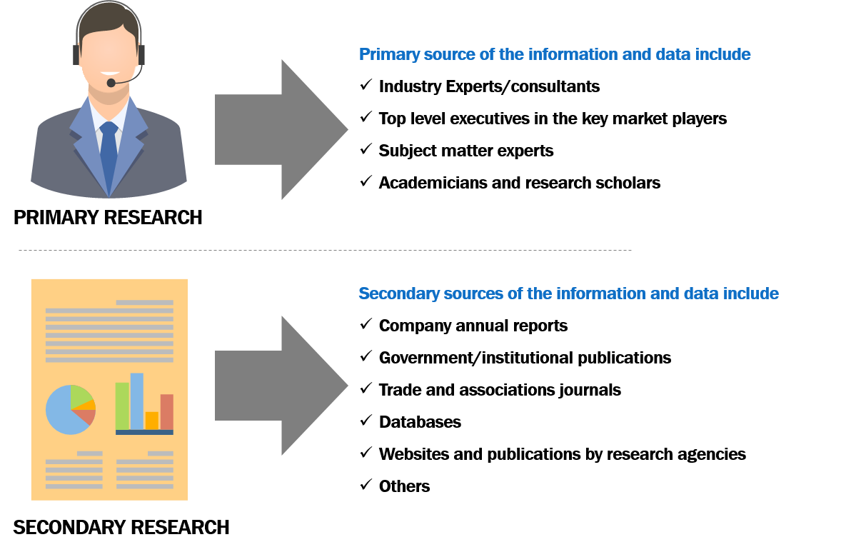

Source: Infinium Global Research Analysis

* + - 1. Primary Research:

Extensive primary research was conducted to gain a deeper insight into the market and the industry’s performance. In this report, we have conducted primary interviews with executives from the leading market players in the market, subject matter experts, suppliers, and distributors. Approximately 20% and 80% of primary interviews have been conducted from the demand and supply sides, respectively. Primary data has been collected through questionnaires, emails, LinkedIn, and telephonic interviews. In the canvassing of primaries, we have strived to cover various departments within organizations, such as sales, operations, and administration, to provide a holistic viewpoint in our report.

We have conducted primary interviews with 10-12 key players from the major countries. The key countries considered for the particular market include - The U.S., Germany, France, China, India, Japan, and among others.

Primary interviews not only help in data validation but also provide critical insights into the market, current business scenario, and future expectations and enhance the quality of our reports. In addition to analyzing the current and historical trends, our analysts predict where the market is headed, over the next five years.

**Primary Sources Considered During This Particular Study:**

Industry Experts/Consultants

Top Level Executives in the Key pesticide residue testing market Players

Subject Matter Experts in the Industry

Academicians and Research Scholars

**Data Points Received Through Primary Research During the Course of Study:**

Market Sizing and Growth Rate (%)

Key Player’s Information

Market Dynamics (Driver, Restraints and Opportunity)

Majorly Used Products and Their Costing in the Market

Product Availability

Regional Scenario

Breakdown of The Profiles of Primaries as Follows:

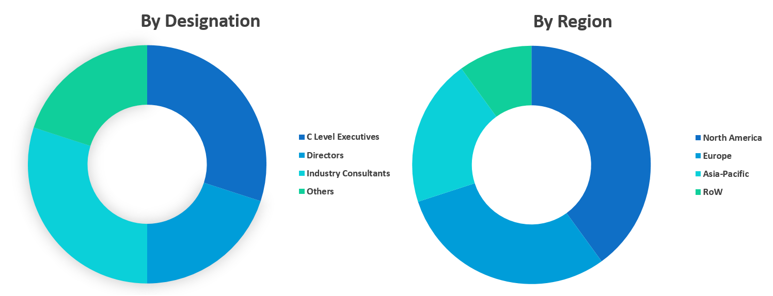

Source: Infinium Global Research Analysis

Primary interviews not only help in data validation but also provide critical insights into the market, current business scenario, and future expectations and enhance the quality of our reports. In addition to analyzing the current and historical trends, our analysts predict where the market is headed, over the next five years.

**Primary Sources Considered During This Particular Study:**

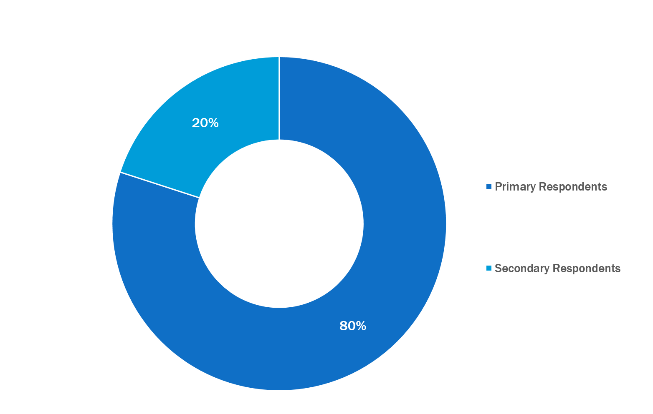

Source: Infinium Global Research Analysis

* + - 1. Secondary Research:

Secondary research was mainly used to collect and identify information useful for extensive, market-oriented, and commercial study of the pesticide residue testing market. It was also used to obtain key information about major players, market classification, and segmentation according to the industry trends, & developments related to the market. For this study, analysts have gathered information from various credible sources, such as annual reports, SEC filings, journals, white papers, corporate presentations, company websites and some paid databases, and many others. Furthermore, internal sources are also used in secondary research such as in-house research reports, sales results, marketing activity, etc.

**The Secondary Sources of the Data Typically Include**

Company Reports and Publications

Government/Institutional Publications

Trade and Associations’ Journals

Databases such as WTO (World Trade Organization), OECD (The Organization for Economic Co-operation and Development), Hoovers, Factiva, and the World Bank, Among Others.

Stockholm International Peace Research Institute

World Bank

United Nations Department of Disarmament Affairs

* 1. Research Approaches

RESEARCH APPROACHES - BOTTOM UP

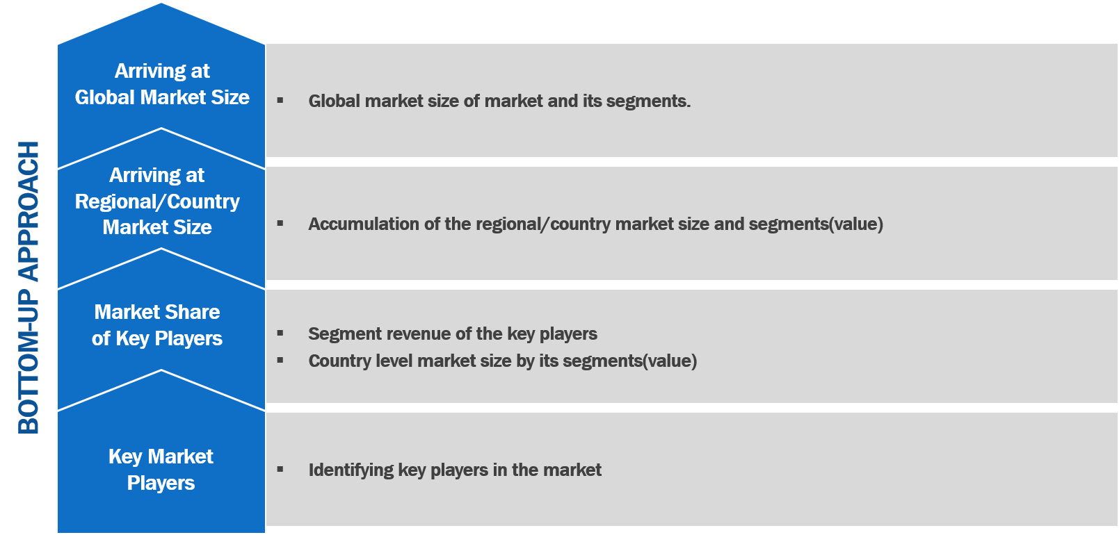

Source: Infinium Global Research Analysis

RESEARCH APPROACHES - TOP-DOWN

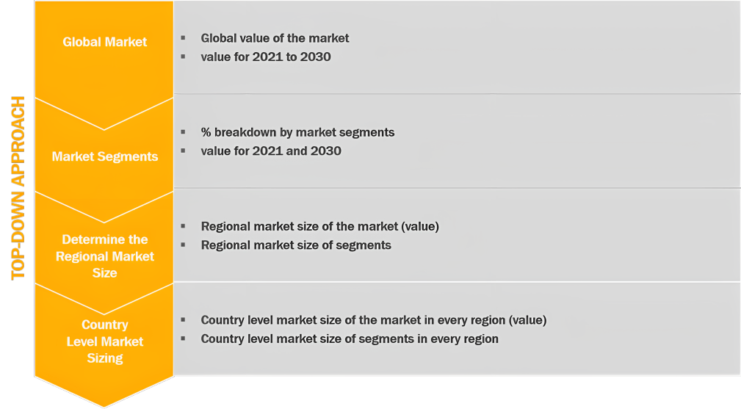

Source: Infinium Global Research Analysis

The market research study on the global pesticide residue testing market provides deep insights into the trends and opportunities in the market for the forecast period 2023 to 2030. Moreover, the market estimates are provided in terms of revenue in USD million. Furthermore, the research covers the analysis of the various segments in the global pesticide residue testing market. The estimates in the global pesticide residue testing market are based on both bottom-up and top-down approaches. In the bottom-up approach, the revenues of the key players are determined and added to arrive at a country or regional market size. The country market sizes are added to arrive at the regional market size. Further, the market size of the regions is added to arrive at the global market size of the pesticide residue testing market.

In the top-down approach, the global market size is estimated based on secondary research and historic data. Using this approach the regional market size is obtained by splitting the global number by the percentage share of each region such as North America, Europe, Asia Pacific, and RoW. The regional market was then divided as per the market share of the type, food tested, and technology.

IGR - RESEARCH METHOD AND DATA TRIANGULATION

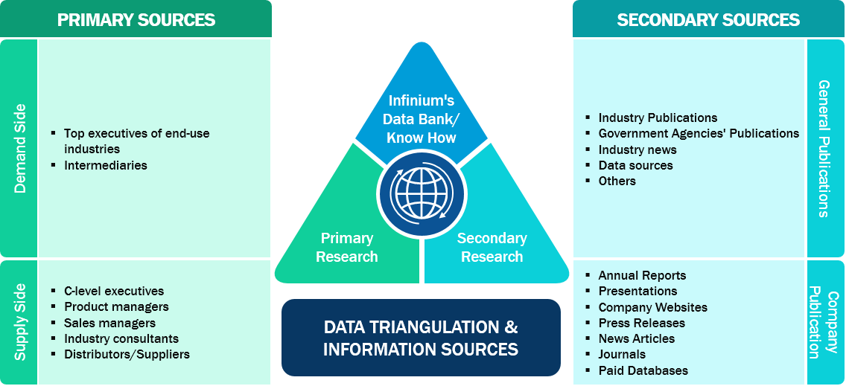

Source: Infinium Global Research Analysis

The market size of the pesticide residue testing market is determined based on the top-down approach. The market size is validated using primary interviews with the participants working with some of the leading players in the pesticide residue testing market. The primary interview participant typically includes managers and CXO-level executives of the leading players in this market. The primary interviews not only help identify the market size of the pesticide residue testing market but also identify the factors that promote the growth in the market and the factors that restrain the growth in this market. The views of primary respondents were reconciled to provide a qualitative analysis of the pesticide residue testing market. The primary respondents also help identify the top 5-10 players and their possible market share in the respective country markets and in the world market. The bottom-up approach is used to validate the global market size of the pesticide residue testing market. With the help of primary interviews and secondary research, the market size of the pesticide residue testing market is determined for each country studied, which then is added to arrive at the regional market size and thereby obtain the global market size. This in turn helps us to validate the market size of the pesticide residue testing market in the world market.

1. Executive Summary
   1. Global Pesticide Residue Testing Market Highlights, (USD Million)

The global pesticide residue testing market is expected to grow at a CAGR of significant between 2023 and 2030 in terms of value. The market for pesticide residue testing is anticipated to expand over the course of the forecast period as a result of rising instances of pesticide residue contamination in crops and increased danger of pesticide residue contamination in livestock feed. Effective pesticide residue testing techniques are necessary for sustainable food production given the expanding worldwide population. The implementation of strict food safety standards, developments in testing technology, and worldwide trade in food supplies are driving the global market for pesticide residue testing. Expanding food trade between emerging markets' borders increases the market's potential for expansion. Food must be tested for pesticide residues due to the rising incidence of food-borne illnesses and the unsanitary and subpar processing facilities in some companies. Pesticide residue testing markets in several developing regions. Numerous developing nations' pesticide residue testing industries are poorly organized, sophisticated, and technologically backward. Due to restricted resources, outdated technology, and inadequate management, many developing nations are likely to lack adequate food control laboratory infrastructure.

GLOBAL PESTICIDE RESIDUE TESTING MARKET HIGHLIGHTS

|  |  |  |
| --- | --- | --- |
| Parameter | 2022 | 2030 |
| Global Pesticide Residue Testing Market | Value: 0 USD million | Value: 0 USD million |
| CAGR (2023-2030) | Value: significant |  |
| Pesticide Residue Testing Market by Type Value (USD Million) | Herbicides: xx  Others: xx | Herbicides: xx  Others: xx |
| Pesticide Residue Testing Market by Food Tested Value (USD Million) | Dairy: xx  Fruits and Vegetables: xx | Dairy: xx  Fruits and Vegetables: xx |
| Pesticide Residue Testing Market by Technology Value (USD Million) | LC-MS/GC-MS: xx  High-performance Liquid Chromatography: xx  Gas Chromatography: xx  Others: xx | LC-MS/GC-MS: xx  High-performance Liquid Chromatography: xx  Gas Chromatography: xx  Others: xx |
| Global Pesticide Residue Testing Market by Region (USD Million) | North America: xx  Europe: xx  Asia Pacific: xx  RoW: xx | North America: xx  Europe: xx  Asia Pacific: xx  RoW: xx |

Source: Infinium Global Research Analysis

The report provides profiles of the companies in the Global pesticide residue testing market such as SGS, Intertek Group plc, Eurofins Scientific SE, Thermo Fisher Scientific Inc., ALS Limited, AsureQuality Limited, Anacon Laboratories, Bureau Veritas, Microbac Laboratories, Inc. and TÜV SÜD.

* 1. Global Pesticide Residue Testing Market Projection

GLOBAL PESTICIDE RESIDUE TESTING MARKET, 2021-2030 (USD MILLION)

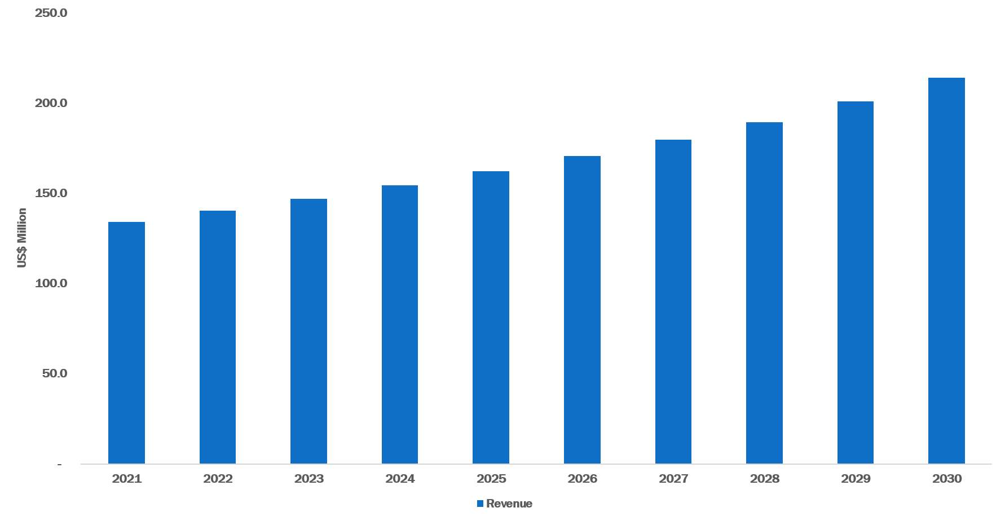

Source: Infinium Global Research Analysis

Content removed from the sample

* 1. Global Pesticide Residue Testing Market CAGR (USD Million) Growth, By Regions

GLOBAL PESTICIDE RESIDUE TESTING MARKET, CAGR (USD MILLION) GROWTH BY REGIONS (2023 - 2030)

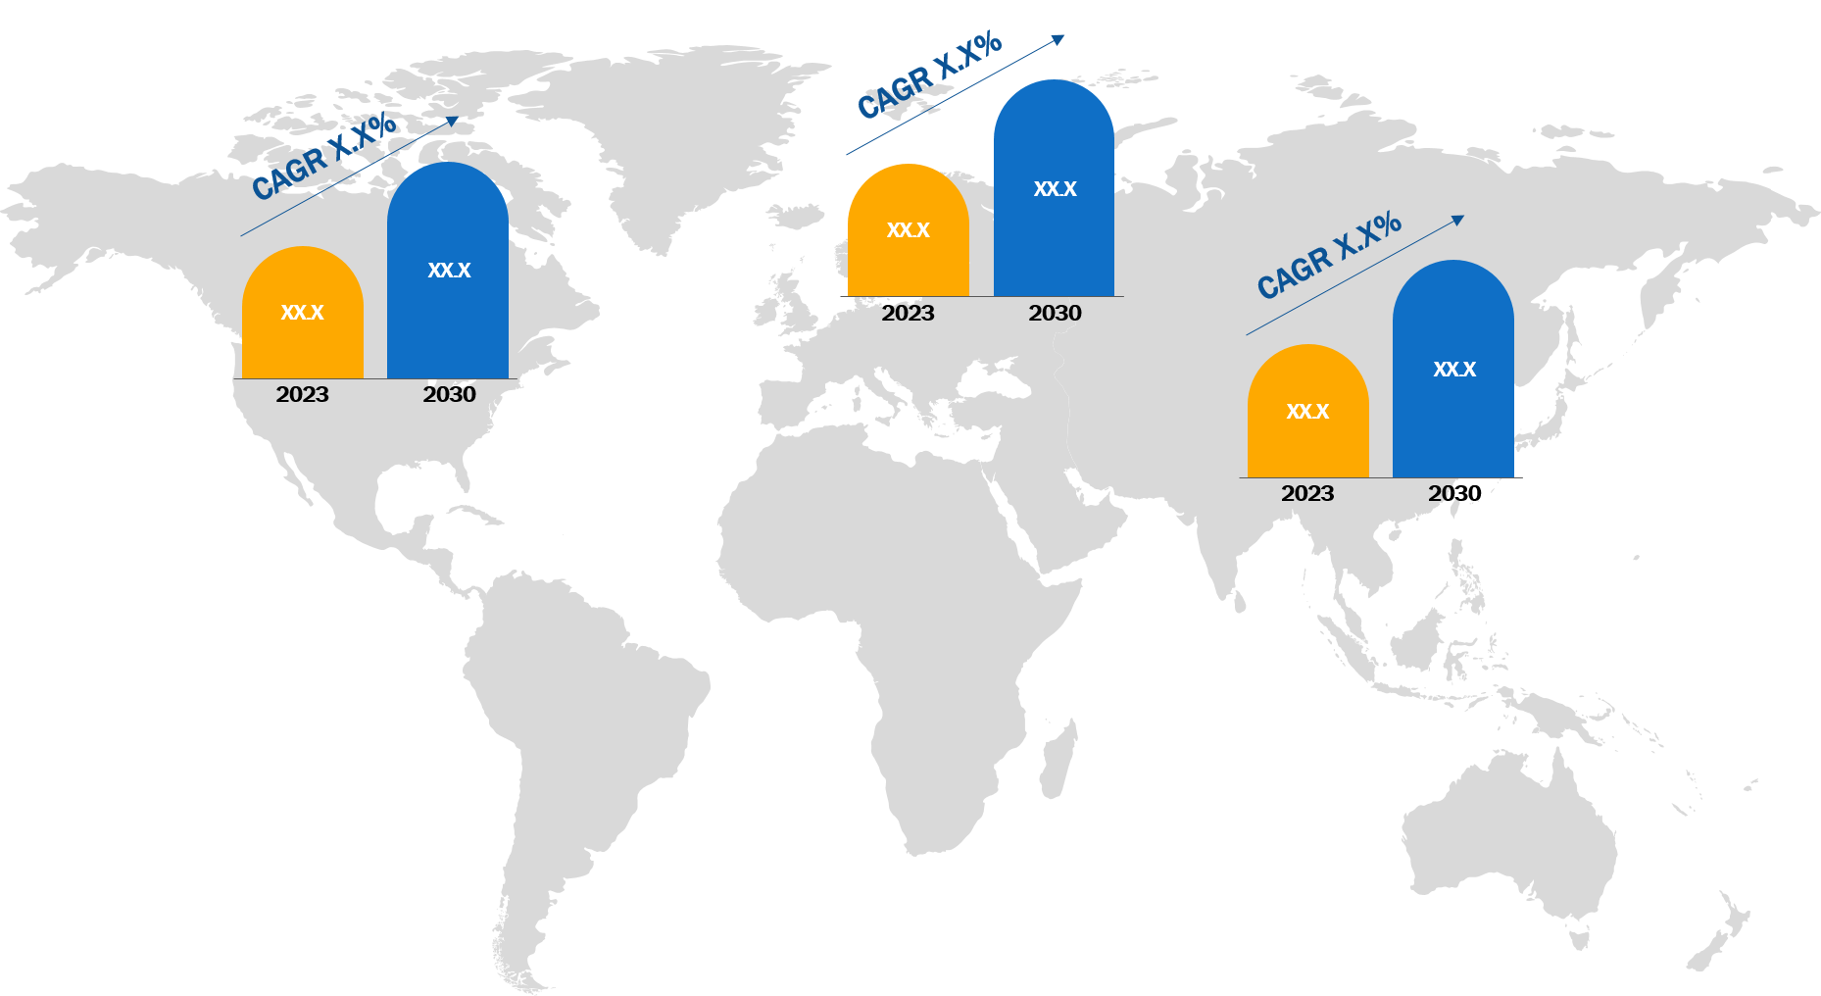

Source: Infinium Global Research Analysis

Content removed from the sample

* 1. Most Lucrative Country Markets, 2023

**This data point includes information on most lucrative country markets in 2023**

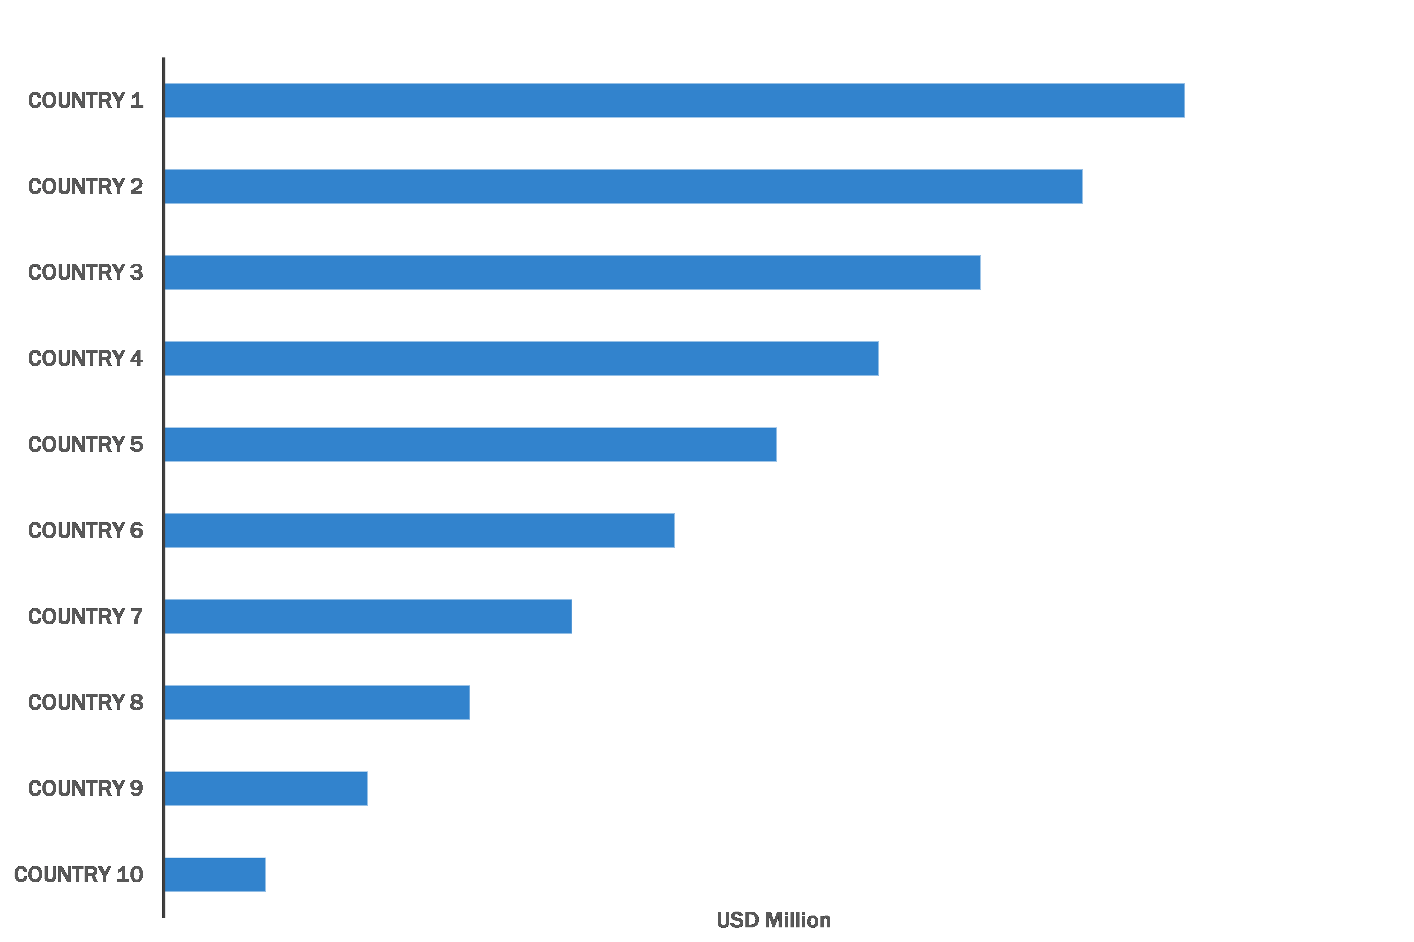

Source: Infinium Global Research Analysis

1. Market Overview & Competitiveness
   1. Introduction

**The introduction includes the overview of the Drivers, Restraint, and Opportunities factors included in the report.**

* 1. DRO Analysis

DRO stands for drivers, restraints, and opportunities. The DRO analysis involves, identifying the factors that are likely to have an impact on the global pesticide residue testing market. It covers an analysis of the short-term and long-term impact of drivers and restraints. Through this analysis, both short-term and long-term opportunities are identified. These opportunities present the investment options and new markets for the market players in the pesticide residue testing market.

Drivers refer to the factors that are expected to drive or boost the market size or demand for pesticide residue testing market. The analysis involves the identification of both demand side and supply side factors that drive the demand as well as environmental factors that favor the market conditions for the growth of pesticide residue testing market both in the short run and long run.

* + 1. Drivers
       1. Increasing demand for at-home and point-of-care testing is influencing the market growth.

Explanation about factor 1 that drives the market and its impact over the period of 2021 to 2030. Here the analysis for 2021 and 2022 presents the historic trends of factor 1 and the analysis for 2023 to 2030 represents the future impact and trends of factor 1 over this period. This is backed by supporting research or data.

* + - 1. Growing prevalence of infectious diseases is driving the market growth.

Explanation about factor 2 that drives the market and its impact over the period of 2021 to 2030. Here the analysis for 2021 and 2022 presents the historic trends of factor 2 and the analysis for 2023 to 2030 represents the future impact and trends of factor 2 over this period. This is backed by supporting research or data.

DRIVERS OF GLOBAL PESTICIDE RESIDUE TESTING MARKET, IMPACT ANALYSIS

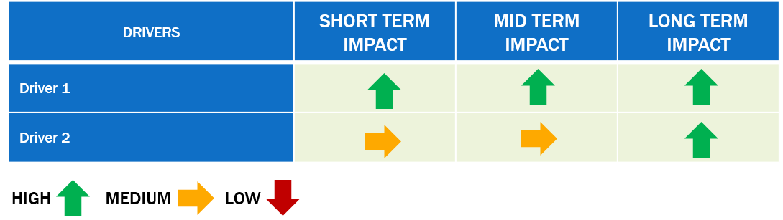

Source: Infinium Global Research Analysis

* + 1. Restraints
       1. Challenges such as regulatory hurdles and concerns about the accuracy and reliability of self-administered tests is expected to hamper the market growth.

Explanation about a restraining factor 1 that restraints the market and its impact over the period of 2021 to 2030. Here the analysis for 2021 and 2022 presents the historic trends of restraining factor 1 and the analysis for 2023 to 2030 represents the future impact and trends of restraining factor 1 over this period. This is backed by supporting research or data.

RESTRAINTS OF GLOBAL PESTICIDE RESIDUE TESTING MARKET, IMPACT ANALYSIS

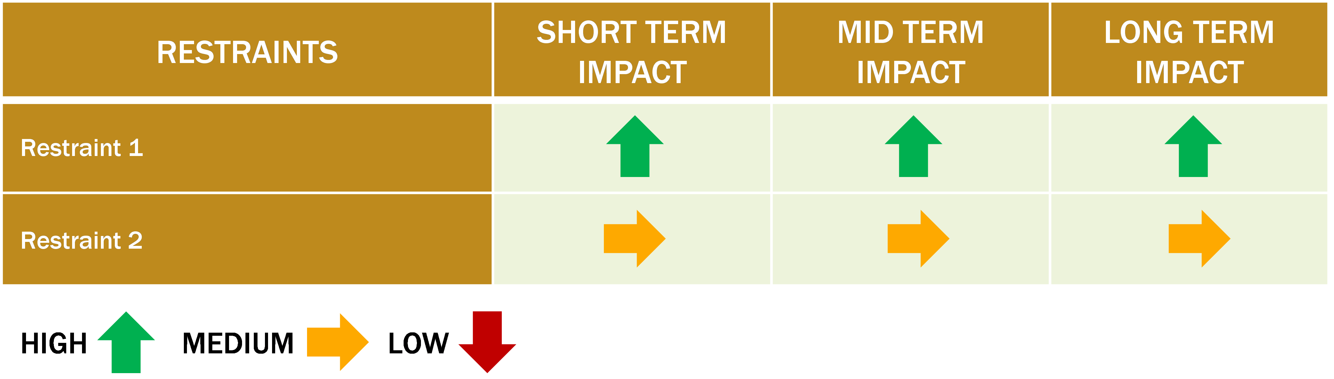

Source: Infinium Global Research Analysis

* + 1. Opportunities
       1. The integration of self-testing lateral flow assays with digital technologies, such as mobile applications and cloud-based data storage, could provide new opportunities for improving test accuracy and data analysis.

Explanation of opportunity factor 1 that provides an opportunity in the market and its impact over the period of 2021 to 2030. Here the analysis for 2021 and 2022 presents the historic trends of restraining factor 1 and the analysis for 2023 to 2030 represents the future impact and trends of opportunity factor 1 over this period. This is backed by supporting research or data.

* 1. Porter's Five Forces Analysis

Porter's five forces analysis provides insights into the competitiveness of the industry using five main factors, known as forces, such as the bargaining power of suppliers, bargaining power of buyers, the threat of substitutes, the threat of new entrants, and industry rivalry. These five forces determine how much competition subsists in a market and accordingly the profitability and attractiveness of this market for a company. An attractive industry will be the one where combined power of the competitive forces will increase profitability in the industry.

PORTER'S FIVE FORCES ANALYSIS

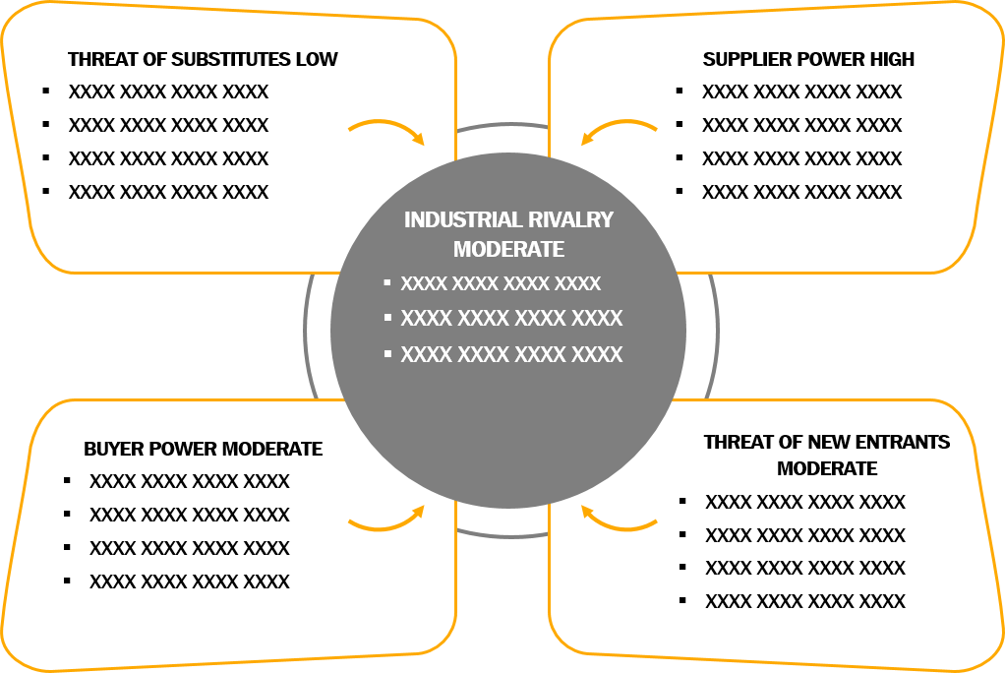

Source: Infinium Global Research Analysis

* 1. IGR- Growth Matrix Analysis

Growth matrix developed by Infinium Global Research, also known as IGR-Growth Matrix helps understand the market situation of the business segments. It helps identify the most attractive segment for the investment purpose and helps the companies to make better decisions in strategy making. The IGR- Growth Matrix presents the zones that define the position of the Type, Food Tested, and Technology segment or region based on the market size, growth anticipated, and the growth factors & historic growth. Following are the zones that IGR- Growth Matrix considers

Risky Zone: Low market size and low growth rate. Investment in this segment is risky

Retention Zone: High market size and low growth rate, the companies operating in this segment should retain their investments in this segment. Companies may focus on extensive marketing and advertisements

Consolidation Zone: High growth rate and high market size, the companies operating in the segments that have the high market size and high growth should focus on consolidating their market position in these segments. Mergers and acquisitions, extensive marketing programs, and new product developments can be used as marketing strategies to consolidate the market in these segments.

Opportunity Zone: High growth low market size

Safe Zone: Moderate growth and moderate market size.

* + 1. IGR-Growth Matrix Analysis by Type

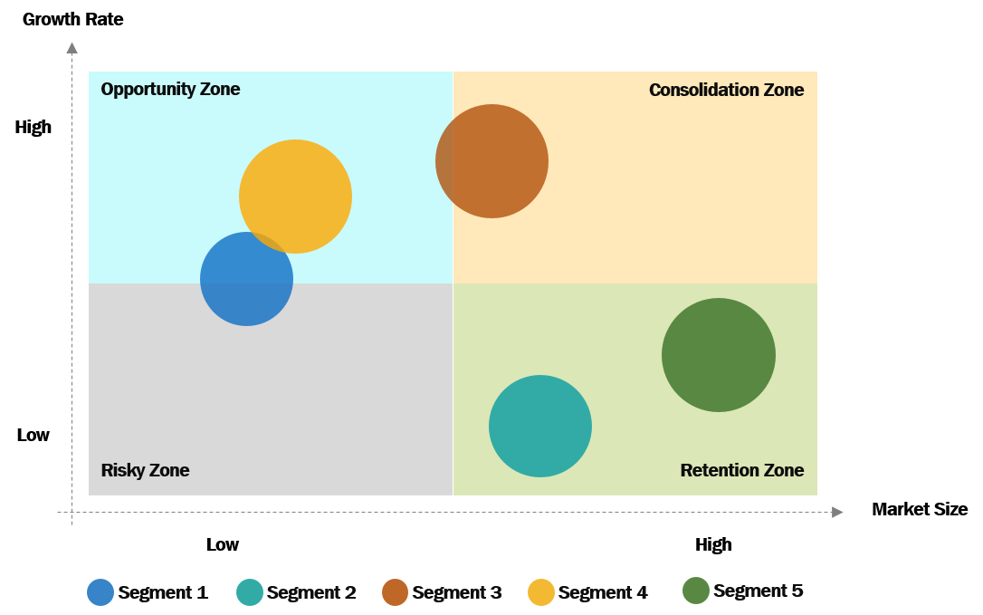

Source: Infinium Global Research Analysis

* + 1. IGR-Growth Matrix Analysis by Food Tested

Same as the preceding point. Full details will be provided in the complete report.

* + 1. IGR-Growth Matrix Analysis by Technology

Same as the preceding point. Full details will be provided in the complete report.

* + 1. IGR-Growth Matrix Analysis by Region

Same as the preceding point. Full details will be provided in the complete report.

* 1. Value Chain Analysis of Pesticide Residue Testing Market

VALUE CHAIN ANALYSIS

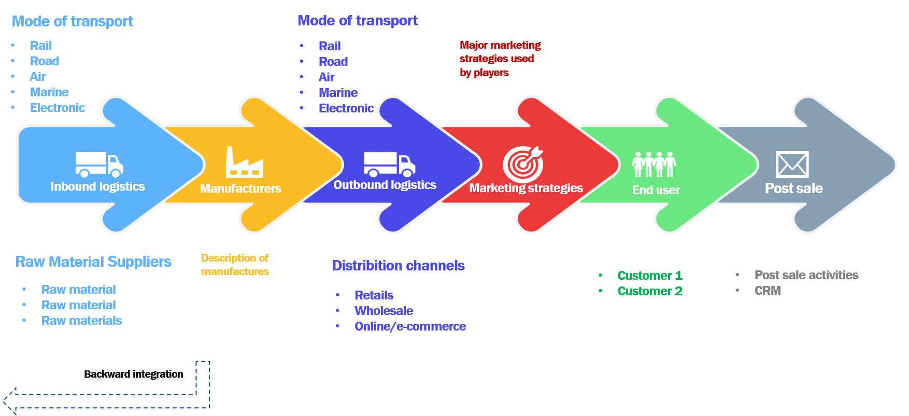

Source: Infinium Global Research Analysis

1. Pesticide Residue Testing Market Macro Indicator Analysis

Macroeconomic indicators are numbers or data readings that depict the state of the economy in a specific nation, area, or industry. Any trader should be aware of macroeconomic indicators because they might have a big impact on market changes. This is why macroeconomic indicators will be used in the majority of fundamental analyses.

1. Global Pesticide Residue Testing Market by Type
   1. Overview

Global Pesticide Residue Testing Market is segmented based on Type as Herbicides, and Others. XX segment leads the segment and is anticipated to dominate in the forecast period.

GLOBAL PESTICIDE RESIDUE TESTING MARKET BY TYPE, 2022 - 2030 (REVENUE % SHARE)

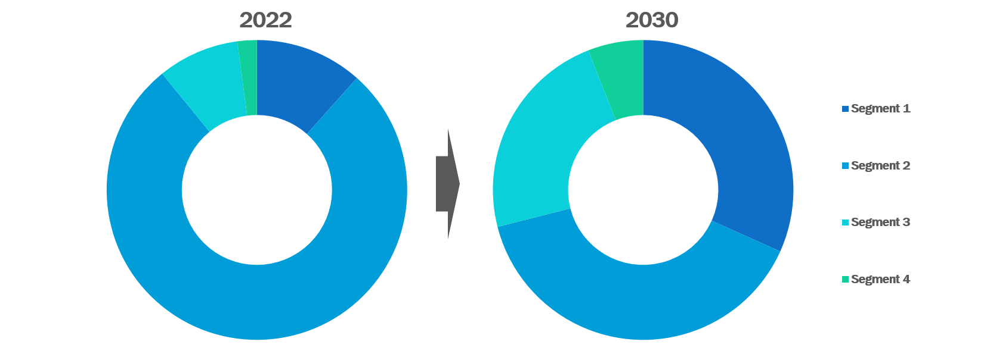

Source: Infinium Global Research Analysis

*Note: The above image is only for sample representation. The actual image differs from the above sample image.

GLOBAL PESTICIDE RESIDUE TESTING MARKET BY TYPE, 2021 - 2030 (USD Million)

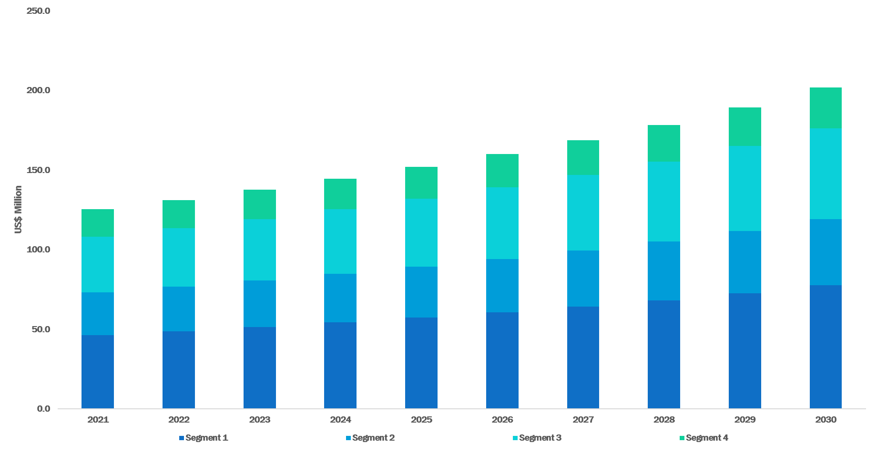

Source: Infinium Global Research Analysis

*Note: The above image is only for sample representation. The actual image differs from the above sample image.

GLOBAL PESTICIDE RESIDUE TESTING MARKET BY TYPE, 2021 - 2030 (USD Million)

|  |  |  |  |  |  |  |  |  |  |  |  |
| --- | --- | --- | --- | --- | --- | --- | --- | --- | --- | --- | --- |
| Type | 2021 | 2022 | 2023 | 2024 | 2025 | 2026 | 2027 | 2028 | 2029 | 2030 | CAGR % |
| Herbicides | XX.X | XX.X | XX.X | XX.X | XX.X | XX.X | XX.X | XX.X | XX.X | XX.X | XX.X |
| Others | XX.X | XX.X | XX.X | XX.X | XX.X | XX.X | XX.X | XX.X | XX.X | XX.X | XX.X |
| Total | XX.X | XX.X | XX.X | XX.X | XX.X | XX.X | XX.X | XX.X | XX.X | XX.X | XX.X |

Source: Infinium Global Research Analysis

Content removed from the sample

* 1. Herbicides

**This Point Includes Herbicides Segment Analysis and Trends.**

GLOBAL PESTICIDE RESIDUE TESTING MARKET BY HERBICIDES BY TYPE, 2021 - 2030 (USD Million)



Source: Infinium Global Research Analysis

GLOBAL PESTICIDE RESIDUE TESTING MARKET BY HERBICIDES BY TYPE, 2021 - 2030 (USD Million)

|  |  |  |  |  |  |  |  |  |  |  |  |
| --- | --- | --- | --- | --- | --- | --- | --- | --- | --- | --- | --- |
| Herbicides | 2021 | 2022 | 2023 | 2024 | 2025 | 2026 | 2027 | 2028 | 2029 | 2030 | CAGR % |
| Pesticides | XX.X | XX.X | XX.X | XX.X | XX.X | XX.X | XX.X | XX.X | XX.X | XX.X | XX.X |
| Total | XX.X | XX.X | XX.X | XX.X | XX.X | XX.X | XX.X | XX.X | XX.X | XX.X | XX.X |

Source: Infinium Global Research Analysis

Content removed from the sample

* + 1. Pesticides

Content removed from the sample

GLOBAL PESTICIDE RESIDUE TESTING MARKET BY PESTICIDES BY HERBICIDES, 2021 - 2030 (USD Million)



Source: Infinium Global Research Analysis

GLOBAL PESTICIDE RESIDUE TESTING MARKET BY PESTICIDES BY HERBICIDES, 2021 - 2030 (USD Million)

|  |  |  |  |  |  |  |  |  |  |  |  |
| --- | --- | --- | --- | --- | --- | --- | --- | --- | --- | --- | --- |
| Pesticides | 2021 | 2022 | 2023 | 2024 | 2025 | 2026 | 2027 | 2028 | 2029 | 2030 | CAGR % |
| Fungicides | XX.X | XX.X | XX.X | XX.X | XX.X | XX.X | XX.X | XX.X | XX.X | XX.X | XX.X |
| Total | XX.X | XX.X | XX.X | XX.X | XX.X | XX.X | XX.X | XX.X | XX.X | XX.X | XX.X |

Source: Infinium Global Research Analysis

Content removed from the sample

* + - 1. Fungicides

Content removed from the sample

GLOBAL PESTICIDE RESIDUE TESTING MARKET BY FUNGICIDES BY REGION, 2021 - 2030 (USD Million)



GLOBAL PESTICIDE RESIDUE TESTING MARKET BY FUNGICIDES BY REGION, 2021 - 2030 (USD Million)

|  |  |  |  |  |  |  |  |  |  |  |  |
| --- | --- | --- | --- | --- | --- | --- | --- | --- | --- | --- | --- |
| Region | 2021 | 2022 | 2023 | 2024 | 2025 | 2026 | 2027 | 2028 | 2029 | 2030 | CAGR % |
| North America | XX.X | XX.X | XX.X | XX.X | XX.X | XX.X | XX.X | XX.X | XX.X | XX.X | XX.X |
| Europe | XX.X | XX.X | XX.X | XX.X | XX.X | XX.X | XX.X | XX.X | XX.X | XX.X | XX.X |
| Asia Pacific | XX.X | XX.X | XX.X | XX.X | XX.X | XX.X | XX.X | XX.X | XX.X | XX.X | XX.X |
| RoW | XX.X | XX.X | XX.X | XX.X | XX.X | XX.X | XX.X | XX.X | XX.X | XX.X | XX.X |
| Total | XX.X | XX.X | XX.X | XX.X | XX.X | XX.X | XX.X | XX.X | XX.X | XX.X | XX.X |

Source: Infinium Global Research Analysis

Content removed from the sample

* 1. Others

**This Point Includes Others Segment Analysis and Trends.**

GLOBAL PESTICIDE RESIDUE TESTING MARKET BY OTHERS BY REGION, 2021 - 2030 (USD Million)



Source: Infinium Global Research Analysis

GLOBAL PESTICIDE RESIDUE TESTING MARKET BY OTHERS BY REGION, 2021 - 2030 (USD Million)

|  |  |  |  |  |  |  |  |  |  |  |  |
| --- | --- | --- | --- | --- | --- | --- | --- | --- | --- | --- | --- |
| Region | 2021 | 2022 | 2023 | 2024 | 2025 | 2026 | 2027 | 2028 | 2029 | 2030 | CAGR % |
| North America | XX.X | XX.X | XX.X | XX.X | XX.X | XX.X | XX.X | XX.X | XX.X | XX.X | XX.X |
| Europe | XX.X | XX.X | XX.X | XX.X | XX.X | XX.X | XX.X | XX.X | XX.X | XX.X | XX.X |
| Asia Pacific | XX.X | XX.X | XX.X | XX.X | XX.X | XX.X | XX.X | XX.X | XX.X | XX.X | XX.X |
| RoW | XX.X | XX.X | XX.X | XX.X | XX.X | XX.X | XX.X | XX.X | XX.X | XX.X | XX.X |
| Total | XX.X | XX.X | XX.X | XX.X | XX.X | XX.X | XX.X | XX.X | XX.X | XX.X | XX.X |

Source: Infinium Global Research Analysis

Content removed from the sample

1. Global Pesticide Residue Testing Market by Food Tested
   1. Overview

Global Pesticide Residue Testing Market is segmented based on Food Tested as Herbicides, and Others. Herbicides, Others, Dairy, and Fruits and Vegetables. XX segment leads the segment and is anticipated to dominate in the forecast period.

GLOBAL PESTICIDE RESIDUE TESTING MARKET BY FOOD TESTED, 2022 - 2030 (REVENUE % SHARE)



Source: Infinium Global Research Analysis

*Note: The above image is only for sample representation. The actual image differs from the above sample image.

GLOBAL PESTICIDE RESIDUE TESTING MARKET BY FOOD TESTED, 2021 - 2030 (USD Million)



Source: Infinium Global Research Analysis

*Note: The above image is only for sample representation. The actual image differs from the above sample image.

GLOBAL PESTICIDE RESIDUE TESTING MARKET BY FOOD TESTED, 2021 - 2030 (USD Million)

|  |  |  |  |  |  |  |  |  |  |  |  |
| --- | --- | --- | --- | --- | --- | --- | --- | --- | --- | --- | --- |
| Food Tested | 2021 | 2022 | 2023 | 2024 | 2025 | 2026 | 2027 | 2028 | 2029 | 2030 | CAGR % |
| Dairy | XX.X | XX.X | XX.X | XX.X | XX.X | XX.X | XX.X | XX.X | XX.X | XX.X | XX.X |
| Fruits And Vegetables | XX.X | XX.X | XX.X | XX.X | XX.X | XX.X | XX.X | XX.X | XX.X | XX.X | XX.X |
| Total | XX.X | XX.X | XX.X | XX.X | XX.X | XX.X | XX.X | XX.X | XX.X | XX.X | XX.X |

Source: Infinium Global Research Analysis

Content removed from the sample

* 1. Dairy

**This Point Includes Dairy Segment Analysis and Trends.**

GLOBAL PESTICIDE RESIDUE TESTING MARKET BY DAIRY BY FOOD TESTED, 2021 - 2030 (USD Million)



Source: Infinium Global Research Analysis

GLOBAL PESTICIDE RESIDUE TESTING MARKET BY DAIRY BY FOOD TESTED, 2021 - 2030 (USD Million)

|  |  |  |  |  |  |  |  |  |  |  |  |
| --- | --- | --- | --- | --- | --- | --- | --- | --- | --- | --- | --- |
| Dairy | 2021 | 2022 | 2023 | 2024 | 2025 | 2026 | 2027 | 2028 | 2029 | 2030 | CAGR % |
| Processed Food | XX.X | XX.X | XX.X | XX.X | XX.X | XX.X | XX.X | XX.X | XX.X | XX.X | XX.X |
| Total | XX.X | XX.X | XX.X | XX.X | XX.X | XX.X | XX.X | XX.X | XX.X | XX.X | XX.X |

Source: Infinium Global Research Analysis

Content removed from the sample

* + 1. Processed Food

Content removed from the sample

GLOBAL PESTICIDE RESIDUE TESTING MARKET BY PROCESSED FOOD BY DAIRY, 2021 - 2030 (USD Million)



Source: Infinium Global Research Analysis

GLOBAL PESTICIDE RESIDUE TESTING MARKET BY PROCESSED FOOD BY DAIRY, 2021 - 2030 (USD Million)

|  |  |  |  |  |  |  |  |  |  |  |  |
| --- | --- | --- | --- | --- | --- | --- | --- | --- | --- | --- | --- |
| Processed Food | 2021 | 2022 | 2023 | 2024 | 2025 | 2026 | 2027 | 2028 | 2029 | 2030 | CAGR % |
| Cereals And Grains | XX.X | XX.X | XX.X | XX.X | XX.X | XX.X | XX.X | XX.X | XX.X | XX.X | XX.X |
| Meat And Poultry | XX.X | XX.X | XX.X | XX.X | XX.X | XX.X | XX.X | XX.X | XX.X | XX.X | XX.X |
| Total | XX.X | XX.X | XX.X | XX.X | XX.X | XX.X | XX.X | XX.X | XX.X | XX.X | XX.X |

Source: Infinium Global Research Analysis

Content removed from the sample

* + - 1. Cereals and Grains

Content removed from the sample

GLOBAL PESTICIDE RESIDUE TESTING MARKET BY CEREALS AND GRAINS BY REGION, 2021 - 2030 (USD Million)



GLOBAL PESTICIDE RESIDUE TESTING MARKET BY CEREALS AND GRAINS BY REGION, 2021 - 2030 (USD Million)

|  |  |  |  |  |  |  |  |  |  |  |  |
| --- | --- | --- | --- | --- | --- | --- | --- | --- | --- | --- | --- |
| Region | 2021 | 2022 | 2023 | 2024 | 2025 | 2026 | 2027 | 2028 | 2029 | 2030 | CAGR % |
| North America | XX.X | XX.X | XX.X | XX.X | XX.X | XX.X | XX.X | XX.X | XX.X | XX.X | XX.X |
| Europe | XX.X | XX.X | XX.X | XX.X | XX.X | XX.X | XX.X | XX.X | XX.X | XX.X | XX.X |
| Asia Pacific | XX.X | XX.X | XX.X | XX.X | XX.X | XX.X | XX.X | XX.X | XX.X | XX.X | XX.X |
| RoW | XX.X | XX.X | XX.X | XX.X | XX.X | XX.X | XX.X | XX.X | XX.X | XX.X | XX.X |
| Total | XX.X | XX.X | XX.X | XX.X | XX.X | XX.X | XX.X | XX.X | XX.X | XX.X | XX.X |

Source: Infinium Global Research Analysis

Content removed from the sample

* + - 1. Meat and Poultry

Same as the preceding segment. Full details will be provided in the complete report.

* 1. Fruits and Vegetables

**This Point Includes Fruits and Vegetables Segment Analysis and Trends.**

GLOBAL PESTICIDE RESIDUE TESTING MARKET BY FRUITS AND VEGETABLES BY REGION, 2021 - 2030 (USD Million)



Source: Infinium Global Research Analysis

GLOBAL PESTICIDE RESIDUE TESTING MARKET BY FRUITS AND VEGETABLES BY REGION, 2021 - 2030 (USD Million)

|  |  |  |  |  |  |  |  |  |  |  |  |
| --- | --- | --- | --- | --- | --- | --- | --- | --- | --- | --- | --- |
| Region | 2021 | 2022 | 2023 | 2024 | 2025 | 2026 | 2027 | 2028 | 2029 | 2030 | CAGR % |
| North America | XX.X | XX.X | XX.X | XX.X | XX.X | XX.X | XX.X | XX.X | XX.X | XX.X | XX.X |
| Europe | XX.X | XX.X | XX.X | XX.X | XX.X | XX.X | XX.X | XX.X | XX.X | XX.X | XX.X |
| Asia Pacific | XX.X | XX.X | XX.X | XX.X | XX.X | XX.X | XX.X | XX.X | XX.X | XX.X | XX.X |
| RoW | XX.X | XX.X | XX.X | XX.X | XX.X | XX.X | XX.X | XX.X | XX.X | XX.X | XX.X |
| Total | XX.X | XX.X | XX.X | XX.X | XX.X | XX.X | XX.X | XX.X | XX.X | XX.X | XX.X |

Source: Infinium Global Research Analysis

Content removed from the sample

1. Global Pesticide Residue Testing Market by Technology
   1. Overview

Global Pesticide Residue Testing Market is segmented based on Technology as Herbicides, and Others. Herbicides, Others, Dairy, and Fruits and Vegetables. Herbicides, Others, Dairy, Fruits and Vegetables, LC-MS/GC-MS, High-performance Liquid Chromatography, Gas Chromatography, and Others. XX segment leads the segment and is anticipated to dominate in the forecast period.

GLOBAL PESTICIDE RESIDUE TESTING MARKET BY TECHNOLOGY, 2022 - 2030 (REVENUE % SHARE)



Source: Infinium Global Research Analysis

*Note: The above image is only for sample representation. The actual image differs from the above sample image.

GLOBAL PESTICIDE RESIDUE TESTING MARKET BY TECHNOLOGY, 2021 - 2030 (USD Million)



Source: Infinium Global Research Analysis

*Note: The above image is only for sample representation. The actual image differs from the above sample image.

GLOBAL PESTICIDE RESIDUE TESTING MARKET BY TECHNOLOGY, 2021 - 2030 (USD Million)

|  |  |  |  |  |  |  |  |  |  |  |  |
| --- | --- | --- | --- | --- | --- | --- | --- | --- | --- | --- | --- |
| Technology | 2021 | 2022 | 2023 | 2024 | 2025 | 2026 | 2027 | 2028 | 2029 | 2030 | CAGR % |
| LC-MS/GC-MS | XX.X | XX.X | XX.X | XX.X | XX.X | XX.X | XX.X | XX.X | XX.X | XX.X | XX.X |
| High-performance Liquid Chromatography | XX.X | XX.X | XX.X | XX.X | XX.X | XX.X | XX.X | XX.X | XX.X | XX.X | XX.X |
| Gas Chromatography | XX.X | XX.X | XX.X | XX.X | XX.X | XX.X | XX.X | XX.X | XX.X | XX.X | XX.X |
| Others | XX.X | XX.X | XX.X | XX.X | XX.X | XX.X | XX.X | XX.X | XX.X | XX.X | XX.X |
| Total | XX.X | XX.X | XX.X | XX.X | XX.X | XX.X | XX.X | XX.X | XX.X | XX.X | XX.X |

Source: Infinium Global Research Analysis

Content removed from the sample

* 1. LC-MS/GC-MS

**This Point Includes LC-MS/GC-MS Segment Analysis and Trends.**

GLOBAL PESTICIDE RESIDUE TESTING MARKET BY LC-MS/GC-MS BY REGION, 2021 - 2030 (USD Million)



Source: Infinium Global Research Analysis

GLOBAL PESTICIDE RESIDUE TESTING MARKET BY LC-MS/GC-MS BY REGION, 2021 - 2030 (USD Million)

|  |  |  |  |  |  |  |  |  |  |  |  |
| --- | --- | --- | --- | --- | --- | --- | --- | --- | --- | --- | --- |
| Region | 2021 | 2022 | 2023 | 2024 | 2025 | 2026 | 2027 | 2028 | 2029 | 2030 | CAGR % |
| North America | XX.X | XX.X | XX.X | XX.X | XX.X | XX.X | XX.X | XX.X | XX.X | XX.X | XX.X |
| Europe | XX.X | XX.X | XX.X | XX.X | XX.X | XX.X | XX.X | XX.X | XX.X | XX.X | XX.X |
| Asia Pacific | XX.X | XX.X | XX.X | XX.X | XX.X | XX.X | XX.X | XX.X | XX.X | XX.X | XX.X |
| RoW | XX.X | XX.X | XX.X | XX.X | XX.X | XX.X | XX.X | XX.X | XX.X | XX.X | XX.X |
| Total | XX.X | XX.X | XX.X | XX.X | XX.X | XX.X | XX.X | XX.X | XX.X | XX.X | XX.X |

Source: Infinium Global Research Analysis

Content removed from the sample

* 1. High-performance Liquid Chromatography

**This Point Includes High-performance Liquid Chromatography Segment Analysis and Trends.**

GLOBAL PESTICIDE RESIDUE TESTING MARKET BY HIGH-PERFORMANCE LIQUID CHROMATOGRAPHY BY REGION, 2021 - 2030 (USD Million)



Source: Infinium Global Research Analysis

GLOBAL PESTICIDE RESIDUE TESTING MARKET BY HIGH-PERFORMANCE LIQUID CHROMATOGRAPHY BY REGION, 2021 - 2030 (USD Million)

|  |  |  |  |  |  |  |  |  |  |  |  |
| --- | --- | --- | --- | --- | --- | --- | --- | --- | --- | --- | --- |
| Region | 2021 | 2022 | 2023 | 2024 | 2025 | 2026 | 2027 | 2028 | 2029 | 2030 | CAGR % |
| North America | XX.X | XX.X | XX.X | XX.X | XX.X | XX.X | XX.X | XX.X | XX.X | XX.X | XX.X |
| Europe | XX.X | XX.X | XX.X | XX.X | XX.X | XX.X | XX.X | XX.X | XX.X | XX.X | XX.X |
| Asia Pacific | XX.X | XX.X | XX.X | XX.X | XX.X | XX.X | XX.X | XX.X | XX.X | XX.X | XX.X |
| RoW | XX.X | XX.X | XX.X | XX.X | XX.X | XX.X | XX.X | XX.X | XX.X | XX.X | XX.X |
| Total | XX.X | XX.X | XX.X | XX.X | XX.X | XX.X | XX.X | XX.X | XX.X | XX.X | XX.X |

Source: Infinium Global Research Analysis

Content removed from the sample

* 1. Gas Chromatography

**This Point Includes Gas Chromatography Segment Analysis and Trends.**

GLOBAL PESTICIDE RESIDUE TESTING MARKET BY GAS CHROMATOGRAPHY BY REGION, 2021 - 2030 (USD Million)



Source: Infinium Global Research Analysis

GLOBAL PESTICIDE RESIDUE TESTING MARKET BY GAS CHROMATOGRAPHY BY REGION, 2021 - 2030 (USD Million)

|  |  |  |  |  |  |  |  |  |  |  |  |
| --- | --- | --- | --- | --- | --- | --- | --- | --- | --- | --- | --- |
| Region | 2021 | 2022 | 2023 | 2024 | 2025 | 2026 | 2027 | 2028 | 2029 | 2030 | CAGR % |
| North America | XX.X | XX.X | XX.X | XX.X | XX.X | XX.X | XX.X | XX.X | XX.X | XX.X | XX.X |
| Europe | XX.X | XX.X | XX.X | XX.X | XX.X | XX.X | XX.X | XX.X | XX.X | XX.X | XX.X |
| Asia Pacific | XX.X | XX.X | XX.X | XX.X | XX.X | XX.X | XX.X | XX.X | XX.X | XX.X | XX.X |
| RoW | XX.X | XX.X | XX.X | XX.X | XX.X | XX.X | XX.X | XX.X | XX.X | XX.X | XX.X |
| Total | XX.X | XX.X | XX.X | XX.X | XX.X | XX.X | XX.X | XX.X | XX.X | XX.X | XX.X |

Source: Infinium Global Research Analysis

Content removed from the sample

* 1. Others

**This Point Includes Others Segment Analysis and Trends.**

GLOBAL PESTICIDE RESIDUE TESTING MARKET BY OTHERS BY REGION, 2021 - 2030 (USD Million)



Source: Infinium Global Research Analysis

GLOBAL PESTICIDE RESIDUE TESTING MARKET BY OTHERS BY REGION, 2021 - 2030 (USD Million)

|  |  |  |  |  |  |  |  |  |  |  |  |
| --- | --- | --- | --- | --- | --- | --- | --- | --- | --- | --- | --- |
| Region | 2021 | 2022 | 2023 | 2024 | 2025 | 2026 | 2027 | 2028 | 2029 | 2030 | CAGR % |
| North America | XX.X | XX.X | XX.X | XX.X | XX.X | XX.X | XX.X | XX.X | XX.X | XX.X | XX.X |
| Europe | XX.X | XX.X | XX.X | XX.X | XX.X | XX.X | XX.X | XX.X | XX.X | XX.X | XX.X |
| Asia Pacific | XX.X | XX.X | XX.X | XX.X | XX.X | XX.X | XX.X | XX.X | XX.X | XX.X | XX.X |
| RoW | XX.X | XX.X | XX.X | XX.X | XX.X | XX.X | XX.X | XX.X | XX.X | XX.X | XX.X |
| Total | XX.X | XX.X | XX.X | XX.X | XX.X | XX.X | XX.X | XX.X | XX.X | XX.X | XX.X |

Source: Infinium Global Research Analysis

Content removed from the sample

1. Global Pesticide Residue Testing Market, by Region
   1. Overview

The United States leads the growth market in North America due to innovative industries and expanding R&D activities for providing product types like devices, reagents & kits, and other services. Europe dominates the growth of the market during the forecast period. Germany is also expected to experience a promising growth rate during the forecast period due to the increasing use of reagents and kits. Due to technological advancements, food testing innovation, expanding regional consumption, and a changing lifestyle, China is predicted to lead the market in the Asia-Pacific area.

GLOBAL PESTICIDE RESIDUE TESTING MARKET BY REGION, 2022 - 2030(REVENUE % SHARE)

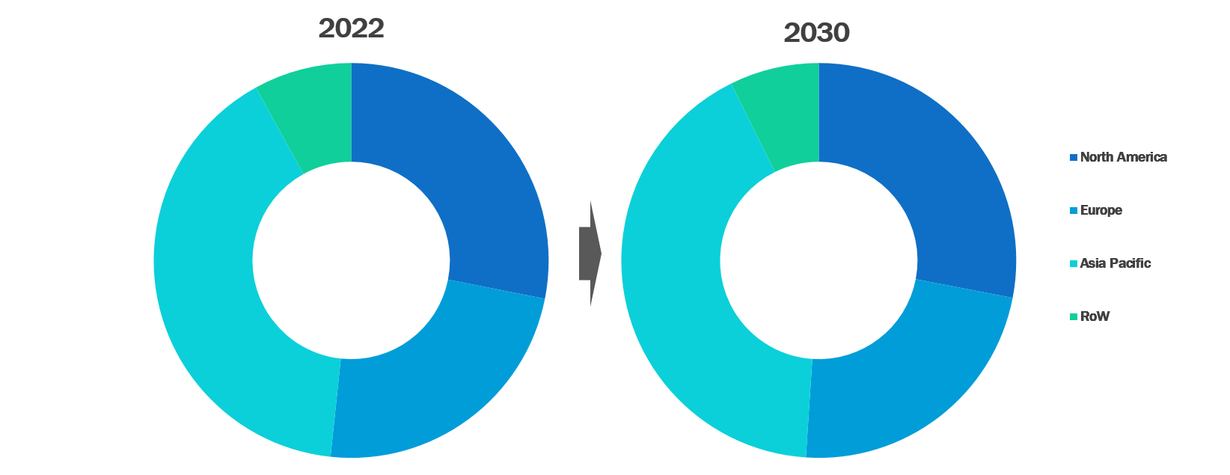

Source: Infinium Global Research Analysis

*Note: The above image is only for sample representation. The actual image differs from the above sample image.

GLOBAL PESTICIDE RESIDUE TESTING MARKET BY REGION, 2021 - 2030 (USD MILLION)

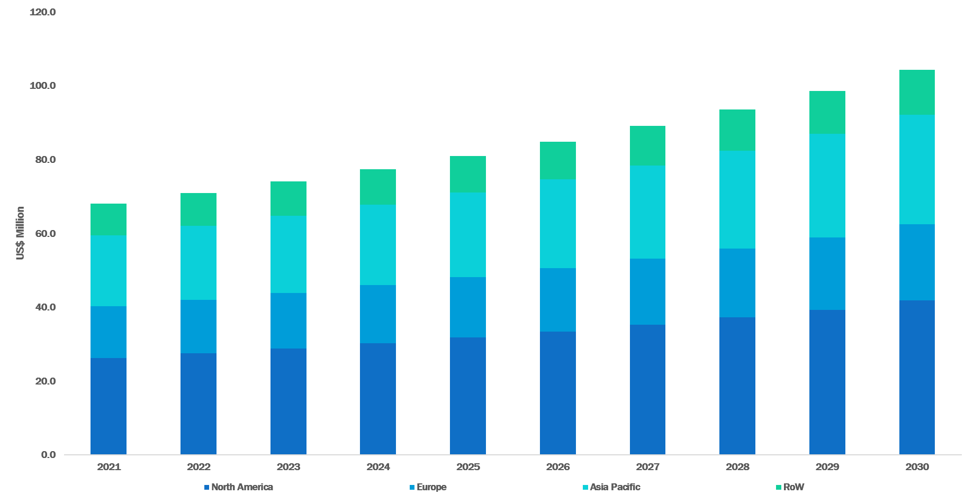

GLOBAL PESTICIDE RESIDUE TESTING MARKET BY REGION, 2021 - 2030 (USD Million)

|  |  |  |  |  |  |  |  |  |  |  |  |
| --- | --- | --- | --- | --- | --- | --- | --- | --- | --- | --- | --- |
| Region | 2021 | 2022 | 2023 | 2024 | 2025 | 2026 | 2027 | 2028 | 2029 | 2030 | CAGR % |
| North America | XX.X | XX.X | XX.X | XX.X | XX.X | XX.X | XX.X | XX.X | XX.X | XX.X | XX.X |
| Europe | XX.X | XX.X | XX.X | XX.X | XX.X | XX.X | XX.X | XX.X | XX.X | XX.X | XX.X |
| Asia Pacific | XX.X | XX.X | XX.X | XX.X | XX.X | XX.X | XX.X | XX.X | XX.X | XX.X | XX.X |
| RoW | XX.X | XX.X | XX.X | XX.X | XX.X | XX.X | XX.X | XX.X | XX.X | XX.X | XX.X |
| Total | XX.X | XX.X | XX.X | XX.X | XX.X | XX.X | XX.X | XX.X | XX.X | XX.X | XX.X |

Source: Infinium Global Research Analysis

Content removed from the sample

* 1. North America Pesticide Residue Testing Market
     1. North America Pesticide Residue Testing Market by Type

NORTH AMERICA PESTICIDE RESIDUE TESTING MARKET BY TYPE 2021 - 2030 (USD Million)



Source: Infinium Global Research Analysis

*Note: The above image is only for sample representation. The actual image differs from the above sample image.

NORTH AMERICA PESTICIDE RESIDUE TESTING MARKET BY TYPE 2021 - 2030 (USD Million)

|  |  |  |  |  |  |  |  |  |  |  |  |
| --- | --- | --- | --- | --- | --- | --- | --- | --- | --- | --- | --- |
| Type | 2021 | 2022 | 2023 | 2024 | 2025 | 2026 | 2027 | 2028 | 2029 | 2030 | CAGR % |
| Herbicides | XX.X | XX.X | XX.X | XX.X | XX.X | XX.X | XX.X | XX.X | XX.X | XX.X | XX.X |
| Others | XX.X | XX.X | XX.X | XX.X | XX.X | XX.X | XX.X | XX.X | XX.X | XX.X | XX.X |
| Total | XX.X | XX.X | XX.X | XX.X | XX.X | XX.X | XX.X | XX.X | XX.X | XX.X | XX.X |

Source: Infinium Global Research Analysis

Content removed from the sample

* + 1. North America Pesticide Residue Testing Market by Food Tested

NORTH AMERICA PESTICIDE RESIDUE TESTING MARKET BY FOOD TESTED 2021 - 2030 (USD Million)



Source: Infinium Global Research Analysis

*Note: The above image is only for sample representation. The actual image differs from the above sample image.

NORTH AMERICA PESTICIDE RESIDUE TESTING MARKET BY FOOD TESTED 2021 - 2030 (USD Million)

|  |  |  |  |  |  |  |  |  |  |  |  |
| --- | --- | --- | --- | --- | --- | --- | --- | --- | --- | --- | --- |
| Food Tested | 2021 | 2022 | 2023 | 2024 | 2025 | 2026 | 2027 | 2028 | 2029 | 2030 | CAGR % |
| Dairy | XX.X | XX.X | XX.X | XX.X | XX.X | XX.X | XX.X | XX.X | XX.X | XX.X | XX.X |
| Fruits And Vegetables | XX.X | XX.X | XX.X | XX.X | XX.X | XX.X | XX.X | XX.X | XX.X | XX.X | XX.X |
| Total | XX.X | XX.X | XX.X | XX.X | XX.X | XX.X | XX.X | XX.X | XX.X | XX.X | XX.X |

Source: Infinium Global Research Analysis

Content removed from the sample

* + 1. North America Pesticide Residue Testing Market by Technology

NORTH AMERICA PESTICIDE RESIDUE TESTING MARKET BY TECHNOLOGY 2021 - 2030 (USD Million)



Source: Infinium Global Research Analysis

*Note: The above image is only for sample representation. The actual image differs from the above sample image.

NORTH AMERICA PESTICIDE RESIDUE TESTING MARKET BY TECHNOLOGY 2021 - 2030 (USD Million)

|  |  |  |  |  |  |  |  |  |  |  |  |
| --- | --- | --- | --- | --- | --- | --- | --- | --- | --- | --- | --- |
| Technology | 2021 | 2022 | 2023 | 2024 | 2025 | 2026 | 2027 | 2028 | 2029 | 2030 | CAGR % |
| LC-MS/GC-MS | XX.X | XX.X | XX.X | XX.X | XX.X | XX.X | XX.X | XX.X | XX.X | XX.X | XX.X |
| High-performance Liquid Chromatography | XX.X | XX.X | XX.X | XX.X | XX.X | XX.X | XX.X | XX.X | XX.X | XX.X | XX.X |
| Gas Chromatography | XX.X | XX.X | XX.X | XX.X | XX.X | XX.X | XX.X | XX.X | XX.X | XX.X | XX.X |
| Others | XX.X | XX.X | XX.X | XX.X | XX.X | XX.X | XX.X | XX.X | XX.X | XX.X | XX.X |
| Total | XX.X | XX.X | XX.X | XX.X | XX.X | XX.X | XX.X | XX.X | XX.X | XX.X | XX.X |

Source: Infinium Global Research Analysis

Content removed from the sample

* + 1. North America Pesticide Residue Testing Market, by Country

NORTH AMERICA PESTICIDE RESIDUE TESTING MARKET, BY COUNTRY 2021 - 2030 (USD Million)

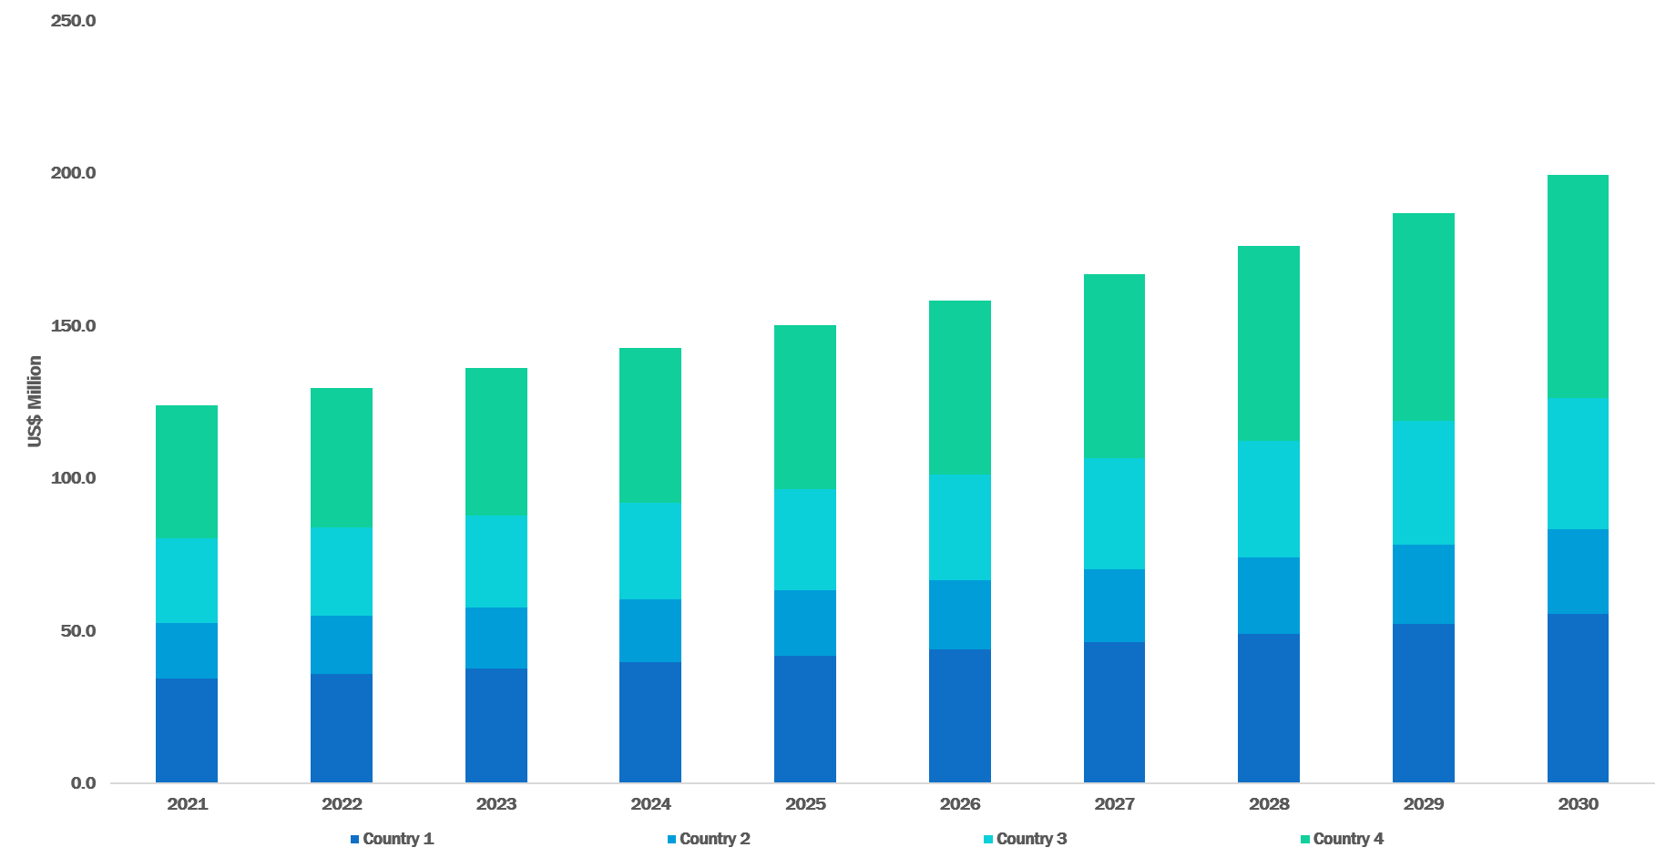

Source: Infinium Global Research Analysis

NORTH AMERICA PESTICIDE RESIDUE TESTING MARKET, BY COUNTRY 2021 - 2030 (USD Million)

|  |  |  |  |  |  |  |  |  |  |  |  |
| --- | --- | --- | --- | --- | --- | --- | --- | --- | --- | --- | --- |
| Country | 2021 | 2022 | 2023 | 2024 | 2025 | 2026 | 2027 | 2028 | 2029 | 2030 | CAGR % |
| The U.S. | XX.X | XX.X | XX.X | XX.X | XX.X | XX.X | XX.X | XX.X | XX.X | XX.X | XX.X |
| Canada | XX.X | XX.X | XX.X | XX.X | XX.X | XX.X | XX.X | XX.X | XX.X | XX.X | XX.X |
| Mexico | XX.X | XX.X | XX.X | XX.X | XX.X | XX.X | XX.X | XX.X | XX.X | XX.X | XX.X |
| Total | XX.X | XX.X | XX.X | XX.X | XX.X | XX.X | XX.X | XX.X | XX.X | XX.X | XX.X |

Source: Infinium Global Research Analysis

Content removed from the sample

* + - 1. The U.S.
         1. The U.S. Pesticide Residue Testing Market, by Type

THE U.S. PESTICIDE RESIDUE TESTING MARKET, BY TYPE 2021 - 2030 (USD Million)



Source: Infinium Global Research Analysis

*Note: The above image is only for sample representation. The actual image differs from the above sample image.

THE U.S. PESTICIDE RESIDUE TESTING MARKET, BY TYPE 2021 - 2030 (USD Million)

|  |  |  |  |  |  |  |  |  |  |  |  |
| --- | --- | --- | --- | --- | --- | --- | --- | --- | --- | --- | --- |
| Type | 2021 | 2022 | 2023 | 2024 | 2025 | 2026 | 2027 | 2028 | 2029 | 2030 | CAGR % |
| Herbicides | XX.X | XX.X | XX.X | XX.X | XX.X | XX.X | XX.X | XX.X | XX.X | XX.X | XX.X |
| Others | XX.X | XX.X | XX.X | XX.X | XX.X | XX.X | XX.X | XX.X | XX.X | XX.X | XX.X |
| Total | XX.X | XX.X | XX.X | XX.X | XX.X | XX.X | XX.X | XX.X | XX.X | XX.X | XX.X |

Source: Infinium Global Research Analysis

Content removed from the sample

* + - * 1. The U.S. Pesticide Residue Testing Market, by Food Tested

THE U.S. PESTICIDE RESIDUE TESTING MARKET, BY FOOD TESTED 2021 - 2030 (USD Million)



Source: Infinium Global Research Analysis

*Note: The above image is only for sample representation. The actual image differs from the above sample image.

THE U.S. PESTICIDE RESIDUE TESTING MARKET, BY FOOD TESTED 2021 - 2030 (USD Million)

|  |  |  |  |  |  |  |  |  |  |  |  |
| --- | --- | --- | --- | --- | --- | --- | --- | --- | --- | --- | --- |
| Food Tested | 2021 | 2022 | 2023 | 2024 | 2025 | 2026 | 2027 | 2028 | 2029 | 2030 | CAGR % |
| Dairy | XX.X | XX.X | XX.X | XX.X | XX.X | XX.X | XX.X | XX.X | XX.X | XX.X | XX.X |
| Fruits And Vegetables | XX.X | XX.X | XX.X | XX.X | XX.X | XX.X | XX.X | XX.X | XX.X | XX.X | XX.X |
| Total | XX.X | XX.X | XX.X | XX.X | XX.X | XX.X | XX.X | XX.X | XX.X | XX.X | XX.X |

Source: Infinium Global Research Analysis

Content removed from the sample

* + - * 1. The U.S. Pesticide Residue Testing Market, by Technology

THE U.S. PESTICIDE RESIDUE TESTING MARKET, BY TECHNOLOGY 2021 - 2030 (USD Million)



Source: Infinium Global Research Analysis

*Note: The above image is only for sample representation. The actual image differs from the above sample image.

THE U.S. PESTICIDE RESIDUE TESTING MARKET, BY TECHNOLOGY 2021 - 2030 (USD Million)

|  |  |  |  |  |  |  |  |  |  |  |  |
| --- | --- | --- | --- | --- | --- | --- | --- | --- | --- | --- | --- |
| Technology | 2021 | 2022 | 2023 | 2024 | 2025 | 2026 | 2027 | 2028 | 2029 | 2030 | CAGR % |
| LC-MS/GC-MS | XX.X | XX.X | XX.X | XX.X | XX.X | XX.X | XX.X | XX.X | XX.X | XX.X | XX.X |
| High-performance Liquid Chromatography | XX.X | XX.X | XX.X | XX.X | XX.X | XX.X | XX.X | XX.X | XX.X | XX.X | XX.X |
| Gas Chromatography | XX.X | XX.X | XX.X | XX.X | XX.X | XX.X | XX.X | XX.X | XX.X | XX.X | XX.X |
| Others | XX.X | XX.X | XX.X | XX.X | XX.X | XX.X | XX.X | XX.X | XX.X | XX.X | XX.X |
| Total | XX.X | XX.X | XX.X | XX.X | XX.X | XX.X | XX.X | XX.X | XX.X | XX.X | XX.X |

Source: Infinium Global Research Analysis

Content removed from the sample

* + - 1. Canada

Same as that of the preceding country. Full details will be provided in the complete report.

* + - 1. Mexico

Same as that of the preceding country. Full details will be provided in the complete report.

* 1. Europe Pesticide Residue Testing Market

Same as that of the preceding region. Full details will be provided in the complete report.

* 1. Asia Pacific Pesticide Residue Testing Market

Same as that of the preceding region. Full details will be provided in the complete report.

* 1. RoW Pesticide Residue Testing Market

Same as that of the preceding region. Full details will be provided in the complete report.

1. Company Profiles and Competitive Landscape
   1. Competitive Landscape in the Pesticide Residue Testing Market



Source: Infinium Global Research Analysis

Content removed from the sample

* 1. Companies Profiles
     1. Sgs
        1. Overview

Content removed from the sample

* + - 1. Company Snapshot

Add Company Snapshot Image of Sgs

Source: Infinium Global Research Analysis

* + - 1. Financial Snapshot



Source: Infinium Global Research Analysis

* + - 1. Product Portfolio

Content removed from the sample

* + - 1. Recent Developments



Source: Infinium Global Research Analysis

* + 1. Intertek Group plc
    2. Eurofins Scientific SE
    3. Thermo Fisher Scientific Inc.
    4. ALS Limited
    5. AsureQuality Limited
    6. Anacon Laboratories
    7. Bureau Veritas
    8. Microbac Laboratories, Inc.
    9. TÜV SÜD

(N.B.: Names of companies profiled in the report. Final report will contain the details of each company same as that of the above referenced)