SOFTWARE REQUIREMENTS
SPECIFICATION (SRS)
for
SNAKE GAME

Version: 1.0
Status: Draft for Review
Prepared by: Charan, Vrunda, Ved and Tushar
Course: Software Engineering Mini-Project
Department of Computer Science and Engineering
PES University, Bengaluru
Technology: C++ and SFML
Date: 12 October 2026

Document Control

Revision History
Version | Date | Author(s) | Change Summary | Approval
1.0 | 12-10-2026 | Project team | Initial project SRS | Pending

Approvals
Role | Name | Signature / Email | Date
Project guide | Adithya | [To be completed] | [To be completed]
Team representative | Vrunda | [To be completed] | [To be completed]

1. Introduction

1.1 Purpose
This Software Requirements Specification (SRS) defines the functional, non-functional and security requirements for the Snake Game mini-project. It provides a shared basis for implementation, review and testing.

1.2 Scope
Snake Game is a single-player desktop game planned in C++ using SFML. The player controls a snake using keyboard input, collects food, increases the snake's length and score, and avoids collisions with the play-area boundary and its own body. After a fatal collision, the game displays the game-over state and final score and allows the player to restart. Online services and database functionality are outside the intended scope.

1.3 Intended Audience and Reading Suggestions
The intended audience includes the project team, testers, course instructor and evaluators. Section 2 describes the product; Section 3 specifies external interfaces; Sections 4 and 5 define functional, non-functional and security requirements; Section 6 summarizes quality attributes and acceptance; Section 7 presents the use-case model; and Section 8 maps requirements to tests.

1.4 References
- Software Engineering Mini-Project Deliverables Part-1 instructions provided for the course.
- SFML documentation for the version selected by the project team.
- C++ compiler and language documentation relevant to the team's selected build environment.

1.5 Definitions, Acronyms and Abbreviations
Term | Definition
SRS | Software Requirements Specification
FR | Functional Requirement
NFR | Non-Functional Requirement
SFML | Simple and Fast Multimedia Library
UML | Unified Modeling Language
RTM | Requirements Traceability Matrix
FPS | Frames per second

2. Overall Description

2.1 Product Perspective
The game is a standalone desktop application. SFML is used for the game window, event handling and graphics. The intended core game operates locally and does not require a network connection or database.

2.2 Product Functions
- Start a round and display the snake, food, play area and score.
- Accept keyboard input to control the snake's direction.
- Move the snake and prevent an immediate 180-degree reversal.
- Place food, detect food collection, grow the snake and update the score.
- Detect boundary and self-collisions and enter the game-over state.
- Display the final score, allow restart and close the application safely.

2.3 User Classes and Characteristics
Player: the primary user, who uses keyboard controls and reads the game state and score. The game is intended to be usable without specialist technical knowledge.
Developer / Tester: team members who build the application, inspect its modules and verify requirements using the separate Test Plan.

2.4 Operating Environment
The game is intended for a desktop or laptop with a keyboard, graphical display, compatible C++ compiler and the SFML version selected by the team. The exact compiler and SFML versions should be recorded in the project README.

2.5 Design and Implementation Constraints
The project is planned in C++ using SFML. Keyboard input is the primary control method. The application is intended to be a local desktop game; the project requirements do not specify online play or database integration.

2.6 Assumptions and Dependencies
A compatible C++ build environment, SFML installation and graphical desktop environment are assumed to be available. Successful build and execution depend on the compiler, SFML version and build instructions selected by the team.

3. External Interface Requirements

3.1 User Interfaces
The game interface shall display the play area, snake, food and current score. When a fatal collision occurs, the interface shall display a game-over message and final score. Controls and restart instructions shall be documented in the interface or README.

3.2 Hardware Interfaces
The game uses a standard keyboard for input and a graphical display for output. No dedicated hardware device is required.

3.3 Software Interfaces
The application shall be built using a compatible C++ compiler and the SFML version selected by the team. The exact versions and build/run steps shall be documented in the README.

3.4 Communications Interfaces
Not applicable to the intended core game. The game is designed to operate locally without network communication.

4. System Features and Functional Requirements
Each functional requirement is uniquely identified and has an observable acceptance criterion. The requirements use 'shall' statements so that they can be verified.
Requirement ID | Functional Requirement | Acceptance Criteria
FR-01 | The system shall start a new round when the player invokes the agreed start action. | The game enters the playing state.
FR-02 | The system shall display a bounded play area. | The play-area boundary is visible.
FR-03 | The system shall place the snake fully inside the play area at the start of a round. | Every initial snake segment is inside the boundary.
FR-04 | The system shall accept the documented keyboard keys to change the snake's direction. | A valid direction key changes the direction according to the control rules.
FR-05 | The system shall move the snake in its current direction during gameplay. | The head advances and the body follows.
FR-06 | The system shall reject an immediate 180-degree direction reversal. | An opposite-direction input does not reverse the snake directly.
FR-07 | The system shall place food at a valid position inside the play area that is not occupied by the snake. | Food appears inside the play area without overlapping the snake.
FR-08 | The system shall detect when the snake reaches food. | One food-consumption event is registered for the food item.
FR-09 | The system shall increase the snake's length after food is consumed. | At least one segment is added after a food-consumption event.
FR-10 | The system shall increase the score by the configured value when food is consumed. | The displayed score increases by the configured food value.
FR-11 | The system shall generate replacement food after food is consumed. | A new food item appears at a valid unoccupied position.
FR-12 | The system shall detect a collision between the snake's head and the play-area boundary. | A boundary collision triggers the game-over state.
FR-13 | The system shall detect a collision between the snake's head and its own body. | A self-collision triggers the game-over state.
FR-14 | The system shall stop snake movement after a fatal collision. | The snake no longer moves after the game-over state begins.
FR-15 | The system shall display a game-over message and the final score after a fatal collision. | The game-over message and final score are visible.
FR-16 | The system shall allow the player to restart after game over. | A new round starts without relaunching the application.
FR-17 | The system shall reset the snake, direction and score when a new round starts. | The new round begins with the defined initial state and score.
FR-18 | The system shall close safely when the player closes the game window. | The application exits without crashing.

5. Non-Functional Requirements
Non-functional requirements specify measurable quality or operational expectations. Actual results must be recorded in the Test Plan after execution.
Requirement ID / Category | Non-Functional Requirement | Acceptance Criteria / Measurement
NFR-01 — Performance | The game shall average at least 30 frames per second during a 60-second normal gameplay run on the agreed test computer. | Measured average is at least 30 FPS during the defined run.
NFR-02 — Usability | The game controls and restart action shall be described in the game interface or README. | A reviewer can identify the controls and restart procedure from the supplied instructions.
NFR-03 — Reliability | The game shall complete 10 consecutive start/restart cycles without crashing. | All 10 cycles complete without a crash.
NFR-04 — Maintainability | The implementation shall separate movement, food, collision, game control and rendering responsibilities into identifiable modules or classes where practical. | Code review can identify these responsibilities in the implementation.
NFR-05 — Compatibility | The project shall build and launch using the compiler and SFML version documented by the team. | A clean build and launch succeed in the documented environment.
NFR-06 — Documentation | The README shall list the required tools, SFML dependency and build/run steps. | A teammate can follow the README to prepare the environment and attempt to build and launch the game.

5.1 Security

5.1.1 Security Objectives
Objective ID | Security Objective
SO-01 | Prevent unsupported keyboard input or invalid game-state changes from causing the application to crash.
SO-02 | Keep the application within its intended local-game behaviour and avoid unintended access to unrelated files or execution of operating-system commands.

5.1.2 Security Requirements
Requirement ID | Security Requirement | Verification / Acceptance Criteria
SR-01 | The system shall ignore unsupported keyboard keys without crashing. | Unsupported keys are ignored and gameplay remains responsive.
SR-02 | The system shall not execute operating-system commands in response to player input. | Code review finds no player-input path that executes operating-system commands.
SR-03 | The system shall not read or modify unrelated user files during normal gameplay. | Code review finds no unrelated user-file access during normal gameplay.
SR-04 | The system shall validate direction changes against the current game state. | Immediate reverse-direction input is rejected.
SR-05 | The system shall handle window-close events and shutdown safely. | Closing the window exits without a crash.

6. Quality Attributes and Acceptance Tests

6.1 Quality Attributes
The quality requirements cover performance (NFR-01), usability (NFR-02), reliability (NFR-03), maintainability (NFR-04), compatibility (NFR-05), documentation (NFR-06) and safe input/shutdown behaviour (SR-01 to SR-05).

6.2 Acceptance Criteria / Exit Criteria
Acceptance should be determined by executing the corresponding tests in the separate Test Plan. The team should verify the requirements, resolve critical defects and record actual results. Requirements must not be marked as passed before the relevant test or review has been completed.

6.3 Acceptance Test Summary
Test Area | What is Verified | Related Requirements | Current Status
Startup and display | Start action, play area and initial snake state | FR-01 to FR-03 | Not Run
Input and movement | Direction keys, movement and reverse-direction prevention | FR-04 to FR-06; SR-01; SR-04 | Not Run
Food and score | Food placement, collection, growth, scoring and replacement food | FR-07 to FR-11 | Not Run
Collision and game over | Boundary/self-collision, stopping and final score | FR-12 to FR-15 | Not Run
Restart and shutdown | Restart, reset and safe close | FR-16 to FR-18; SR-05 | Not Run
Quality attributes | Performance, usability, reliability, maintainability, compatibility and documentation | NFR-01 to NFR-06 | Not Run
Security review | No input-driven command execution or unrelated file access | SO-01 to SO-02; SR-01 to SR-05 | Not Run

7. UML Use-Case Diagram
The diagram shows the Player actor and the principal interactions with the Snake Game system.
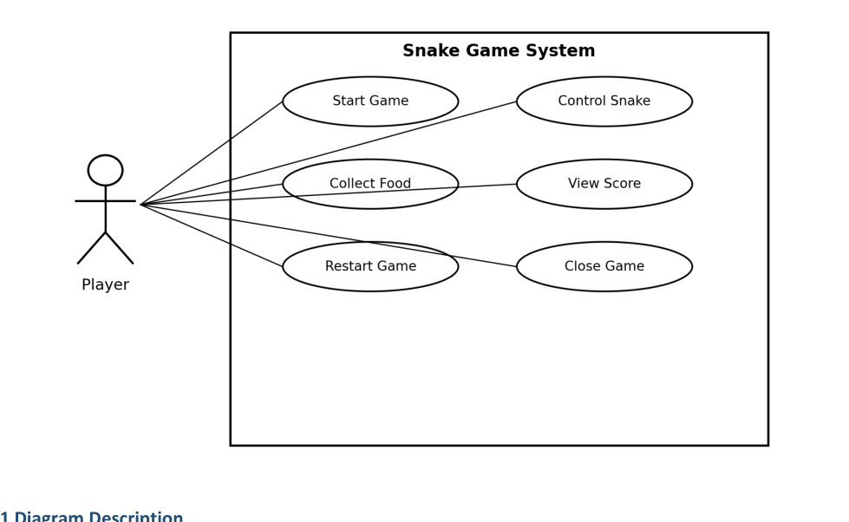

7.1 Diagram Description
The Player starts a game, controls the snake, collects food through gameplay, views the score, restarts after game over and closes the game. The system boundary is labelled Snake Game System; the actor is outside the boundary and the use cases are inside it.

8. Requirements Traceability Matrix (RTM)
Status key: N = Not Run, P = Pass, F = Fail, NA = Not Applicable. The IDs below are intended to be aligned with the team's separate Test Plan. All statuses remain Not Run until the corresponding test or review is performed.
Requirement ID | Requirement Summary | SRS Section / Module | Test Reference | Status
FR-01 | Start new round | Section 4 / game control | TC-01 | N
FR-02 | Display bounded play area | Section 4 / rendering | TC-01 | N
FR-03 | Initial snake placement | Section 4 / snake setup | TC-01 | N
FR-04 | Keyboard direction input | Section 4 / input control | TC-02 | N
FR-05 | Snake movement | Section 4 / movement | TC-02 | N
FR-06 | Reject immediate reversal | Sections 4, 5.1 / input control | TC-02, TC-13 | N
FR-07 | Valid food placement | Section 4 / food | TC-03 | N
FR-08 | Detect food collection | Section 4 / food | TC-03 | N
FR-09 | Grow snake after food | Section 4 / snake | TC-03 | N
FR-10 | Update score | Section 4 / score | TC-04 | N
FR-11 | Generate replacement food | Section 4 / food | TC-04 | N
FR-12 | Boundary collision | Section 4 / collision | TC-05 | N
FR-13 | Self-collision | Section 4 / collision | TC-05 | N
FR-14 | Stop after fatal collision | Section 4 / game state | TC-05 | N
FR-15 | Show game over and final score | Section 4 / user interface | TC-05 | N
FR-16 | Restart after game over | Section 4 / game control | TC-06 | N
FR-17 | Reset state for new round | Section 4 / game control | TC-06 | N
FR-18 | Safe application close | Sections 3, 4 / window events | TC-07 | N
NFR-01 | Performance at 30 FPS target | Section 5 / rendering loop | TC-08 | N
NFR-02 | Controls and restart documented | Section 5 / UI and README | TC-09 | N
NFR-03 | 10 restart cycles without crash | Section 5 / game lifecycle | TC-10 | N
NFR-04 | Responsibilities identifiable in code | Section 5 / code structure | TC-11 | N
NFR-05 | Clean build and launch | Section 5 / build environment | TC-12 | N
NFR-06 | README has build/run instructions | Section 5 / documentation | TC-12 | N
SR-01 | Ignore unsupported keys safely | Section 5.1 / input handling | TC-13 | N
SR-02 | No input-driven OS command execution | Section 5.1 / code review | TC-14 | N
SR-03 | No unrelated user-file access | Section 5.1 / code review | TC-14 | N
SR-04 | Validate direction changes | Section 5.1 / input handling | TC-13 | N
SR-05 | Safe window-close and shutdown | Section 5.1 / lifecycle | TC-07 | N

Appendix A: Glossary
Term | Definition
Game-over state | The state entered after a fatal collision, in which the snake stops moving and the final score is shown.
Acceptance criterion | An observable condition used to decide whether a requirement is satisfied.
Traceability | A documented relationship between a requirement and its corresponding verification test.

.

