Software Architecture and Design Specification
Project: Snake Game
Version: 1.0
Date: 12 October 2026
Status: Draft for team review
Prepared by: Ved Mudkavi | PES1UG24CS522
Team member | SRN | Responsibility
Yele Charan | PES1UG25CS856 | SRS; snake movement
Vrunda C | PES1UG24CS541 | Test plan; food and scoring
Ved Mudkavi | PES1UG24CS522 | Architecture and design; collisions
Tushar N | PES1UG24CS504 | Integration and traceability; lifecycle

Revision History
Version | Date | Author | Change summary
1.0 | 12 Oct 2026 | Ved Mudkavi | Initial Snake design aligned to SRS version 1.0.

Approvals
Team representative: Vrunda C. Team review and instructor approval are pending; no approval is asserted in this document.

1. Introduction

1.1 Purpose
This document defines the proposed architecture and design of the Snake Game mini-project. It translates the requirements in the team SRS dated 12 October 2026 into module responsibilities, game-state rules, component interactions and C++ interfaces. The design separates game logic from SFML graphics so movement, food and collisions can be tested independently.

1.2 Scope
The application is a local, single-player desktop game written in C++ with SFML. Its scope includes starting a round, keyboard direction control, snake movement, valid food placement, growth and scoring, fatal boundary and self-collisions, final-score display, restart and safe shutdown. Network services, accounts and databases are outside the SRS scope. Increasing difficulty is an enhancement requiring agreement and an SRS update before implementation.

1.3 Audience
The intended readers are the development team, test-plan author, integration reviewer, course instructor and evaluators. Developers use the interfaces and update order; testers use the traceability matrix and invariants; reviewers use the diagrams and design rationale.

1.4 Definitions
SAD: Software Architecture and Design Specification. SRS: Software Requirements Specification. STP: Software Test Plan. RTM: Requirements Traceability Matrix. UML: Unified Modeling Language. SFML: Simple and Fast Multimedia Library. Tick: one discrete snake movement update. Cell: an integer grid coordinate. FPS: rendered frames per second.

2. Document Overview

2.1 How to use this document
Section 3 defines architecture, responsibilities, technology choices, risks, requirement mappings and security. Section 4 defines runtime behaviour, two sequence diagrams, interfaces, error handling and the player experience. Section 5 contains a glossary, source references and supporting tools. Interfaces and controls are proposed design decisions to be reconciled with the implementation during review.

2.2 Related Documents
The design baseline is Snake Game SRS version 1.0, dated 12 October 2026 and marked Draft for Review. The separate STP and team RTM should retain the same FR, NFR, SR and test IDs. SRS test references TC-01 through TC-14 are used here as planned verification links; this document does not claim that tests have run.

3. Architecture

3.1 Goals and Constraints
Support all 18 functional requirements, retain responsive rendering, and keep movement, food, collision, game control and rendering identifiable. NFR-01 sets an average of at least 30 FPS over a 60-second normal run on the agreed test computer. NFR-03 requires ten consecutive start/restart cycles without a crash. These are verification targets, not measured results.
Use a single process with one main loop and in-memory state. C++ and SFML are required by the SRS. The compiler, C++ standard, SFML version, operating system and test computer must be pinned in the README before compatibility and performance testing. Avoid platform-specific commands in runtime input handling.

3.2 Stakeholders and Concerns
Stakeholder | Design concern
Player | Clear controls, valid movement, accurate score and predictable restart.
Developers | Separate ownership, small interfaces and reproducible builds.
Tester | Deterministic test setup and observable acceptance criteria.
Integrator and instructor | Consistency with SRS/STP, traceability and reviewed contributions.

3.3 Component UML Diagram
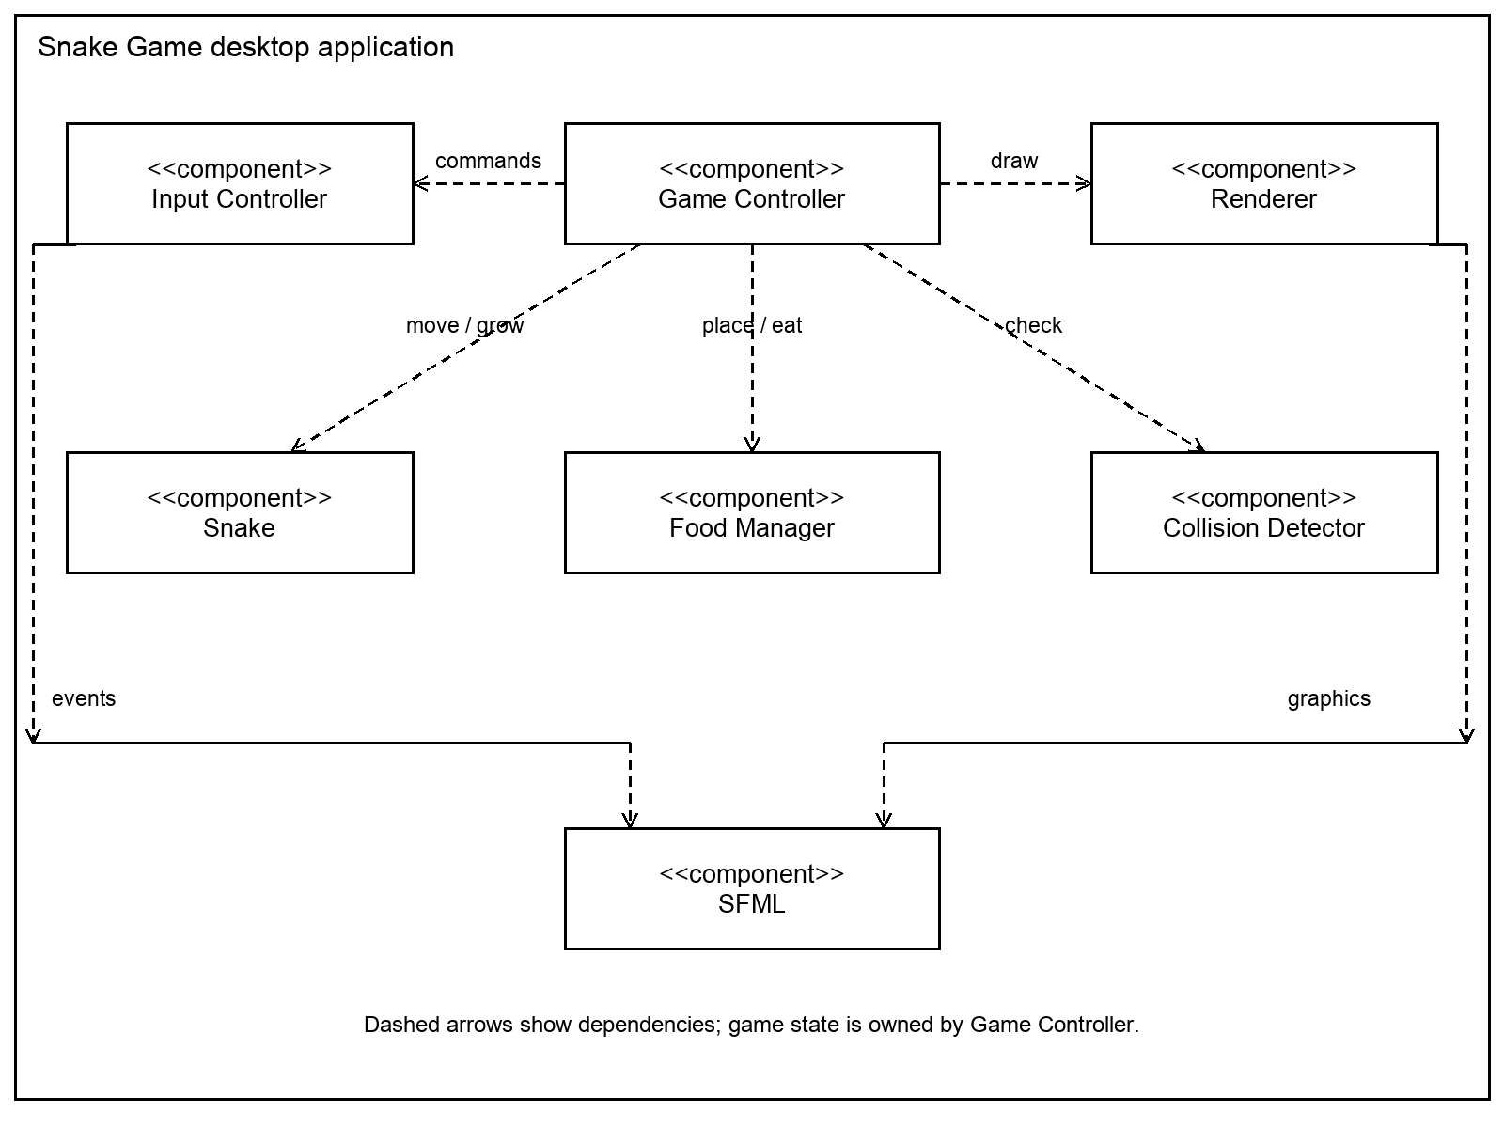
Figure 1. Component dependencies within the local Snake Game application.

3.4 Component Descriptions
Component | Responsibility and owned data
Game Controller | Owns round state, score, board bounds and movement timer; coordinates a valid update and reset.
Input Controller | Maps SFML events to documented commands; ignores unsupported input.
Snake | Owns an ordered collection of cells, head first, current direction and one pending direction change.
Food Manager | Owns an optional food cell; selects a free cell within bounds using a supplied random generator.
Collision Detector | Pure checks of a proposed head cell against bounds and the body; returns None, Boundary or Self.
Renderer | Displays a read-only view of the board, snake, food, score and state; owns graphics resources.
SFML platform adapter | Provides the window, event polling, timing and graphics. Domain logic uses no window objects.

Game Controller provides snapshots to rendering and passes plain cell data to domain modules. Food Manager and Collision Detector do not modify the snake. Rendering never changes the score or round state. Game Controller applies changes in the order defined in Section 4.1.

3.5 Chosen Architecture Pattern and Rationale
Choose a modular architecture with presentation, application coordination and domain logic responsibilities. SFML rendering and event translation form the presentation boundary; Game Controller forms application coordination; Snake, Food Manager and Collision Detector implement domain rules. All components run locally in the same process.
This structure supports the team division and allows Google Test to exercise pure logic without opening a window. A single class containing all game behaviour would make independent work and testing harder. Distributed services would add network and deployment complexity without supporting an SRS requirement. Event polling and a fixed movement tick fit this local interactive game.

3.6 Technology Stack and Data Stores
Runtime: C++ and SFML. Proposed build: CMake with compiler and SFML versions pinned in README. Verification: Google Test for domain logic, plus manual desktop tests for graphics and controls. Collaboration: Git and GitHub branches and pull requests; GitHub Projects for backlog and sprint planning. GitHub Actions is planned for build/test checks under the Part-2 course instructions.
Snake cells, food, score and round state are stored only in memory and reset on restart. No database, login, persistent high-score file or network API is required. Docker, Jenkins and SonarQube were listed in the initial overview; their setup is not assumed complete. Graphical launch tests require a suitable desktop environment even when logic tests run in CI.

3.7 Risks and Mitigations
Risk | Mitigation and verification
Compiler or SFML mismatch | Pin dependency versions and document clean build steps; verify TC-12.
Input burst causes reversal | Accept at most one valid direction change per movement tick; test TC-02 and TC-13.
Self-collision false positive at tail | Exclude the departing tail on a non-growing move; include it when growing; test TC-05.
Food selection stalls on a full board | Enumerate free cells; return BoardFull immediately when none exist. Test full-board case under TC-03/04.
Timing changes game speed | Use elapsed time and a fixed movement interval independent of render rate; measure TC-08.
Restart leaves stale state | Reset body, direction, score, food, timer and pending input as one operation; test TC-06 and TC-10.
Documents and code diverge | Review interfaces and mappings across SRS, SAD and STP; record approved changes.

3.8 Traceability to Requirements
Every SRS requirement below maps to a design responsibility and the test reference already proposed by the SRS. Test execution results belong in the STP/RTM; all remain unverified here.
ID | Requirement | Design module or section | SRS test
FR-01 | Start round | Game Controller; 4.1, 4.5 | TC-01
FR-02 | Bounded play area | Renderer; 4.5 | TC-01
FR-03 | Initial snake in bounds | Snake and reset; 4.1 | TC-01
FR-04 | Direction keys | Input Controller; 4.3, 4.5 | TC-02
FR-05 | Snake movement | Snake and tick; 4.1, 4.3 | TC-02
FR-06 | Reject immediate reversal | Snake pending input; 4.1, 4.3 | TC-02, TC-13
FR-07 | Valid food placement | Food Manager; 4.3 | TC-03
FR-08 | Food collection | Game Controller; Figure 3 | TC-03
FR-09 | Snake growth | Snake.advance; Figure 3 | TC-03
FR-10 | Score increase | Game Controller; 4.1 | TC-04
FR-11 | Replacement food | Food Manager; Figure 3 | TC-04
FR-12 | Boundary collision | Collision Detector; 4.3 | TC-05
FR-13 | Self-collision | Collision Detector; 4.3 | TC-05
FR-14 | Stop on collision | GameOver guard; 4.1 | TC-05
FR-15 | Final score and message | Renderer; 4.5 | TC-05
FR-16 | Restart | Game Controller; 4.1 | TC-06
FR-17 | Reset round state | Game Controller; 4.1 | TC-06
FR-18 | Safe close | Window event handling; 4.4 | TC-07

3.8 Traceability to Requirements continued
ID | Requirement | Design module or section | SRS test
NFR-01 | 30 FPS average target | Timing and Renderer; 4.1, 4.4 | TC-08
NFR-02 | Documented controls | Renderer and README; 4.5 | TC-09
NFR-03 | Ten restart cycles | Reset and lifecycle; 4.1 | TC-10
NFR-04 | Separate responsibilities | Component structure; 3.4 | TC-11
NFR-05 | Clean build and launch | Build environment; 3.6 | TC-12
NFR-06 | Build/run documentation | README and dependencies; 3.6 | TC-12
SR-01 | Ignore unsupported keys | Input allowlist; 3.9 | TC-13
SR-02 | No input-driven OS commands | Local command dispatch; 3.9 | TC-14
SR-03 | No unrelated file access | Fixed assets; 3.9 | TC-14
SR-04 | Validate direction changes | Snake and state guards; 4.3 | TC-13
SR-05 | Safe shutdown | Close-event path; 4.4 | TC-07

SO-01 is supported by SR-01, SR-04 and SR-05; SO-02 is supported by SR-02 and SR-03. Security objectives describe intent, while the SR IDs define the corresponding checks.

3.9 Security Architecture
The relevant trust boundary is between platform events and valid domain commands. A second boundary is between fixed application assets and the file system. Input is mapped to a small command enum. No text input, shell execution, user-provided path, database or network service is part of normal gameplay.
Threat or failure | Control and SRS link
Malformed or unsupported input | Allow only documented commands; ignore other keys. Validate state and direction before changes (SO-01, SR-01, SR-04).
Invalid state mutation | Keep score and state private to Game Controller; expose read-only rendering data. Unit-test invariants (SO-01).
Unrelated file access or command execution | Load only packaged assets from fixed paths; never derive paths or shell commands from input (SO-02, SR-02, SR-03).
Availability failure | Bound food placement work by board size; handle missing resources and window close without uncontrolled failure (SO-01, SR-05).
Spoofing or privilege escalation | No user identities, roles or privileged operations are designed. Reassess if accounts, network or persistence are added.

Console diagnostics contain error categories and game-state information only. Do not log user directories or personal data. Use automatic resource ownership and standard containers; avoid unchecked coordinate indexing and raw owning pointers. Security checks remain pending execution and review.

4. Design

4.1 Design Overview
Use integer grid coordinates with origin at the upper-left. Valid cells satisfy 0 <= x < columns and 0 <= y < rows. The body is ordered head-to-tail; direction is Up, Down, Left or Right. Proposed initial settings are a 30 x 20 grid, a three-cell horizontal snake, score zero, ten points per food and a 150 ms movement interval. These values are design defaults requiring team confirmation; the SRS leaves them configurable.
State model: Ready -> Playing on start; Playing -> GameOver on a fatal collision; GameOver -> Playing on restart; any state -> Closing on window close. Add RoundComplete for the defensive full-board case: show the score, stop movement and permit restart. This is an edge-case design extension rather than an existing SRS feature.
Main-loop order: poll events, handle close immediately, translate supported commands, process a start/restart action, run due movement ticks only while Playing, then render. Render FPS and movement rate are independent. Cap accumulated elapsed time to avoid a long burst of catch-up movement after a stalled frame.
At each movement tick: apply the accepted pending direction; compute the next head; check whether that cell contains food; check boundary and self-collision using whether the move would grow. On a fatal collision, set GameOver and leave body/score unchanged. On a valid move, add the new head and remove the tail unless growing. If food was consumed, increment score once and request replacement food. Reset the direction-change latch for the next tick.
Only one accepted direction change is allowed between ticks. Reject an immediate opposite direction; an ignored input does not consume the latch. This prevents a rapid Right -> Up -> Left event burst from reversing the snake before it moves. On a non-growing move, entering the current tail cell is valid because that cell is vacated in the same tick. On a growing move, the tail stays and must participate in collision checks.
Restart constructs a valid initial body, clears pending input and elapsed time, sets the initial direction and score, and places new food on a free cell. Invalid board dimensions or an impossible initial body cause controlled initialization failure. Invariants: all committed snake cells are inside bounds and distinct; food is unoccupied; score changes only on food consumption; GameOver and RoundComplete never advance the snake.

4.2 UML Sequence Diagrams
Figure 2 covers keyboard input and collision evaluation. Figure 3 covers a valid food-consumption update. Dashed messages represent returned results. The explanations identify branches and state changes outside the main message path.

4.2.1 Gameplay and Collision Flow
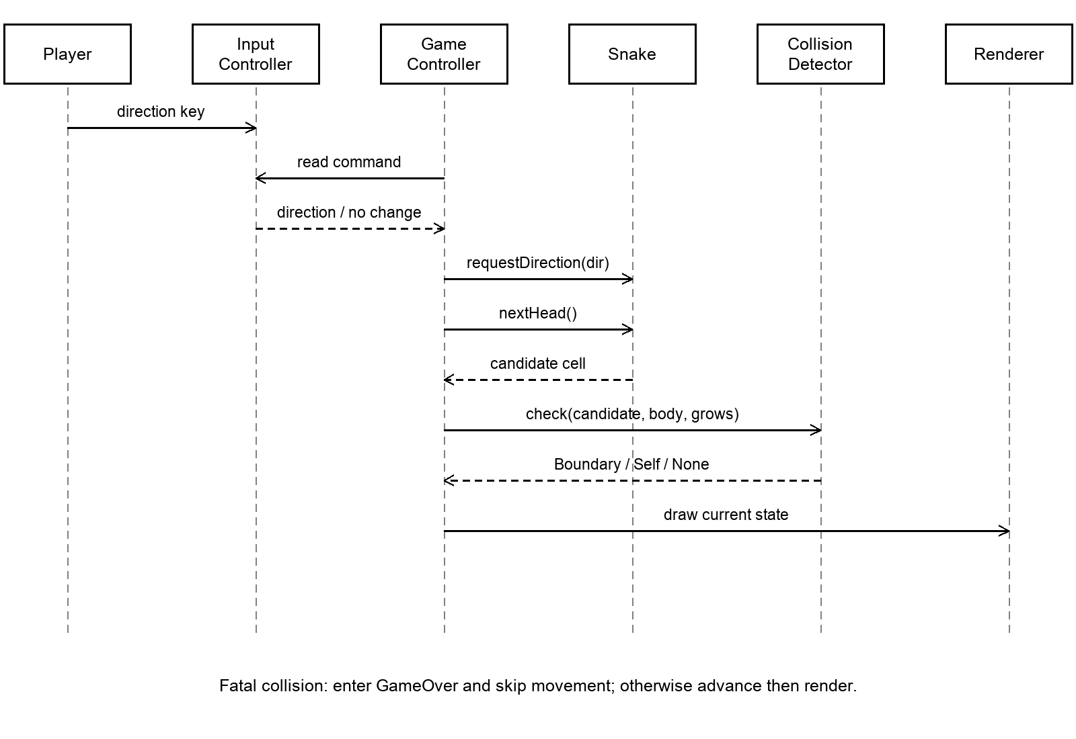
Figure 2. Input, candidate movement, collision decision and rendering.
Precondition: the round is Playing and a movement tick is due. Unsupported input produces no command. Snake accepts a direction only when it is valid for the current state and input latch. Collision Detector checks the proposed head before a move is committed. A Boundary or Self result changes the state to GameOver, preserving the final score. A None result advances the snake and permits any food update. Renderer draws the resulting snapshot. This flow covers FR-04 to FR-06 and FR-12 to FR-15, with SR-01 and SR-04.

4.2.2 Food Consumption Flow
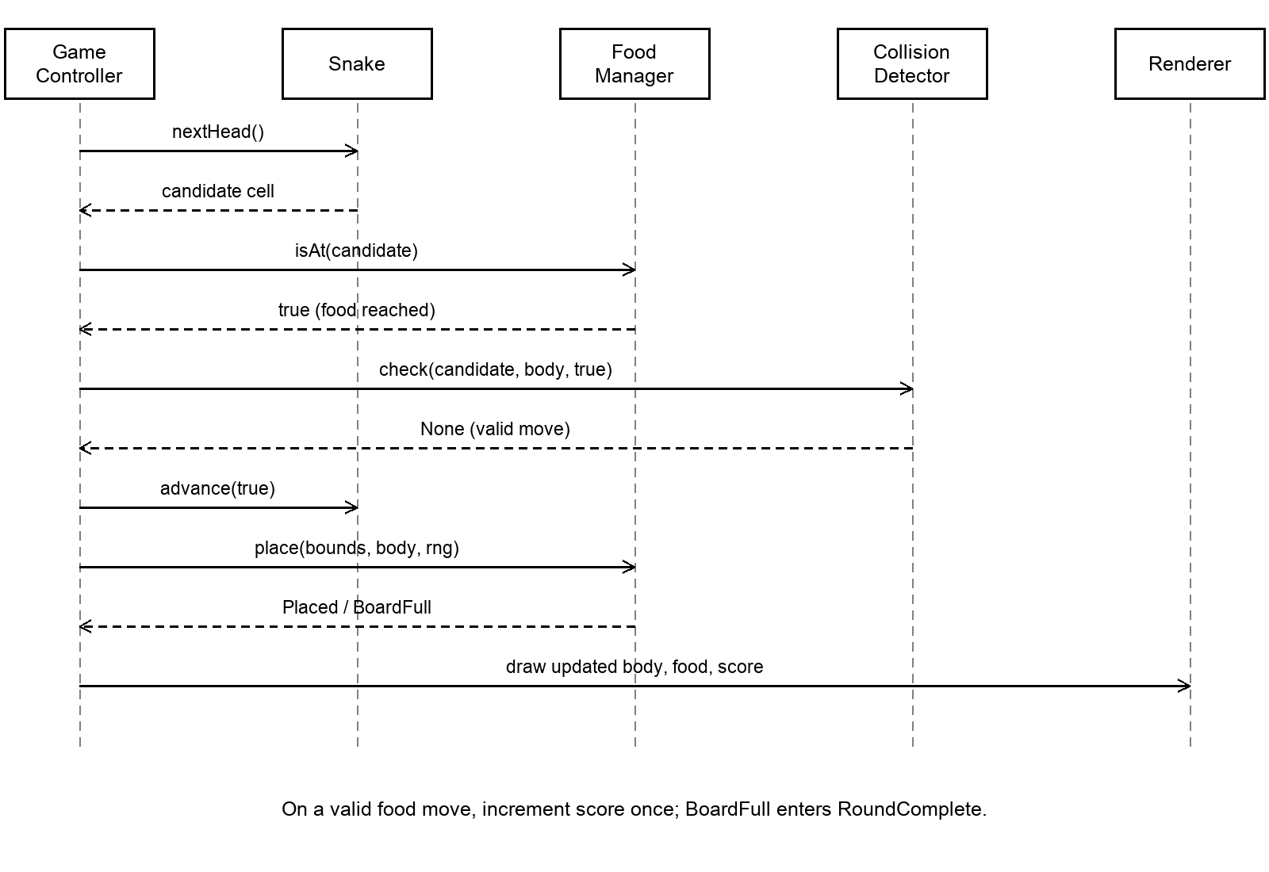
Figure 3. Valid food move, growth, replacement placement and display.
Precondition: the proposed head reaches food and Collision Detector returns None. Game Controller calls advance(true), adds the configured food score exactly once, then requests a replacement free cell. Food Manager selects from currently unoccupied cells. If no free cell remains, it clears food and returns BoardFull; Game Controller enters RoundComplete. The renderer displays the new length and score. This flow covers FR-07 to FR-11. Fatal collisions take priority over food consumption and never award points.

4.3 API Design
The following are proposed C++ class contracts for local components, not HTTP endpoints. Shared types: Cell { int x; int y; }; BoardBounds { int columns; int rows; }; Direction { Up, Down, Left, Right }; CollisionType { None, Boundary, Self }; PlacementResult { Placed, BoardFull, InvalidBounds }. The implementation may adapt signatures to the agreed C++ standard while preserving these contracts.

4.3.1 Snake Interface
Operation | Contract
reset(initialBody, direction) | Accept a valid, distinct head-first body. Clear pending input and growth state. Reject invalid setup before Playing.
bool requestDirection(Direction dir) | Accept at most one non-opposite change per tick. Return false for reversal or additional accepted changes. No movement occurs here.
Cell nextHead() const | Return the adjacent cell for the pending/current direction without modifying the body.
void advance(bool grow) | Commit the previously validated candidate. Add the head; keep the tail if grow is true, otherwise remove it. Reset input latch.
const Body& body() const | Expose the ordered cells read-only to collision checks, placement and rendering.

4.3.2 Collision Detector Interface
CollisionType check(Cell nextHead, const Body& body, BoardBounds bounds, bool grows) const;
Return Boundary when the candidate is outside bounds. Otherwise compare it with occupied body cells. Include all cells on a growing move; exclude the last cell on a non-growing move. Return Self for a match and None otherwise. The function has no side effects and requires a non-empty valid body and positive bounds. Game Controller validates those preconditions at initialization. Worst-case work is linear in snake length.

4.3.3 Food Manager Interface
bool isAt(Cell candidate) const; PlacementResult place(BoardBounds bounds, const Body& body, RandomGenerator& rng); optional<Cell> position() const;
isAt returns true only when food exists at the candidate. place enumerates valid free cells, samples one using the supplied generator and stores it. Return InvalidBounds for non-positive dimensions and BoardFull with no food when the free set is empty. Bound selection work by board capacity; do not retry random cells indefinitely. Tests supply a fixed random seed. A test fixture can supply a known starting food position.

4.3.4 Game Controller and Renderer Interfaces
Game Controller exposes startRound(), handleCommand(Command), update(elapsedTime) and snapshot() const. snapshot is read-only and includes state, body, optional food, bounds and score. Renderer exposes draw(const GameSnapshot&) and never mutates gameplay. Renderer initialization reports asset-loading failure to the application bootstrap. Window-close commands always take precedence over other events.

4.4 Error Handling Logging and Monitoring
Condition | Response
Unsupported direction or key | Ignore the command and continue; do not change score or valid state.
Fatal boundary or self-collision | Normal gameplay outcome: enter GameOver, stop updates and show final score.
Missing font or graphics resource | Print a concise initialization error and terminate cleanly before gameplay; no unrelated file search.
Invalid configuration or empty initial body | Reject initialization; report the configuration category and exit cleanly.
No free cell for food | Enter RoundComplete; stop movement and display restart instructions.
Window-close event | Leave the main loop and release SFML resources through normal ownership.
Unexpected initialization/runtime exception | Catch at the application boundary, report a concise diagnostic and release resources; do not resume corrupted state.

Use console diagnostics for initialization and unexpected errors. Collision events do not need error logs. During performance verification, measure rendered frames across a 60-second run on the documented machine, recording build configuration and achieved average FPS. Record ten restart outcomes separately. Build/test results and manual acceptance evidence belong in the STP and repository; no monitoring server is required.

4.5 UX Design
Proposed controls: Enter starts a Ready round; arrow keys change direction; R restarts from GameOver or RoundComplete; closing the window exits from any state. Display these instructions on the game screen and README. Confirm the controls with the team before freezing the implementation.
Ready shows the bounded play area and start instruction. Playing shows distinct snake and food cells with the current score outside the grid. GameOver keeps the final board visible with a clear message, final score and restart prompt. RoundComplete uses a completion message and the same restart affordance. Use readable text, visible boundaries and distinguishable shapes; rendering should not rely solely on colour to identify food.

4.6 Open Issues and Next Steps
Confirm compiler, C++ standard, SFML version, board configuration, controls and scoring defaults. Agree on the precise interfaces across the four members and align the separate STP with TC-01 to TC-14. Confirm the full-board handling extension and whether increasing difficulty should become an SRS requirement.
Implement domain modules and tests first; integrate SFML rendering and lifecycle; run documented functional, quality and security checks; review changes through individual branches and pull requests. Record deviations from the submitted SRS/SAD and update the documents together. Final class names and signatures should be agreed during integration review.

5. Appendices

5.1 Glossary
Body: ordered snake cells, head first. Candidate head: intended next cell before collision validation. GameOver: stopped state after a fatal collision. RoundComplete: stopped state after filling all board cells. Input latch: rule allowing one accepted turn per movement tick. Deterministic test: a test with controlled state and random inputs.

5.2 References
1. Snake Game Software Requirements Specification, version 1.0, team draft dated 12 October 2026.
2. SAD Template.docx supplied for the course; its structure is retained and example content is adapted to Snake.
3. Software Engineering Mini-Project Deliverables Part-1 and Part-2, supplied course instruction screenshots.
4. Team Part-1 work distribution for Snake Game, supplied by the team.

5.3 Tools
Development: C++ compiler, SFML and proposed CMake build. Verification: Google Test and desktop acceptance checks. Collaboration: Git, GitHub, GitHub Projects and planned GitHub Actions checks. The accompanying diagrams are PNG files for inclusion in repository documentation. Exact dependency versions must be recorded when the build environment is agreed.

