IntraRoute documentation

The IntraRoute’s application purpose is to mimic what the selection of the shortest path between two nodes in an intranet type network would look like, and visually show how various pathfinding algorithms work. The program is divided into 4 translation units: structures, engine, main and graphicsEngine.
The main class resides in the main.cpp file and creates the graphical interface that the user will interact with. It defines a few global variables, most of them constants to be used throughout the program, with the most important variable being the int** m. This variable holds a dynamically-allocated matrix of size NUM_NODES x NUM_NODES which describes the relationships between nodes in a graph, while the structures::Node* nodes variable holds information about the nodes themselves. The main functionality the main.cpp file achieves is the creation of the GUI, this is achieved by first calling the init() function which initializes the window and button objects, loading fonts and setting the time_link variable.

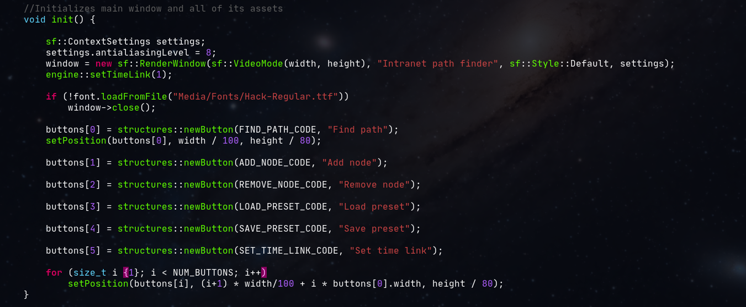
(the init() function)
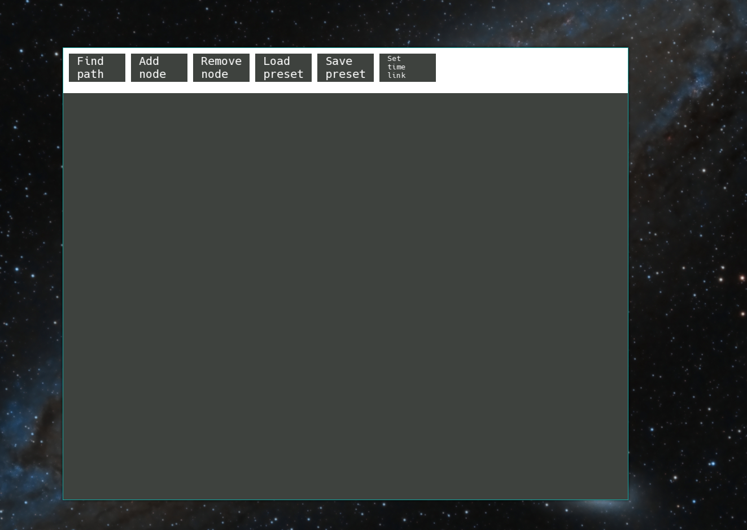
(how the initialized window looks like)
After the init() method finishes the program enters a while loop which checks if any event has occurred and handles them. In case of a mouse click event, the program calls the isButtonClicked(float x, float y) function which takes as parameters the x and y position of the mouse cursor at the moment the event was produced. If a button was clicked, the choice(int code) function is called which does a specific action depending on the code of the button.
The button class is declared in the structures.hpp file and defined in the structures.cpp. It has a height and a width, which help initialize a sf::RectangleShape instance variable which will be used to draw the button. There is also a sf::Text variable which holds the text displayed on the button and an int variable code which is the code of the button that will be used to associate it with a specific action. The Button class’ has 3 methods: setPosition(float x, float y) which sets the position of the button on the screen, setText(std::string text) which changes the text instance variable and the draw(sf::RenderWindow &window) function which draws the button in the window.
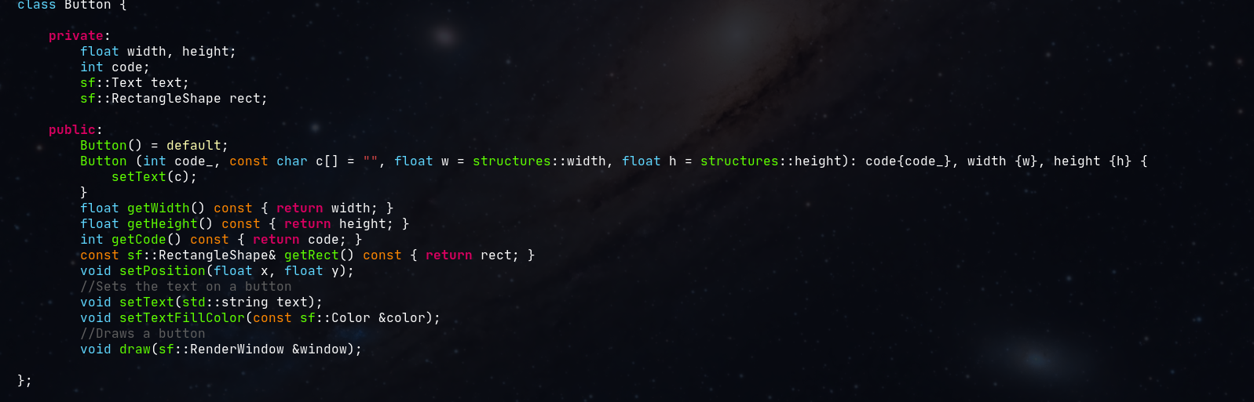
(Button class)
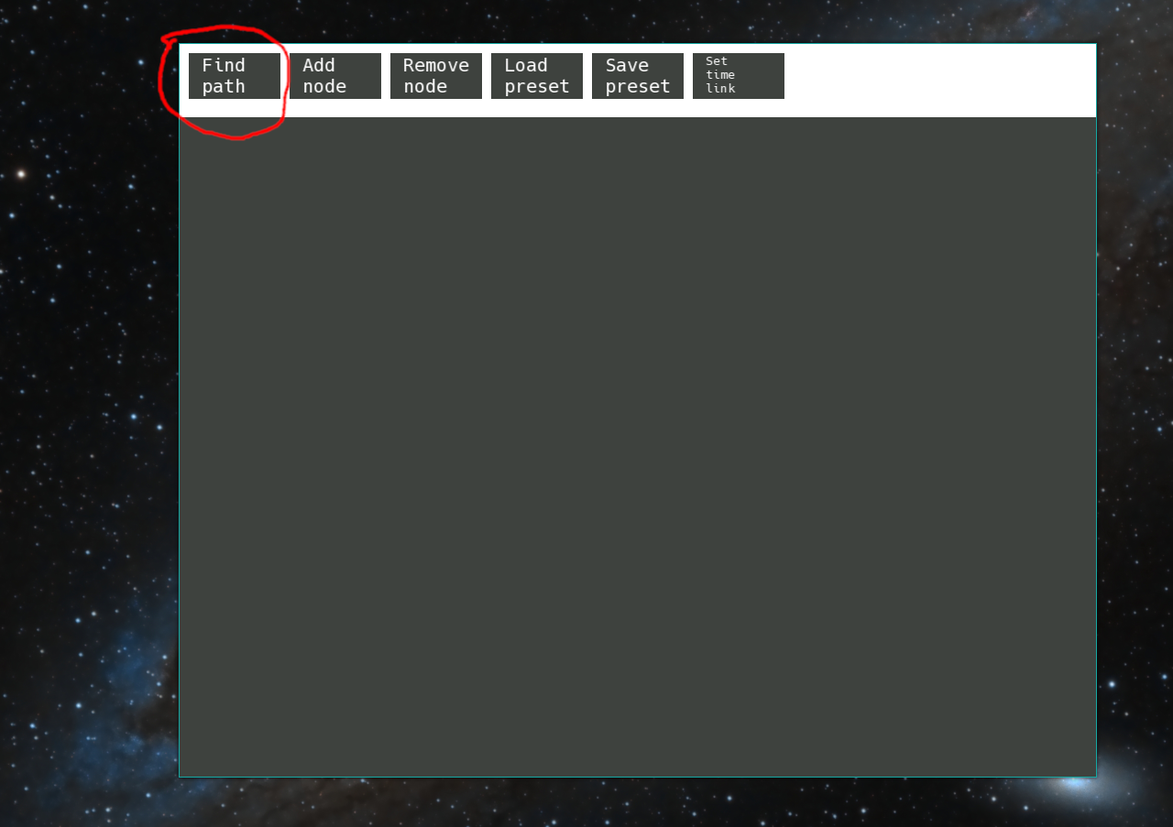
(how a button looks like)
Another important class is the Node class which defines the information that is help by a node in a graph: the height and width, a sf::RectangleShape defined by the height and width variables, a sf::Text address variable which holds the “ip address” of the node in the presumed intranet, a sf::Text order variable which holds the order in which the nodes were traversed in the graph. For example a Node variable with an order of “2” means that node was the second to be traversed by a specific algorithm. Of course, this means that some nodes don’t have the order variable set as they weren’t used in the pathfinding process. The last 2 variables are size_t group and size_t index. The way the “ip address” was defined in this program was as a number representing the group and another one representing the index of the node in the group, in the format “x.y.” where x represents the group number and y represents the index number and their main purpose is to uniquely identify a node in the graph. The methods defined by this class are: setPosition(float x, float y) which sets their position inside the window, the isInside(const sf::Vector2i &position) which checks if the coordinates inside the sf::Vector2i object are located inside the Node’s sf::RectangleShape and the lightUp(const sf::Color color) method colors the edge of the sf::RectangleShape with a given color (by default it’s cyan if no color is given).
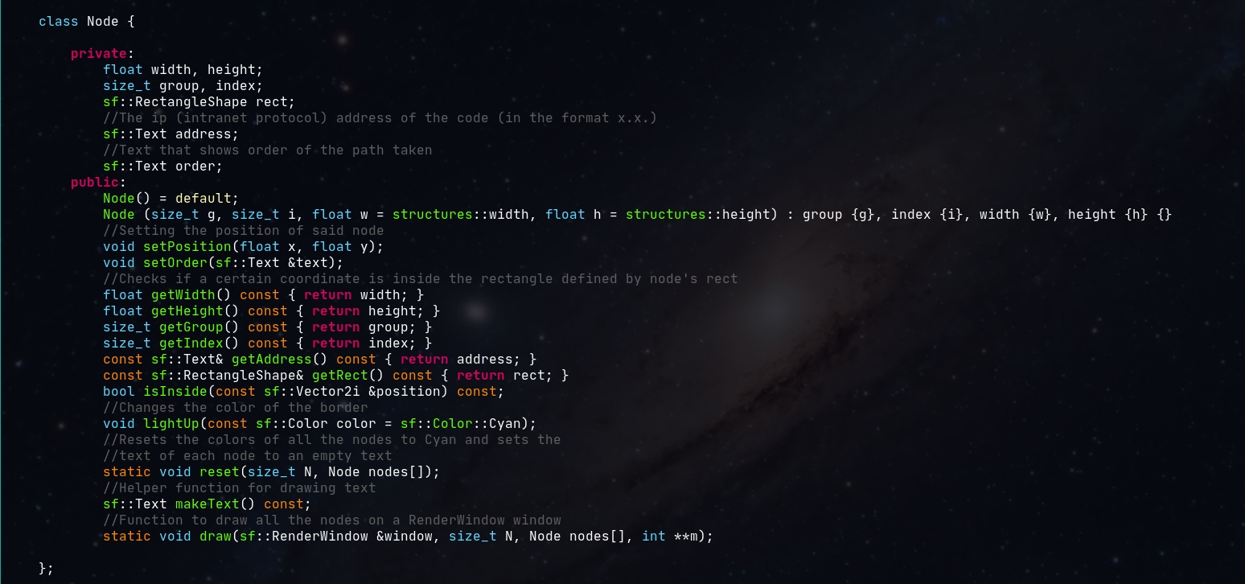
(Node class)
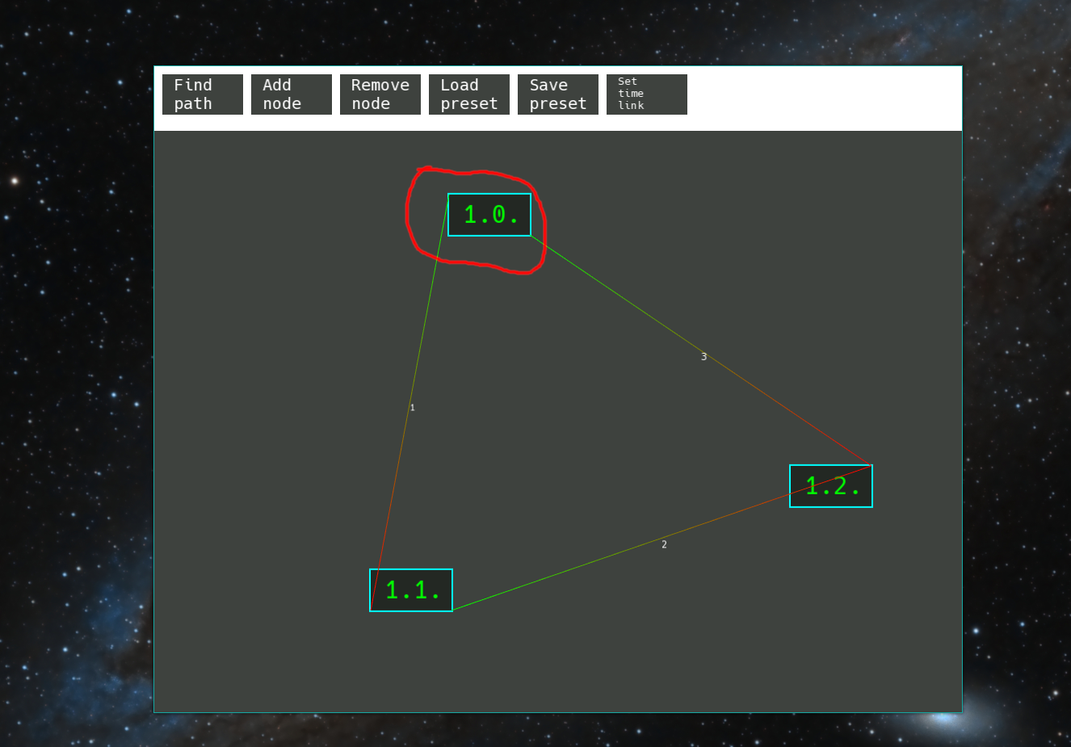
(how a node looks like, the edge between the nodes goes from green to red and the little white number represent the cost of the edge)
Going back to the choice(int code) function, there are 7 actions which a button could do:

- Load a preset: When clicked, the “Load preset” button brings up a prompt which asks the user to enter a filename contained inside the Presets/ folder without the .txt extension. Then, the loadPreset(const std::string &filename) function is called. It first deletes the int** m and structures::Node* nodes variables and also sets NUM_NODES to 0. Afterwards, if the filename is valid it reads in the new nodes’ information.
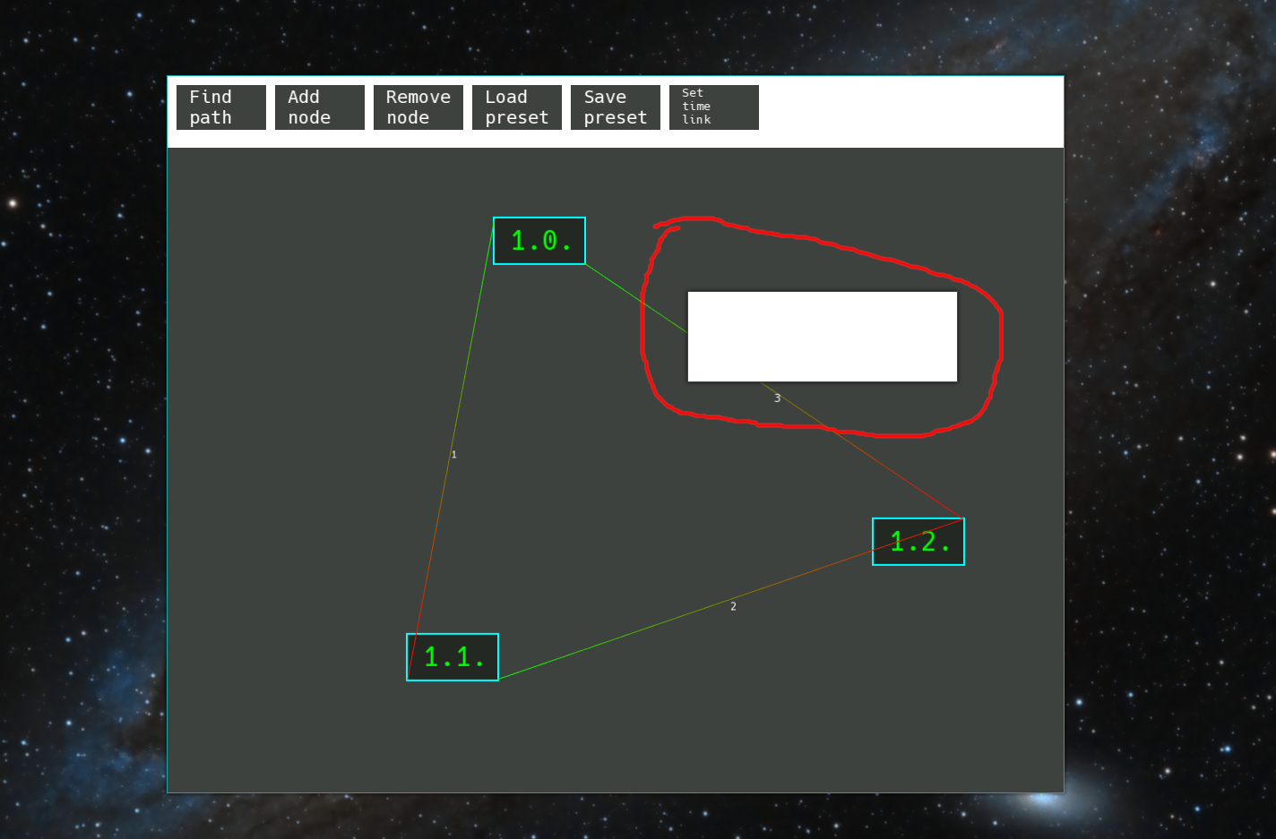
(how a prompt looks like)
- Save a preset: This saves the current graph in a file which can be then loaded back with the “Load preset” button as described above. The structure of a preset is as follows:

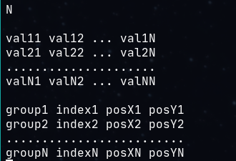

- Add a new node to the graph: The “Add node” button prompts the user to enter first the group of the node and then another prompt to enter the index of the node. It checks if they are valid (numbers) and then creates a new structures::Node object, adds it to the structures::Node* array and also adds one more row and column to the int** m matrix to account for the new node’s relations.
- Remove a node: When clicked, this button turns red to indicate the user is now in Node Deletion Mode (NDM). While in this mode if the user clicks on any node it will be deleted. To get out of the NDM and back to normal mode, simply click the “Remove node” button again, this will set the removeNode flag back to false.
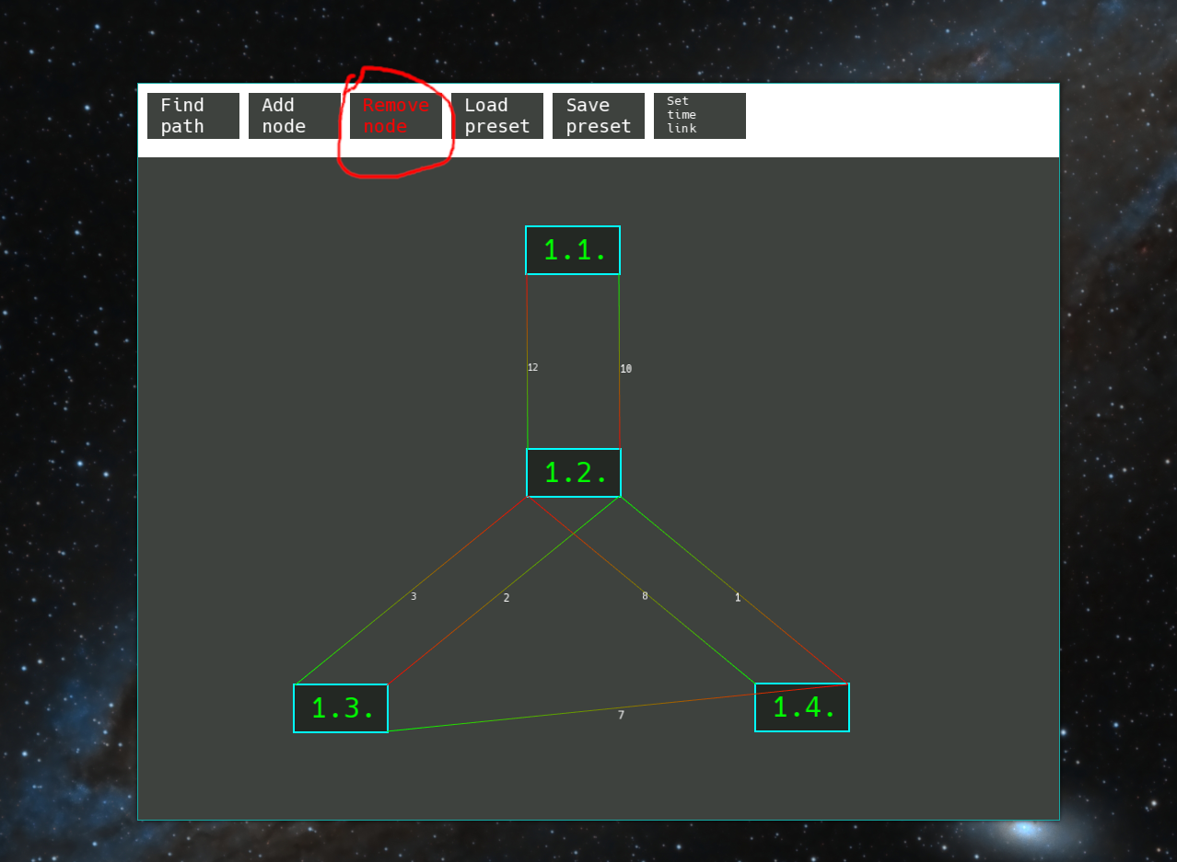
(NDM changes the color of the button)
- Set the timeLink variable: A prompt will appear which and asks the user to enter a valid decimal number which sets the timeLink variable declared inside the engine.hpp file. This variable maps the time duration of one cycle in an algorithm to real life seconds. For example a timeLink of 1 means 1 cycle of an algorithm takes 1 real-life seconds. A timeLink of 2 means that 1 cycle takes 2 real-life seconds. The bigger the number, the slower the program, this helps the user visualize better since he/she can adjust how fast the graph is traversed and better observe the algorithm.
- Finally, there is the “Find path” button: This button prompts the user to enter a valid node address representing the startNode and then another prompt asking for the endNode address. If these nodes are found the structures::reset(size_t N, Node nodes[]) function is called which set all the nodes’ edges to the default color and their order text to an emptry string. Afterwards, a new window appears containing buttons representing different pathfinding algorithms such as DFS, BFS and Djikstra. After a button is clicked, its code is returned and the corresponding graph traversal algorithm is called. For example, if the DFS_CODE is returned then the engine::DFS(sf::RenderWindow &window, size_t N, structures::Node nodes[], int** m, const size_t start_node, const size_t end_node) is called.
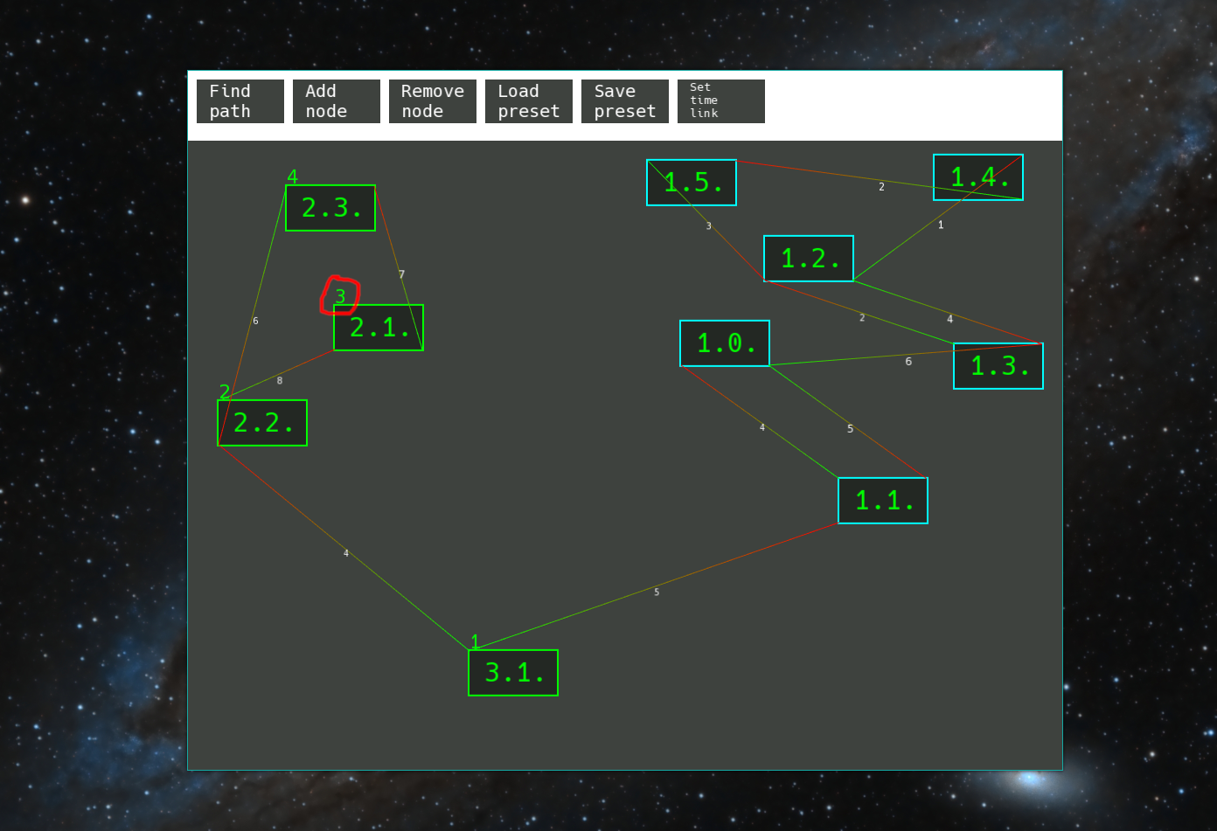
(Graph after algorithm has been run. Little numbers represent the order in which the graph is traverse 1->2->3->4)

Apart from buttons, the user can also right click on the nodes when not in NDM to drag them across the screen and organize them into easier to look at graphs. Moreover, if the user left clicks on node then it becomes selected and its edge color changes to purple. If the user then clicks on another node that creates a new graph edge between the two from the first node clicked to the last node clicked and the user is given a prompt and asked to give the new edge a value. Afterwards, all nodes become unselected again. If the user accidently clicked on one node and whishes to unselect it, simply left click on it again.
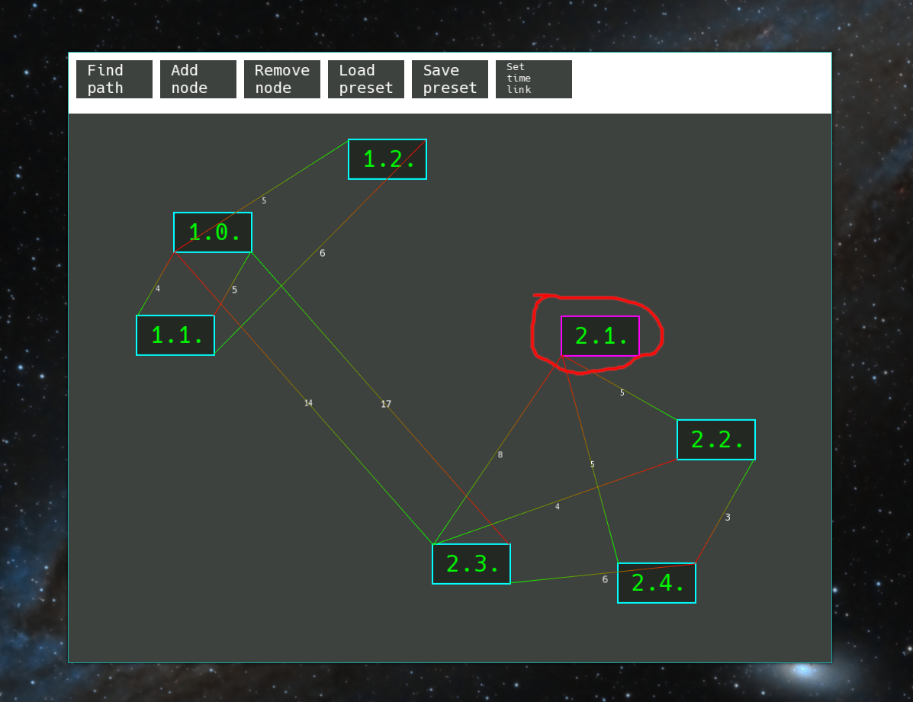
(selected mode)
When closing the program it’s important to keep in mind that all graphs created will not be automatically saved and must be explicitly saved with the “Save preset” button and then loaded back with the “Load preset” button.

