DSA 210 FINAL REPORT
An Analysis of IFSC Climbing Performance and GDP per Capita
Buket Çakır
28/12/2025

Introduction
Climbing is a sport that combines physical strength, technique, problem-solving, and mental focus. Sport climbing has become an increasingly competitive international discipline, with IFSC World Cup events bringing together athletes from a wide range of countries and backgrounds.
This project investigates whether GDP per capita is associated with better competitive outcomes in professional climbing. In this project, GDP per capita in this study is measured in PPP (constant 2021 international dollars), which adjusts for both differences in cost of living between countries and inflation over time. By merging this dataset with the IFSC competition results using the athletes’ nationality, the analysis investigates whether climbers from wealthier countries tend to achieve better competition results.

Motivation
Sport performance is often explained through individual talent, dedication, and training quality. However, access to high quality facilities, professional coaching and competition opportunities is not equally distributed across the world. These resources are strongly influenced by a country’s economic situation, which may create advantages or disadvantages for athletes before they even start to compete.
While climbing is a global sport, elite climbing requires access to indoor climbing walls, advanced equipment, and professional training and exposure to competition, which are all more available and accessible in economically developed countries. In Istanbul the true climbing gyms are very limited. There is “BoulderHane” in the European side and “DuvarX” and “Boulder İstanbul” in the Anatolian side. Outside of Istanbul, climbing facilities in Turkey are even more limited compared to what is available in larger European cities.
I was curious about whether a country’s level of economic development has any real impact on the success of its athletes in international climbing competitions. By combining IFSC World Cup results with GDP per capita data, this project explores whether a country’s wealth is linked to stronger and more consistent performance, or whether climbing remains a sport where success can emerge regardless of economic background.
To understand this relationship better, I will also perform a subgroup analysis by gender to test whether the relationship between GDP and performance varies between male and female athletes.

Data Source and Analysis
All analyses in this project were conducted on a cleaned and processed dataset taken from publicly available sources.
The final dataset was created by integrating two primary data sources:
1. IFSC Competition Results
Athlete performance data were obtained from the Kaggle dataset “IFSC Competition Climbing Results (1991–2024)”, which is scraped from the official IFSC website. This dataset contains detailed information on IFSC World Cup events across multiple seasons, including athlete ids, nationality, discipline, competition date, and ranking outcome.
For this project, athlete rankings were used as the main performance metric, where a lower rank indicates better performance.
2. GDP Per Capita Data
The GDP data were obtained from the Kaggle dataset “Global GDP Per Capita (1990–2023) – World Bank”. This dataset provides yearly GDP per capita values for countries worldwide, measured in purchasing power parity (PPP), constant 2021 international dollars. Using PPP-adjusted values allows for more meaningful comparisons across countries and across time by accounting for differences in cost of living and inflation.

Data Preparation and Cleaning
The raw IFSC competition data and GDP per capita data required several preprocessing steps before analysis:
-Merged athlete-level competition results with athlete information using a unique athlete identifier to construct a complete performance dataset.
-Removed observations with missing or invalid ranking or GDP values to ensure reliable statistical and machine learning analysis.
-Restricted the dataset to seasons up to 2023 because GDP data were only available up to 2023.
For the main exploratory analysis and hypothesis testing, rather than analyzing individual athlete results, competition outcomes were summarized for each country in each season by calculating the average rank and is called country-season in the project.
For the machine learning analysis, results were summarized separately for male and female athletes, creating one observation per country, season, and gender and is called country-season-gender in the project.
After loading both datasets, athlete competition results were merged with GDP per capita data using country codes and season year. Since the IFSC dataset uses sport federation country codes that differ from standard ISO-3 codes used in the World Bank dataset, a country code mapping was applied to ensure correct alignment before merging.

Findings
Exploratory Data Analysis (EDA)
1)Distribution of GDP per Capita
GDP per capita values vary substantially across countries represented in IFSC competitions. Most observations are clustered in the lower to middle income range, while a smaller number of countries have very high GDP per capita values as shown in the figure below.
This wide spread makes GDP per capita a meaningful variable to study, as it captures large differences in national economic conditions that could affect access to training facilities, coaching, and international competition exposure.
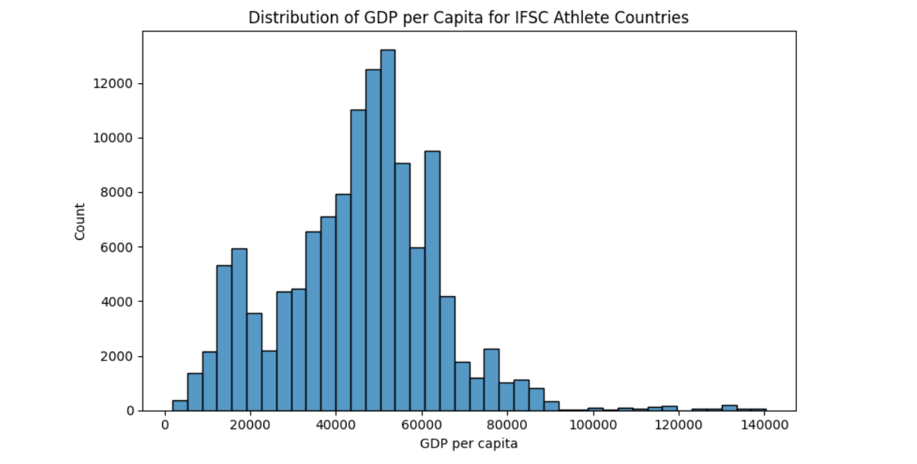

2)Distribution of IFSC Rankings
I then examined the overall distribution of athlete rankings across all competitions. The distribution is heavily right-skewed, with a large concentration of results in the lower rank values (better performance) and a long tail extending towards worse rankings. This is expected in competitive sports, where a small number of athletes consistently place near the top while many others finish lower.
This observation motivated grouping the data at a country–season level, which allows for more stable comparisons across countries and years.

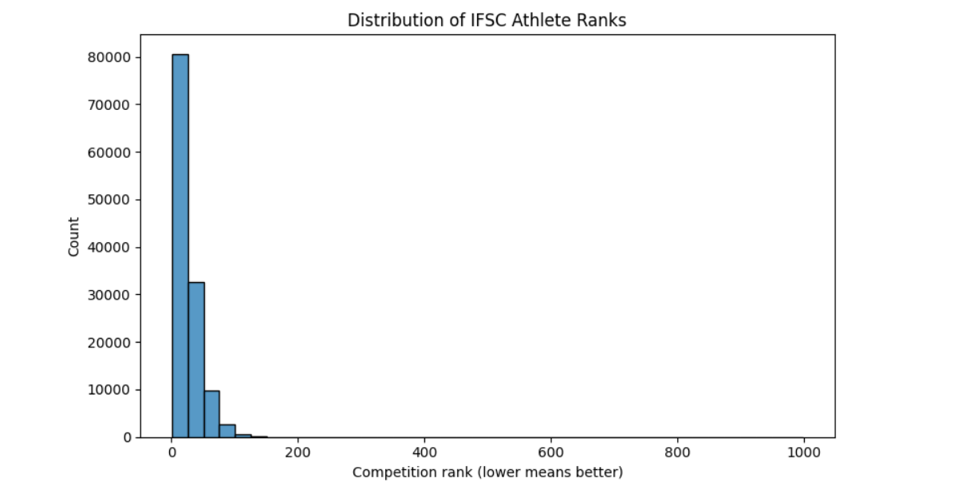

3)GDP per Capita vs. Average IFSC Rank
The scatter plot below visualizing the GDP per capita vs average IFSC rank at the country–season level shows a slight downward trend. Since lower rank values correspond to better performance, this plot suggests that athletes from wealthier countries tend to achieve better average rankings.
However, the plot also shows large overlap across all GDP levels. Many low and middle GDP countries produce competitive athletes, indicating that economic wealth alone does not determine success.
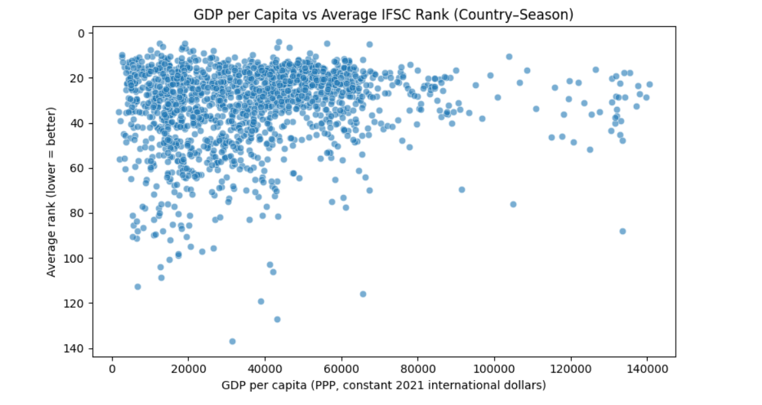

Figure below shows the scatter plot of GDP per capita versus average IFSC rank, with a fitted linear regression line. Although the points are widely scattered, the regression line suggests a weak negative relationship, consistent with the correlation coefficient which is found as -0.136027.
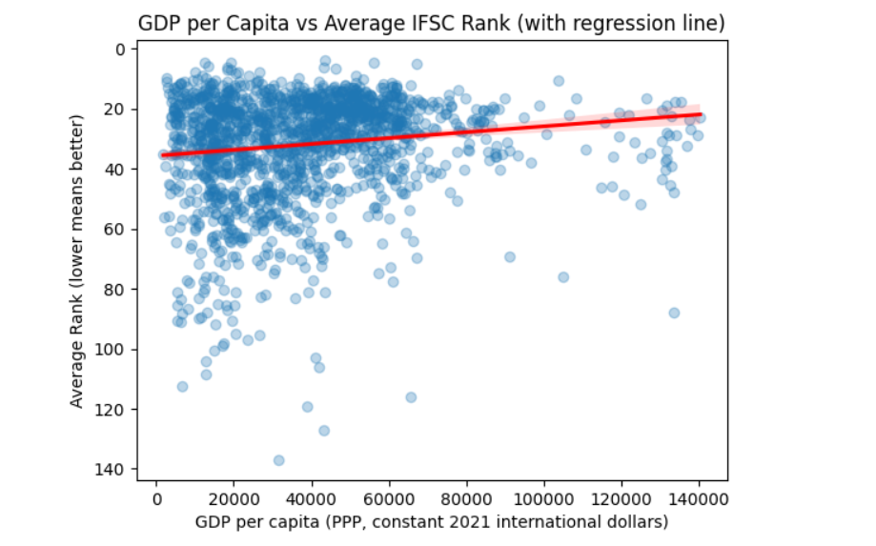

4)Average IFSC Performance by GDP Quartile
We see that low GDP quartile has wide spread and worse median while high GDP quartile has tighter spread and better median. However, there is large overlap between quartiles, and strong performers appear in all GDP groups. This again indicates that while higher GDP may be associated with improved average performance, it does not determine competitive success on its own.
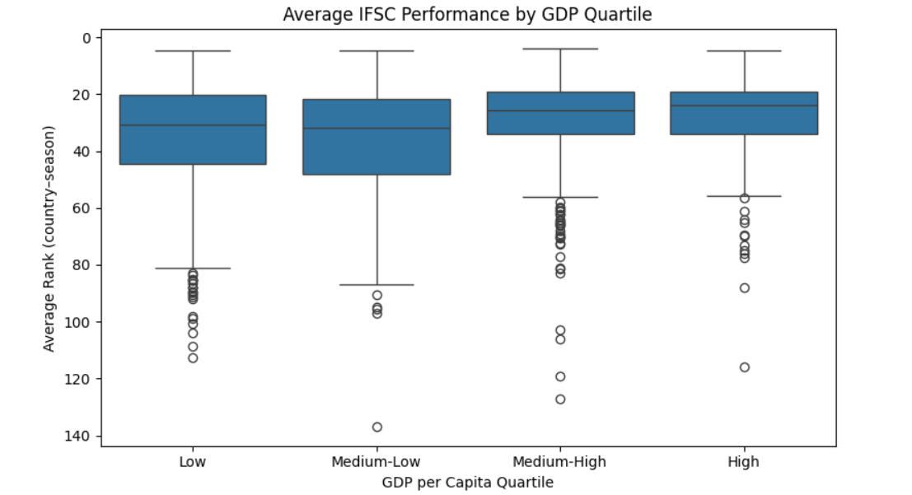

5)Hypothesis Testing
The Null Hypothesis: There is no statistically significant relationship between a country's GDP per capita and the ranking achieved by its athletes in IFSC competition.
The Alternative Hypothesis: Athletes from countries with higher GDP per capita tend to achieve significantly better(lower) ranks in IFSC competitions across season
To formally evaluate whether a country’s economic wealth is associated with climbing performance, several statistical hypothesis tests were conducted using the country–season level dataset.

5.1) Pearson Correlation Test
The Null Hypothesis: There is no linear relationship between GDP per capita and average IFSC rank.
The Alternative Hypothesis: There is a linear relationship between GDP per capita and average IFSC rank.

The Pearson correlation coefficient was used to measure the linear association between GDP per capita and average IFSC rank at the country–season level.

Pearson's correlation test shows that r = -0.1360 and p-value = 2.99E-8 Because p<0.05, we reject the null hypothesis that there is no relationship between GDP per capita and average IFSC rank.

The result indicates a weak but statistically significant negative linear relationship between GDP per capita and average IFSC rank.

5.2) Spearman Rank Correlation Test
The null hypothesis: There is no monotonic relationship between GDP per capita and average IFSC rank.
The Alternative Hypothesis: There is a monotonic relationship between GDP per capita and average IFSC rank.

Because IFSC rankings are ordinal and the relationship may not be strictly linear, the Spearman rank correlation was used.

The Spearman correlation coefficient was found as ρ = -0.14578292755926042 and with a p-value=2.7877510093214044e-09 that indicates p < 0.001.

So even without assuming a straight line (because Pearson's coefficient measured linear relationship), countries with higher GDP per capita still tend to have better (lower) average IFSC ranks.

5.3) Two-Sample t-Test (Low GDP vs High GDP Countries)
The Null Hypothesis: There is no difference in average IFSC rank between low-GDP and high-GDP country-seasons.
The Alternative Hypothesis: High-GDP country-seasons have better (lower) average IFSC ranks than low-GDP country-seasons.
To test whether economic wealth is associated with climbing performance, I conducted a Welch two-sample t-test and compared the average IFSC rankings of countries in the lowest and highest GDP per capita quartiles. The low GDP group had a mean rank of 35.36, while the high GDP group had a mean rank of 27.80, indicating better average performance for countries with higher GDP.
The test gave us a t-statistic of 6.39 and a one-sided p-value of 1.53E-10. Since this p-value<0.001, the null hypothesis was rejected. This provides strong evidence that athletes from higher-GDP countries tend to achieve significantly better rankings in IFSC competitions. While the difference is statistically significant, it does not imply that GDP alone determines success, but rather that economic factors may provide a small advantage.

6) Subgroup Analysis by Gender
I conducted separate analyses for male and female athletes to examine whether the GDP performance relationship differs by gender.

For Male athletes;
Pearson= -0.139
Spearman = -0.148
Both Pearson and Spearman correlations were statistically significant, indicating that this relationship is unlikely to be due to random chance.
For Female athletes;
Pearson= -0.075
Spearman = -0.047
The correlations are weaker here and in some cases, not statistically significant. This suggests that for female climbers, economic conditions at the country level may play a smaller or more complex role, and other factors such as training programs, and representation in the sport may be more influential than national wealth alone.

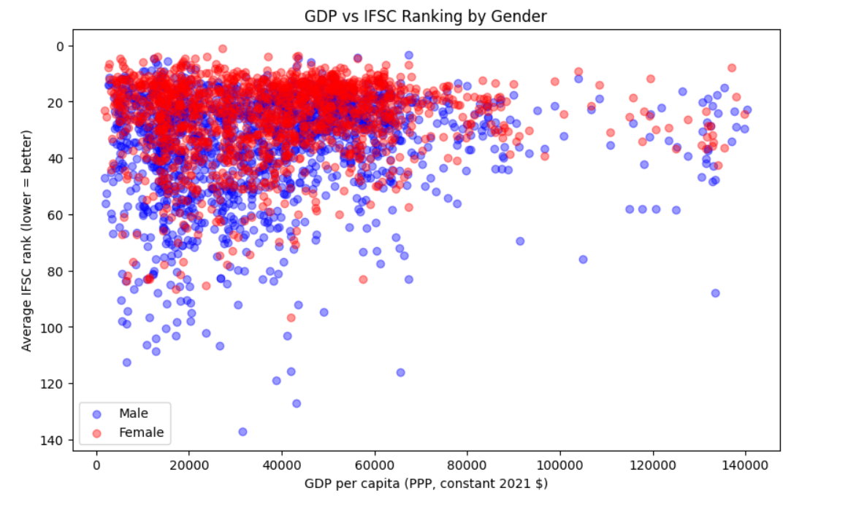
The figure above represents the relationship between GDP per capita and average IFSC rank separately for male and female athletes. While both groups show large overlap across the GDP range, the male distribution shows a clearer downward trend, indicating slightly better average rankings in higher-GDP countries. In contrast, the female results appear more dispersed, with no clear visual trend across GDP levels.

These visual patterns are consistent with the statistical findings.

Machine Learning Approach
In the machine learning part, I used basic machine learning methods to examine whether GDP can be used to predict climbing performance.

Data Preparation for Modeling
For the machine learning analysis, the dataset was summarised at the country–season–gender level. Each observation represents the average competition outcome for athletes of a given gender from a specific country in a particular season.
The features that were used are GDP per capita, event count to represent the number of competition results contributing to the average rank, season to indicate the competition year, gender, encoded as a binary indicator (0 = male, 1 = female)
Two target variables were defined:
-Mean IFSC rank for regression analysis
-Top-20 indicator which is a binary variable equal to 1 if the mean rank was 20 or better, and 0 otherwise to do classification analysis
The dataset was split into training (80%) and test (20%) sets to see how the model performs on unseen data.

1)Linear Regression Model
A multiple linear regression model was used to predict the average IFSC rank of a country–season–gender group. Since lower ranks indicate better performance, a negative coefficient implies improved outcomes.
The linear regression model achieved:
Training R² = 0.20
Test R² = 0.20
This indicates that approximately 20% of the variation in average ranking can be explained by the included features, but %80 of the performance variation remains unexplained.
 | Features | Coefficients
0 | gdp_per_capita | -0.000043
1 | events | -0.107658
2 | season | 0.359742
3 | gender_01 | -9.803230

GDP per capita has a negative coefficient, meaning that higher GDP per capita is associated with lower (better) average ranks when controlling for event participation, season, and gender. This finding is consistent with earlier results from correlation analysis and hypothesis testing.
The event count feature also showes a negative association with rank, suggesting that country-seasons with greater participation tend to perform slightly better on average.

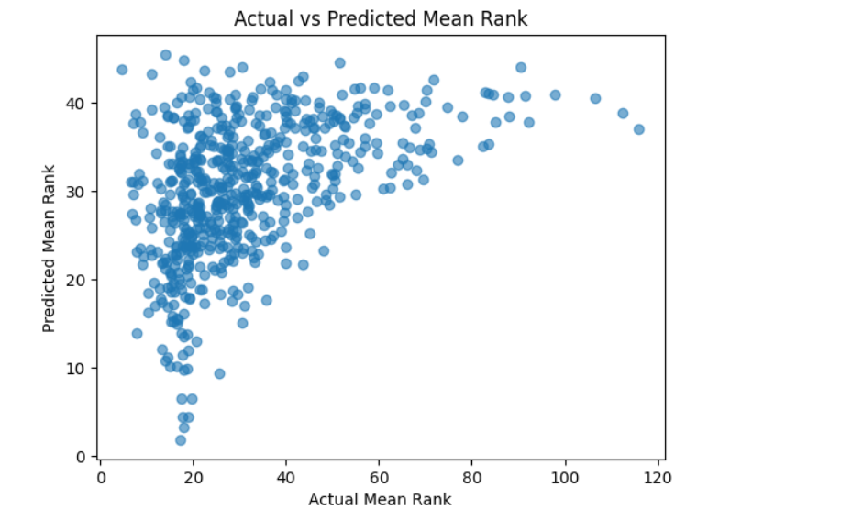
The scatter plot compares true country–season–gender mean ranks to model predictions. Points are widely scattered which shows large prediction error. This is consistent with the low test R squared result which was approximately 0.20, meaning the model captures a weak overall trend but cannot predict precise rankings well.

2)Logistic Regression for predicting Top-20 Performance
To focus on elite outcomes, a logistic regression model was trained to classify whether a country–season-gender group achieved a Top-20 average rank.
The logistic regression model achieved an overall accuracy of approximately 75%. However, because Top-20 cases are relatively rare, accuracy alone does not fully describe model performance.
The confusion matrix came out as:
[[401 19]
[130 57]]
which reveals that the model correctly identifies most non Top-20 cases but it misses a large portion of Top-20 cases, because only 57 out of 188 actual Top-20 cases are correctly classified.

Top-20 class:
Precision = 0.72
Recall = 0.26
F1 = 0.38

The model achieves a precision of approximately 0.72 for Top-20 country-season-gender groups, meaning that when the model predicts a Top-20 outcome, it is often correct. However, the recall is low (0.26), indicating that the model fails to identify a large portion of truly high performing country-season-gender groups.
These results show that the model is effective at recognizing general or lower performance levels but it has limited ability to reliably predict elite outcomes. This suggests that GDP helps explain broad performance patterns but is not sufficient on its own to predict the elite outcomes.

Limitations and Future Work
First, the analysis is done at the country–season level and country-season-gender level, so not at the individual athlete level. This means that strong or weak individual performances may be averaged out, and the results do not fully reflect differences between athletes within the same country.
Second, GDP per capita is a very general measure of a country’s economic situation. While it gives an idea of overall wealth, it does not directly capture factors such as access to climbing gyms, quality of coaching, federation support, or training opportunities, which are likely more important for climbing performance.
Another limitation is that the machine learning models used in this project are simple linear models. This limits their ability to capture more complex or non-linear relationships in the data.

There are several ways this project could be improved or extended in future work.
One possible improvement would be to analyze the data at the athlete level instead of using country-season averages. This could provide a more detailed understanding of how economic factors relate to individual performance.
Future studies could also include additional variables, such as the number of climbing facilities in a country, federation funding, or athletes’ experience levels. These factors may explain elite performance better than GDP alone.
From a modeling perspective, using more advanced machine learning methods could help improve prediction performance.
Lastly, the analysis could be expanded by looking at different climbing disciplines separately as athlete’s preferences can make a difference.

AI Usage
AI was used during the development of this project as a supporting tool for explaining the statistical concepts, checking the code structure and improving the understandability of written explanations.

