

PHARMACOLOGICAL INVESTIGATION
OF EPICATECHIN FROM Chrysophyllum albidum: MOLECULAR MODELING AND BIOLOGICAL EVALUATION OF ITS ANTIPLASMODIAL POTENTIALS
Paul M. Osamudiamen1*, Davies O. Nwude2, Olayinka F. Onifade3, Olubanke Ogunlana4, Mofeli Leoma5, Ogunyemi Oderinlo6, Sunday Ajibade7, Funmi Y. Falope8, Tendamudzimu Tshiwawa9

1Bells University of Technology, Ota, Nigeria, 2Bells University of Technology, Ota, Nigeria, 3Bells University of Technology, Ota, Nigeria, 4Covenant University, Ota, Nigeria, 5Rhodes University, Makhanda, South Africa, 6University of Limpopo, Mankweng, South Africa, 7Redeemer's University, Ede, Nigeria, 8Bells University of Technology, Ota, Nigeria, 9Rhodes University, Makhanda, South Africa
In review

Submitted to Journal:
Frontiers in Malaria

Specialty Section:
Antimalarial Drug Resistance

Article type:
Original Research Article

Manuscript ID:
1797476

Received on:
27 Jan 2026

Revised on:
28 Jan 2026

Journal website link:
www.frontiersin.org



Scope Statement

Medicinal plants contain bioactive constituents that have potential biological abilities, including antioxidative, antimicrobial and antidiabetic abilities. Chyrsophyllum albidum is traditionally used for medicinal purpose and this study is aimed to investigate the antioxidative, antioxidant and, antimalarial potentials of the extracts and isolated compound - epicatechin from the ethyl acetate extract of the stem. The result of the study shows that the extracts of the stem bark Chrysophyllum albidum and its isolated compound - epicatechin show promising therapeutic abilities. We believe that our results will appeal to a broad audience and will be of interest to the readers of your journal.

Conflict of interest statement

The authors declare that the research was conducted in the absence of any commercial or financial relationships that could be construed as a potential conflict of interest

Credit Author Statement
In review

Sunday Ajibade: Formal Analysis, Investigation, Resources, Writing – review & editing. Olubanke Ogunlana: Data curation, Methodology, Project administration, Resources, Supervision, Writing – review & editing. Davies Okechukwu Nwude: Conceptualization, Project administration, Supervision, Writing – review & editing. Funmi Yetunde Falope: Formal Analysis, Methodology, Resources, Writing – review
& editing. Mofeli Leoma: Data curation, Methodology, Software, Writing – review & editing. Ogunyemi Oderinlo: Conceptualization, Data curation, Formal Analysis, Methodology, Writing – review & editing. Olayinka Fisayo Onifade: Investigation, Methodology, Supervision, Writing – review & editing. Paul Matthew Osamudiamen: Conceptualization, Investigation, Project administration, Supervision, Writing – original draft. Tendamudzimu Tshiwawa: Data curation, Formal Analysis, Investigation, Methodology, Writing – review & editing.

Keywords

antimalarial, antioxidant, Chrysophyllum albidum, epicatechin, Plasmodium berghei

Abstract
Word count: 292
Chrysophyllum albidum (Family: Sapotaceae) is used as a traditional folklore medicinal plant. This study is aimed at investigating the antioxidant and antiparasitic effects of C. albidum stem bark extracts on Plasmodium berghei-infected mice through in vitro, in silico and in vivo models. C. albidum stem bark (2 kg) was pulverized and extracted using maceration with n-hexane, ethyl acetate, and methanol, yielding extracts labelled as CASBH, CASBET, and CASBMET, respectively. CASBET was further fractionated to obtain an isolated compound identified as epicatechin. In vitro antioxidant assay was carried out using 2,2-diphenyl-1-picrylhydrazyl (DPPH). In silico antimalarial assay was evaluated using two malaria receptor proteins (4ZCS and 6A2K), linked to Plasmodium falciparum with epicatechin docked into the active site of the two target proteins, while chloroquine and artemether were used as standard drugs. Furthermore, the in vivo antimalarial assay was conducted using fifty male mice divided into ten groups: group I (normal control), groups II-IV (mice treated with distilled water (0.2 mL), chloroquine (10 mg/kg), and epicatechin (10 mg/kg), respectively), and groups V to X (mice treated with 40 and 80 mg/kg of CASBH, CASBET, and CASBMET, respectively). The results revealed that epicatechin (IC50 = 35.54 µg/ml) demonstrated comparable antioxidant activity to gallic acid (IC50 = 28.29 µg/ml) and higher activity than BHT (IC50 = 86.36 µg/ml), and ascorbic acid (IC50
= 112.30 µg/ml). For the in silico study, epicatechin had better interactions with 4ZCS (-7.5 kcal/mol) than chloroquine (-6.8 kcal/mol). Finally, the in vivo study revealed that the ethyl acetate extract (38.0%) at 80 mg/kg bw, had the highest reduction in parasitemia, followed by epicatechin (32.5%) which is higher than chloroquine (23.5%). This research provides detailed chemical and biological insights into C. albidum and its isolated compound epicatechin, which possesses high antioxidant and antimalarial properties.

Funding statement

The author(s) declare that no financial support was received for the research and/or publication of this article.

Ethics statements

Studies involving animal subjects
Generated Statement: The animal study was approved by Covenant Health Research Ethics Committee. The study was conducted in accordance with the local legislation and institutional requirements.

Studies involving human subjects
Generated Statement: No human studies are presented in the manuscript.

Inclusion of identifiable human data
Generated Statement: No potentially identifiable images or data are presented in this study.

Data availability statement

Generated Statement: The datasets presented in this study can be found in online repositories. The names of the repository/repositories and accession number(s) can be found in the article/supplementary material.

Generative AI disclosure

No Generative AI was used in the preparation of this manuscript.
In review

- PHARMACOLOGICAL INVESTIGATION OF EPICATECHIN FROM Chrysophyllum

albidum: MOLECULAR MODELING AND BIOLOGICAL EVALUATION OF ITS
- ANTIPLASMODIAL POTENTIALS
4
5
- Osamudiamen P.M.1, Nwude D.O.1, Onifade F.O.2, Ogunlana O.O.3, Leoma M. B4, Oderinlo
- O.O.5, Ajibade S.O.6, Ahmed S.O.1, and Tshiwawa T.4.
8
9 1Chemical Sciences Dept., (Ind. Chemistry Unit), Bells University of Technology, Ota, Ogun State
- 2Chemical Sciences Dept., (Biochemistry Unit), Bells University of Technology, Ota, Ogun State
- 3Department of Biochemistry, Covenant University, Ota, Ogun State
- 4Department of Chemistry, Rhodes University, Makhanda, South Africa
- 5Department of Chemistry, School of Physical and Mineral Sciences, University of Limpopo,
- Limpopo South Africa
- 6Department of Chemical Sciences, Redeemers University, Ede, Osun State
16
17 Corresponding author: Dr. Osamudiamen P. M. Email: pmosamudiamen@gmail.com,
18 Mobile No: +2348139720375
In review

Abstract
- Chrysophyllum albidum (Family: Sapotaceae) is used as a traditional folklore medicinal plant. This
- study is aimed at investigating the antioxidant and antiparasitic effects of C. albidum stem bark
- extracts on Plasmodium berghei-infected mice through in vitro, in silico and in vivo models. C.
- albidum stem bark (2 kg) was pulverised and extracted using maceration with n-hexane, ethyl
- acetate, and methanol, yielding extracts labelled as CASBH, CASBET, and CASBMET,
- respectively. CASBET was further fractionated to obtain an isolated compound identified as
- epicatechin. In vitro antioxidant assay was carried out using 2,2-diphenyl-1-picrylhydrazyl
- (DPPH). In silico antimalarial assay was evaluated using two malaria receptor proteins (4ZCS and
- 6A2K), linked to Plasmodium falciparum with epicatechin docked into the active site of the two
- target proteins, while chloroquine and artemether were used as standard drugs. Furthermore, the
- in vivo antimalarial assay was conducted using fifty male mice divided into ten groups: group I
- (normal control), groups II-IV (mice treated with distilled water (0.2 mL), chloroquine (10 mg/kg),
- and epicatechin (10 mg/kg), respectively), and groups V to X (mice treated with 40 and 80 mg/kg
- of CASBH, CASBET, and CASBMET, respectively). The results revealed that epicatechin (IC50
- = 35.54 µg/ml) demonstrated comparable antioxidant activity to gallic acid (IC50 = 28.29 µg/ml)
- and higher activity than Butylated hydroxytoluene (IC50 = 86.36 µg/ml), and ascorbic acid (IC50 = 112.30 µg/ml). For the in silico study, epicatechin had better interactions with 4ZCS (-7.5 kcal/mol) than chloroquine (-6.8 kcal/mol). Finally, the in vivo study revealed that the ethyl acetate extract (38.0%) at 80
- mg/kgbw, had the highest reduction in parasitemia, followed by epicatechin (32.5%) which is
- higher than chloroquine (23.5%). This research provides detailed chemical and biological insights
- into C. albidum and its isolated compound epicatechin, which possesses high antioxidant and
- antimalarial properties.
- Keywords: Chrysophyllum albidum, Plasmodium berghei, antimalarial, antioxidant, epicatechin

1.1 BACKGROUND OF STUDY
- Malaria is an acute febrile illness caused by Plasmodium parasites, including Plasmodium ovale,
- P. knowlesi, P. falciparum, P. vivax, and P. malariae, which is transmitted by the Anopheles
- mosquitoes. It is one of the major causes of public concern and has been estimated to cause 0.7-1
- million deaths per year (Venkatesan, 2025). It was recorded in 2018 that 400,500 individuals died
- of cerebral malaria, a neurological complication caused by P. falciparum, which is the deadliest
- form of malaria (Ravindar, et al., 2023; Umar, et al., 2018). Two hundred and twenty-eight million
- clinical cases and 405,000 deaths caused by malaria were recorded in 2018, with 94% of these
- deaths occurring in Sub-Saharan Africa. Sixty-seven percent of the global deaths caused by
- malaria occurred in children under the age of five (Varo, et al., 2020).
- Furthermore, in the first 15 years of the Malarial Millennium project (2000-2015), there was a
- consistent reduction in the malaria burden with significant changes in geographical distribution
- and an overall reduction in malaria mortality. These findings led to a second attempt at malaria
- eradication by the global health community. Between 2016 and 2020, progress in the malaria
- burden seemed impeded, as some countries were making progress in the elimination process while
- others were showing disturbing increasing incidences of malaria (Varo, et al., 2020). Antimalarial
In review
- drug resistance, on the other hand, results in a global comeback of malaria, making a major threat
- to malaria control (Shibeshi, et al., 2020). The reason for ongoing research into new antimalarial
- drugs emanate from the parasites' growing resistance to already available treatments. It is
- anticipated that using active compounds obtained from plants will provide people with efficient
- and safe malarial treatment options since locally used medicinal plants lack validity on their
- efficacy (Umar, et al., 2018). The World Health Organization (WHO) estimates that 80% of people
- in developing countries use traditional medicine for their primary healthcare needs, and medicinal
- plants are the most used and lucrative form of traditional medicine. However, it is important to
- note that the herbal medicine industry is growing rapidly due to the rising cost of synthetic
- pharmaceutical drugs, the perception that natural products are effective without side effects, and
- consumer preference (Zaidi, et al., 2022). WHO also stated that about 35%-40% of the 252
- essential medicines considered for the management and treatment of diseases are of plant origin
71 (Asase, 2023).
- Considering the high attrition rate in traditional drug discovery, in silico-aided drug discovery
- offers an appealing approach to fast-track the delivery of hit/lead compounds and lower the
- attrition rate in drug discovery (Oderinlo, et al., 2022). Molecular docking stands as a pivotal
- computational technique in the realm of drug discovery, serving as an essential tool for predicting
- and understanding the interactions between small molecules (ligands) and target biomolecules,
- predominantly proteins (Sarkar, et al., 2023). This method aids in interpreting the preferred
- orientations and conformations of these molecules, providing critical insights into the binding
- interactions that form stable complexes. In drug discovery, molecular docking plays a multifaceted
- role with far-reaching significance. It serves as the backbone for virtual screening, a process where
- vast databases of compounds are computationally screened to unearth potential drug candidates
- (Li, et al., 2024). One of the distinguishing features of molecular docking lies in its ability to
- predict binding affinities and unveil intricate interaction patterns between a ligand and the

84
85

86
87
88
89
90
91
92
93
94
95
96
97
98
99

100
101
102
103
104
105
106
107
108
109
110
111
112
113
114
115
116
117
118
119
120
121
122
123
124
biological targets, thus offering detailed understanding of how molecules interact with enzymes/proteins, aiding in the optimisation of the hit/lead compounds (Han, et al., 2023).
Phytochemicals such as flavonoids, terpenoids, tannins, and resins have been reported in C. albidum, which is also known as agbalumo in Yoruba, udala in Igbo, and khada in Hausa languages, a medicinal plant belonging to the Sapotaceae family. It is also known as the African star apple, a forest plant species with natural occurrence in the diverse zones of Uganda, Nigeria, and the Niger Republic (Ajayi, et al., 2020; George, et al., 2018). Fruit pulp, skin, and seeds of C. albidum have been reported to contain essential metal ions. It is rich in antioxidants, which aim at promoting good health by getting rid of oxidative stress-related infectious and noninfectious diseases. The leaves have been applied in malaria and yellow fever remedies, cure of stomach aches, and management of diarrhoea (Imaga, et al., 2023). Despite its many therapeutic benefits, there have been cases of anorexia or weakness after the ingestion of the plant extract, thereby limiting its usage (Ezema, et al., 2021). The primary aim of this research is to isolate bioactive compounds from the stem bark of C. albidum using the bioassay-guided method and determine the in vitro antioxidant and in silico and in vivo antimalarial assessment of the extracts and main isolated compounds.
In review

Materials and methods Reagents
Analytical-grade chemicals (hexane, methanol, ethanol, ethyl acetate, dichloromethane, acetone, 2,2-diphenyl-1-picrylhydrazyl (DPPH), sulfuric acid, sodium tungstate, Tris buffer (hydroxyl methyl amine methane), sodium chloride, disodium, dithiobis-25-nitrobenzoic acid (DNTB), ethylene diamine tetra acetic acid (EDTA), thiobarbituric acid (TBA), trichloroacetic acid (TCA), hydrochloric acid (HCl), pyrogallol, and tris-HCl (buffer solution) were bought from a chemical store in Lagos, Nigeria.

Apparatus/Equipment
An analytical weighing balance, UV/Visible spectrophotometer, conical flask, Fourier Transform Infra-Red (FT-IR) spectrometer, 400 MHz Nuclear Magnetic Resonance (NMR) spectrometer, capillary tubes, column chromatographic setup, wash bottles, syringe, measuring cylinder, filter paper, heating mantle, beakers, water bath, and deep freezer are among the tools used. A stoppered glass jar (maceration method).

Ethical approval
This study was approved based on the compliance with ethical standards and the relevant institutional guidelines on the care and use of laboratory by the Research Ethics Committee, with the approval number CHREC/432/2024.

Plant Materials, Collection and Authentication
Fresh C. albidum stem barks were collected from its natural habitat at Atan in the Ado-Odo/Ota Local Government Area of Ogun State, Southwestern Nigeria. Identification of the plant was carried out at the Forestry Research Institute of Nigeria (FRIN), Ibadan, Nigeria (Voucher No. FHI: 1142106). The stem barks were air-dried at room temperature, pulverised using a milling machine and preserved in airtight containers until use.

125
126
127
128
129
130
131
132
133
134
135
136
137
138
139
140
141
142
143
144
145
146

Preparation of the plant extracts and isolation
The powdered stem bark of C. albidum (2 kg) was macerated with n-hexane, ethyl acetate and methanol successively for 24 hours, after which it was filtered (Whatman filter paper No. 1) and each filtrate concentrated in vacuo at 40°C to dryness to give the n-hexane extract (CASBH). ethyl acetate (CASBET) and methanol (CASBMET) extract.

Chrysophyllum albidum (2 kg) powdered stem bark was macerated in 2.5 L of 100% n-hexane for 24 hours with gentle mixing occasionally. The filtrate was then concentrated in a vacuum at 40 ^{O}C until it was dry, yielding the n-hexane extract (CASBHE). The filtrate was filtered using Whatman filter paper No. 1. The marc would be properly spread out, rotated often, and given a full day to dry. To obtain the ethyl acetate extract (CASBEE), 2.5 L of ethyl acetate was added to the marc and left to stand for 24 hours with sporadic shaking. After that, it was filtered and concentrated until it was completely dry. After a day, the dried marc was again extracted using 2.5 L of methanol for 24 hours, and it underwent a similar procedure to produce the methane extract (CASBME). The isolated chemical was produced by using methanol, ethyl acetate, and hexane.

Chromatographic techniques
The ethyl acetate extract (CASBET) was subjected to column chromatography using silica gel (70–230 mesh) as an adsorbent and eluted with hexane in increasing proportions of ethyl acetate (5% ethyl acetate in 95% n-hexane to 100% ethyl acetate) and thereafter with ethyl acetate in increasing proportions of methanol. Twenty-four fractions were collected in all and pooled together based on TLC analysis to give seven sub-fractions, F1 to F7.
Sub-fraction 3 (F3) was again further purified using a micro column (silica gel, 70-230 mesh) and eluted with 10% methanol in dichloromethane to obtain six (6) fractions (C1-C6). Sub-fractions C2
– C5, which gave a single spot on TLC, were then pooled together to obtain compound 1. The isolated compound was subjected to 1D and 2D NMR and FT-IR spectroscopic techniques to fully characterise it.
In review

Antioxidant activities
The DPPH antioxidant assay was carried out according to (Osamudiamen, et al., 2020). A DPPH solution (0.1 mM) in methanol was prepared, and 1 ml of this solution was added to 0.5 mL of different concentrations (200-12.5 µg/mL) of the extracts. The reaction mixture was left in the dark at room temperature for 30 minutes, after which the absorbance was read at 517 nm. The percentage inhibition of DPPH activity was obtained using the equation below:

% inhibition = 𝐴0−𝐴𝑆
𝐴𝑆
×100 Equation 1

147
148
149
150
151
152
153
154
155
156
157
158
159
160
161
162
163
164
Where Ao is the absorbance of the control and As is the absorbance of the samples.

Protein preparation
Molecular docking is a widely used computational approach for modelling the interactions between small molecules and target proteins at the atomic level, thereby aiding in the identification of novel drug candidates (Mokgopa, et al., 2024; Hegde, et al., 2024). This study meticulously examined the potential antimalarial properties of epicatechin through molecular docking, using BioVia Discovery Studio and Auto Dock Vina tools (Ukonu, 2023) and molecular docking simulations were performed using Schrödinger software 2021 Maestro (Tumakuru, et al., 2024). Critical to the docking process was the protein preparation step, which involved BioVia Discovery Studio removing water, previous ligands, and other unwanted molecules and adding polar hydrogen to the protein. The receptor proteins (PDB IDs: 4ZCS and 6A2K), linked to P. falciparum malaria, were obtained from the Protein Data Bank (https://www.rcsb.org) (Kundu, et al., 2018). These proteins have been characterised and published, affirming their significance in malaria research. Visualisation of the docking results was achieved using BioVia Discovery Studio (Yuan, et al., 2017; Kundu, 2018), aiding in the detailed interpretation of the molecular interactions between epicatechin and the receptor proteins.

165

166
167
168
169
170
171

172

173
174

175
176
177
178
179
180
181

182
183
184
185
186

187
188
189
190
191
192

193
194
195
196
197
198
199
200
201
202

Molecular Dynamics Simulation
Molecular dynamics (MD) simulations were carried out using the Desmond package implemented in Schrödinger Maestro. The MD simulations were performed under default conditions with constant pressure (1.01325 bar) and temperature (300 K) (Hegde, et al., 2024). Approximately 1000 frames were generated, with trajectories recorded at 100 ps intervals and an energy tolerance of 1.2 kcal/mol. The OPLS_2005 force field was applied, and the complexes were equilibrated using the Brownian dynamics NPT ensemble (Hegde, et al., 2024)

Density Functional Theory (DFT)
The calculations were performed with the Gaussian 09 software package with a basis set of B3LYP/6-31+G(d,p).

Pharmacokinetic property predictions
SwissADME (http://www.swissadme.ch/) and ProTox (https://toxnew.charite.de/protoxII/) web tools were employed to evaluate the pharmacokinetics, drug-likeness, and toxicity features (ADMET) of the hit compounds and reference ligands. The ligands' canonical SMILES were uploaded to both servers (Banerjee, et al., 2024; Daina, et al., 2017), generating the relevant ADMET parameters automatically. This analysis provided insights into the compounds' pharmacokinetic properties, drug-likeness, and potential toxicity.
In review
Antimalarial in vivo studies
A total of fifty (50) Swiss albino mice weighing between 18 and 24 g (male) were purchased from the Animal House, Nigeria Institute of Medical Research (NIMR), Yaba, Lagos, Nigeria. They were housed in aluminium cages exposed to a 12-hour day/night cycle and fed with grower’s mash and clean water with acclimatisation for at least two weeks before use.

Parasite
A donor mouse infected with P. berghei berghei NK 65, maintained by serial intraperitoneal passaging in mice, was obtained from NIMR Lagos. The mouse was euthanised after attaining at least 30% parasitaemia; the blood obtained was diluted to 0.2 ml containing 1 × 107 infected erythrocytes. Each of the acclimatised and grouped mice was inoculated with 0.2 ml of the diluted blood.

Experimental animal
The mice were divided into ten groups, with five mice per group (n = 5). In each case, diluted parasitaemic blood was injected into the animals based on their body weight from groups II to X. Briefly, an inoculum of 0.2 mL of diluted blood containing 1 × 10⁷ P. berghei-parasitised red blood cells were administered intraperitoneally to each of the forty-five (45) test mice, which were then randomly assigned to nine groups (II–X). The normal control group (Group I) received a normal diet. Two hours later, mice in Groups II to IV were orally administered distilled water (0.2 mL), chloroquine (10 mg/kg, p.o.), and epicatechin (10 mg/kg, p.o.), respectively. Groups V to X received 40 and 80 mg/kg of the n-hexane (CASBH), ethyl acetate (CASBET) and methanol (CASBMET) extracts, respectively.

203
204
205
206
207
208
On the fifth day, blood smears were prepared from tail vein blood samples, fixed with methanol, stained with Giemsa, and examined under a microscope to determine the percentage parasitaemia per dose. The mice were further observed for 28 days post-treatment to monitor mortality, which was recorded accordingly. The mice were anesthetized using ketamine injection intraperitoneally at the dosage of 100 mg/kg body weight.
Table 1: Experimental design for in vivo antimalarial

Group Label Dosage (mg/kg body weight)

  - Normal control
(Non-parasitaemic mice)
Regular feed

  - Parasitaemic mice 0.2 ml P. berghei + water
  - Parasitaemic mice 0.2 ml P. berghei + 10 mg/kgbw Chloroquine IV Parasitaemic mice 0.2 ml P. berghei + 10 mg/kgbw Epicatechin V Parasitaemic mice 0.2 ml P. berghei + 40 mg/kgbw CASBH
VI Parasitaemic mice 0.2 ml P. berghei + 80 mg/kgbw CASBH VII Parasitaemic mice 0.2 ml P. berghei + 40 mg/kgbw CASBET VIII Parasitaemic mice 0.2 ml P. berghei + 80 mg/kgbw CASBET IX Parasitaemic mice 0.2 ml P. berghei + 40 mg/kgbw CASBMET X Parasitaemic mice 0.2 ml P. berghei + 80 mg/kgbw CASBMET
In review

209

210
211
212
213
214
215
216
217

Average percentage parasitaemia and the median effective doses
Each of the Giemsa-stained blood smears was viewed under the microscope using the oil immersion (x 100) objective, and ten fields with uniform distribution of red cells were counted. For each of the fields selected, the numbers of parasitised red blood cells (PRBC), as well as unparasitised red blood cells (UPRBC), were counted. The percentage parasitaemia for each field will be calculated from the number of parasitised red blood cells divided by the total number of counted red blood cells, multiplied by 100. The average value obtained for each mouse and subsequently for each group of the five mice will be calculated and recorded as the mean percentage parasitaemia for each group.
% �𝑎�𝑎�𝑖�𝑎��𝑖𝑎 𝑁𝐶 − % �𝑎�𝑎�𝑖�𝑎��𝑖𝑎 𝑇

% �ℎ����������𝑖�� = 100 (
% �𝑎�𝑎�𝑖�𝑎��𝑖𝑎 𝑁𝐶
) Equation 2

218
Where NC is the negative control and Td is the test dose.

219
220
221
222
223

Survival times and percentage survivors
The treated mice were observed for mortality for 28 days from the day of drug administration in order to determine the survival times and percentage of survivors elicited by the extracts in the mice. The survival time for each mouse was recorded in days, and the average for each group was determined as days ± SEM. The percentage of survivors, or survival rate, for each group was

224
225

226
227
228

229

230
231
232
233
234

235
236

237
238
239

240
241
242
243
244
245
246
247
248
249
250
251
252
253
254
255
256
estimated from the average survival time as the percentage of mice eliciting survival time that falls within the average for the whole group.

Statistical analysis
All values were expressed as the mean ± standard error of the mean (SEM). Data were analyzed using one-way ANOVA using GraphPad Prism. Values were considered statistically significant at 𝑃 < 0.05.

Results
Elucidation of epicatechin
The isolated compound was brown amorphous powder; it gave a positive test with ferric chloride, indicating the presence of phenolic groups, which are typical of polyphenols and tannins. The infrared (KBr, νmax, cm⁻¹) spectrum showed a broad peak at 3458.21 cm⁻¹, indicating O-H stretch, and 1639.90 cm⁻¹, indicating C=C stretch.
1H NMR (400 Hz, MEOD) δ: 7.05 (1H, s), 6.80 (1H, d, J = 8.4 Hz), 6.76 (1H, d, J = 8.1 Hz), 6.52
(0H, s), 4.17 (1H, d, J = 4.0 Hz), 2.86 (1H, dd, J = 16.8, 4.7 Hz), 2.74 (1H, dd, J = 16.8, 3.0 Hz).
In review

13C NMR (100 Hz, MEOD) δ: 78.48 (C-2), 66.1 (C-3), 27.88 (C-4), 156.27 (C-5), 94.98 (C-6),
156.62 (C-7), 94.48 (C-8), 155.98 (C-9), 98.67 (C-10), 130.89 (C-1’), 114.50 (C-2’), 144.55 (C-
3’), 144.85 (C-4’), 113.92 (C-5’), 118 (C-6’) as represented in figure 2.

The 1H NMR spectrum (Figure 1) showed that the ring A-aromatic protons indicated H-6 and H- 8 coupling in a meta position, with each yielding a doublet at δH 5.94 and 5.92 (d, 2.3 Hz, each). The spectrum also showed the signals of the B-ring aromatic protons are of the ABX-type, with the methine proton at H-5’ being split by H-6’ in an ortho position, yielding a doublet at δH 6.76 (d, J = 8.1 Hz), and H-6’ also being split by H-5’, giving a doublet at δH 6.80 (d, J = 8.4 Hz).
These signals attributed to ring C are the protons at H-4, which were split by H-3 and gave a doublet of doublets at δH 2.74 (dd, J = 3.03, 16.84 Hz) and δH 2.86 (dd, J = 4.73, 16.78 Hz). The position of the H-2 chemical shift (δH 4.83) suggests that the flavan structure possesses the correct cis-2,3 stereochemistry, typical of epicatechin structures. This was supported by the small value for the coupling constant (< 1 Hz) of the H-2 by H-3 proton, which appeared as a broad singlet at H-2 (δH 4.83).
The 13C NMR (Figure 2) and DEPT spectra (SI) showed fifteen carbon signals, which consisted
of one methylene, seven methine and seven quaternary carbons. These signals were as follows:
δ = 78.5 (C-2), 66.1 (C-3), 27.9 (C-4), 156.3 (C-5), 95.0 (C-6), 156.6 (C-7), 94.5 (C-8), 160.0
(C-9), 98.7 (C-10), 130.9 (C-1’), 114.5 (C-2’), 144.6 (C-3’), 144.9 (C-4’), 114.0 (C-5’), 118.0
(C-6’). These data led to the elucidation of the isolated compound as epicatechin (Figure 3), shown below.

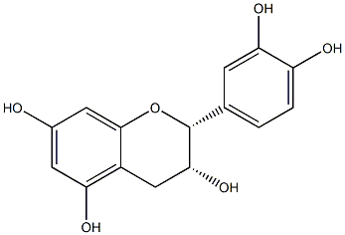
257

258
Figure 1 3: Structure of epicatechin (molecular formula: C15H14O6)

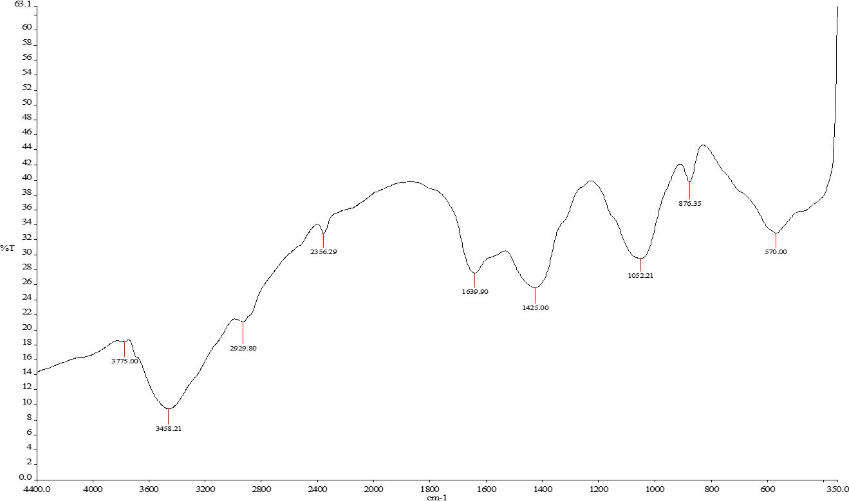

Figure 2: FT-IR Spectrum of the compound

Figure 3: ¹H NMR Spectrum (400 MHz, MeOD) of the compound

264
265

Figure 4: ¹³C NMR Spectrum of the compound

Figure 5: DEPT-135 Spectrum of the compound

Antioxidant activities

The result of the DPPH antioxidant activity of C. albidum stem bark extracts and epicatechin is shown in Figure 4. The results demonstrated that the ethyl acetate extract (IC50 = 20.86 µg/ml) exhibited the highest antioxidant activity, while the isolated compound epicatechin (IC50 of 35.54
In review
µg/ml) showed a comparable activity to the standard drug gallic acid (IC50 = 28.29 µg/ml).
120
112.3
100
86.36
80
60
45.96
CASBH
CASBET CASBMET
Epicatechin
Ascorbic acid
40
38.18
35.54
28.29
20.86
Gallic acid
BHT
20
0
Concentration (µg/ml)

Figure 2 4: Antioxidant activities of C. albidum stem bark extracts and epicatechin in comparison with the standards. Values were expressed as mean ± SEM. Differences were considered significant at p<0.05
Analysis of in-silico molecular docking simulation
The molecular docking analysis involved assessing the interactions of epicatechin with malaria protein receptors 6A2K and 4ZCS. The results obtained from the docking analysis were presented in Table 2, providing crucial information about the binding affinity of epicatechin to the specified receptors. These interactions offer valuable insights into the high activity of epicatechin. Epicatechin had a high docking score of -9.64 Kcal/mol with protein 6A2K and a docking score of -7.67 Kcal/mol with protein 4ZCS. The co-crystal molecules had high docking scores; it was -
11.23 Kcal/mol for 6A2K and -12.97 Kcal/mol for 4ZCS. The amino acids and interactions are

275
276
277
278
279
also shown on the table; epicatechin only had hydrogen bond interaction for 6A2K and hydrogen bond and pi-pi stacking bond for 4ZCS.

Table 2: Docking score and detailed interactions of epicatechin and reference molecule

Protein Binding
affinity (kcal/mol)
Amino acids Interactions

Epicatechin
6A2K -9.64 SER 108, SER 111, ILE 112, PRO 113,
LEU 119, ILE 14, CYS 15, ALA 16,
PHE, MET 55, THR 185, ASP 54, ILE
164, GLY 165, GLY 44, TRP 48, LEU
46, VAL 45
4ZCS -7.67 HIE 630, ASP 627, TYR 626, VAL 625,
GLY 624, TYR 714, LYS 663, HIP 709,
In review
ASP 710, THR 753, ARG 755, GLU
757, GLN 636, HIE 633, GLY 632
Hydrogen bond

Hydrogen bond, Pi-Pi stacking bond

Co-crystal molecule
6A2K -11.23 CYS 15, ALA 16, ILE 164, GLY 165,
GLY 166, SER 167, VAL 168, TYR
170, GLU 172, VAL 146, LYS 145,
LEU 127, SER 128, THR 139, LEU
131, GLY 105, THR 107, SER 108

4ZCS -12.97 CYS 690, PRO 691, TRP 692, ILE 740,
TYR 741, TYR 714, LYS 663, HIP 709,
ASP 710, GLN 754, ARG 755, THR
756, GLN 636, HIE 633, GLY 632, SER
760, VAL 759, ASP 627, VAL 625,
THR 654
Hydrogen bond

Hydrogen bond

Artemether 4ZCS -8.4 LYS:E:663, VAL:E:625, ARG:E:755,
ASP:E:710, HIS:E:633

Chloroquine 4ZCS -6.8 THR:E:756, HIS:E:630, ARG:E:755,
ASP:E:627, MET:E:628

280
281
282
283
284
285

286
287
288
289
290
291
292
293
294

295
296
297
298
299
300
301
302
303
304
305
306
307
308

Protein-Ligand Interactions
The 2D diagrams were used to illustrate the binding of epicatechin with proteins 6A2K and 4ZCS. Figure 5 shows that both proteins form a stabilising hydrogen bond with epicatechin, and also a pi-pi stacking bond was observed with protein 4ZCS. In Figure 5(a), epicatechin shows direct interaction with the amino acids ILE 164 and ASP 54 of protein 6A2K. Interestingly, in Figure 5(b) the amino acid THR 756 of protein 4ZCS shows direct interaction with epicatechin, and HIE 633 shows pi-pi stacking bonding with its aromatic ring. However, epicatechin had more hydrogen bond interactions with protein 6A2K; we may assume that this is the reason it had a high docking score of -9.64 kcal/mol compared to 4ZCS with a docking score of -7.67 kcal/mol.

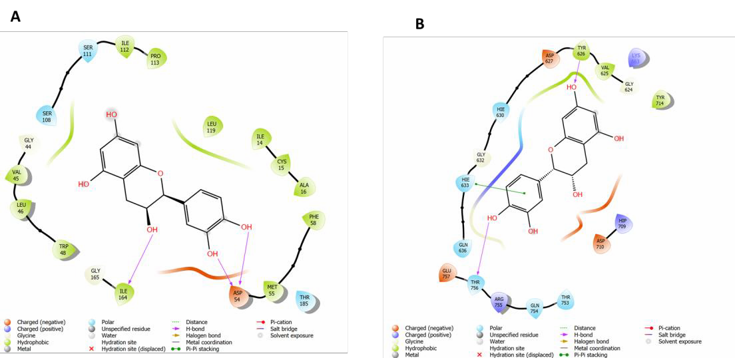
Figure 5: The 2D- interactions for epicatechin with (a) 6A2K and (b) 4ZCS
In review

Molecular dynamics (MD) simulations
Root Mean Square Deviation (RMSD) Analysis
The RMSD plot for the molecular dynamics (MD) simulations of the protein 6A2K, which had the highest binding energy with epicatechin, is shown. RMSD is a key metric used to evaluate the average change in displacement of a selection of atoms for a specific frame across the trajectory relative to a reference frame, thereby providing insight into the structural stability of the complex over time (Details, et al., 2023; Hollingsworth & Dror, 2018). In this study, the calculations were performed based on the Cα atoms for 100 ns simulation. From Figure 6, it is evident that the system has achieved stability below 4.8 Å with minor fluctuations throughout the simulation (Matondo, et al., 2022). It is important to note that epicatechin remained bound with the active site of the protein throughout the trajectory, as shown by the RMSD distance between the protein and the ligand (Hegde, 2023).

309
310
311
312
313
314
315
316
317

318
319

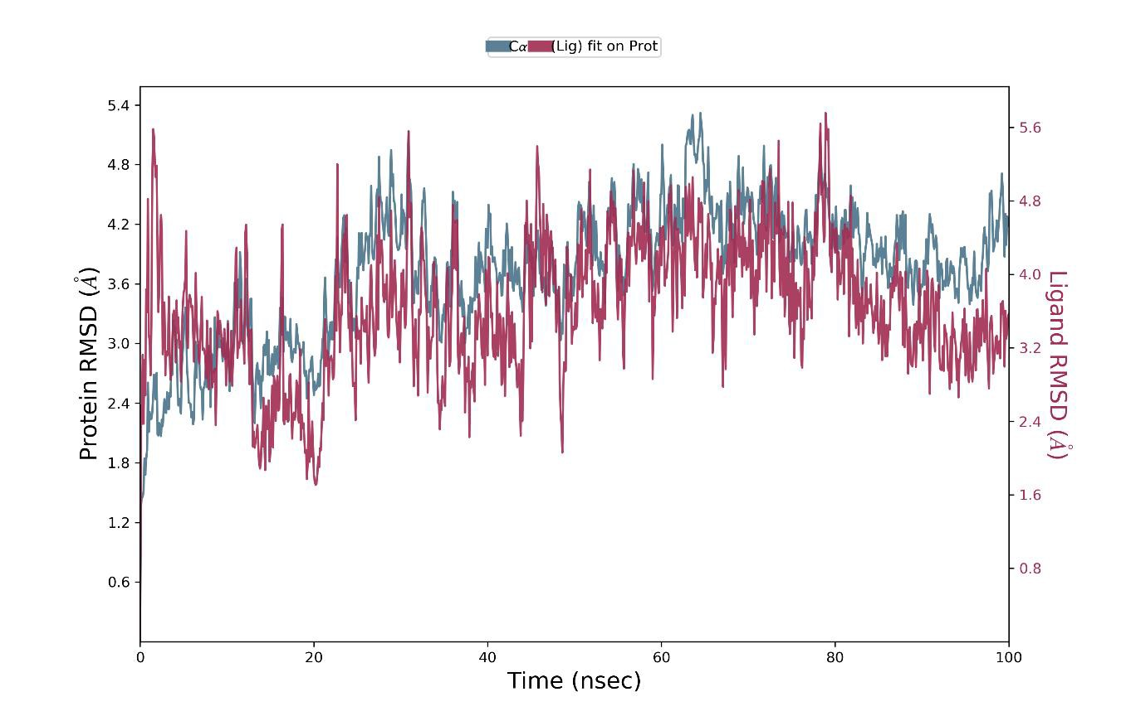
Figure 6: The RSMD simulations plot for epicatechin with protein 6A2K
In review

Protein-ligand contact profile
To further clarify the interactions between the protein residues and molecules, we analysed the protein-ligand contact profile. In Figure 7, the strongest interaction was a combination of hydrogen and hydrophobic bonds, with the amino acid ASP 54 above 2.0 (Khan, 2019; Hegde, 2023). We may assume that these interactions significantly contributed to the high docking score between epicatechin and the protein. The rest of the interactions were hydrogen, water bridges and hydrophobic bonds, which were all below 1.0.

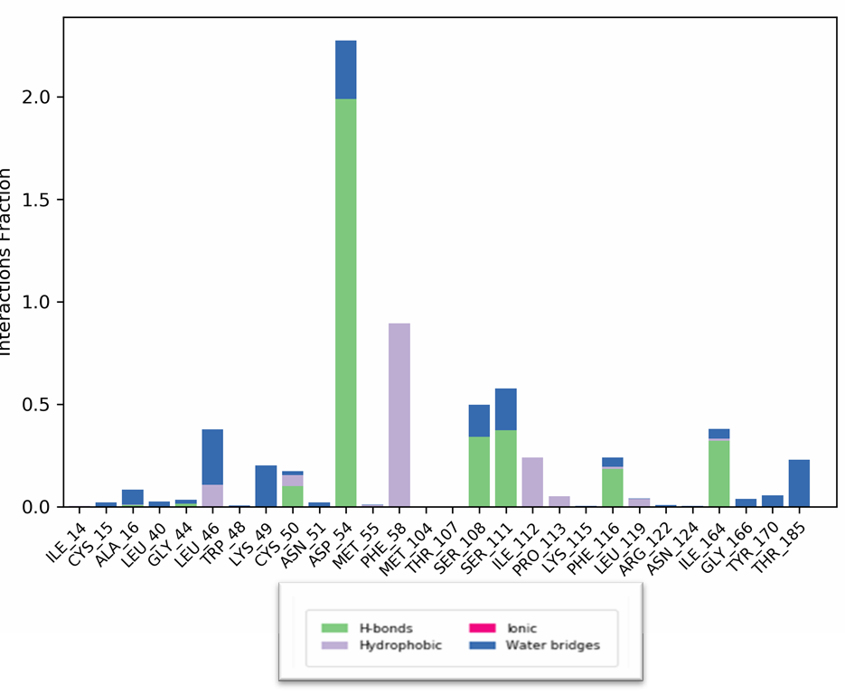

Figure 7: Protein-ligand contact plot for the molecule and 6A2K

320
321
322
323
324
325
326
327
328
329
330
331
332
333
334
335
336
337
338
339
340
341
342

Absorption, Distribution, Metabolism, and Excretion (ADME)
Information on the drug-likeness, pharmacokinetic, and ADMET (Absorption, Distribution, Metabolism, Excretion, and Toxicity) properties of a compound can help predict its drug ability. In drug discovery, the primary goal is to identify the hit compounds with the favourable drug-like properties (Mokgopa, et al., 2024; Tumakuru, et al., 2024). The ADME is utilised to assess key physicochemical properties, including absorption, distribution, metabolism and excretion. Table 3 summarises the calculated pharmacokinetic and physicochemical properties. The theoretical results indicate that epicatechin fully complies with Lipinski’s rule of five, as it had zero violations (Verma, 2019). The molecular weight was 290.3 Da, which is within the acceptable limit of 500. The number of hydrogen bond acceptors (HBA) was 5.4, which is below 10, and the number of hydrogen bond donors (HBD) was exactly 5; these were also within the acceptable limits. Further analysis shows that the aqueous solubility (QPlogS) also falls within the allowed range (<0.5) as it is -2.582 (Verma, 2019).
The QPlogKhsa is -0.104, which is within the permissible range (-1.5 to 1.5), which suggests no violation of human serum albumin binding. Additionally, the human oral absorption is predicted to be medium with a score of 2 (Tumakuru, et al., 2024). The oral bioavailability was also not violated, as the polar surface area (PSA) was 113, which is within the acceptable range of 7.0-
In review
200.0. It also exhibited high absorption values and lacked the ability to permeate the blood-brain barrier. Additionally, it demonstrated low liver toxicity. Overall, the molecule is orally active and has no violation of Lipinski’s rule of five, and this confirms an excellent pharmacokinetic profile (Mokgopa, et al., 2024). Thus, the ADMET properties of epicatechin suggest that it could be considered a possible drug candidate.
Table 3: Physiochemical parameters of epicatechin

Physiochemical parameters
MW(Da) | 290.3
logPo/w (MLOGP) | 5.860
HBA | 5.400
HBD | 5
Rule of five | 0
PSA (Å2) | 113.2
QPlogPw | 8.441
QPlogPo/w | 0.443
QPlogS | -2.582
QPlogBB | -1.851
QPPMDCK | 23.240
QP logKp | -4.642
QPlogKhsa | -0.104
Human Oral Absorption | 2
Percent Human Oral Absorption | 61.242
343

344
345
346
347
348
349
350
351
352
353
354

Density Functional Theory (DFT)
Density Functional Theory (DFT) calculations were performed to gain understanding of the chemical reactivity of the molecule (Matondo, et al., 2022). In this section, the focus was on computing the quantum mechanical parameters such as highest occupied molecular orbital energy (HOMO), lowest unoccupied molecular orbitals (LUMO) and energy gaps of the ligands. These parameters play an important role in interpreting molecular reactivity (Hussein & Azeez, 2023). The HOMO is associated with sites prone to nucleophilic interactions, while the LUMO is favourable for electrophilic interactions. The HOMO-LUMO gap was calculated to be approximately 5.70 eV, which suggests that the molecule has quite high energy to transition from the ground state to an excited state (Matondo, et al., 2022).
Table 4: The HOMO and LUMO Energies (in a.u.) and the energy gap

Parameters | Molecule
𝜀𝐻𝑂�𝑂 | -0.21844
𝜀�𝑈�𝑂 | -0.00915
∆𝐸𝐻−� (eV) | 5.70

355
356
357
358
359
360

361
362
363
364
365
366
367
368
369
370

Frontier Molecular orbitals
In review
The HOMO is localised around the aromatic ring; this indicates that the region is electron dense, and this contributes to the electron-donating character (Mokgopa, et al., 2024; Tumakuru, et al., 2024). The LUMO extends across the other aromatic ring. This distribution indicates that the region is mostly favourable for electron acceptance.

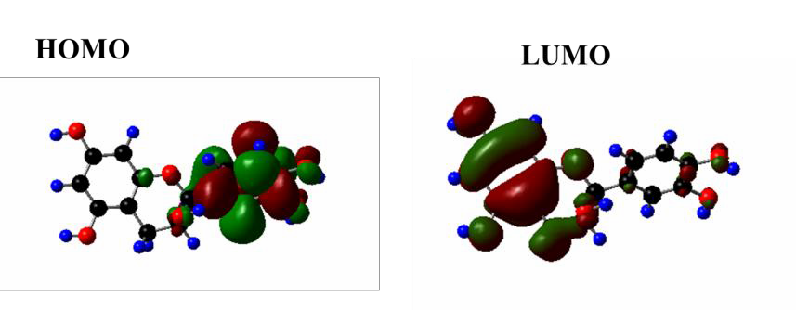
Figure 8: The frontier orbital The HOMO and LUMO

Molecular electrostatic potential (MEP)
The molecular electrostatic potential (MEP) is a valuable tool for visualising the distribution of charges within a molecule (Mokgopa, et al., 2024; Matondo, et al., 2022). In Figure 9, different colours are shown; the blue colour indicates a positive region which is favourable for nucleophilic interactions, and the red colour indicates negative potential which is favourable for electrophilic interactions. Overall, the oxygen atoms appear to be strong donors in red regions, while hydrogen atoms are electron-deficient and appear in blue zones. The MEP helps to predict reactive sites, which gives insights into the ligand-receptor interactions (Matondo, et al., 2022).

371
372
373
374
375
376
377
378
379
380
381

382

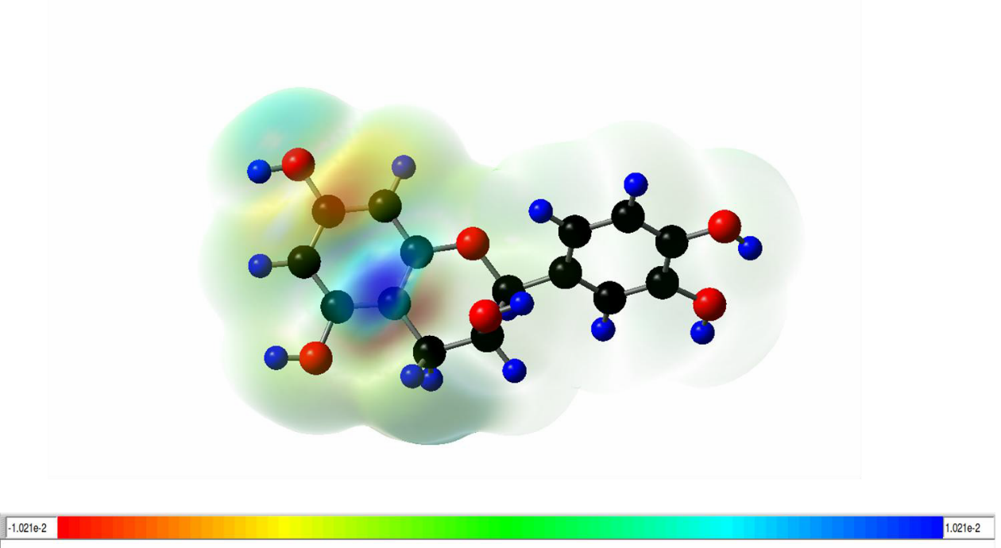
Figure 9: Molecular electrostatic (MEP) plot for epicatechin
In review
Antimalarial in vivo studies
The ethyl acetate extract of C. albidum showed the highest reduction in parasitemia (38%) at 80 mg/kgbw compared to chloroquine (23.5%). The methanol extract also showed moderate efficacy, with parasitemia reductions of 34.7% at 80 mg/kgbw. Epicatechin demonstrated a 32.5% reduction in parasitemia at 10 mg/kgbw, which was even higher than that of chloroquine at the same dosage. The ethyl acetate extract’s high efficacy could be attributed to the presence of the bioactive compound(s) which interfere with the parasite’s lifecycle. Epicatechin's antimalarial activity, which was higher than that of chloroquine, indicates its potential as an adjuvant therapy. The safety profile of the extracts was comparable to chloroquine, with no significant toxicity observed.
Table 5: Results of the Chrysophyllum albidum stem bark parasitemia counts

 | Groups | % Suppression treatment 5 | % Suppression treatment 8
 | Normal control | 0 | 0
 | Negative control | 30.0 | 50.0
 | Chloroquine (10 mg/kgbw) | 21.5 | 23.5
 | Epicatechin (10 mg/kgbw) | 19.0 | 32.5
 | N-Hexane (40 mg/kgbw) | 8.83 | 16.7
 | N-Hexane (80 mg/kgbw) | 18.5 | 21.2
 | Ethyl Acetate (40 mg/kgbw) | 23.5 | 28.5
 | Ethyl Acetate (80 mg/kgbw) | 19.0 | 38.0
 | Methanol (40 mg/kgbw) | 22.5 | 24.5
 | Methanol (80 mg/kgbw) | 24.0 | 34.7
383
384

385
386
387
388
389
390
391
392
393
394
395
396
397
398

399
400
401
402
403
404
405
406
407
408
409
410
411
412
413
414
415
416
417
418
419
420
421
422
423
424
425
426

Discussion
Malaria is a major public health concern in sub-Saharan Africa, although it is preventable and can be cured. The resistance prevalent to most antimalarial drugs has led to the search for alternative treatments. C. albidum, also known as African star apple, belongs to the family Sapotaceae and is used in traditional folklore medicine to cure various diseases. Antimalarial drug resistance, on the other hand, results in a global comeback of malaria, making a major threat to malaria control (Shibeshi, et al., 2020). Malaria treatment drugs like chloroquine and artemisinin originated from plant sources (Orijajogun, et al., 2013). The nutritional value and potency of the different parts of the plant, C. albidum, have long been established (Arueya & Ugwu, 2017). By foraging for free radicals, increasing endogenous antioxidant enzyme level, and decreasing lipid peroxidation, the antioxidant properties of the plant develop (Adebayo, et al., 2011). C. albidum has by far been put into numerous uses aside from its pharmacological and clinical uses. It has been used in the production of marmalade, soft drinks, and syrup. Its high pectin content also suggests plasma cholesterol level reduction (Ajayi, et al., 2020).
Successive solvent extraction of the stem bark of C. albidum and subsequent column chromatography led to the isolation of a brown amorphous compound identified as epicatechin via chemical analysis, IR, and NMR spectroscopy. The infrared spectrum showed a broad peak at 3458.21 cm⁻¹ indicating O-H stretch and 1639.90 cm⁻¹ indicating C=C stretch. The 1H NMR spectrum showed that the ring A-aromatic protons indicated H-6 and H-8 coupling in a meta position, with each yielding a doublet at δH 5.94 and 5.92 (d, 2.3 Hz, each). The spectrum also showed the signals of the B-ring aromatic protons are of the ABX-type, with the methine proton at H-5’ being split by H-6’ in an ortho position, yielding a doublet at δH 6.76 (d, J = 8.1 Hz), and H-6’ also being split by H-5’, giving a doublet at δH 6.80 (d, J = 8.4 Hz). These signals attributed to ring C are the protons at H-4, which were split by H-3 and gave a doublet of doublets at δH 2.74 (dd, J = 3.03, 16.84 Hz) and δH 2.86 (dd, J = 4.73, 16.78 Hz). The position of the H-2 chemical shift (δH 4.83) suggests that the flavan structure possesses the correct cis-2,3 stereochemistry, typical of epicatechin structures (Anitha, et al., 2021).
In review
Among the extracts, CASBET showed excellent antioxidant activity, even more than the most active standard (i.e., gallic acid). It is not surprising that epicatechin isolated from the CASBET fraction displayed good antioxidant activity. It could be rationalised that epicatechin in synergy with other components of the CASBET extract was responsible for the excellent antioxidant activity exerted by the extract. It is well-established that polyphenols such as flavonoids, phenols, and saponins possess very good antioxidant properties (Odutayo, et al., 2020). Furthermore, these antioxidant phytochemical constituents are predominantly polar and can act as radical scavengers either through an electron-donating mechanism or a hydrogen-donating mechanism (Rahman, et al., 2015).
From a molecular docking perspective, epicatechin displayed the best binding affinity with the protein 6A2K, a malarial dihydrofolate reductase protein. It formed three stabilising hydrogen bonds with the amino acids ASP 54 and ILE 164 via the hydroxyl groups of the rings B and C, respectively. The better binding profile of epicatechin to this enzyme may be predicated on this extensive hydrogen bonding. On the other hand, epicatechin engaged in pi-pi stacking interaction with the amino acid HIE 633 of the protein 4ZCS through its aromatic ring B. In addition, it formed

427
428
429
430
431
432
433
434
435
436
437
438
439
440
441
442
443
444
445

446
447
448
449
450
451
452
453
454
455
456
457
458
459
460
461
two hydrogen bonds with the amino acids TYR 626 and THR 756 with the aromatic rings A and B, respectively. Furthermore, the RMSD analysis showed that epicatechin remained bound to the active site of the protein throughout the analysis. The ADMET analysis provides a comprehensive view of how a molecule would interact and behave when it enters the body (En-Nahli, et al., 2023). Epicatechin exhibited high absorption values, and it can be distributed throughout the body. However, it lacked the ability to permeate the blood-brain barrier. Additionally, epicatechin demonstrated low liver toxicity. The ADMET properties of epicatechin suggest that it could be considered a possible drug candidate.
This study also evaluated the in vivo antimalarial efficacy of epicatechin and C. albidum extracts (hexane, methanol, ethyl acetate) in comparison with the standard drug chloroquine. The ethyl acetate extract of C. albidum showed the highest reduction in parasitemia (38%) at 80 mg/kgbw, comparable to chloroquine (23.5%). Methanol extract also showed moderate efficacy, with parasitemia reductions of 34.7% at 80 mg/kgbw. Epicatechin demonstrated a 32.5% reduction at 10 mg/kgbw, which was even higher than that of chloroquine (23.5%) at the same dosage. The ethyl acetate extract’s high efficacy could be attributed to the presence of the bioactive compound(s) which interfere with the parasite’s lifecycle. Epicatechin's antimalarial activity was higher than that of chloroquine, indicating its potential as an adjuvant therapy. The safety profile of the extracts was comparable to chloroquine, with no significant toxicity observed. The results from this study agree totally with the results from the in silico studies.
In review

Conclusion
The assays conducted to evaluate antioxidant activity unequivocally demonstrated the robust free radical scavenging capabilities of C. albidum extracts. Notably, epicatechin emerged as a potent antioxidant, effectively neutralising oxidative stress markers. Furthermore, epicatechin demonstrated a striking reduction in parasitemia higher than that of chloroquine at the same dosage. Our study has shown that epicatechin had good binding scores of -9.64 Kcal/mol with protein 6A2K and a docking score of -7.67 Kcal/mol with protein 4ZCS. Further light was shed on the in-silico insights using molecular dynamics simulations, which confirmed that the molecule remained in the binding pocket of the protein active site. In addition, pharmacokinetic analysis also demonstrated that the molecule exhibits favourable drug-like properties, and chemical reactivity analysis, frontier molecular orbitals and molecular electrostatic potentials were performed and used to evaluate the reactivity characteristics of the molecule. These findings suggest that epicatechin could be probed further as a potential template in antimalarial drug discovery and further harness C. albidum as a formidable natural resource for combating oxidative damage implicated in various disease states.

462

463
464
465

REFERENCE

Adebayo, A. et al., 2011. Antioxidant activities of the leaves of Chrysophyllum albidum. Pakistan Journal of Pharmaceutical Science, 24(4), pp. 545-551.

466
467
468
Ajayi, A. M., Chidebe, E. O., Ben-Azu, B. & Umukoro, S., 2020. Chrysophyllum albidum (African star apple) fruit-supplemented diet enhances cognitive functions and attenuates lipopolysaccharide-induced memory impairment, oxidative stress, and release of proinflammatory cytokine. Nutrire, 45(2), p. 20.

469
470
471
Anitha, S., Krishnan, S., Senthilkumar, K. & Sasirekha, V., 2021. A comparative investigation on the scavenging of 2,2-diphenyl-1-picrylhydrazyl radical by the natural antioxidants (+) catechin and (-) epicatechin. Journal of Molecular Structure, Volume 1242, p. 130805.

472
473
474
Arueya, G. L. & Ugwu, G. F., 2017. Development and evaluation of African star apple (Chrysophyllum albidum) based food supplement and its potential in combating oxidative stress. Journal of Functional Foods, Volume 33, p. 376–385.

475
476
Asase, A., 2023. Ghana’s herbal medicine industry: Prospects, challenges and ways forward from a
developing country perspective. Frontiers in Pharmacology, Volume 14, p. 126739.

477
478
479
Banerjee, S. et al., 2024. Fragment-based investigation of thiourea derivatives as VEGFR-2 inhibitors: A cross-validated approach of ligand-based and structure-based molecular modeling studies. Journal of Biomolecular Structure and Dynamics, 42(2), p. 1047–1063.

480
481
Burley, S. K. et al., 2019. Protein Data Bank: The single global archive for 3D macromolecular structure data. Nucleic Acids Research, 47(D1), p. D520–D528.

482
483
Daina, A., Michielin, O. & Zoete, V., 2017. SwissADME: a free web tool to evaluate pharmacokinetics, drug-likeness and medicinal chemistry friendliness of small molecules. Scientific Reports, 7(1), p. 42717.

484
Details, S., Information, P. & Information, L., 2023. Protein-Ligand RMSD. pp. 1-10.

485
In review
486
En-Nahli, F. et al., 2023. ADMET profiling and molecular docking of pyrazole and pyrazolines derivatives as antimicrobial agents. Arabian Journal of Chemistry, 16(11), p. 105262.

487
488
489
490
Ezema, B. et al., 2021. Tropical Journal of Natural Product Research Original Research Article. Cholinesterase Inhibition, Biological Activity and Characterization of Chrysophyllum Albidum Leaf and Stem-Bark Chloroform Extract Using GC-MS: An In Vitro Study. Tropical Journal of Natural Product Research, 5(1), pp. 130-134.

491
492
George, O. A., Adenipekun, E. O., Fasogbon, S. A. & Oparanozie, J. A., 2018. Antimicrobial Activities of Chrysophyllum Albidum Leaves, Fruits and Seeds. American Journal of Biomedical Sciences, pp. 28-44.

493
494
Guca, E. N. G. N. H. F. M. L. I. R. H. F. .. &. C. R. ). ,., 2018. Structural determinants of the catalytic mechanism of Plasmodium CCT, a key enzyme of malaria lipid biosynthesis.. Scientific Reports, 1.(8).

495
496
497
Han, J. H. et al., 2023. Natural compounds as lactate dehydrogenase inhibitors: Potential therapeutics for lactate dehydrogenase inhibitors-related diseases. Frontiers in Pharmacology, Volume 14, p.
1275000.

498
499
Hegde, V. N., 2023. Structural , computational and in silico studies of 4- bromo-3-flurobenzonitrile as anti-Alzheimer and anti-Parkinson agents. J. Biomol. Struct Dyn, pp. 1-25.

500
501
502
Hegde, V. et al., 2024. Structural, computational and in silico studies of 4-bromo-3-flurobenzonitrile as anti-Alzheimer and anti-Parkinson agents. Journal of Biomolecular Structure and Dynamics, 42(9), pp. 4619-4643.

503
504
Hollingsworth, S. & Dror, R. O., 2018. Molecular Dynamics Simulation for All. Neuron, 99(6), pp. 1129- 1143.

505
506
507
Hussein, Y. & Azeez, Y., 2023. DFT analysis and in silico exploration of drug- likeness , toxicity prediction , bioactivity score , and chemical reactivity properties of the urolithins. J. Biomol. Struct. Dyn, 41(4), pp.
1168-1177.

508
509
Imaga, N. A., Iheagwam, F. N., Urua, E. & Ebigwai, E. A., 2023. Nutritional, Phytochemical, and Biological Activities of Chrysophyllum albidum Fruit Extracts from Lagos. The Scientific World Journal, pp. 1-11.

510
511
Khan, M., 2019. Pharmacophore modeling, 3D-QSAR, docking study and ADME prediction of acyl 1,3,4- thiadiazole amides and sulfonamides as antitubulin agents. Arab. J. Chem, 12(8), pp. 5000-5018.

512
513
514
Komarov, I. V., Bugrov, V. A., Cherednychenko, A. & Grygorenko, O. O., 2024. Insights into Modeling Approaches in Chemistry: Assessing Ligand‐Protein Binding Thermodynamics Based on Rigid‐Flexible Model Molecules. The Chemical Record, 24(2), p. e202300276.

515
516
In review
Kumar, S., 2020. Discovery Studio: A Comprehensive Suite for Modeling and Simulation of Biological Systems. Journal of Computational Chemistry, 41(8), p. 659–667.

517
518
Kundu, P. S. A. J. M. M. M. M. J. P. V. L. L. A. &. J., 2018. Structural delineation of potent transmission- blocking epitope I on malaria antigen. p. 48/45.

519
520
Kundu, P. et al., 2018. Structural delineation of potent transmission-blocking epitope I on malaria antigen Pfs48/45. Nature Communications, 9(1), p. 4458.

521
522
523
Li, Z. et al., 2024. Structure-based drug repurposing targeting pathogenic virus superfamily 1 helicase: An integrated multi-computational screening and bioactivity identification strategy. Chinese Chemical Letters, p. 110737.

524
525
526
Li, Z. J. T., Balendra, K. H. T. & Kong, K. H., 2005. Finite Element Modelling of Cyclic Behaviour of Shear Wall Structure Retrofitted Using GFRP.. American Concrete Institute, Special publication, Volume 230, pp. 1305-1324..

527
528
529
Matondo, A., Dendera, W., Isamura, B. K. & Mambo, H. V. S., 2022. In silico Drug Repurposing of Anticancer Drug 5-FU and Analogues Against SARS-CoV-2 Main Protease. Molecular Docking , Molecular Dynamics Simulation , Pharmacokinetics and Chemical Reactivity Studies, Volume August, pp. 59-77.

530
531
Mokgopa, K., Lobb, K. & Tshiwawa, T., 2024. A Computational Study of Green Tea Extracts and their Derivatives as Potential Inhibitors for Squalene Monooxygenase. Med. Chem, 20(7), pp. 721-732.

532
533
Odutayo, O. E. et al., 2020. Fermentation Enhanced Biotransformation of Compounds in the Kernel of Chrysophyllum albidum. Molecules, 25(24), p. 6021.

534
535
536
Orijajogun, O. J. et al., 2013. The preliminary chemical constituents and free radical scavanging activities of the exocarp of the fruit extract of african star apple. International Journal of Research in Pharmacy and Science, 3(3), pp. 72-80.

537
538
539
Osamudiamen, P. M. et al., 2017. Isolation, characterization, and in-vitro anti-cancer activity of bioactive cassane diterpenoids from the roots of Mezoneuron benthamianum (Baill.).. Journal of biologically active products from nature, 7(3), pp. 157-165.

540
541
542
Osamudiamen, P. M., Oluremi, B. B., Oderinlo, O. O. & Aiyelaagbe, O. O., 2020. Trans-resveratrol, piceatannol and gallic acid: Potent polyphenols isolated from Mezoneuron benthamianum effective as anticaries, antioxidant and cytotoxic agents. Scientific African, Volume 7, pp. 1-7.

543
544
545
Osamudiamen, P. M., Oluremi, B. B., Osamudiamen, F. T. & Aiyelaagbe, O. O., 2020. Inhibitory effects of Mezoneuron benthamianum root extracts on oral cariogenic microorganisms and 2,2-diphenyl-1- picrylhydrazyl (DPPH) scavenging radical.. Clinical Phytoscience, p. 49.

546
547
548
Rahman, M. M., Islam, M. B., Biswas, M. & Khursid Alam, A., 2015. in vitro antioxidant and free radical scavenging activities of different parts of tabebuia pallida growing in Bangladesh. BMC Research notes, 8(1), p. 621.

549
550
Ravindar, L., Hasbullah, S. A., Rakesh, K. P. & Hassan, N. I., 2023. Recent developments in antimalarial activities of 4-aminoquinoline derivatives. European Journal of Medicinal Chemistry, p. 256.

551
552
553
In review
Rogowska, A. et al., 2024. Deciphering the complexes of zinc ions and hen egg white lysozyme: Instrumental analysis. Molecular docking, and antimicrobial assessment. Spectrochimica Acta Part A: Molecular and Biomolecular Spectroscopy, p. 305.

554
555
Sarkar, N., Singh, A., Kumar, P. & Kaushik, M., 2023. Protein kinases: Role of their dysregulation in carcinogenesis, identification and inhibition. Drug Research, 73(4), p. 189–199.

556
557
Shibeshi, M. A., Kifle, Z. D. & Atnafie, S. A., 2020. Antimalarial Drug Resistance and Novel Targets for Antimalarial Drug Discovery. Infection and Drug Resistance, Volume 13, pp. 4047-4060.

558
559
560
Trott, O., 2010. AutoDock Vina: Improving the Speed and Accuracy of Docking with a New Scoring Function, Efficient Optimization, and Multithreading. Journal of Computational Chemistry, 2(31), pp. 455-461.

561
562
563
Tumakuru, N. et al., 2024. Unraveling the crystal structure, stability and drug likeness of 1,3,4-oxadiazole derivatives against Myelofibrosis: a combined experimental and computational investigation. J. Biomol. Struct. Dyn., pp. 1-15.

564
565
566
Ukonu, C., 2023. Insilco Anticancer Assessment of the Bioactive Compounds of Afromomium Melengueta on HER2 Protein Associated with Breast Cancer. International JOurnal of Women in Technical Education and Employment, 4(2), pp. 1-15.

567
568
569
Umar, M. B. et al., 2018. Evaluation of the antimalarial and liver function potentials of methanol extract of Chrysophyllum albidum stem bark in plasmodium berghei—Infected mice. Journal of Biomed Pharmaceutical Science, 1(1), p. 106.

570
Varo, R., Chaccour, C. & Bassat, Q., 2020. Update on malaria. s.l.:s.n.

571
Venkatesan, P., 2025. WHO world malaria report 2024. The Lancet Microbe, 6(4), p. 101073.

572
573
Verma, G., 2019. Pharmacophore modeling, 3D-QSAR, docking and ADME prediction of quinazoline based EGFR inhibitors. Arab. J. Chem, 12(8), pp. 4815–4839,.

574
575
Yuan, S., Chan, H. C. S. & Hu, Z., 2017. Using PYMOL as a platform for computational drug design. WIREs Computational Molecular Science, 7(2), p. e1298.

576
577
Zaidi, S. F. et al., 2022. Public knowledge, attitudes, and practices towards herbal medicines; a cross- sectional study in Western Saudi Arabia. BMC Complementary Medicine and Therapies, 22(1), p. 326.

In review

578
579

