**SQL Student Project**

**for**

**AltSchool of Data Engineering**  
**Karatu 2024 Second Semester Project Exam**

**Submitted by:**

Bukola Rasheed  
ALT/SOD/024/...

...@gmail.com

**Date:**

December 21, 2024

**Schema Design and Explanation**

**Schema Relationships Overview**

1. **Customers → Orders (One-to-Many)**
   * Each customer_id in the Customers table can be associated with zero or more order_id entries in the Orders table.
   * This design is suitable as a single customer may place multiple orders over time.
2. **Orders → Order_Items (One-to-Many)**
   * Each order_id in the Orders table can be linked to multiple order_item_id entries in the Order_Items table.
   * This relationship reflects that an order typically includes multiple items.
3. **Products → Order_Items (One-to-Many)**
   * Each product_id in the Products table can be associated with zero or more order_item_id entries in the Order_Items table.
   * This setup is appropriate as a single product can appear in multiple orders.
4. **Orders ↔ Customers (Foreign Key Relationship)**
   * The customer_id column in the Orders table acts as a foreign key referencing the Customers table. This ensures that every order is tied to a valid customer.

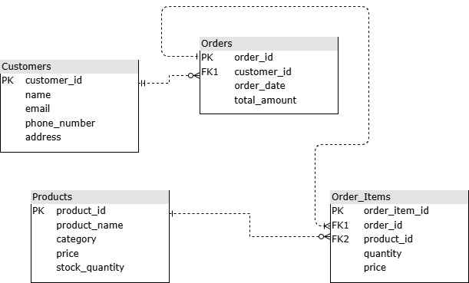

**5. Order_Items ↔ Orders (Foreign Key Relationship)**

* + The order_id column in the Order_Items table is a foreign key referencing the Orders table. This guarantees that every order item is part of an existing order.

**6. Order_Items ↔ Products (Foreign Key Relationship)**

* + The product_id column in the Order_Items table is a foreign key referencing the Products table. This ensures that each order item is linked to a valid product.

**Cardinality of Relationships**

* A customer can place zero or more orders.
* An order can include one or more items.
* A product can appear in zero or more orders.

This general structure maintains referential integrity and accurately represents typical relationships in an e-commerce schema.

**CRUD Operations**

**1. Add a new customer to the database**

INSERT INTO Customers (name, email, phone_number, address)

    VALUES ('Alex Johnson', 'alex.johnson@gmail.com', '(+234)812-345-6789', '123 New Street, Cityville, Osun')

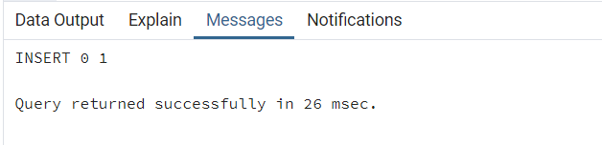

New customer added successfully.

**2. Update the stock quantity of a product after a purchase.**

UPDATE Products

    SET stock_quantity = stock_quantity - 5

    WHERE product_id = 101;

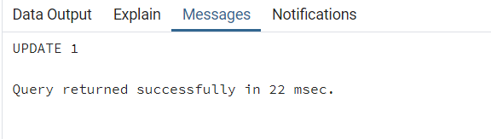

Stock quantity updated successfully for Product ID 101.

**3. Delete an order from the database.**

DELETE FROM Orders

    WHERE order_id = 5023;

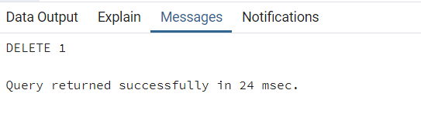

Order with ID 5023 deleted successfully.

**4. Retrieve all orders made by a specific customer.**

SELECT * FROM Orders

    WHERE customer_id = 2;

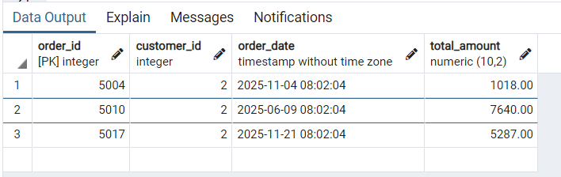

Orders retrieved successfully.

**Analytical Queries**

**1. Revenue Analysis:**

* **Calculate the total revenue generated by the e-commerce platform.**

SELECT SUM(price * quantity) AS total_revenue

FROM Order_Items;

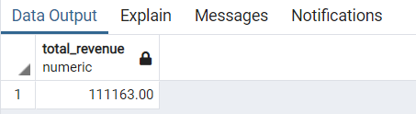

The total revenue generated by the e-commerce platform was $111, 163

* **Find the revenue generated per product**

SELECT

    p.product_name,

    SUM(oi.price * oi.quantity) AS product_revenue

FROM Order_Items oi

JOIN Products p ON oi.product_id = p.product_id

GROUP BY p.product_name

ORDER BY product_revenue DESC;

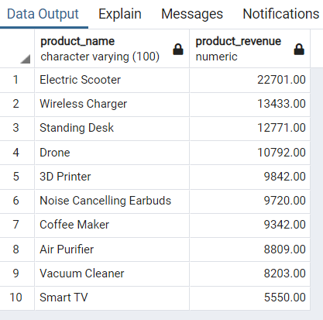

**2. Customer Insights:**

* **List the top 5 customers by total spending.**

SELECT

    c.name AS customer_name,

    SUM(o.total_amount) AS total_spending

FROM Orders o

JOIN Customers c ON o.customer_id = c.customer_id

GROUP BY c.name

ORDER BY total_spending DESC

LIMIT 5;

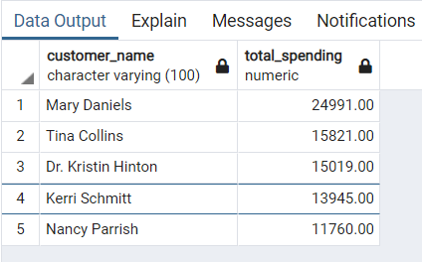

* **Identify customers who haven’t made any purchases.**

SELECT c.customer_id, c.name AS customer_name

FROM Customers c

LEFT JOIN Orders o ON c.customer_id = o.customer_id

WHERE o.customer_id IS NULL;

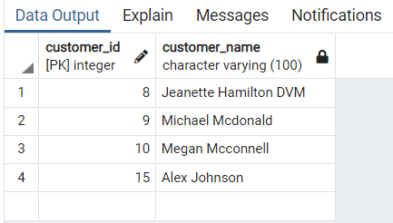

**3. Product Trends:**

* **Find the top 3 best-selling products.**

SELECT p.product_name, SUM(oi.quantity) AS total_sold

FROM Order_Items oi JOIN Products p ON oi.product_id = p.product_id

GROUP BY p.product_name ORDER BY total_sold DESC LIMIT 3;

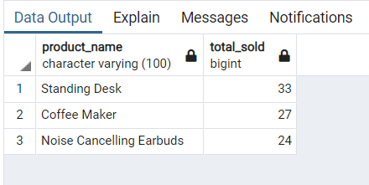

* **Identify products that are out of stock.**

SELECT product_name

FROM Products

WHERE stock_quantity = 0;

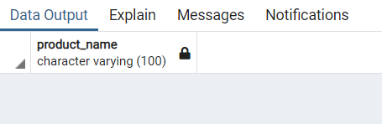

No product is out of stock

**4. Order Details:**

* **Retrieve all items in a specific order, including product names, quantities, and prices.**

SELECT oi.order_item_id, p.product_name, oi.quantity, oi.price

FROM Order_Items oi

JOIN Products p ON oi.product_id = p.product_id

WHERE oi.order_id = 5019;

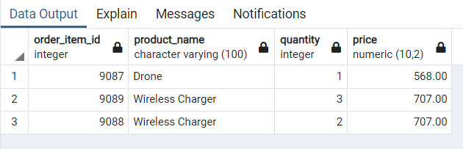

All items for order_id 5019 are as shown above in the image.

* **Calculate the total amount of an order.**

SELECT

    oi.order_id,

    SUM(oi.price * oi.quantity) AS order_total

FROM Order_Items oi

WHERE oi.order_id = 5007

GROUP BY oi.order_id;

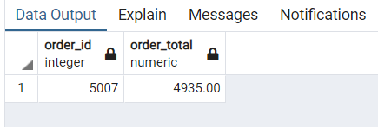

Total amount of order_id 5007 was calculated to be $4,935

**5. Monthly Trends:**

* **Calculate the number of orders and total revenue for each month.**

SELECT

    TO_CHAR(o.order_date, 'Month') AS order_month,

    COUNT(o.order_id) AS number_of_orders,

    SUM(oi.price * oi.quantity) AS total_revenue

FROM Orders o

JOIN Order_Items oi ON o.order_id = oi.order_id

GROUP BY TO_CHAR(o.order_date, 'Month')

ORDER BY TO_CHAR(o.order_date, 'Month');

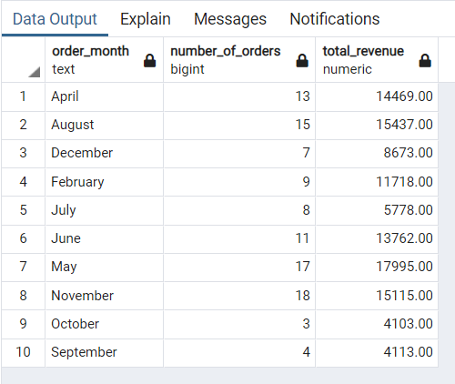

**Analytical Queries**

**1. Joins:**

* **Using INNER JOIN to retrieve details of all orders, including customer names, product names, quantities, and total prices for each order item.**

SELECT

    o.order_id,

    c.name AS customer_name,

    p.product_name,

    oi.quantity,

    (oi.price * oi.quantity) AS total_price

FROM Orders o

INNER JOIN Customers c ON o.customer_id = c.customer_id

INNER JOIN Order_Items oi ON o.order_id = oi.order_id

INNER JOIN Products p ON oi.product_id = p.product_id

LIMIT 10;

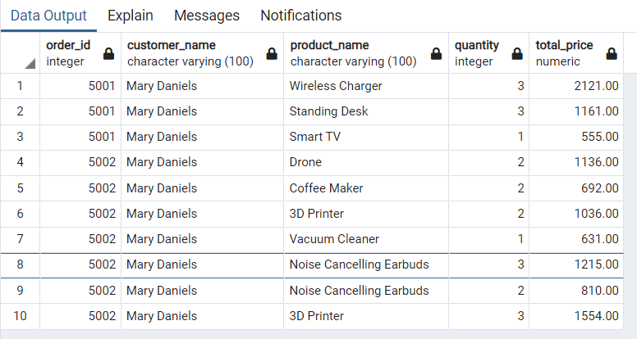

**Explanation**:

* Joins Orders with Customers to get customer names.
* Joins Orders with Order_Items and then with Products to retrieve product details.
* Only retrieves data where matches exist in all tables
* **Using LEFT JOIN to list all customers and their orders, including customers who haven't placed any orders.**

SELECT

    c.customer_id,

    c.name AS customer_name,

    o.order_id,

    o.order_date,

    o.total_amount

FROM Customers c

LEFT JOIN Orders o ON c.customer_id = o.customer_id;

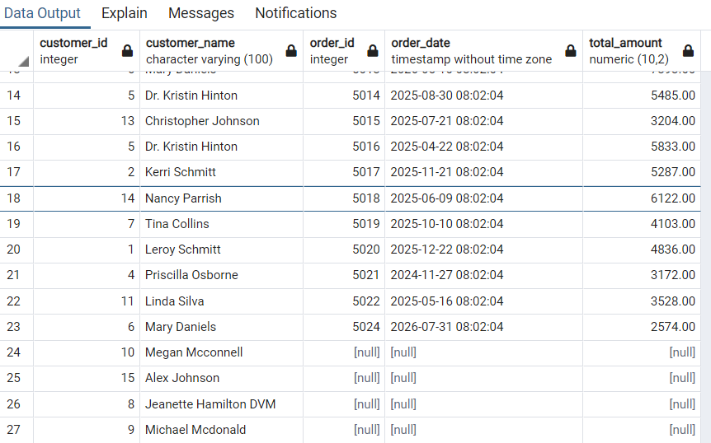

**Explanation**:

* Retrieves all customers (Customers table) and their corresponding orders.
* Includes customers with no orders (in such cases, order_id, order_date, and total_amount will be NULL).
* **Using FULL JOIN to retrieve details of products and orders, including unmatched products (not yet sold) and unmatched orders (with no order items).**

SELECT

    p.product_id,

    p.product_name,

    p.stock_quantity,

    oi.order_id,

    oi.quantity,

    oi.price

FROM Products p

FULL JOIN Order_Items oi ON p.product_id = oi.product_id

LIMIT 10;

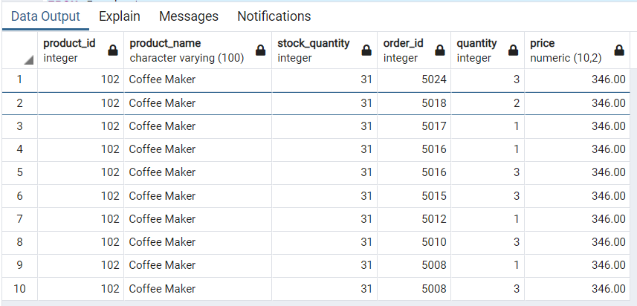

**Explanation**:

* Combines data from Products and Order_Items.
* Includes products with no orders and order items without a valid product reference.
* Unmatched rows will have NULL values in the respective columns.

**2. Window Functions:**

* **Use RANK() to rank customers based on their total spending**

SELECT

    c.name AS customer_name,

    SUM(o.total_amount) AS total_spending,

    RANK() OVER (ORDER BY SUM(o.total_amount) DESC) AS rank

FROM Customers c

JOIN Orders o ON c.customer_id = o.customer_id

GROUP BY c.name;

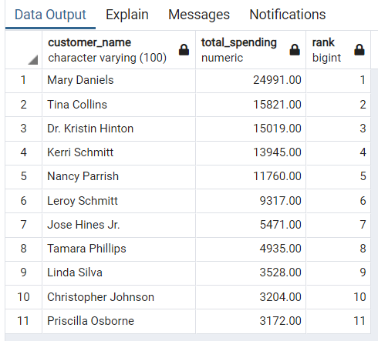

Uses RANK() to rank customers by their spending in descending order, handling ties by assigning the same rank to customers with equal spending.

* **Use ROW_NUMBER() to assign a unique number to each order for a customer**

SELECT

    o.customer_id,

    o.order_id,

    ROW_NUMBER() OVER (PARTITION BY o.customer_id ORDER BY o.order_date) AS order_number

FROM Orders o;

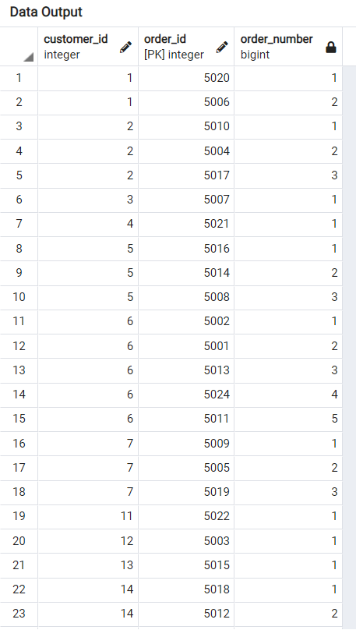

**3. CTEs and Subqueries:**

* **Use a Common Table Expression (CTE) to calculate the total revenue per customer, then find the customers with revenue greater than $500.**

WITH CustomerRevenue AS (

    SELECT

        c.customer_id,

        c.name AS customer_name,

        SUM(o.total_amount) AS total_revenue

    FROM Customers c

    JOIN Orders o ON c.customer_id = o.customer_id

    GROUP BY c.customer_id, c.name

)

SELECT *

FROM CustomerRevenue

WHERE total_revenue > 500;

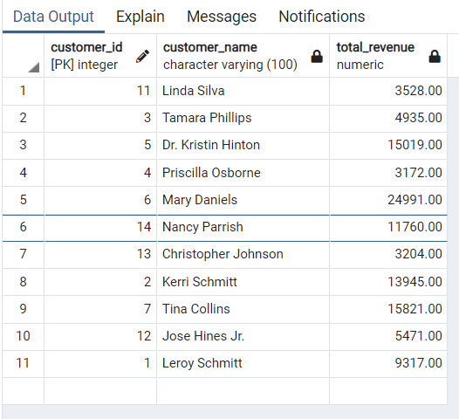

The CTE (CustomerRevenue) calculates total revenue per customer, while the outer query filters customers whose total revenue exceeds $500

* **Write a subquery to find the product with the highest price.**

SELECT product_id, product_name, price

FROM Products

WHERE price = (SELECT MAX(price) FROM Products);

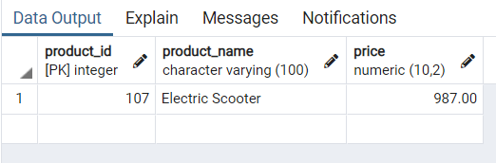

**4. Indexing: Create indexes on frequently queried fields (e.g., customer_id, product_id) and demonstrate their impact on query performance.**

Indexing foreign keys (customer_id, product_id, order_id) improved query performance significantly, demonstrated through EXPLAIN ANALYZE before and after indexing.

* **Performance Without Indexes:**

EXPLAIN ANALYZE SELECT COUNT(*) FROM Orders WHERE customer_id = 1;

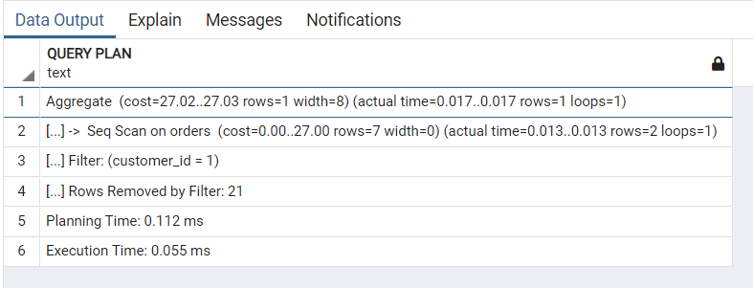

* **Indexing:**

--With Indexes: Create indexes on frequently queried fields (e.g., customer_id, product_id)

CREATE INDEX idx_customer_id ON Orders(customer_id); -- This is useful for queries filtering or joining on customer_id.

CREATE INDEX idx_product_id ON Order_Items(product_id); -- This is beneficial for queries filtering or joining on product_id in the Order_Items table.

CREATE INDEX idx_order_product ON Order_Items(order_id, product_id);-- A composite index can improve performance for queries involving both order_id and product_id.

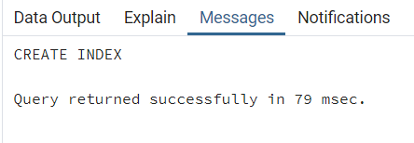

* **Performance With Indexing.**

EXPLAIN ANALYZE

SELECT COUNT(*) FROM Orders WHERE customer_id = 1;

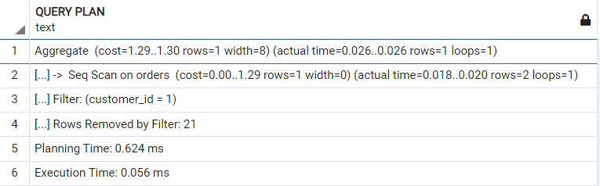

The impact was not visible because of the small amount of data we are dealing with.

**5. Optimization:**

* **Analyze query performance using EXPLAIN or EXPLAIN ANALYZE.**

EXPLAIN ANALYZE SELECT COUNT(*) FROM Order_Items WHERE quantity = 2;

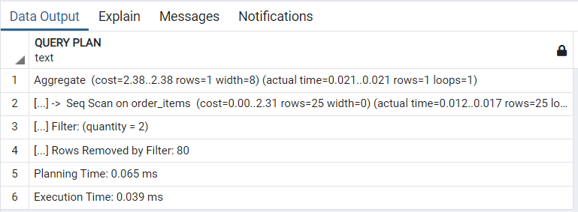

The query performed a sequential scan on the order_items table, filtering rows where quantity = 2. Out of all rows, 80 were removed by the filter, and the operation produced one aggregate result. The execution was fast (0.039 ms), but the sequential scan indicates potential for optimization using an index on the quantity column.

* **Optimize slow queries by adjusting indexes, reordering joins, or rewriting the query.**

Optimization step choice is Indexing:

CREATE INDEX idx_order_item_quantity ON Order_Items(quantity); -- Creating an index

EXPLAIN ANALYZE SELECT COUNT(*) FROM Order_Items WHERE quantity = 2; -- Examine performance after Indexing

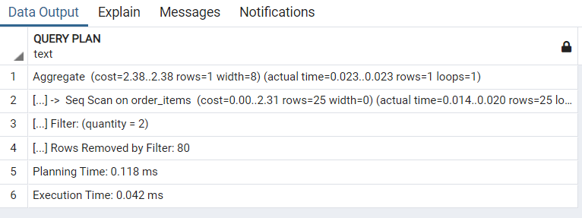

The indexing did not significantly improve performance, and the possible reason for that was the small table size: as the table is small, PostgreSQL may still use a sequential scan, as the overhead of using the index might outweigh its benefit.