**Curriculum Vitae**

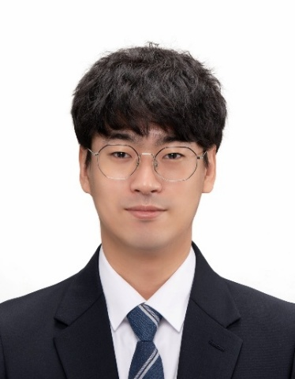

**Joohoon Kim**

**Postdoctoral Researcher at Pohang University of Science and Technology (POSTECH) Institute of Artificial Intelligence (PIAI)**

**E-mail |** [kimjuhoon@postech.ac.kr](mailto:kimjuhoon@postech.ac.kr)

**Phone |** +82-54-279-6806

**Office |** R1259 RIST Building I

**Google scholar | LinkedIn | ORCID |**

**Education**

* **B.S. in Mechanical Engineering**, POSTECH, Korea (2017 – 2021)
* **M.S./Ph.D. in Mechanical Engineering**, POSTECH, Korea (2021 – 2026)

**Experience**

* **Postdoctoral Researcher**, PIAI, Korea (2026 – current)
* **Entrepreneurial Member**, Metacloud, Korea (2023 – 2024)

Funded by I-Corps program (Startup investment program by the Ministry of Science and ICT)

* **Visiting Researcher**, Plant and Food Research, New Zealand (2023)

Host: Dr. Jonghyun Choi

* **Visiting Researcher**, Northeastern University, USA (2022)

Host: Prof. Yongmin Liu

* **Visiting Researcher**, Massachusetts Institute of Technology, USA (2022)

Host: Prof. Juejun Hu

* **Entrepreneurial Leader**, ThinLens, Korea (2022 – 2023)

Funded by I-Corps program (Startup investment program by the Ministry of Science and ICT)

* **Undergraduate Researcher**, POSTECH, Korea (2019 – 2021)

Advisor: Junsuk Rho

* **Internship**, Samsung Electronics, Korea (2018)

**Selective Honors and Awards**

* Editage Grant (2nd place) (2024)
* Presidential Science Fellowship (Ph.D.) (2024 – 2026)
* Asan Biomedical Science Fellowship (2024 – 2026)
* iCore Lab Start-Up Award (Grand Prize) (2024)
* NAEK Wonik “Young Engineers Honor Society” Award (1st place) (2024)
* 3.1 Fellowship (2023 – 2024)
* KIDS Award (Gold), IMID (2023)
* Samsung Humantech Paper Award (Silver) (2023)
* Talent Award of Korea (2022)
* KIDS Award (Gold), IMID (2022)

**Selected Publications (First Authored)**

**Dr. Joohoon Kim is postdoctoral researcher at PIAI**

* **Wide-field-of-view, switchable, multi-dimensional light-field display using a metasurface lentiuclar lens**

***Nature*** (In revision)

* **300 units per second roll-to-roll manufacturing of visible metalenses**

***Nature*** (In revision)

* **Scalable manufacturing of high-index atomic layer-polymer hybrid metasurfaces for metaphotonics in the visible**

***Nature Materials* 22**, 474-481, 2023 **[IF: 38.5]**

* **Roll-to-plate printable RGB achromatic metalens for wide-field-of-view holographic near-eye display**

***Nature Materials* 24**, 535-543, 2025 **[IF: 38.5]**

* **Full-color augmented reality near-eye displays using single-layer achromatic metasurface waveguides**

***Nature Nanotechnology* 20**, 747-754, 2025 **[IF: 34.9]**

* **A water-soluble label for food products prevents packaging waste and counterfeiting**

***Nature Food* 5**, 293-300, 2024 **[IF: 21.9]**

* **Anti-aliased metasurfaces beyond the Nyquist limit**

***Nature Communications* 16**, 411, 2025 **[IF: 15.7]**

* **Polariton condensate far-detuned from exciton resonance in WS2 bound states in the continuum**

***Nature Communications*** (In revision)

* **Amorphous to crystalline transition in nanoimprinted sol-gel titanium oxide metasurfaces**

***Advanced Materials* 36**, 2405378, 2024 **[IF: 26.8]**

* **Dynamic hyperspectral holography enabled by inverse-designed metasurfaces with oblique helicoidal cholesterics**

***Advanced Materials* 36**, 2311785, 2024 **[IF: 26.8]**

* **Multicolor and 3D holography generated by inverse-design single-cell metasurfaces**

***Advanced Materials* 35**, 2208520, 2023 **[IF: 26.8]**

* **Metasurfaces-driven hyperspectral imaging via multiplexed plasmonic resonance energy transfer**

***Advanced Materials* 35**, 2300229, 2023 **[IF: 26.8]**

**Professional Services**

* **Proposal Reviewer**

Served as proposal reviewer for ***Israeli Ministry of Innovation, Science and Technology***

* **Journal Reviewer**

Regular reviewer for ***Nature Communications*, *Light: Science & Applications*, *Optica*, *ACS Photonics*, *Nanophotonics*, *Communications Physics*, *Scientific Reports*, *Optics Express*, *Optics Letters*, *Optics and Laser Technology*, *Nanomaterials*, *Displays***