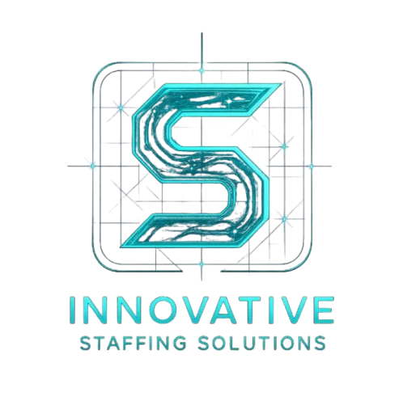 | | Office: Pune, Maharashtra, India | info@innovativestaffingsolutions.online

OFFER LETTER – {{designation}}
Date: {{today_date}}

Candidate Name: {{name}}
Email: {{email}}
Phone: {{phone}}
Address: {{address}}

We are pleased to offer you the position of {{designation}} at Innovative Staffing Solutions, effective {{joining_date}}.
{{ai_generated_content}}
During this internship, your responsibilities will include:
- Assisting in designing and developing projects in the {{domain}} domain
- Collaborating with the team on real-time tasks and deliverables
- Participating in reviews, documentation, and team discussions
- Contributing to research, analysis, and process improvements
- Supporting senior team members in project execution
- Maintaining daily reports and updating progress regularly

This internship position is project-based and remotely coordinated unless stated otherwise. Your performance and learning progress will be evaluated throughout the internship, and high-performing interns may receive extended opportunities or full-time consideration.
We are excited to welcome you to Innovative Staffing Solutions and look forward to your meaningful contributions.

For Innovative Staffing Solutions

Authorized Signatory
Name: Kaif Khan
Designation: Founder & Proprietor
Date: {{today_date}}

hr@innovativestaffingsolutions.online | +91 7447802076 | innovativestaffingsolutions.online

