 KRYOTHERM
6 Aerodromnaya street, Saint-Petersburg, 197348 Russia
Tel: +7 812 394-13-10, fax: +7 812 394-12-67, E-mail: info@kryotherm.ru, http://www.kryotherm.ru
SPECIFICATION OF THERMOELECTRIC MODULE TB-127-0.8-1.5
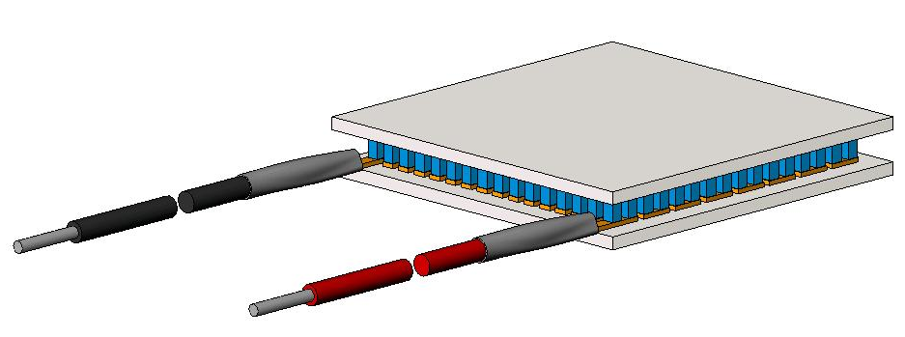 |  |  | 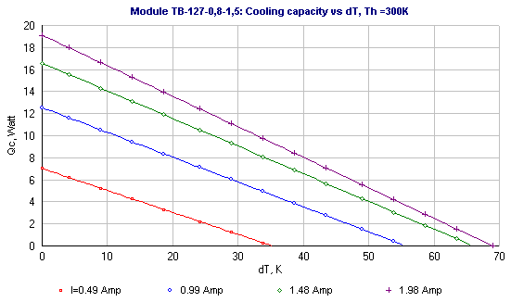  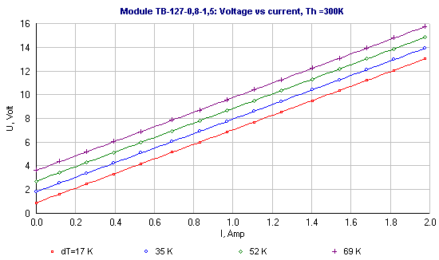
  Thermoelectrical parameters | Unit | Value
  Imax | Amps | 2.0
  Umax | Volts | 15.7
  ∆Tmax | K | 69
  Qmax | Watts | 19.1
  R_{ac} (at 295 K) | Ohm | 6.4
  Tolerance | % | ±10
  All parameters except R_{ac} are given at Th=300 K
  Assembly parameters | Unit | Value
  Wires | 20AWG
  Cross section | mm²
  Metallization | Not
  Sealing | Not
  Internal solder | °C | 139
  Brazing solder | °C | Not
  Operational parameters | Unit | Value
  Working temperature range | °C | -50 ÷ +120
  Max. processing temperature | °C | 130
  ROHS compliance |  | -
