During this assignment I worked on the front and back end for an Airbnb clone. It took me quite a bit of time to achieve the accomplish look that I desired and I enjoyed every bit of building this assignment.

The home page is where majority of my time was spent. I started by creating a mock-up by hand and once satisfied committing to building the same look for the site. However, things don’t always go to plan as a few ideas did not fit on the design of the page. Once the look was complete, I battled with width, height, margin, object-fit, as well as max and min width to achieve scalable images for both the mobile and desktop. This was important to me as the images could come out stretched and no one likes a distorted image. Using bootstrap also helped to accomplish perfect columns and spacing allowing the website to be easily scalable and mobile friendly.

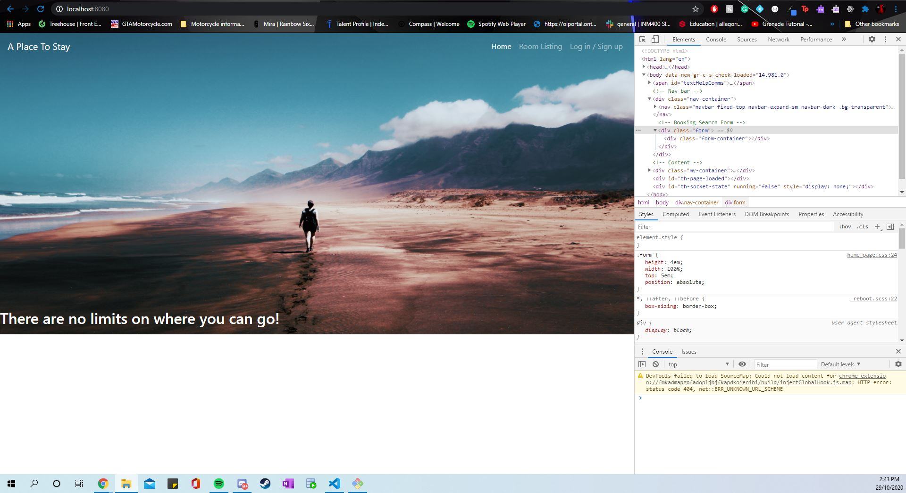



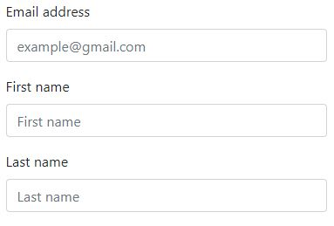

During the development I initially thought of using JavaScript such as createElement and appendChild to populate the page with the rooms content. But, decided to give handlebars a try and was pleasantly suppressed at how much easier it made it to populate the page. The back-end took a little bit more time as I intended but that was due to wanting to create a separate json file to contain the rooms data. This made it so much easier to display the data and made the code look a lot cleaner in the end.

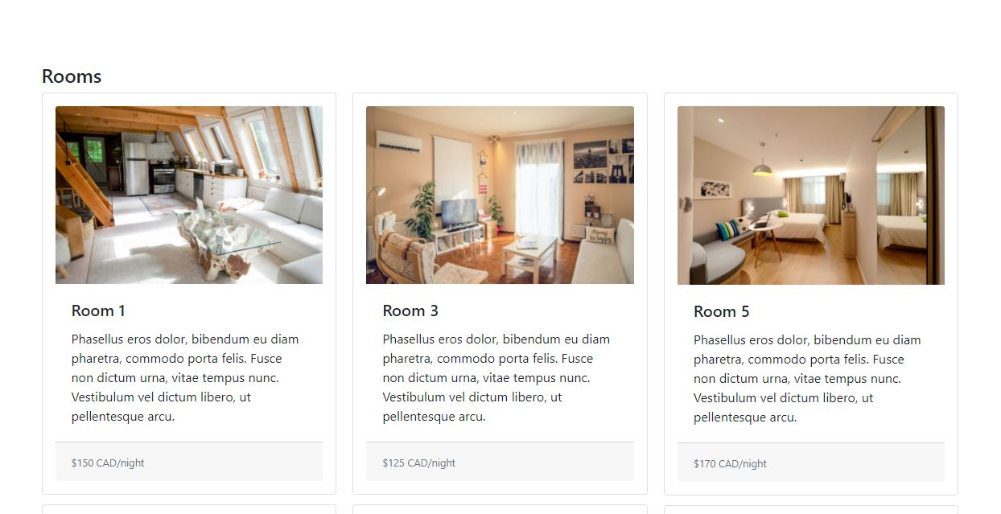

For back-end I ultimately decided to use body parser instead of multer because currently I am not needing a middleware to handle the text and the photo. I also learnt about template engine handlebars to populate the screen for the rooms. Using app.engine to register handlebars with the express app. I then set up the routes to my view (pages) using the path module in unison with the sendFile method in order to serve the information from my html page.

Finally, hosting the website to Heroku was easy enough as through the assignment I kept up to date committing and pushing the work to my repository on GitHub. So, when it came down to setting up the link all I had to do was log in to Heroku and push my master branch.