Team member:

Feng Huang

Meng Tan

Zhaojie Liu

Topic: Parking lock battery curve model



Purpose: In order to accurately calculate the current battery level of a parking lock, estimate remaining battery life and send low-power reminder to users, we developed this parking lock power management model based on nearly 1.4 million lock operation records.

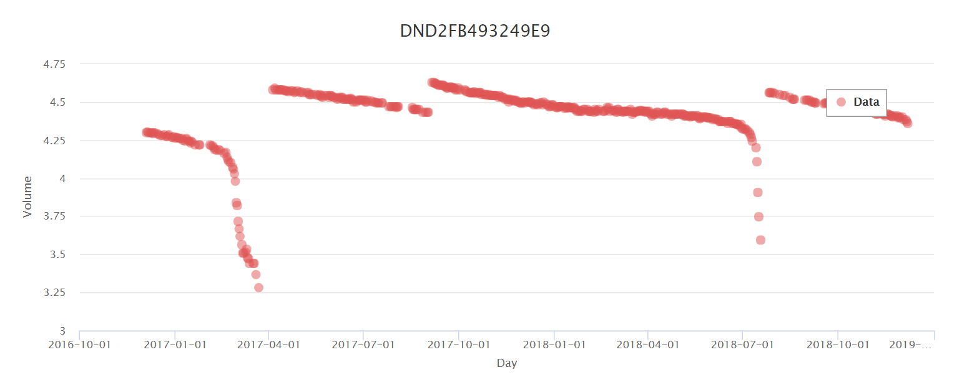

Process:

filter valid data by clearing abnormal values

determine if and when battery is replaced and if so, segment the data

analyze history data to fit current data

plot battery curve and show current battery percentage