|  |  |
| --- | --- |
|  | **FPT ACADEMY INTERNATIONAL**  **FPT – APTECH COMPUTER EDUCATION** |

**Java Florist**

User Guide

|  |  |  |
| --- | --- | --- |
| **Advisor:** | MR. HOANG DUC QUANG | |
| **Semester:** | 3 | |
| **Batch No:** | T1.2203.E1 | |
| **Group No:** | 2 | |
| **Order:** | **Full name** | **Roll No.** |
| 1. | Bui Minh Tin | Student1370240 |
| 2. | Nguyen Ngoc Minh | Student1370242 |
| 3. | Le Hoang Thanh Phat | Student1372897 |

August 2023

1. **User**  
   1. You can view the product and add to cart  
   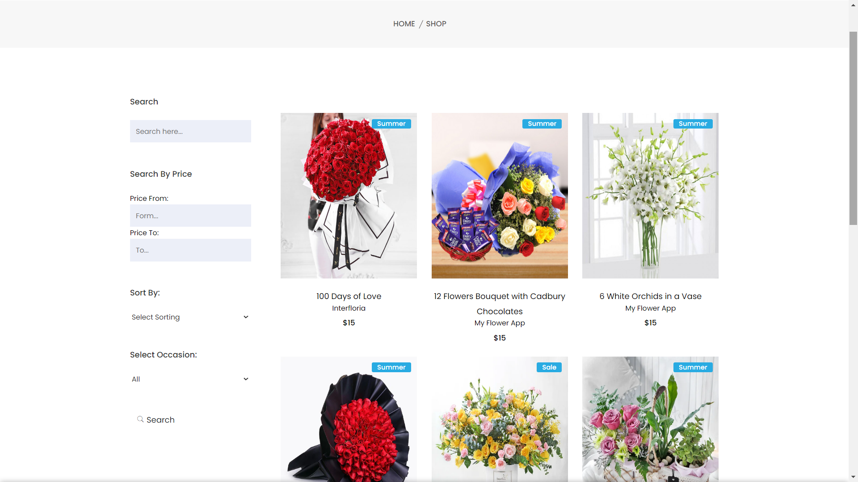  
   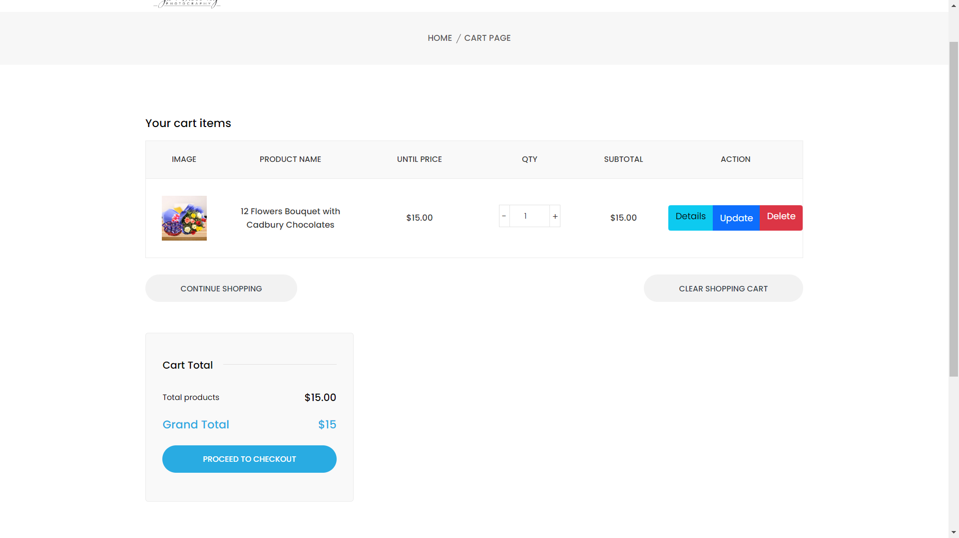  
     
     
   2. Check Out and Payment  
   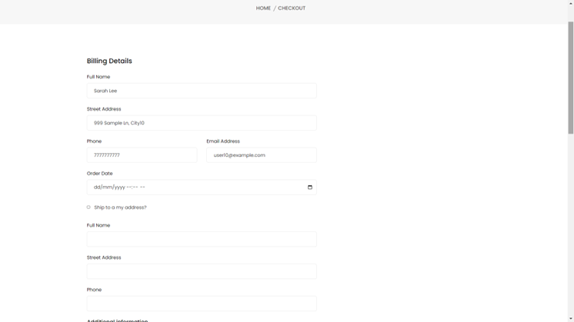  
   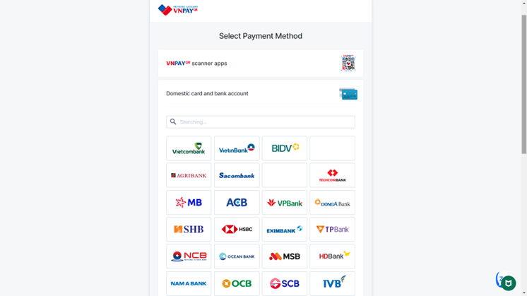  
     
     
     
     
   3. Login and Register  
   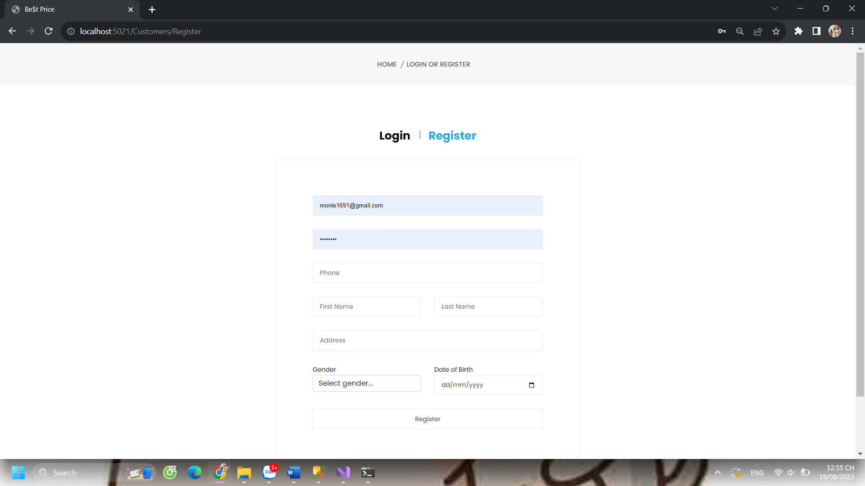  
   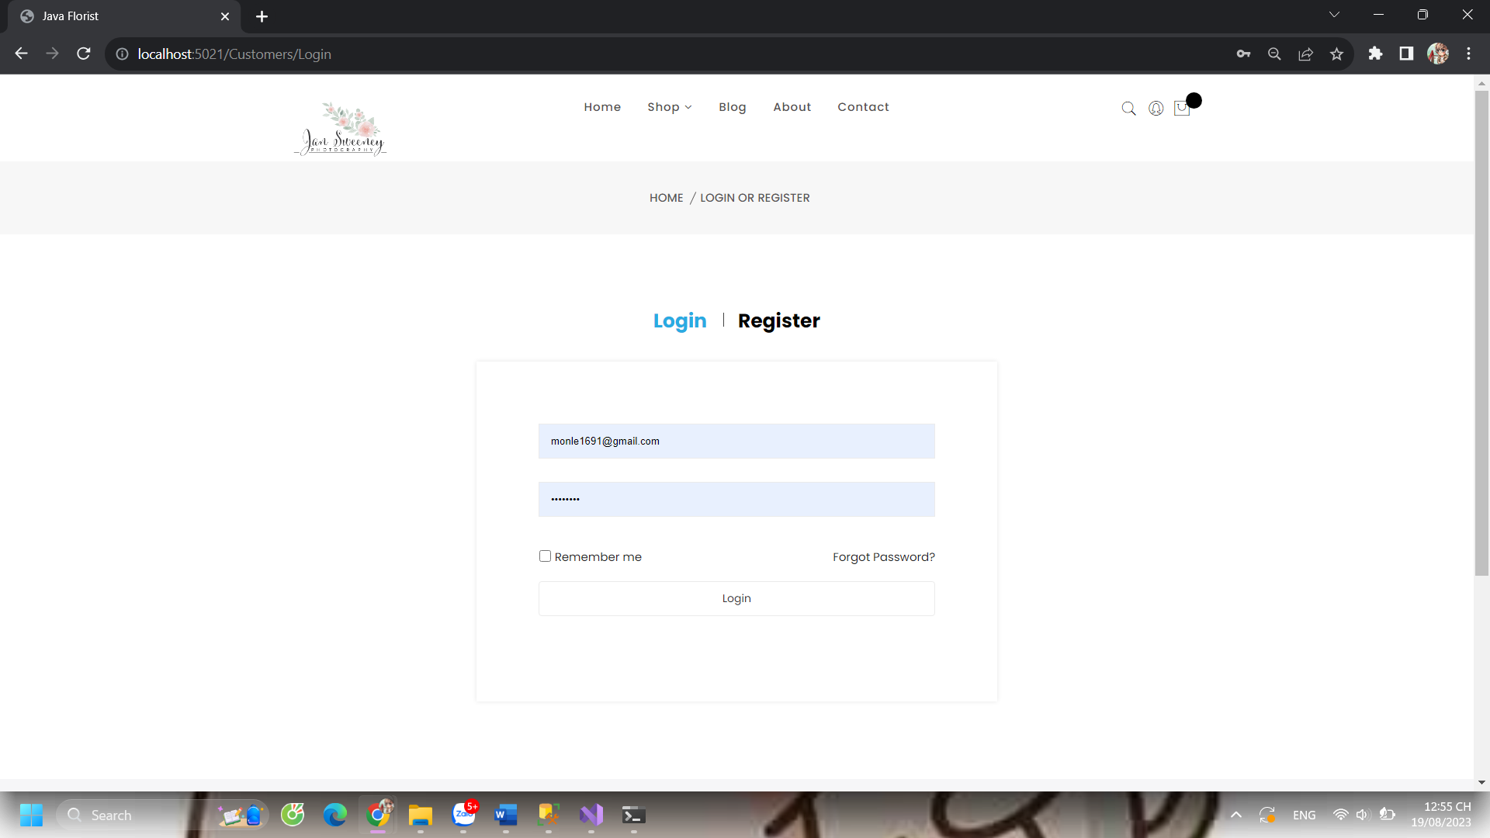  
   4. View Order and Order details  
   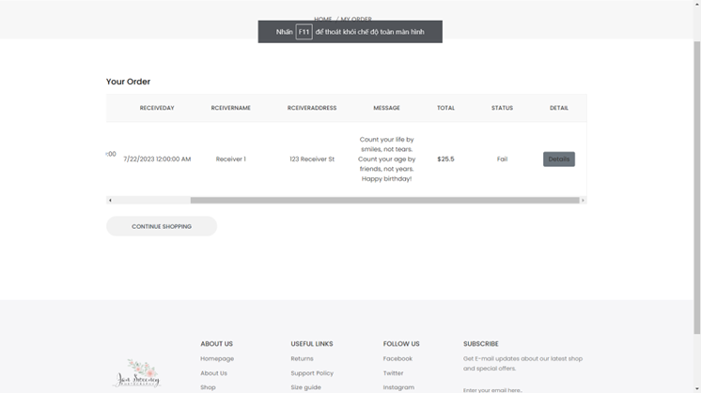  
   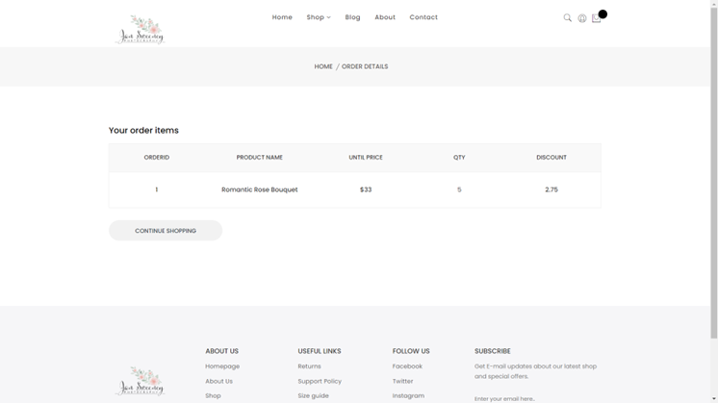  
     
   5. Order Recipt

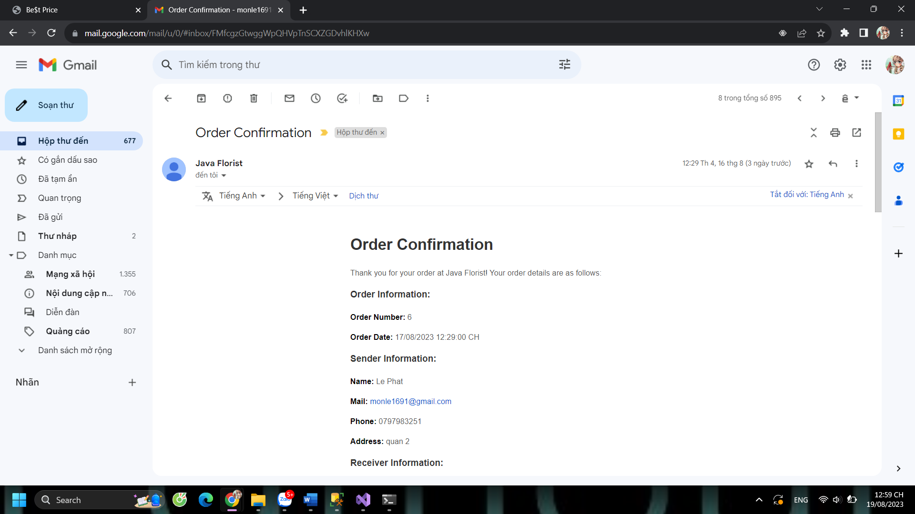  
6. Continue shopping

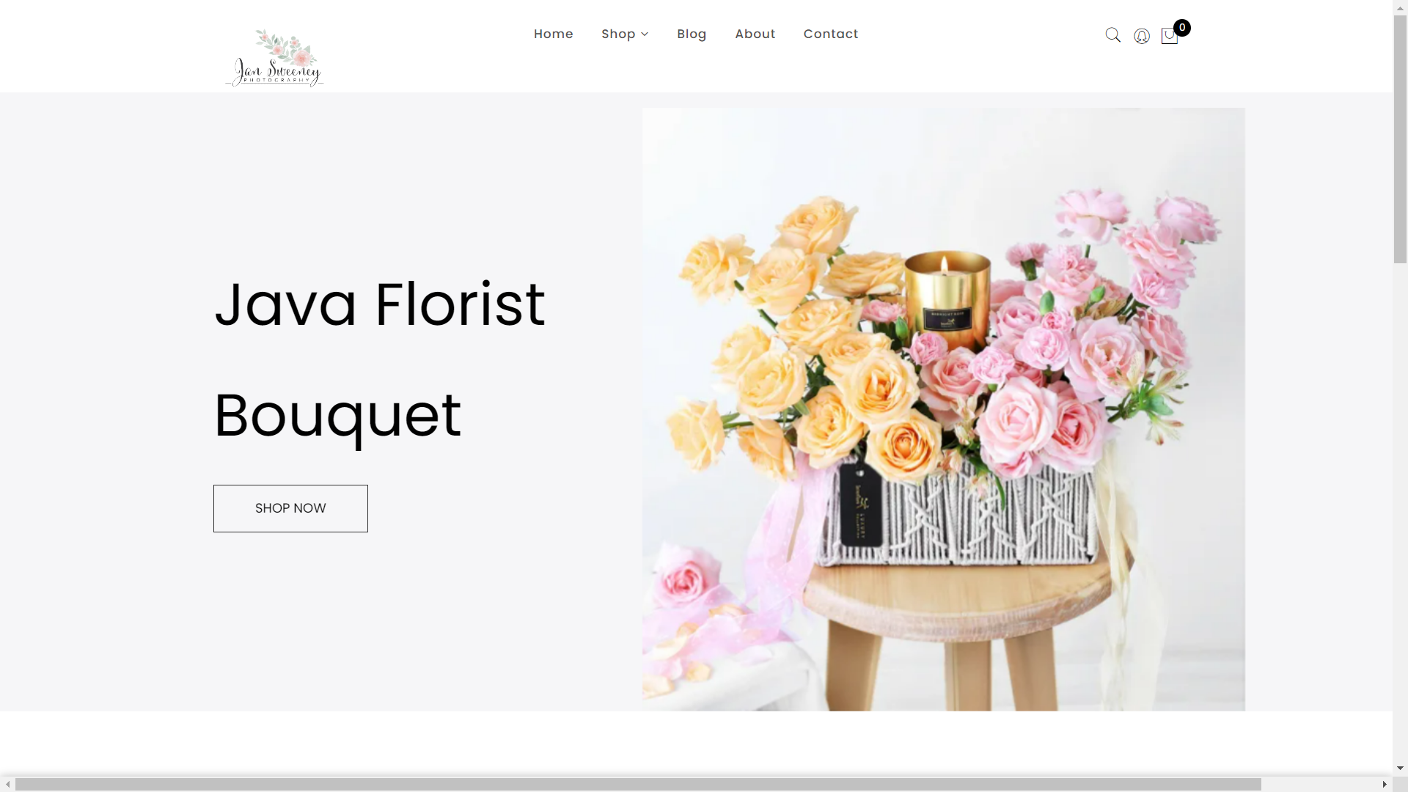

1. Florist  
   1. Index Total Order Of Shop  
   - View all order of shop

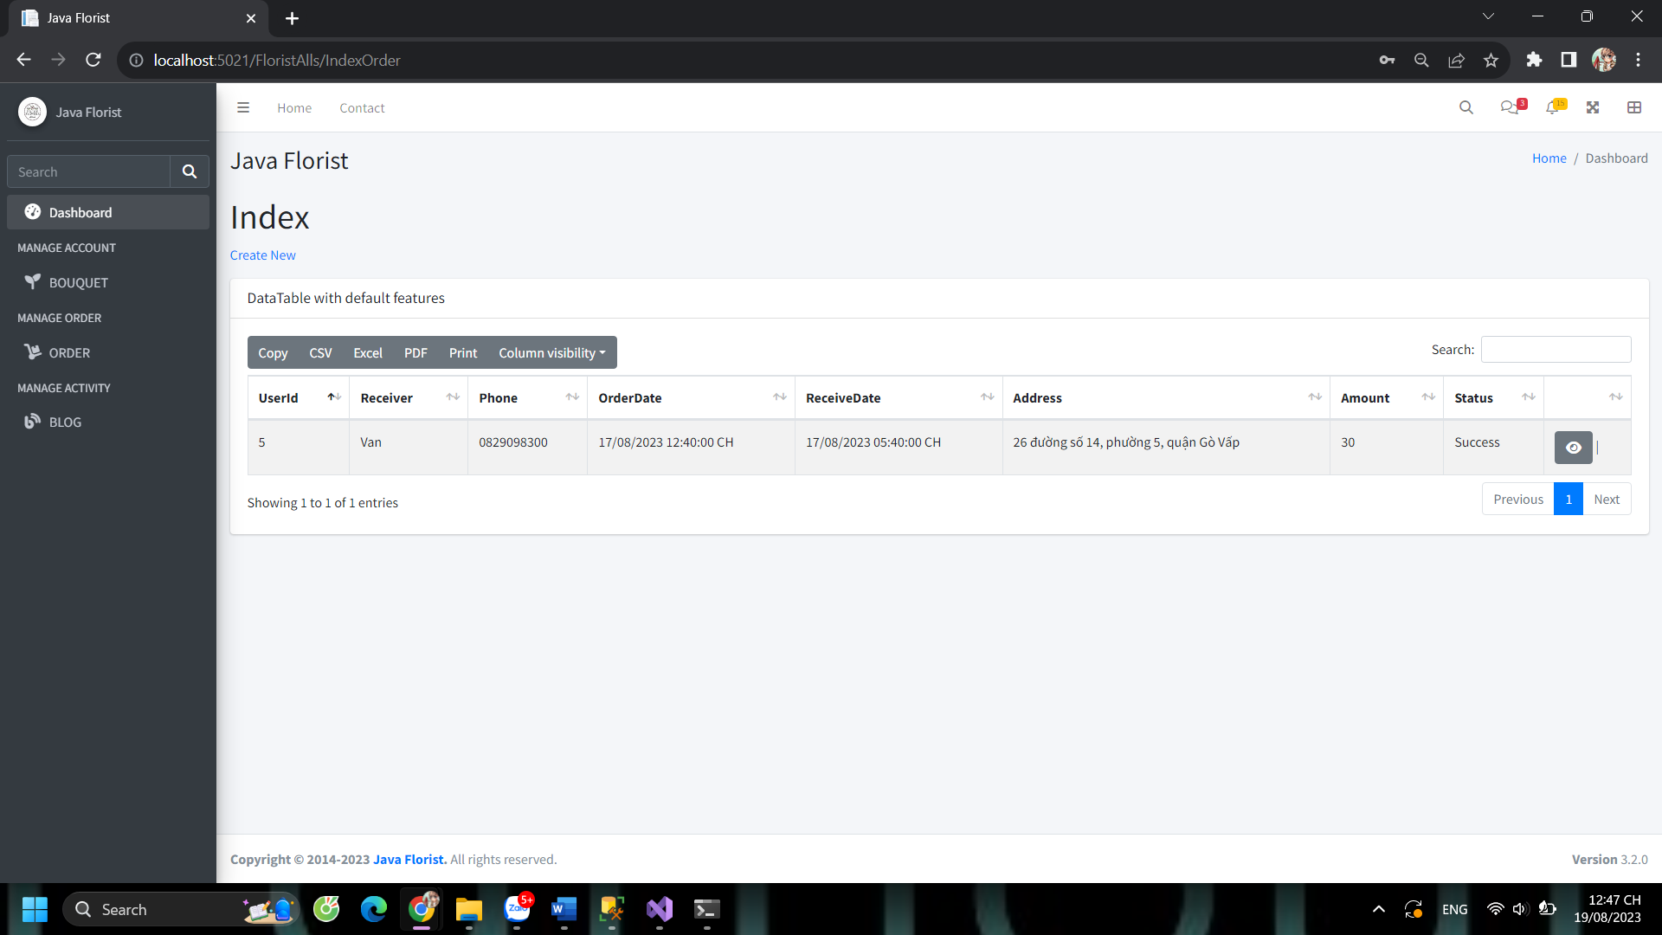

2. Bouquet Of Shop

- CRUD all of bouquet

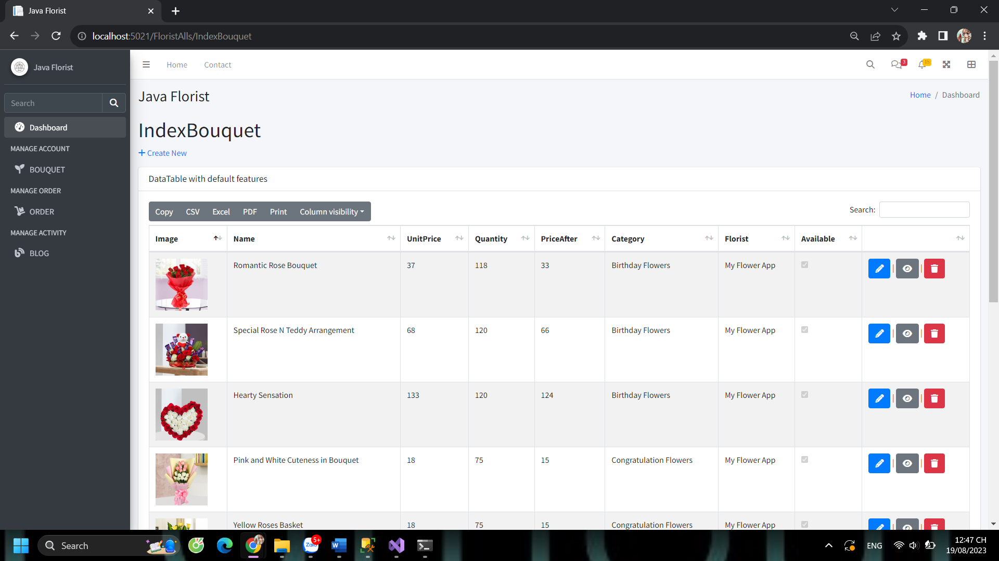

1. Admin

1. Report Of Website and Shop

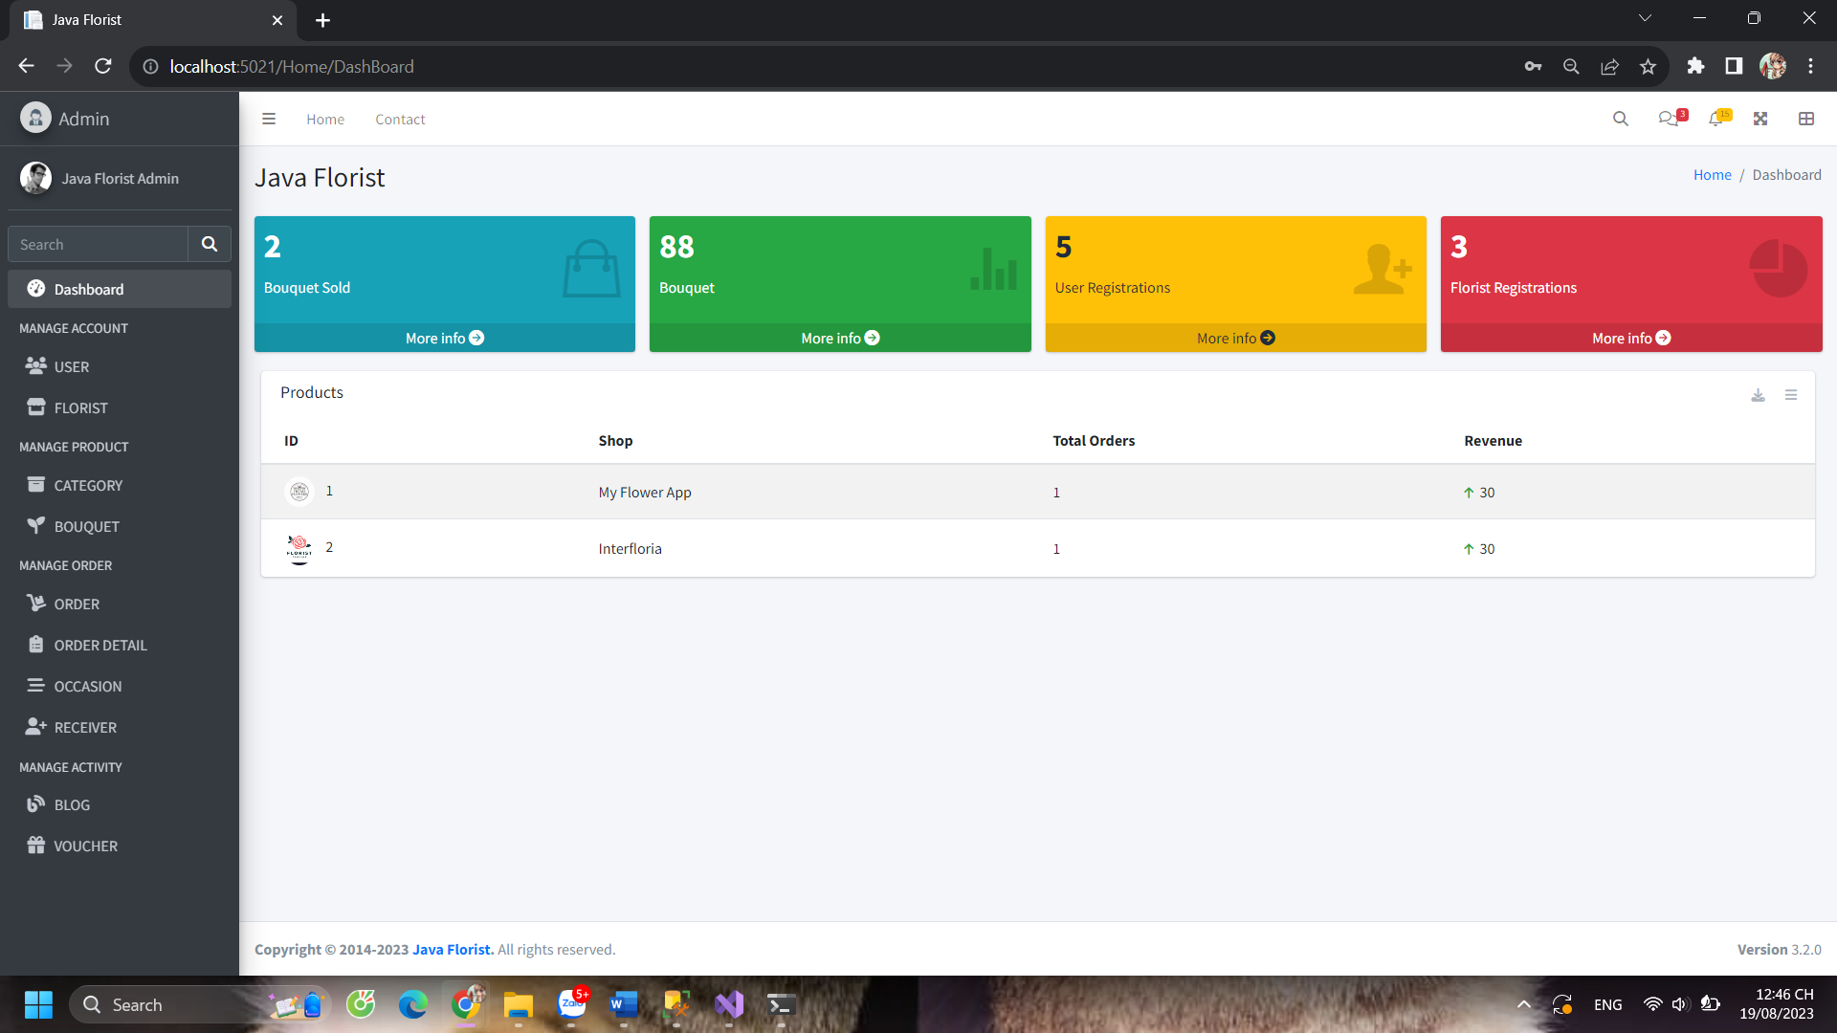

2. All Bouquet

