1. 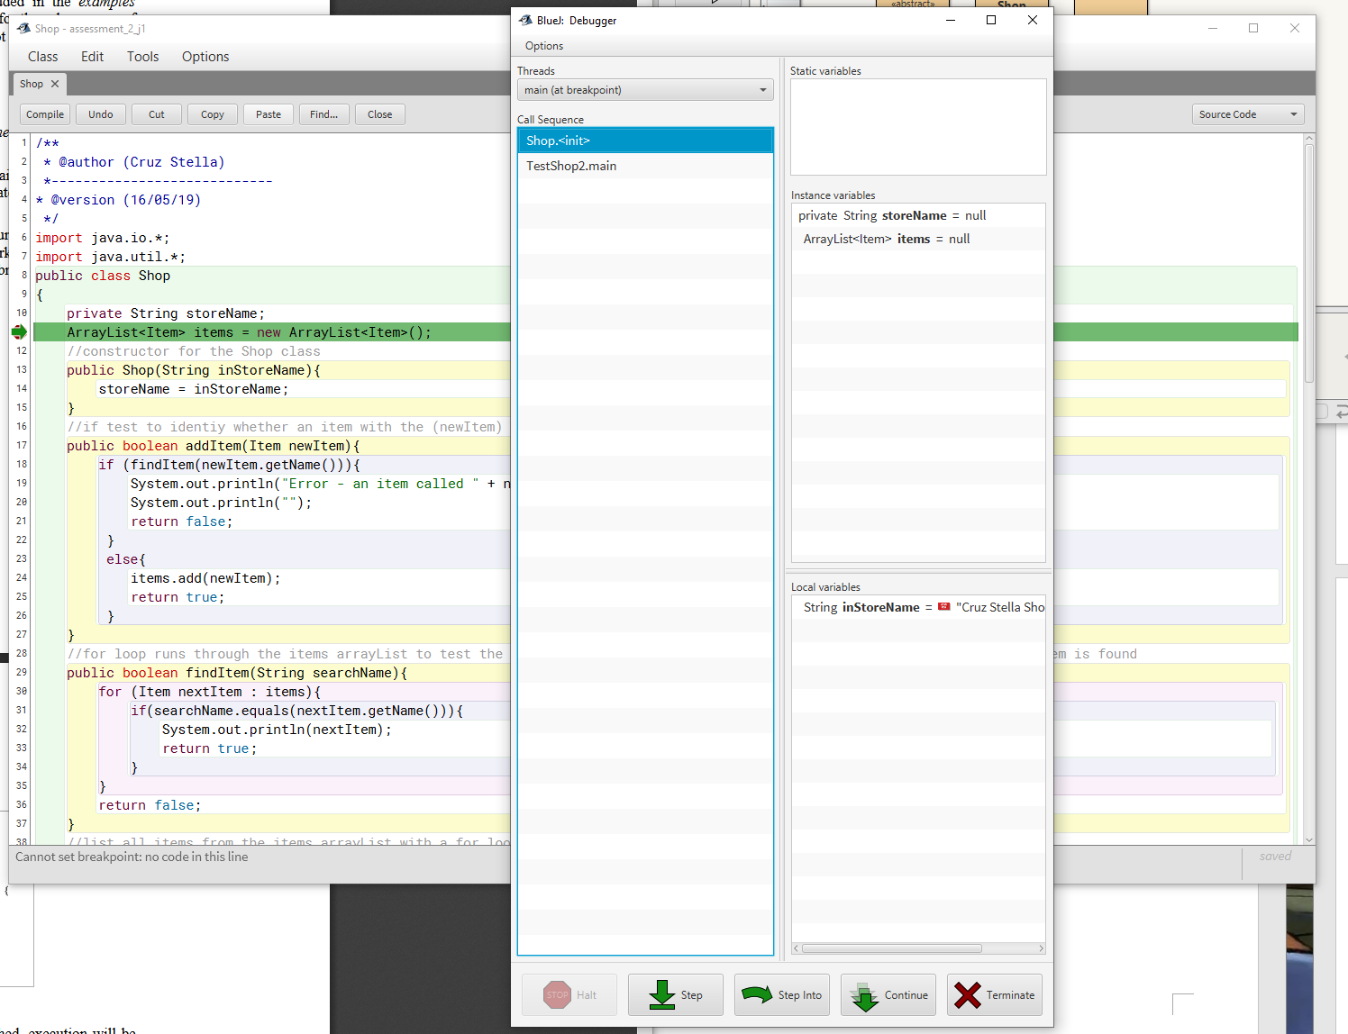Paste in a screen shot of your Shop class with your name as author visible with a line break set &the debugger just about to run that line
2. I have read my code line by line to identify where, and what the correct name (or spelling) is for a variable I have made.
3. 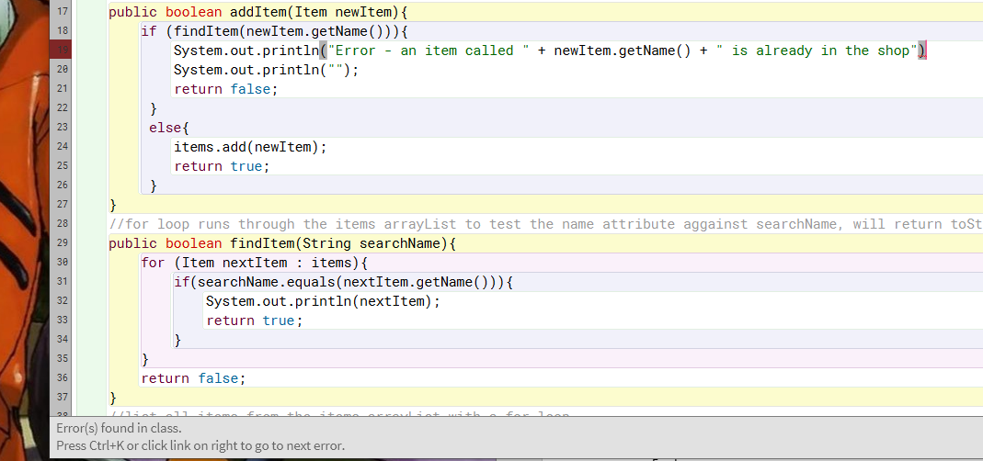This error has come happened because I did not end the line with a semi-colon ";".
4. Results of Bluej terminal window

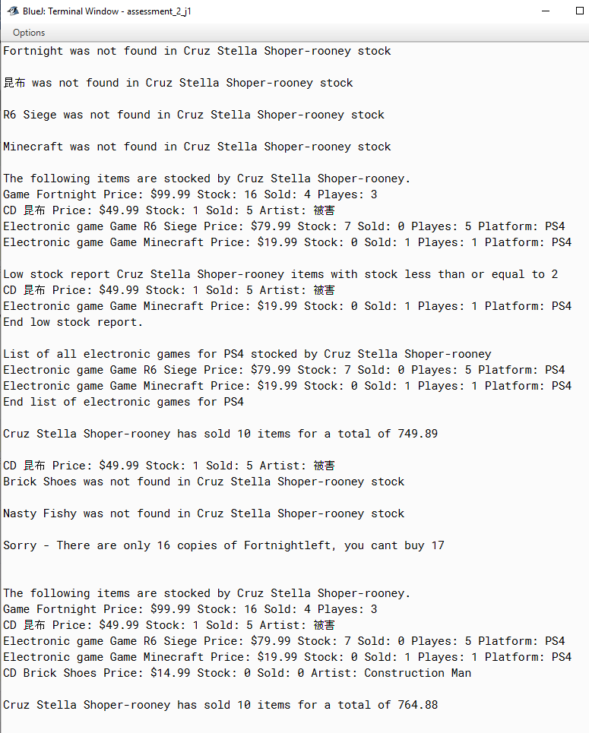

**Results of order_report.txt:**

Cruz Stella Shoper-rooneyorders processed Tue May 21 15:57:38 AEST 2019

Fortnight Purchase of 4 copies successfully processed.

昆布Purchase of 5 copies successfully processed.

R6 Siege Purchase of 0 copies could not be processed.

Minecraft Purchase of 1 copies successfully processed.

Brick Shoes Purchase of 0 copies could not be processed.

**The system has successfully passed the tests. No errors have shown.**

1. I wrote this program in the programming language Java SE 12. I used OOP in this project to create represent and hold data of items in a store. OOP is a way of programming that works with data that has been grouped together as an "Object".
2. This program is developed by getting the clients requirements of the program, then the boss has designed the class diagram, where I have written the code for them, which will be combined with the GUI and tested.
3. A GUI for this system might ask you to fill in text boxes with the data required, such as a games name, players, and price. Once all the information is filled in the user would have to press a button to confirm the entry.

Paste in a screen shot from the API of the information on ArrayLists

1. 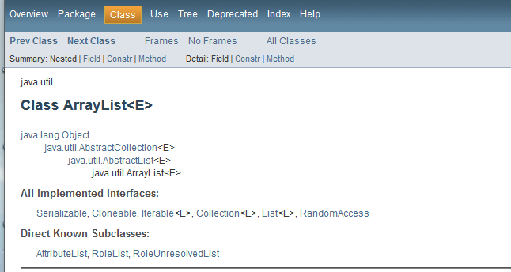
2. True. The benefit of testing is that it helps identify the errors you have made in the code. Testing while in development ensures you do not release a broken product, as long as you have been fixing the errors along the way.
3. Test types: Unit testing, integration testing, system testing, performance testing.

Test tools: JTest, The Grinder, TestNG, Junit, JWalk.