StarwarsApp by Guillermo Siliuto

Testing Arguments
- Argument input as expected
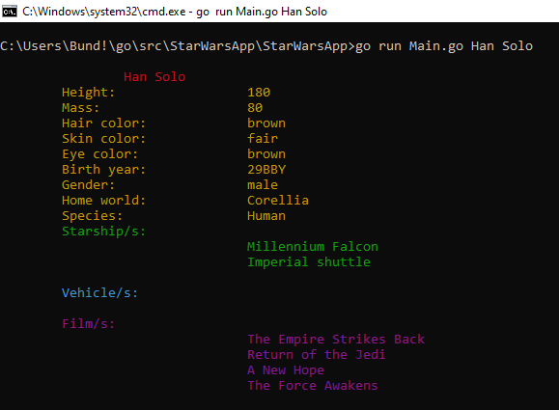
The application shows the information of the character
- No arguments input at initialize the application
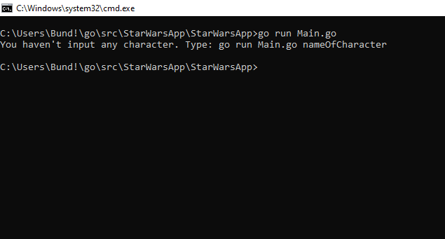
The application informs about the lack of arguments and closes sitself.
- Partial or erroneous name of character as argument
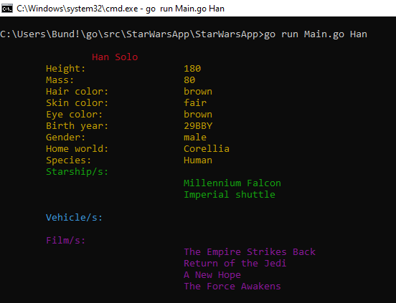
The application completes the name of the character and shows its information
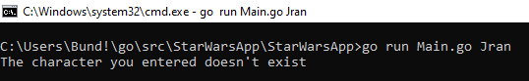
The application can't find a match with the erroneous name, shows an error an closes
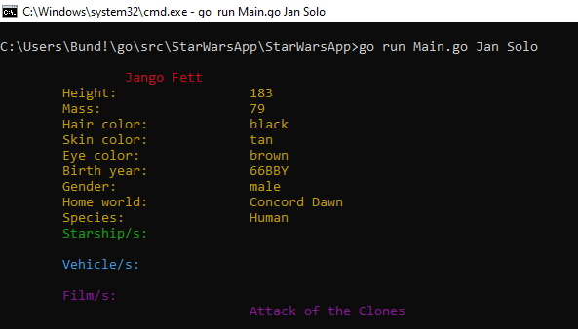
The application matches the closest name with the ones that exists and shows its information

